
Spinal Cord and Brain Injury Research Group
Stark Neuroscience Research Institute
320 W. 15th St., NB, Neurosci. Bldg. 500E
Indianapolis, IN 46202
Office: 317-274-1036
Fax: 317-278-5849
E-mail: xu26@iupui.edu

December 23, 2018

Vineeta Bajaj, Ph.D.
Science Editor
JoVE
617.674.1888

Re: Spinal Cord Lateral Hemisection and Asymmetric Behavioral Assessments in Adult Rats
Manuscript #: 57126 R2

Dear Vineeta,

Thank you for the editorial review of our manuscript 57126 R2 and your patience waiting for our revision. It took us longer than anticipated to complete the revision due to new neurobehavioral experiments conducted to address your comments. We tracked the changes within the manuscript to identify all of the edits. We also uploaded a separate rebuttal document that addressed each of the editorial comments individually.

I have added a few lab members as co-authors due to their contribution to the new experiments incorporated into the revised manuscript.

We thank you again for your consideration of our manuscript and are looking forward to hearing from you soon.

Yours Sincerely,
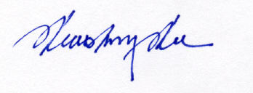
Xiao-Ming Xu, M.D., Ph.D.
Professor and Mari Hulman George Chair of Neurological Surgery
Scientific Director, Spinal Cord and Brain Injury Research Group
Phone: (317) 274-1036; Fax: (317) 278-5849; E-mail: xu26@iupui.edu

