Dear editor
Thank you very much for your reviewing and replying to our manuscript (ID: JOVE57116R4). We have revised the manuscript and video accordingly. We also responded point by point to the comments and modified the video as the editor’s comments. We sincerely hope this revised manuscript is more acceptable for publication.
Thank you again and all the reviewers for the kind advice and look forward to hearing from you soon.
Yours sincerely,
Huihua Qu
Beijing University of Chinese Medicine

E-mail: quhuihuadr@163.com.

Point by point response to the comments
1. How does Figure 3B show polyclonal hybridoma?
Response: we have modified Fig.3 as follows:
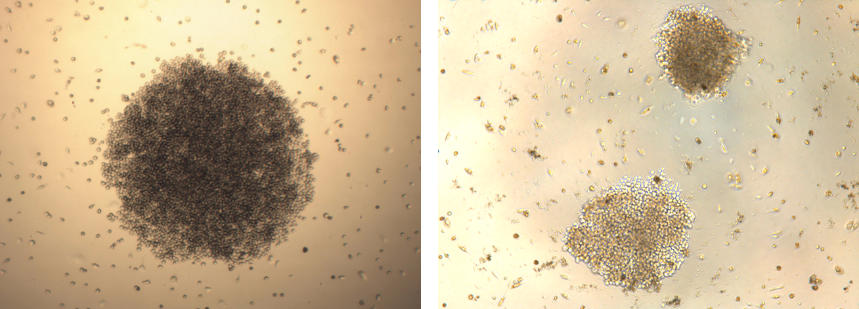
Figure 3: Representative images of stable monoclonal (A) and polyclonal (B) hybridomas.
2. 2:00 onwards - The narration of the video in the protocol does not match the written protocol in the manuscript. Please re-record the narration in the video by reading word for word the written protocol text. This will meet our video publication standard for grammar and clarity. The written protocol text is currently acceptable, but the video narration is not. However, please exclude the sacrificing of the mouse from the video and the video narration.
Response: We have re-recorded the entire protocol narration. Please check.
3. 2:00 onwards - Please ensure that the video is matched to the narration as well. If you are talking about adding 100 uL of sodium periodate, the video should show this and the narration should state this. There are many instances where the video does not agree with the narration.
Response: We have re-recorded the entire protocol narration. Please check.
4. Another example is that it is very hard to follow the Immunization step of the protocol. The narration skips around from step 2.1 to 2.2 and then back to step 2.1.
Response: We have re-recorded the entire protocol narration. Please check.
5. step 3.2.1 says that the 50x HAT media was dissolved in 10 mL of RPMI-1640 but the video narration says that it was only 5 mL. Which is it?
Response:10 mL should be right. We have modified the 3.2.1.
6. 4:57: What is meant by percussion the cells? This is not an English sentence. This is repeated many more times. Please revise and include this in the written manuscript as well.
Response: We have modified the words and re-recorded the entire protocol narration.
7. Please do not use the words "sucked up". Use aspirate instead.
Response: We have modified the words in video.
8. Preparation is misspelled incorrectly in the protocol section headers: 3:35: Preparation of cell fusion; 9:08 - Preparation of monoclonal hybridomas,
Response: Sorry for the fault. We have modified the words in video.
9. Please re-record the entire protocol narration by reading the written text of the written manuscript word for word. However, please exclude the sacrificing of the mouse from the video and the video narration.
Response: We have modified the video, please check.
10. While showing the representative results in the results section of the video, please use screen-capture to show the results instead of filming the computer screen and pointing to it with a finger.
Response: We have modified the video, please check.

