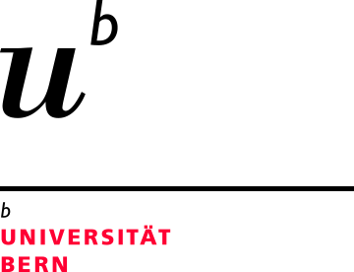Prof. Dr. Matthias Arenz

Department of Chemistry and Biochemistry
University of Bern
Freiestrasse 3
CH - 3012 Bern
Tel +41 31 631 53 84
Email: matthias.arenz@dcb.unibe.ch Bern, 21st November 2017

Dear Editor,

Please find attached the revised version of the manuscript entitled

“On the preparation and testing of fuel cell catalysts using the thin film rotating disc electrode method”

by Inaba et al. for publication in Jove.
We addressed all points from the Editor and revised the manuscript accordingly. We submit one manuscript with all changes visible and one with all changes accepted.

Sincerely yours,

Matthias Arenz

