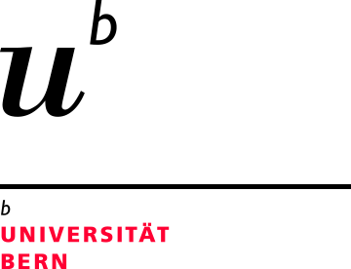Prof. Dr. Matthias Arenz

Department of Chemistry and Biochemistry
University of Bern
Freiestrasse 3
CH - 3012 Bern
Tel +41 31 631 53 84
Email: matthias.arenz@dcb.unibe.ch Bern, 2nd August 2017

Dear Editor,

Please find attached the manuscript entitled

“On the preparation and testing of fuel cell catalysts using the thin film rotating disc electrode method”

by Inaba et al. for publication in Jove. All authors have seen and approved the final version of the manuscript.
Fuel cell technology is a promising piece for future energy schemes relying on renewable energy sources. The can efficiently re-convert the energy carrier hydrogen, which is produced by water electrolysis using renewable energy source like wind or solar power.
In our work, we present a tutorial for the preparation and testing of a Pt/C fuel cell catalyst using the thin-film rotating disk electrode technique. Although this method is widely applied in the scientific community, there is still a need for common procedures and best practice as several research group outlined in recent years. We believe that Jove provides an ideal platform for this purpose.

Sincerely yours,

Matthias Arenz

