Editorial Office
Journal of Visualized Experiments
(JoVE Engineering)

Zurich, 12 May 2017
Submission of revised manuscript (JoVE Submission JoVE56229R1)
Dear Dr. DSouza

Please find enclosed the revised manuscript entitled „experimental protocol to determine the chloride threshold value for corrosion in samples taken from reinforced concrete structures" submitted to the Journal of Visualized Experiments (JoVE).

We have carefully revised the manuscript according to the received editorial comments and provided detailed replies to all comments in a separate file.

On 12 May 2017 we sent you a link to a webserver to download four already recorded video sequences, the receipt of which you confirmed by email.

Thank you very much for your kind attention.

Yours truly,
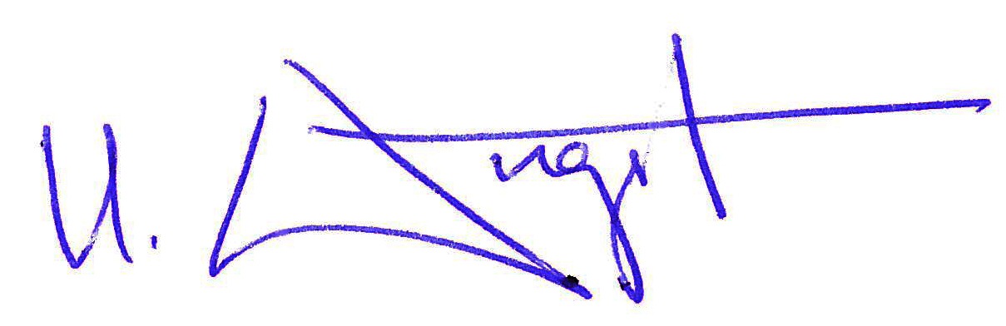
Prof. Dr. Ueli Angst

