Cannula implantation system Introduction
Cannula implantation system is an accepted method of acute and chronic intracranial drug administration for animal experiment. Single cannula system includes guide cannula, dummy cannula, internal cannula and fixing screw. Together with RWD stereotaxic instruments, holders, fixing screws, PE cannulas, injection pumps and other related products, this system provide a set of simple and effective experimental tool of unilateral intracranial administration for neuroscientists. More importantly, RWD offer users can customized cannulas based on their specific experimental requirements.

Components:

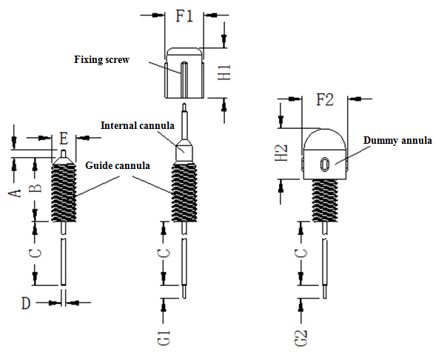

Guide cannula Guide cannula consists of a threaded cylindrical plastic pedestal and a stainless steel tube and it has to be pre-implanted into brain and fixed with dental cement. Both dummy cannula and internal cannula can be inserted into guide cannula individually.
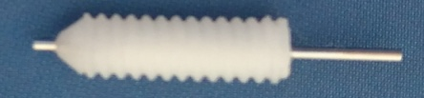

Dummy cannula
Stainless steel wire and threaded plastic cap make a dummy cannula. It can be inserted into guide cannula and fixed by the screw to seal the guide cannula and prevent tissue fluid outflow after injection. The length of the stainless steel wire can be customized according to the actual needs.
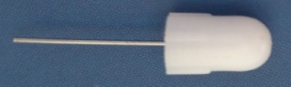
Internal cannula
Internal cannula can be fixed into guide cannula through fixing screw and its tail end is connected with PE tube for injections. The length of internal
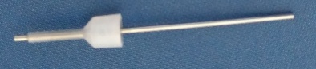
Fixing screw
Fixing screw fixes internal cannula to guide cannula.
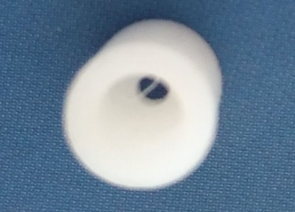

Diagrams:
A - The length of the stainless steel tubing below the plastic pedestal.
B - The height of the cylindrical plastic base.
C - The length of the stainless steel tubing below the plastic pedestal, can be customized.
D - External diameter of stainless steel guide cannulas.
E - External diameter of cylindrical plastic base.
F1 - External diameter of Lock nut.
H1 - Height of Lock nut.
F2 - External diameter of Dummy Cannulas.
H2 - Height of Dummy Cannulas.
G1- The internal cannulas projection length beyond the guide cannulas tip, can be customized.
G2- The dummy cannulas projection length beyond the guide cannulas tip, can be customized.

