Line 93: What type of transducer is used and what is its frequency, please add a note to describe it briefly and add it to the table of materials? Please include ALL parameter settings used (e.g imaging depth, sample freq, power etc)
Response:
We have added 3 lines describing the type of transducer and the settings.
The following text has been added to the manuscript:
“A 5-cm linear-array probe (12.5 Mhz) is used to generate B-mode images (25 Hz). Before each measurement imaging depth, acoustic frequency and power are optimized to visualize interfaces at extra-and intramuscular connective tissues. During the measurement, these settings are not changed.”

Line 175: Please provide an example
Response:
We have made the following adjustments to the manuscript:

Line 173-178:

“Fit the foot of the leg to be scanned into the custom-made footplate.³¹

Connect the custom-made torque wrench with attached goniometer to the footplate³¹ Find the footplate angle corresponding to externally applied torque, e.g. 0Nm (Fig. 2A).

Fix the footplate in the orientation corresponding to the 0Nm net dorsiflexion moment, by using an extendable rod which is connected to the table (Fig. 2A, arrow).”
.
Line 230: These need to be updated, please check. Also, there are no steps below that describe how the landmarks are recorded. Please add these details here and include button clicks.
Response:
We have made the following adjustments:

Line 228-231: “For all muscles, use the MoCap pointer tool to record the marked landmarks (described in sections (3.2.1 and 3.3.2) in the global coordinate system. Move the MoCap pointer tool to the identified anatomical landmarks, and use the MoCap software to record the position by pressing on the “record” button.”

Line 294: 2x Please mention explicit button clicks and software selections
Response:
We have changed the manuscript to explicitly mention button clicks and software selection.

“Open framegrab software (e.g. WinDV) on the measurement computer and start US image acquisition by clicking on the record button. Subsequently, initiate the MoCap data acquisition and activate MoCap data acquisition by pressing a button on the synchronization device, this automatically activates the synchronization device (i.e. piezo crystal) located close to the US probe creating a distinct artefact in the US image at the instance of MoCap initiation (Fig. 1A, Arrow).”

Line 252: We assumed that this happens automatically without user input, if you need to interact with the system please mention explicit software actions.
Response: We have removed this sentences and adjusted editorial changes.
Line

Line 252-257: “While exerting minimal probe pressure yet ensuring image quality, move the probe at a constant speed over the ROI; this is referred to as a “sweep”. Make sure that clear anatomical cross-sectional B-mode US images of the target muscle are recorded.

Visually check for movement of the subject during the examination, if the subject moves abort the sweep and repeat from step 3.2.6.”

Line 262: Please fix.
Response: We have fixed the section reference.
Line 266: Please mention explicit button clicks and software selections.
Response: We have made the following adjustment to explain how additional sweeps are made.

Line 266-269: “Add additional sweeps (as described in section 3.3.3-3.3.5) until the entire ROI is scanned and the medial border of the muscle is imaged completely (Fig. 2B). Use the trace in the gel of the previous sweep to guide the next sweep, slightly overlapping (0.5 cm) the previous swept area.”

Line 292: As there are no details of the reconstruction steps it is unclear what you wish to show here. Are any of the steps below performed in GUI-based software?
Response: We could shortly visualize the 2 main reconstruction steps.
Using custom-made software assign the voxels in the Va with pixel grey-values from the ultrasound images (Bin-filling):
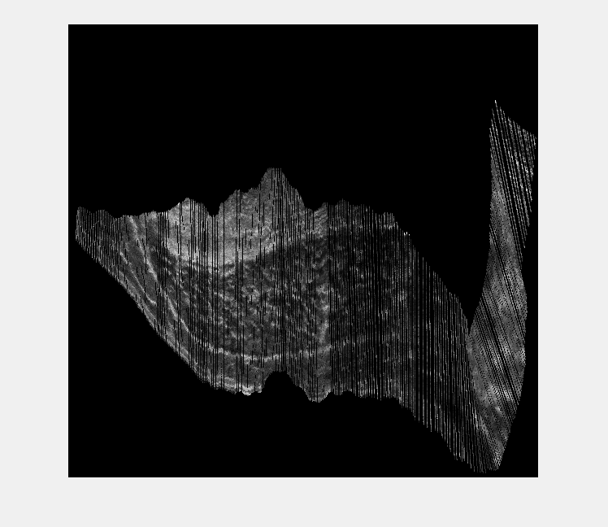
Fill the gaps using an “inpaint procedure”:
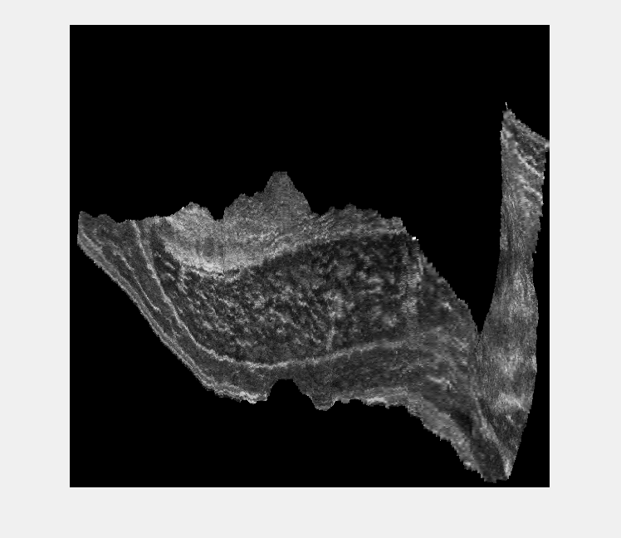
We have made the following adjustments to the manuscript mentioning these 2 main reconstruction steps:
Line 292 -294: “Reconstruct a single 3DUS voxel array (3D image) from a single sweep over the skin of a specific anatomical region of interest (ROI) (e.g. muscle, tendon) by bin-filling and inpainting the 3DUS voxel array.”
Line 297: How? Is this all done using custom scripts?
Response: We have added detail on how we perform this step

Line 297-301: “Synchronize MoCap data and US images by identifying the first US frame containing the piezo crystal created artefact and crop the US image sequence accordingly using VirtualDub software. When using VirtualDub, place the slider at the identified frame and press the home button on the keyboard. Next, move the slider to the end of the measurement and press the end button. Press the F7 button to export the cropped image sequence.”

Line 303: How? Is this all done using custom scripts?

Response: We now mentione that we did this by using a custom-script.

Line 303-305: “Using a custom script define a voxel array (Va) coordinate system which can be filled with US images. Ensure that the Va is oriented in accordance with the scanning direction and sized to fit all the pixels of a single sweep.”
Line 310: How? Is this all done using custom scripts?
Response: We now mention that we did this by using a custom-script.

Line 310-312: Using a custom script assign the voxels in the Va with pixel grey-values from the ultrasound images. This process is described as forward mapping or bin-filling (eq. 3) (Fig 1C)^{23,24}.

Line 323: How? Is this all done using custom scripts?

Response: We had not mentioned that we do this with a custom script and have now mentioned that more detail is given in the next step.
“Using a custom script identify gaps inside the voxel array (i.e. black voxels). Take the following steps by using binary image processing:”

Line 344: Again, as in 3.4, it is unclear what we would show here. We can likely state once that the images are reconstructed to produce the 3D volumes, so 3.4.1 can stay highlighted but 3.5 and 3.5.1 should be unhighlighted.
Response: the importance of this section is to mention that not just a single sweep is reconstructed, instead multiple single sweeps are reconstructed and merged (step 3.5.3 is now highlighted)). We can graphically show how the single sweeps are merged, to form MRI like images. (similar to figure 4)

Line 346-354: “Reconstruct all individual sweeps (described in section 3.4) covering one larger ROI according to the same Va coordinate system (section 3.4).

Create a new Va coordinate system, sized to accommodate all individual reconstructed sweeps.

Place the individual Va’s step by step into the larger Va, if a voxel is already assigned by another Va, this voxel will only be overwritten if the new voxel has a grey value ≥ 10 on an 8-bit scale, otherwise the new voxel grey value is discarded.”

Line 358: Please add step to mention whether the 2D images or 3D volumes are loaded, and mention how.
Response: We have modified the text. Now we mention that the 3DUS images are loaded in the MITK software.

Line 358-362: “Use Medical Interaction Toolkit³⁵ (MITK) to load the 3DUS voxel array and retrieve the coordinates of the origin, insertion and distal end of the muscle belly.

Set the slicing to ‘Coupled crosshair rotation’. Align the axes with muscle or bony structures to precisely retrieve the coordinates.”

Line: 373: How? What is done here?
Response: We now explain how and why the segmentation is performed:

Line 373-379: “ In order to measure muscle volume use MITK to identify muscle belly boundaries between origin and distal end of the muscle belly. Use the build-in MITK segmentation to manually segment multiple anatomical cross-sections evenly distributed along the muscle belly length (Fig. 3A).

Open the ‘segmentation tool’ and create a ‘new segmentation’. Start segmenting the muscle boundaries on an anatomical cross-section halfway along the muscle belly. Press ‘A’ on the keyboard to add a manual segmentation and draw by pressing left mouse button and moving the cursor over the muscles boundaries, Press ‘S’ to remove parts of segmentation.”

Line 391: “If this is to be filmed, explicit details are needed. If you leave this as is it will only be stated in the video.”
Response: This step cannot be visualized, stating it in the video will be sufficient.

Line 394: Unclear what is done here, this should be unhighlighted.
Response: The how to determine the orientation of the mid-longitudinal plane was described in the next Note. We have now included this note into the protocol, to give direction to the reader. These steps can be visualized, as shown in figure 3.

Line 394-400: “Find the orientation of the mid-longitudinal fascicle plane of the muscle belly, containing full length of fascicles (Fig 3)³⁶.

The mid-longitudinal plane is defined by three points. The origin and distal end of the muscle belly are the first two points. The third point is found in an anatomical cross-sectional image halfway between the origin and distal end of the muscle belly. Within this anatomical cross-sectional image, the midpoint between the first two points projected onto the tangent of the distal aponeurosis yields a third point that together with the origin and distal-end of the muscle belly defines the mid-longitudinal plane.”

Line 402: How? This also need not be highlighted
Response: We have made the following adjustments to the manuscript.
Line 402-406: “From the mid-longitudinal plane, measure fascicle length at a pre-defined standardized position between origin and distal end of the muscle belly (e.g. 50%). Segment the muscle boundaries. Place a line halfway the muscle and rotate this line until it matches the direction of the underlying fascicle. The intersection of this line with the muscle boundaries represents the estimate of the fascicle length (Fig 3B).”

