Step 4.1
Initializing the software
On the computer there is installed the monitoring software for logging the data from the measurements and keep record of all the conditions applied to the solar devices. The software is called Tracer 3 (Figure 1).
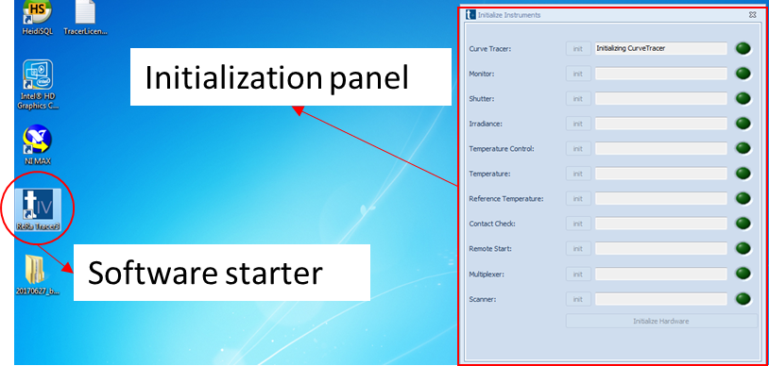
Figure 1: Desktop icon for the software
Step 4.2 (Climate chamber)
Input of the climate chamber
Let’s now move on the programming of the climate chamber controls (Figure 2), the setting can be input through the touch screen on the left hand side of the machine.
There are two main type of condition that can be applied:
- Constant mode, where the values of temperature and relative humidity will be fixed to a constant value and kept until the CC is turned off;
- Programmable mode, where it is possible to input the values of temperature and relative humidity as function of time.

Parameters input for CC
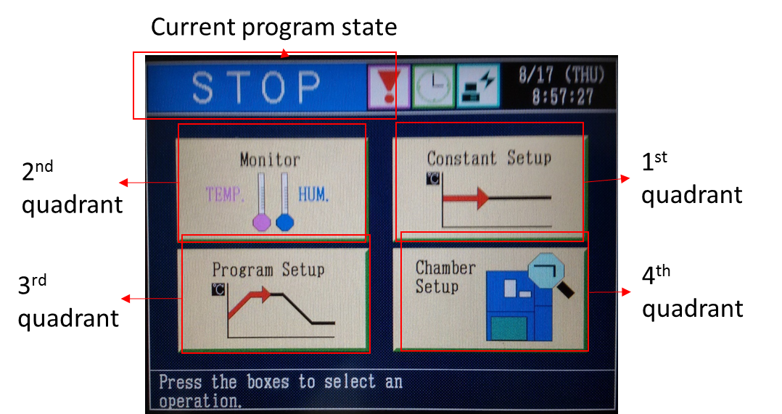
Figure 2: Home screen for climate chamber control
We chose the third quadrant option ‘Program setup’

Third quadrant
With this selection it is possible to schedule the temperature and relative humidity as function of time creating a program that handle the environmental conditions.
After pressing the selection in the 3rd quadrant we are in front of all the programs in the Katrien CC memory, as visible in Figure 3, pressing on the single program we will see the detailed conditions scheduled for this program, Figure 4 .
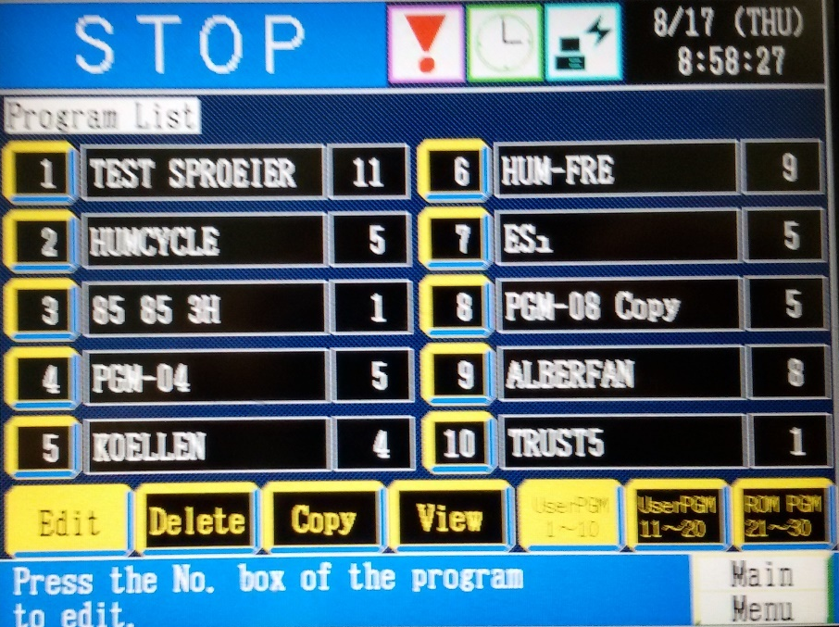
Figure 3: Programs list
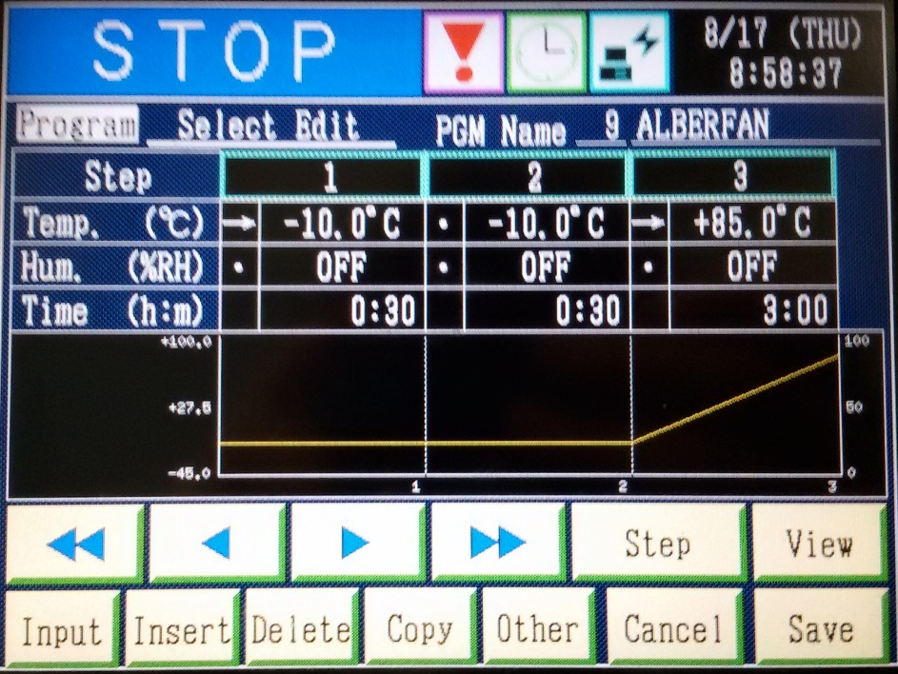
Figure 4: Detail of first 3 steps of DH + illumination experiment
From the Figure 4 it is possible to retrieve the environmental conditions applied for each step and the duration of it. When the environmental value has got an arrow nearby (as for temperature in step 1 Figure 4) it means that there is a speed control to reach that value at the end of the step, when there is a dot nearby the value means that this is kept constant at the stated condition.
For example in Figure 4 there is a controlled cooling in 30 minutes to reach -10°C and kept constant for other 30 minutes during step 2.
When we press on “Input” button we enter the editing mode, as in Figure 5, where it is necessary to select one step in order to modify the specific environmental condition applied.
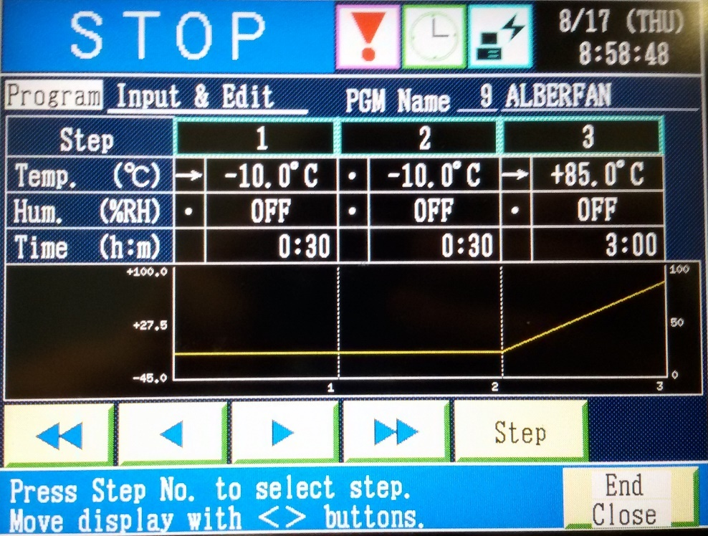
Figure 5: Editing MODE selection of the step
We then make a stabilisation period at room temperature, followed by a slow temperature ramp until 85ºC. Then we turn on the relative humidity to 85% and we leave it like this for e.g. 1000 hours.
We can use the start button to start the requested program (Figure 6).
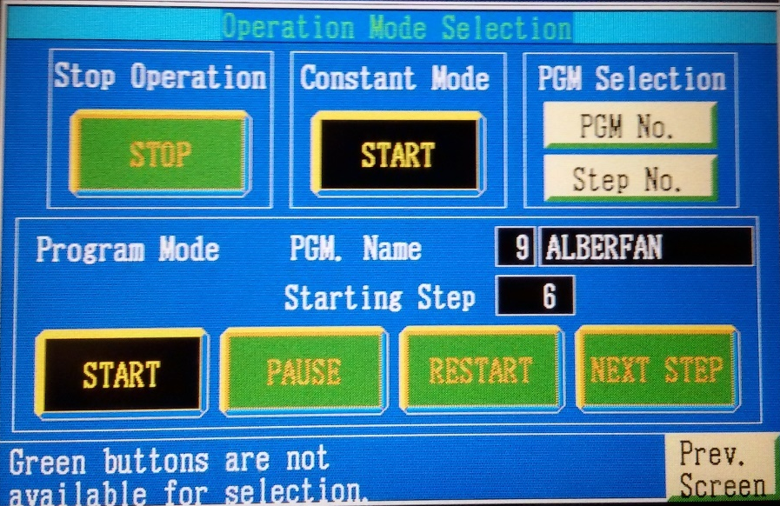
Figure 6: Editing MODE selection of the step

Program the computer (step 4.2, computer)

Specimens parameters
Furthermore when the specimens will be in place with the correct electrical connection and the thermocouple attached to them, it is necessary to input some solar cells characteristics in the Tracer 3 software (Figure 7) in order to perform a correct analysis of the solar device, the values necessary are:
- Sample connection position code (1-32)
- Sample Name
- Thermocouple corresponding to the sample
- Correct surface of the active area
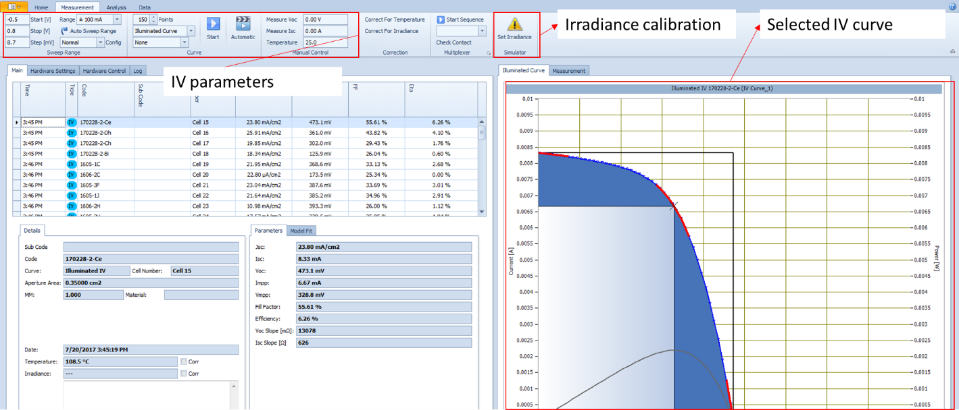
Figure 7: Homepage of Tracer 3 software
In order to input in the software the above mentioned parameters it is necessary to go to Hardware settings Multiplexer MultiplexerPresents as in Figure 8. In this window it is necessary to define a name (Label) for the selected port (example Cell 1), as well as the active area and the temperature input (corresponding to the thermocouple attached to the device).
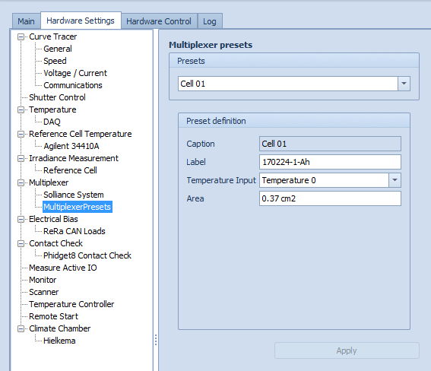
Figure 8: Input of surface active area and thermocouple linked to the solar cell
Press apply to confirm the changes and record the data.

Defining the measurement settings

Programming of the Tracer 3 (Rera) for continues monitoring
It is now necessary to define the parameters for the IV measurements (Figure 9) that will be performed, in particular the value to input are :
- Start voltage [V]
- Stop Voltage [V]
- Step [mV] or number of points
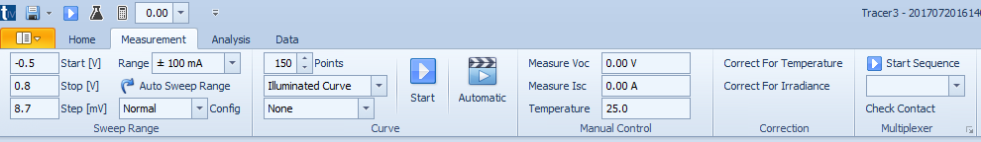
Figure 9: Input measurement settings
In order to record the data from the IV measurements the PC is connected to a local server that log those data, this PC is not connected directly from internet due to safety reasons.
Pressing on the start button on the top left hand corner and selecting Options (Figure 10) we will see the window as in Figure 11. In that picture there are expressed the location in which the local file will be stored, those are 2 types: local IV raw data and project files.
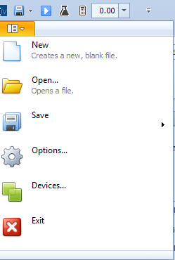
Figure 10: Start menu

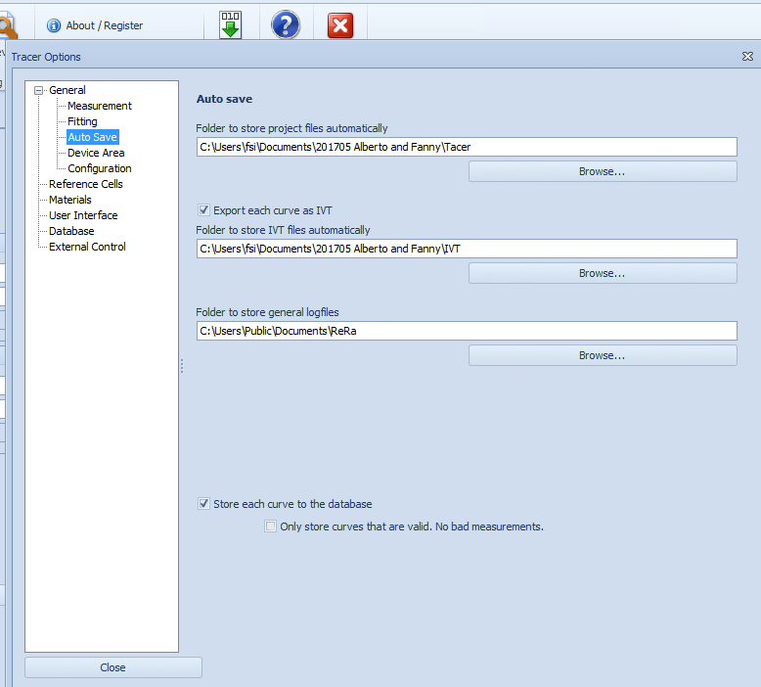
Figure 11: Auto save location (local IV(T) files and project files)

Program the electrical loads (step 4.2, electrical loads)

Electric loads
In order to edit the electric loads parameters it is necessary to go Hardware settings Electrical Bias ReRa CAN Loads as in Figure 12. There are 32 electric loads available one each device that can be fit in the climate chamber for the experiment.
When double clicking on a specific load the window as in Figure 13 will be visible and it is possible to edit the voltage applied to the solar device. In case of changing the Voltage setpoint it is necessary to send the updated to the load.
Loads with the tick are connected, without disconnected.
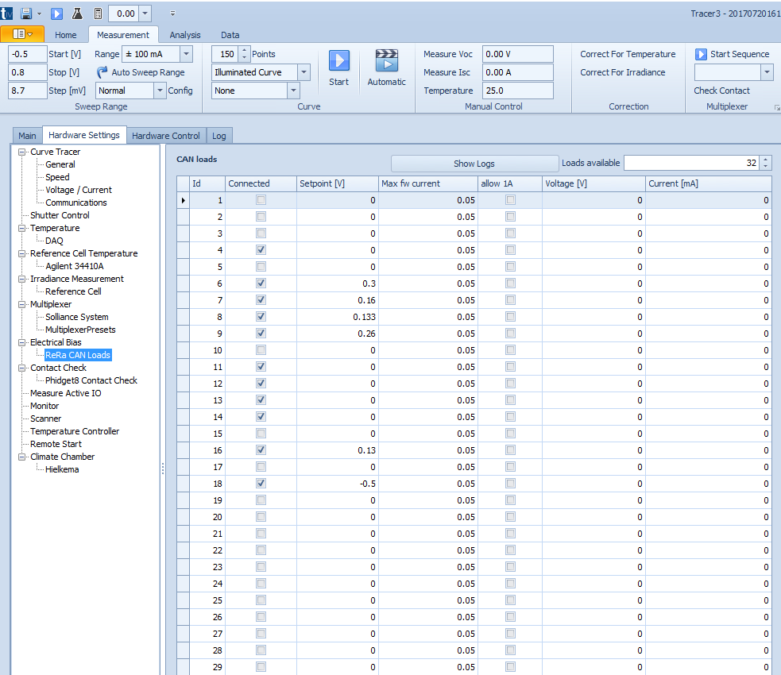
Figure 12: Electric loads overview
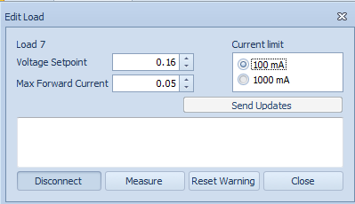
Figure 13: Edit load window

Sequence measurement
Finally it is possible to define a sequence of solar devices to be measured. Pressing the arrow under “Check contact” in the top right hand corner we will see a window where we can insert the number and code of the devices to be measured and their order, as in Figure 14.
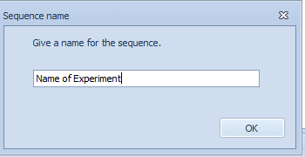
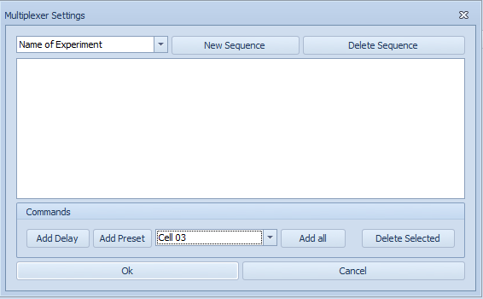
Figure 14: Edit of sequence for continues measurement.
Press “New sequence ” and input the name of the sequence of solar devices. From the commands window we can now select the location of the solar device we are interested into and add them to the list of the monitored specimens. Pressing “Ok” we confirm and save the sequence.
Pressing on ”Automatic Sequence” (Figure 15) it is possible to start the continues IV measurements and edit the waiting time between a sequence and the next one.
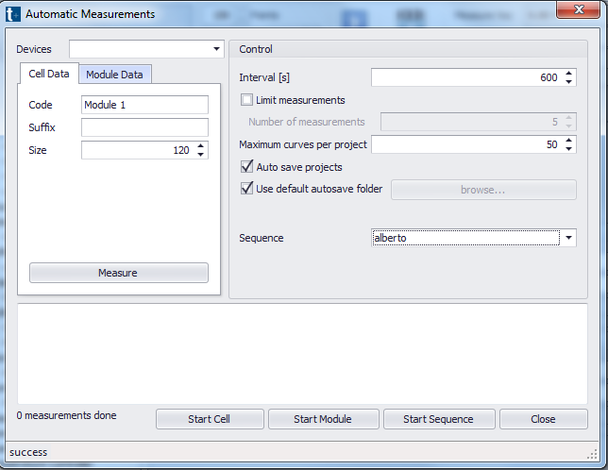
Figure 15: Automatic sequence start-up.

Monitoring the climate chamber (step 4.3 and 4.4)
With the second quadrant option, we can monitor the climate chamber. Figure 16 represents the monitoring interface of the CC, as saying the screen where there a reported the set point value of temperature and relative humidity, as well as the current value registered inside the machine.
In these steps, the temperature will go up to 85ºC, while the RH will stay close to zero.

Second quadrant option
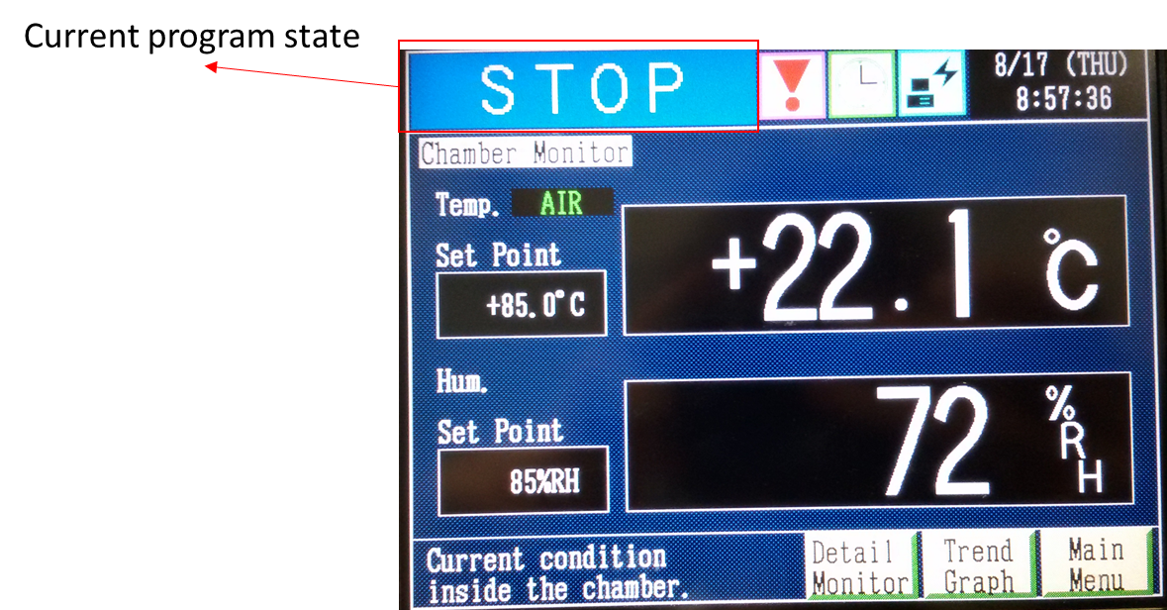
Figure 16: Monitoring interface for CC
Measure the IV curves (step 4.5)
Show a few curves occurring during measurements
Figure 7: Page showing the IV measurements

Monitoring the climate chamber (step 4.6)
With the second quadrant option, we can monitor the climate chamber. The Figure 16 represents the monitoring interface of the CC, as saying the screen where there a reported the set point value of temperature and relative humidity, as well as the current value registered inside the machine.
In these steps, the temperature will remain 85ºC, while the RH will rapidly increase to 85% RH.

Second quadrant option
Figure 18: Monitoring interface for CC

Measure the IV curves (step 4.7)
Similar screen as step 4.5
Cooling down the climate chamber (step 4.9)
With the second quadrant option, we can monitor the climate chamber. The Figure 17 represents the monitoring interface of the CC, as saying the screen where there a reported the set point value of temperature and relative humidity, as well as the current value registered inside the machine.
In these steps, the relative humidity will first rapidly go to a low value, after which the temperature will slowly go back to room temperature.

Second quadrant option
Figure 17: Monitoring interface for CC

