Editorial comments:
-Please provide a little more information about the "custom-made jacketed vessel" in steps 1.1 and 1.8. If the construction has been mentioned elsewhere then a citation will be sufficient; otherwise a brief description would be helpful.
We have added a new figure (Figure 1) showing the construction in detail. The other figures have been renumbered accordingly.
Clarification is requested: Do the authors wish to include Section 2 in the video? This section includes obtaining tissue from the operating room during a neonatal or pediatric surgical procedure, which does not pose any technical problems but may require additional release forms or sensitivity in filming. Please use highlighting to indicate which sections of the protocol should be filmed.
We do not believe that filming in the operating theatre is essential for the description of the method. Weighing the additional information against the sensitivity in filming procedures in patients we prefer not to include this into the video.
Reviewer #1:
1. When working with human cardiac specimen, improper tissue handling during transportation between the surgery room and the laboratory drastically reduces survival. The author did not clearly describe the transportation time. As the tissue was not cardioplegically arrested with high KCl solution, a long transportation time will damage large percentage of cells.
We have added information on transportation time in our experiments (page 5): In our experiments, the time interval between excision and arrival in the laboratory was 17 ± 4.5 minutes (mean ± standard deviation, n=21).
2. Slicing in a low calcium solution prior to performing acute experiment in normal calcium solution should avoid calcium related tissue injury. It would be interesting to compare mechanical and electrical parameters using this calcium reintroduction method versus using the working calcium concentration directly.
This is beyond the scope of our study. Patient material can only be obtained from procedures which are performed infrequently. We understand that this is an important issue indeed, however, we are not able to investigate this point due to low patient numbers.
3. The "solution A" described in the manuscript is pH calibrated to 7.4 with NaOH, however it also contains NaH2PO4 which when bubbled with carbogen changes pH. It is not clear if the author used pure O2 or carbogen in the slice preparation step.
We have clarified this in the manuscript:
Page 3: Oxygenate the solution in the vibratome chamber by bubbling with pure O₂ .
Page 4: Oxygenate by bubbling with pure O₂.
4. 30 mM BDM is used for EC uncoupling. As authors mentioned in the discussion, BDM can alter calcium handling, especially at this high concentration. Is there a reason why 30 mM is used over 10 presented in some of the cited studies?
We have used this concentration in the past and we are not aware of data suggesting that calcium handling remains altered after washing out BDM. To avoid a confounding effect of BDM we made sure that exposure was limited to approximately 1 hr.
5. Z-axis vibration is critical for the viability and longevity of slice preparation. Did the author track amount of z-axis vibration in their vibratome?
The vibratome we used for this study was not able to track z-axis vibration. We did not aim for longevity.
6. Mechanical study and electrical study used two different media (IMDM and DMEM). Both these culture media have different ionic concentration compared to Tyrodes which most studies are performed in. Author should indicate why these medias are chosen for acute studies over standard Tyrodes.
The media can be adapted as required. This was already discussed in the submitted manuscript on page 5-6: Notes: Physiological buffer solutions such as Tyrode’s solution (solution A) or Krebs-Henseleit buffer as well as cell culture medium such as Iscove’s modified Dulbecco’s medium can be used for subsequent measurements. Particular attention should be paid on an appropriated calcium concentration between 1.2 – 2.0 mmol/L.
7. Author should clarify the pacing frequency used to calculate APD in figure 3.
We have added this information:
Page 6: Tissue slices were electrically stimulated at 1 Hz with a glass micropipette filled with DMEM and connected to a stimulation device.
Page 7: (A) Representative action potential recordings of a myocardial tissue slice before (baseline, black) and after administration of 0.1 µmol/L E4031 (dark gray) and subsequent addition of 0.1 µmol/L Isoproterenol (ISO, light gray) stimulated at 1 Hz.
8. Author should indicate typically what percentage of cells in slices are viable. Mechanical properties will likely change due to number of contracting cells.
We are unable to determine the absolute number of viable and non-viable cardiomyocytes and non-myocytes, respectively. To give an overall impression of the viability of the preparation, we performed live/dead cell viability stainings using Calcein-AM and propidium iodide (Rebuttal-Figure 1).
Rebuttal-Figure 1: Live/dead cell viability staining. (A) Staining of viable cells using Calcein-AM. (B) Staining of non-vital cells using propidium iodide. (C) Merged (green: Calcein-AM, red: propidium iodide).

9. This protocol lacks organotypic culture step, which limits its applicability for chronic studies. For example, a recent study (ref. 5) has demonstrated significant difference between acute and chronic effects of phenylephrine. This protocol also lacks electrical or optical mapping techniques. Please discuss these limitations.
This is beyond the scope of our study and was already discussed on page 8: Following the present protocol, measurements can be performed for 4-8 h with the generated cardiac slices. An adapted culture protocol should be established when aiming for long-term experiments such as screening for chronic drug effects. Brandenburger et al.¹¹ developed a culture system allowing the maintenance of human adult cardiac slices for at least 28 days. Validation of the reliability of long-term cultures is however still lacking as alterations of physiological parameters should be expected over longer periods in culture.
Reviewer #2:
1. It is not clear how the authors "mount" the tissue slice on a J-shaped needle - do they use it as a hook? If yes, how are the forces within the whole slice are transferred to the isometric force transducer Instead of showing 3 sample slices in Fig. 1 where 1 slice would suffice, I suggest that the authors use the space for a picture of what the mounted tissue slice would look like.
We thank the Reviewer for the suggestion, but we are afraid that including a figure about mounting of the tissue slices would be beyond the scope of our protocol and would therefore rather confuse the reader. Our intention is to present a protocol enabling the reader to prepare slices for functional measurements, but not to describe the functional measurements themselves. We included representative force and electrophysiological data to give the reader ideas about possible measurement methods and to show that slices prepared by our protocol demonstrate functional properties of heart tissue.
To give the Reviewer an overview, we describe our mounting technique. The setup consists basically of two J-shaped needle hooks, one fixed to the setup assembly and the other connected to the force transducer (Rebuttal-Figure 2). One side of the slice is impaled on a glass capillary with a conic tip. The lumen of the capillary is placed on the tip of the fixed J-shaped hooks and the tissue slice is pushed down in a way that the other side of the slice is pinned to the J-shaped hook of the force transducer. Afterwards, the slice is lowered into the medium-containing measuring chamber. As the horizontal position of the force transducer can be altered, the distance between both hooks is stepwise increased by a motor system until L_{max} is reached.

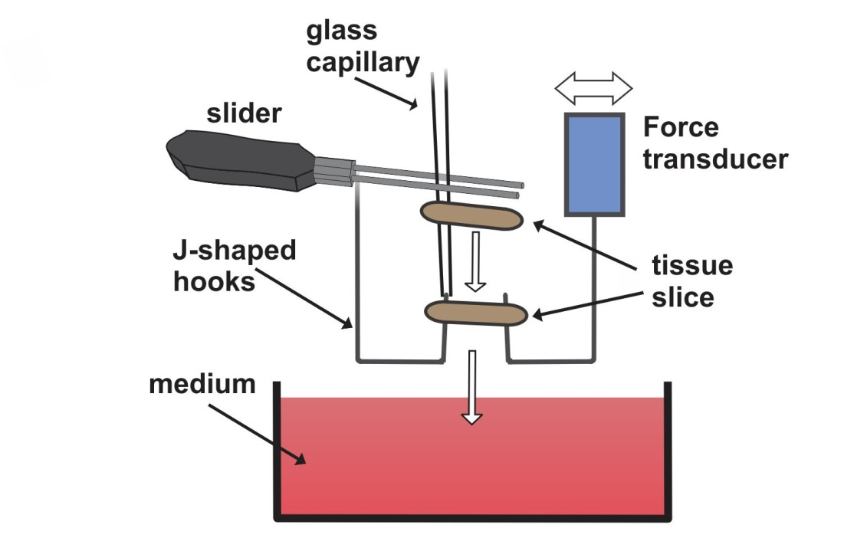
Rebuttal-Figure 2: Technique used for mounting of tissue slices.
2. The authors should provide real time-matched controls in order to demonstrate the stability of the preparations for the entire experimental period and not only for the "pre-intervention" (physiological, pharmacological) time slot. It is essential that the preparations are stable for the equilibration plus the experimental period. [Editorial comment: We understand your concern over having to include data from several additional experiments in order to address the reviewers' comments. While we do not require in depth results for publication in JoVE, the results must accurately demonstrate the efficacy of the proposed method. Additionally, the results must substantiate all claims presented within the manuscript. Please ensure that all claims you make are
We have included representative control measurements (Figure 3D).
3. Time-matched controls are also required for action potential measurements.
We have included a representative control measurement (Figure 4C).
Reviewer #3:
1. The authors describe that myocardial slices were prepared from right ventricular tissue samples of neonates and infantile patients undergoing surgery for congenital heart disease. Please further specify in the legends with eachfigure the precise origin of the tissue used for the experiments (e.g. age of patient, reason for surgery).
We have added this information as required.
Page 6: Representative force-length relationship experiment of a slice obtained from a patient with HLHS at day 7 of life who underwent implantation of a shunt between right ventricle and pulmonary arteries.
Page 7: Slices were obtained from 3 HLHS patients undergoing implantation of a shunt between right ventricle and pulmonary arteries at 2, 7, and 8 days of life.
Page 7: (D) Examples of long-term measurements over 90 minutes from two slices. Right traces (c.-f.) show averaged contractions (interval: 2 minutes) from begin and end of the recordings. These slices were obtained from the right ventricular outflow tract of a patient undergoing TOF repair at 6 months of age.
Page 7: This slice was obtained from a HLHS patient who received a shunt between right ventricle and pulmonary arteries at 69 days of life.

2. For sake of reproducibility could you please further specify how the very small (3x3x3mm) blocks of tissue are prepared.
" 3.2 Pre-cut the tissue into blocks of approximately 3 mm x 3 mm x 3 mm using a scalpel."
Pre-cutting the tissue makes slicing easier; however, the exact size is not important. We therefore use eyeballing to estimate the size of the blocks. To make this clearer, we have changed the sentence:
" 3.2 Pre-cut the tissue into smaller blocks (approximately 3 mm x 3 mm x 3 mm) using a scalpel."
3. Table 1 is somewhat unclear. A table describing the content of solution A and a table describing the necessary equipment would be more appealing.
We agree with the reviewer. It is however an editorial requirement to not divide this information into multiple tables.
4. You used low calcium solution combined with BDM to ensure the absence of contractions during the slicing process, thereby lowering tissue injury. Could you please clarify the choice for both low calcium and BDM instead of either of these options on its own, which would have been easier?
This a very interesting point we are unable to answer. We have used this method in various settings in the past (Pillekamp F 2005, Halbach M 2006, Halbach M 2007, Pillekamp F 2007, Halbach M 2012). Given the small number of preparations (approx. 10-15 per year), we are unable to test whether using either of these options alone would be non-inferior or better.
References
Pillekamp, F., et al. Establishment and characterization of a mouse embryonic heart slice preparation. Cell. Physiol. Biochem. 16(1-3), 127-132 (2005)
Halbach, M., Pillekamp, F., Brockmeier, K., Hescheler, J., Müller-Ehmsen, J., & Reppel, M. Ventricular slices of adult mouse hearts--a new multicellular in vitro model for electrophysiological studies. Cell. Physiol. Biochem. 18(1-3), 1-8 (2006)
Halbach M, Pfannkuche K, Pillekamp F, Ziomka A, Hannes T, Reppel M, Hescheler J, Müller-Ehmsen J. Electrophysiological maturation and integration of murine fetal cardiomyocytes after transplantation. Circ. Res. 101(5):484-92 (2007)
Pillekamp, F., et al. Neonatal murine heart slices. A robust model to study ventricular isometric contractions. Cell. Physiol. Biochem. 20(6), 837-846 (2007)
Halbach M, Krausgrill B, Hannes T, Wiedey M, Peinkofer G, Baumgartner S, Sahito RG, Pfannkuche K, Pillekamp F, Reppel M, Müller-Ehmsen J, Hescheler J. Time-course of the electrophysiological maturation and integration of transplanted cardiomyocytes. J Mol. Cell. Cardiol. 53(3):401-8 (2012)
5. It would be nice to see how the electrophysiology results of the slices differ compared to other techniques, single cell patch clamping and wedge or whole heart preparations. Could you please add a historical comparison with other studies? [Editorial comment: The above comment may be addressed in the Discussion using relevant references.]
This is a very interesting point. However, there are no electrophysiological data from HLHS patient biopsies or from other neonatal myocardial biopsies available at all in the literature. This unfortunately makes a comparison impossible.
6. An Y axis with a line indicating 0 mV should be added to figure 3A.
We have changed former Figure 3, now Figure 4 accordingly.

