9 August 2017

Dear Editor,

Thank you for your email of July 20, 2017 in which you requested modifications of our manuscript entitled “A paired bead and magnet array for molding microwells with variable concave geometries” (manuscript ID: JoVE55548R2). Please find below our point-by-point response to the editorial and production comments and the reviewers’ comments. We believe that after addressing the questions and concerns the revised manuscript is much stronger.

We thank the reviewers for the constructive feedback and look forward to hearing from you regarding the status of our manuscript for publication in JoVe.

Sincerely,

Joong Yull Park, Ph.D., Associate Professor
School of Mechanical Engineering
College of Engineering
Chung-Ang University
Seoul 06974, Republic of Korea
Tel.: +82-2-820-5888, Fax.: +82-2-814-9476, E-mail: jrpark@cau.ac.kr

Editorial and production comments:
• JoVE is unable to publish manuscripts containing commercial sounding language, including trademark or registered trademark symbols (TM/R) and the mention of company brand names before an instrument or reagent. Please remove all commercial sounding language from your manuscript. All commercial products should be sufficiently referenced in the table of materials/reagents. Examples of commercial sounding language in your manuscript are CNC, EGX-350, Roland DGA, HAM Präzision, Schwendi etc.
• Names of manufacturers/suppliers should be removed from the Protocol text (e.g. (EGX-350, Roland DGA, Parkway Irvine, CA, USA) in step 1.2). This information should be confined to the Table of Materials.
Answer: We removed all commercial sounding language and manufacturers/suppliers at protocol 1.2 and 1.6 in the manuscript.

• Please ensure that all items mentioned have been included in the Materials/Equipment list, and are accompanied by a catalog number.
• Please define all abbreviations before use.
• Please use h for hour(s), min for minute(s) and s for seconds throughout the manuscript (including figures and tables).
• Please include spaces between all numbers and units.
• Please include at least six keywords.
Answer: We checked the material/equipment list, abbreviations, unit of times, spaces between all numbers and units and six keywords.

• In the Short Abstract (10-50 words) and Long Abstract (150-300 words), please include a statement that clearly states the goal of the protocol. For example, “This protocol/manuscript describes…”
Answer: We modified the short abstract following editorial comments.

• Please adjust the numbering of your protocol section to follow JoVE’s instructions for authors, 1. should be followed by 1.1) and then 1.1.1) if necessary and all steps should be lined up at the left margin with no indentations. There must also be a one line space between each protocol step.
• Please ensure that all text in the protocol section is written in the imperative tense as if you are telling someone how to do the technique (i.e. “Do this”, “Measure that” etc.). Avoid usage of phrases such as “could be,” “should be,” and “would be” throughout the Protocol. Any text that cannot be written in the imperative tense may be added as a “Note”, however, notes should be used sparingly and actions should be described in the imperative tense wherever possible.
Answer: We checked and modified the protocol section following the instruction.

• Please add more details to your protocol steps. Please ensure you answer the “how” question, i.e. how is the step performed? There should be enough detail in each step to supplement the actions seen in the video so that viewers can easily replicate the protocol.
Answer: We added more details to step 1.1, 1.2, 1.4, 2.3, 2.5, 3.6, 4.1.

• Step 4.6: Please mention the medium used in your studies.
• 4.8: Please mention the cell culture conditions (temperature, CO2, humidity, etc.) used in your studies.
Answer: We added the information of medium and culture conditions to step 4.6 and 4.8.

• Results: Please expand the results text that explains your representative results in the context of the technique you describe; i.e. how do these results show the technique, suggestions about how to analyze the outcome etc. This text should refer to all of the results figures.
Answer: Instead of adding explanation in the results section, we expanded the discussion significantly to include more important information.

• Please expand the figure legends to adequately describe the figures. Each figure or table must have an accompanying legend including a short title, followed by a short description of each panel and/or a general description.
Answer: We expanded the figure legend of figure 5 and added figure legend 8 and 9

• For all microscope images in the figures, please include scale bars and define their sizes in the associated legends.
Answer: We checked and added missing scale bars in figure 5.

• Please expand your discussion to cover the following in detail and in paragraph form: modifications and troubleshooting, limitations of the technique, significance with respect to existing methods, future applications and critical steps within the protocol.
Answer: We expanded the discussion section significantly to include these issues; modifications and troubleshooting, limitations of the technique, significance with respect to existing methods, future applications and critical steps within the protocol.

• Please make sure that your references comply with JoVE instructions for authors. In-text formatting: corresponding reference numbers should appear as superscripts after the appropriate statement(s) in the text of the manuscript. Citation formatting should appear as follows: (For 6 authors or less list all authors. For more than 6 authors, list only the first author then et al.): [Lastname, F.I., LastName, F.I., LastName, F.I. Article Title. Source. Volume (Issue), FirstPage – LastPage, doi:DOI (YEAR).]
Answer: We corrected the references form following JoVE instruction for authors.

• Please take this opportunity to thoroughly proofread your manuscript to ensure that there are no spelling or grammatical errors.
Answer: We have thoroughly read through the manuscript and corrected the language errors.

Production (video) comments:
Editing issues
• 2:52, 3:53, 3:55, 4:50, 5:14, 5:31, 5:35, 6:02, 6:26, 6:30, 7:37, 8:22, 8:53, 9:33, 9:42, 10:13 - These edits are jump cuts, which have a jarring effect on the viewer. Fades should be added to reduce the jarring effect.
Answer: We amended the video accordingly.

Text/formatting issues
• A title card listing the authors' names and affiliations should be placed at the end of the video.
Answer: We amended the video accordingly.

Reviewer #1:
Major Concerns:
1. The unique point is to utilize the magnet array for producing the magnetic flux array (Fig. 4(e)). In contrast, another group utilized a pin holder steel device and single magnet to produce magnetic flux array (Lab Chip, 2008, 8, 134-142). The authors should compare the research and describe the usefulness of the magnet array.

Answer: We thank the reviewer for this comment. The role of 750 um Through-hole-plate was that serving the pit geometry to trap beads. Due to this pit trap structure, it is possible to scratch the bead with an acrylic plate to create a large number of trapped bead arrays at once (protocol 2.4 and figure 1c and d). Without “750um through-hole plate”, each bead should be placed in a 550um hole, one at a time. Therefore, unless a "750um through-hole plate" is used, the time and labour used to make the bead array will be much larger.

To address the above-mentioned issues, some corrections were made (in red) in the manuscript, as shown in the box below.

DISCUSSION:
…
The role of top plate (750 μm hole) was to serve the pit geometry to trap beads. Due to this pit structure, it is possible to scratch the beads with an acrylic plate to create a large number of trapped bead arrays at once (protocol 2.4 and Figure 1c and d). If not using the top plate, each bead must be manually inserted into the base (550 μm hole) one at a time.
…

2. Have the authors tried this with different size stencils and beads? Limitations related to size of the magnets are discussed, but are there any potential issues that users should be aware of if they wish to adapt the technique to different size templates?
Answer: fabrication of microwell using 800 mm diameter beads in 1 x 1 x 1 mm magnet array was tested. The results show that some of the microwells were connected together by holes. The trapped beads were magnetized by magnets. If the gap between magnetic beads were too narrow, the probability of sticking together is higher. Therefore, when "1 x 1 x 1 mm" magnets are used, beads with a diameter of 700 μm or more are not recommended.

To address the above-mentioned issues, some corrections were made (in red) in the manuscript, as shown in the box below.

DISCUSSION:
…
…
…
The limitations of our method include the need for a CNC engraver that is the most expensive device used in our method. Such CNC machines are priced from around $3000. This, however, is still much cheaper than conventional soft lithography facilities. Another inherent limitation of our method is the need for small magnets, and the gap between the microwells is dependent on the magnet size, which was 1 mm in the demonstration described in this paper. It would be difficult to reduce this gap much more since magnets smaller than 500 μm are not readily available. In addition, maximum size of bead was also limited. The trapped beads were magnetized by magnets. If the gap between magnetic beads were too narrow, the probability of sticking together is higher than some of the microwells were connected by holes as shown in Figure 8b. Therefore, when 1 x 1 x 1 mm magnets are used, beads with a diameter of 700 μm or more are not recommended.
…

3. It would be useful for the authors to explain the choice of magnets in greater detail. This is addressed somewhat in Figure 7, but more detailed guidelines in the text about how to select magnetic material, strength, size, etc. would be helpful for non-experts. Would the technique work at all with a single large magnet? What could users expect in terms of results if they decided to forgo use of the magnet array?

Answer: It is recommended that the size of the magnet and the thickness of the "through-hole plate" be based on the size of the bead. The size of the magnet is larger than the diameter of the bead, and the thickness of the "through-hole plate" should not exceed the diameter of the bead. The choice of magnets and plate thicknesses is empirical and a more detailed optimization and parametric study will be included in the future study.

When a single large-sized magnet (5 × 5 × 1 cm) was used, the beads, especially the ones located in the extreme outside holes, tend to be attracted to the stronger magnetic force of the magnet edge. Another problem of using a large magnet is that the beads stick to one another and create spontaneous small chains of beads.

To address the above-mentioned issues, some corrections were made (in red) in the manuscript, as shown in the box below.

DISCUSSION:
The major challenge facing this fabrication method was the secure fixing of the beads in the through-hole array in the aluminum plate. To solve this challenge, magnetic force in the form of a 30 x 30 magnet array was used to fix the beads securely, as shown in Figures 6 and 7. The magnetic flux density of the magnet array, which has the opposite polarity, is strongest at the center of each magnet surface. Because the strength of the magnetic force depends on the flux density, the beads were guided to the center of the top surface of each magnet where they were held in position. If a single large-sized magnet (5 × 5 × 1 cm) was used, the beads, especially the ones located in the extreme outside holes, tend to be attracted to the higher intensity magnetic field created at the magnet edge. Another problem with using large magnets is that the beads stick together spontaneously to create small bead chains (Figure 8a).
…
As a guideline for selecting the size of the magnet and the thickness of the through-hole plate, it is recommended that the size of the magnet and the thickness of the "through-hole plate" be based on the size of the bead. The size of the magnet must be larger than the diameter of the bead, and the thickness of the through-hole plate should not exceed the diameter of the bead. However, since the choice of magnets and plate thickness is empirical, more detailed optimization and parametric studies will be included in future studies.
…

Minor Concerns:
-It appears there are some details missing from the article that are present in the video, e.g., adding methanol during PDMS removal and other details about bead removal.

Answer: We appreciate the reviewer for this information. We added the missing details in protocol section.

To address the above-mentioned issues, some corrections were made (in red) in the manuscript, as shown in the box below.

PROTOCOL:
…
2.3) Stack the aluminum plate assembly on the prepared magnet array (Figure 1b, Figure 2b, and 2c). Align the array of magnets and the array of through holes in the aluminum plate during the stacking process. Then use a sticky tape to fix the position of the magnet array.
…
3.6) Remove the cured PDMS substrate from the mold (Figure 1g). In the removing process, spray methanol using washing bottle to detach PDMS substrate from the mold.
…

-It would be nice to have more detailed descriptions in the text and video of how cells are loaded into the micro-wells, i.e., the step shown in Figure 3.

Answer: Cell loading in a concave microwell is gravity-induced falling and there is no other special principle.

-Higher magnification images of aggregates should be presented, and if possible, authors should show comparison to conventional hanging drop procedure.

Answer: We added the higher magnification images in result section.

To address the above-mentioned issues, some corrections were made (in red) in the manuscript, as shown in the box below.

REPRESENTATIVE RESULTS:
…
Adipose-derived stem cells were cultured in the concave microwells. We seeded 2 x 10⁶ cells on the Φ14 mm concave microwell array. After 24 h, the cells had aggregated into spheroids, as shown in Figure 4. The average diameter of the spheroids formed in our microwell array was 185.68 ± 22.82 μm (day 1, Figure 5a, c). At day 3, the cells had become more aggregated, with the average diameter of the spheroids falling to 147.00 ± 17.11 μm (Figure 5b, d).
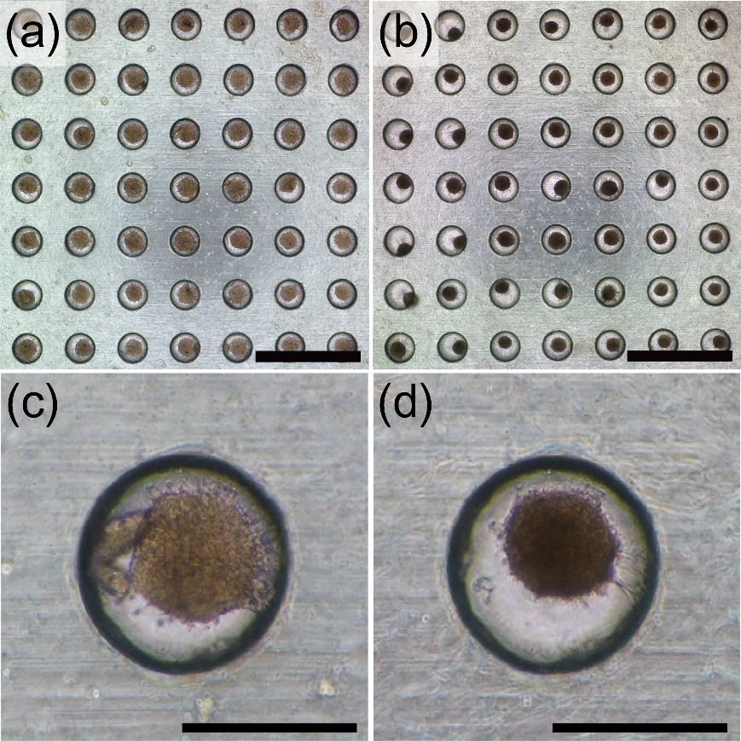
Figure 5: Culture spheroids in concave microwell array. The Φ14-mm microwell array was seeded with 2 x 10⁶ ASCs and cultured for 3 days. (a) Cultured spheroids at Day 1; the cells have started to form spheroids. The scale bar is 2 mm. (b) Cultured spheroids at Day 3; the formed spheroids are more tightly structured, while their average diameter has fallen from 185.68 ± 22.82 μm at Day 1 to 147.00 ± 17.11 μm at Day 3. The scale bar is 2 mm. (c) Magnification images of spheroid at Day 1. The scale bar is 500 μm. (d) Magnification images of spheroid at Day 3. The scale bar is 500 μm.

Additional Comments to Authors:
The conclusion statement in the video is difficult to hear.

Answer: We are very sorry for this error. We re-recoded the conclusion statement in the video.

Reviewer #2:
Minor Concerns:
Suggest a bit more discussion on other alternatives that can produce rounded bottoms. Such alternatives include wet etch of PDMS, but this requires first making a square channel rounding the edges with etchant and are not as effective at producing open top wells. One may still use photolithography to achieve this by greyscale lithography. However this is method still requires a more niche access to a photolithography-capable cleanroom and greyscale photo masks are relatively expensive. Takayama has used backside diffused light lithography to overcome the need for specialized equipment and published on making rounded bottom channels, but this can still apply to open-top wells. Additionally, they have combined the later two methods and used backside pseudo-greyscale diffused light lithography to create features of different heights in a single UV exposure. That too should be capable of producing rounded wells although not the scope of their published work. When compared to the diffused light lithography, the described technique by Park and group has higher aspect ratios (well depth to diameter) which are better for spheroid culture while the diffused light lithography will have more densely patterned wells.

Answer: We thank the reviewer for suggesting a useful discussion. We included the discussion regarding this issue.

To address the above-mentioned issues, some corrections were made (in red) in the manuscript, as shown in the box below.

REPRESENTATIVE RESULTS:
…
Compared with other fabrication methods such as flexible membrane¹⁴, ice lithography¹⁸ and deep reactive ion etching²⁰, this fabrication method does not require special lithography facilities, allows the microwell position to be easily controlled, and can produce a standardized concave microwell shape. In addition, wet etching of PDMS²¹, grayscale lithography²², and backside diffused light lithography²³ have been proposed for the production of concave geometries. However, wet etching of PDMS requires a rectangular structure first to make a concave and round microwell, and is not suitable for making an open microwell. The greyscale lithography method has the advantage of utilizing existing photo lithography facilities, but the need of high priced facilities and greyscale photo mask is a disadvantage. Backside diffused light lithography was another recently reported method useful to fabricate concave microwells with various aspect ratios, but only at the low resolution of pattern density.
…

