Representative Results (In 200 words or less, please describe the outcome of this basic procedure and provide at least one figure. If the result will be should be demonstrated on, then please describe the procedural outcome and cite specific examples within JoVE if possible):

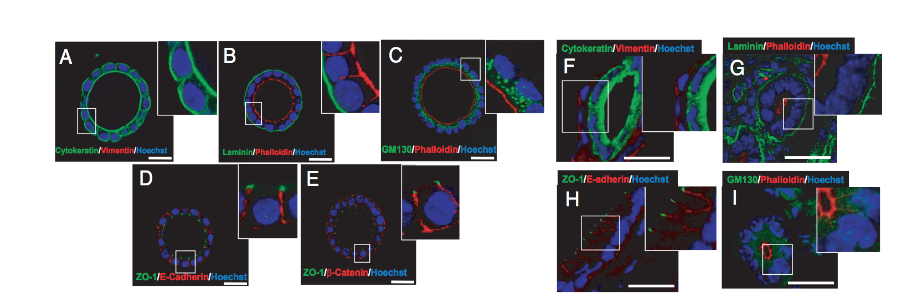
Figure 1. In vitro developed endometrial glands display epithelial apicobasal polarity. Double immunostaining of either in vitro developed glands cultured for 8 days in BIE medium (A–E) or cryostat sections obtained from mouse endometrium (F–I). A and F: Cytokeratin (green) and vimentin (red). B and G: Laminin (green) and phalloidin (red). C and I: GM130 (green) and phalloidin (red). D and H: ZO-1 (green) and E-cadherin (red). E: ZO-1 (green) and β-catenin (red). White scale bar = 20 μm. BIE medium = basal medium supplemented with 5ng/mL EGF and 1:100 dilution of ITS supplement and 3% fresh Matrigel™ Matrix; EGF = epidermal growth factor; ITS = insulin transferrin selenium (Eritja et al., 2010)⁸⁹.
Figure 1 description - Glandular epithelial cell organization, signaling, and secretion more closely resemble the properties observed in vivo when cultured in a 3D environment, in contrast to the behavior that occurs on 2D surfaces ^{10,11}. A 3D in vitro model for endometrial glands is shown in Figure 1. In this model, endometrial epithelial cells were cultured in medium containing Matrigel™ Matrix for 7-8 days followed by immunofluorescence staining of various polarity markers. Marker expression analysis confirmed that the glandular structures were composed exclusively of cells of epithelial origin (1A and 1F). Furthermore, spheroids representing endometrial glands displayed correct apical-basolateral polarity (1B and 1G), positioning of Golgi apparatus (1C and 1I), adherent junctions (ID and IH), and tight junctions (IE).

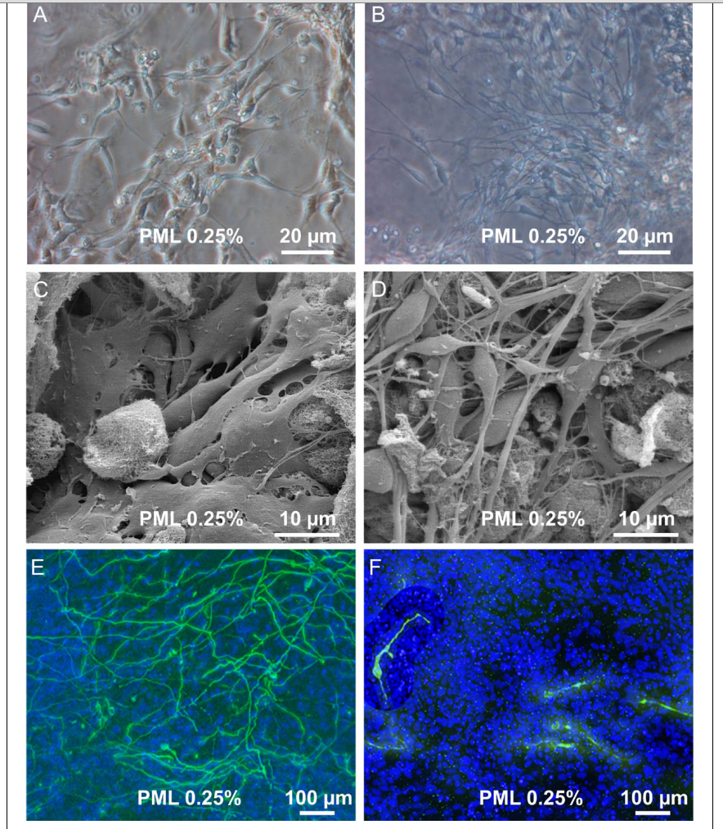

Figure 2. Proliferation and differentiation in 3D scaffold. (A + B) Transmission light picture of proliferating cells in PuraMatrix with 0.25 % laminin (PML) and differentiating cells in PML 0.25% (C + D). Scanning electron microscope picture of proliferating cells and differentiated cells in PML 0.25%. (B + D) Upon induction of differentiation one observes the development of a dense 3 dimensional network of processes. (E) Immunocytochemistry for bIII-tubulin and TH of uninduced cells in PML 0.25% and (F) Cells after 7 days of differentiation revealed a dense network of bIII-tubulin positive cells. TH+ cells were found to possess processes, but without building up a dense network (Ortinau et al. 2010)⁹⁰.
Figure 2 description – In this study, Ortinau and colleagues used a synthetic hydrogel, PuraMatrix™ supplemented with laminin (PML 0.25%) for neuronal differentiation of human neural progenitor cells⁹⁰. Using transmission light microscopy (FIGURE 2A + B) and scanning electron microscopy (FIGURE 2C + D) the researchers showed that neural progenitor cells can develop into a dense network of neuronal processes (FIGURE 2B + D). Furthermore, immunocytochemistry revealed that after 7 days of differentiation, the neuronal precursor cells began to express neuronal markers (βIII-tubulin and tyrosine hydroxylase (TH)) (FIGURE 2E + F). These observations demonstrate how functionalization with appropriate biological factors can convert inert synthetic matrices into useful in vitro models for supporting differentiation of stem and progenitor cells.

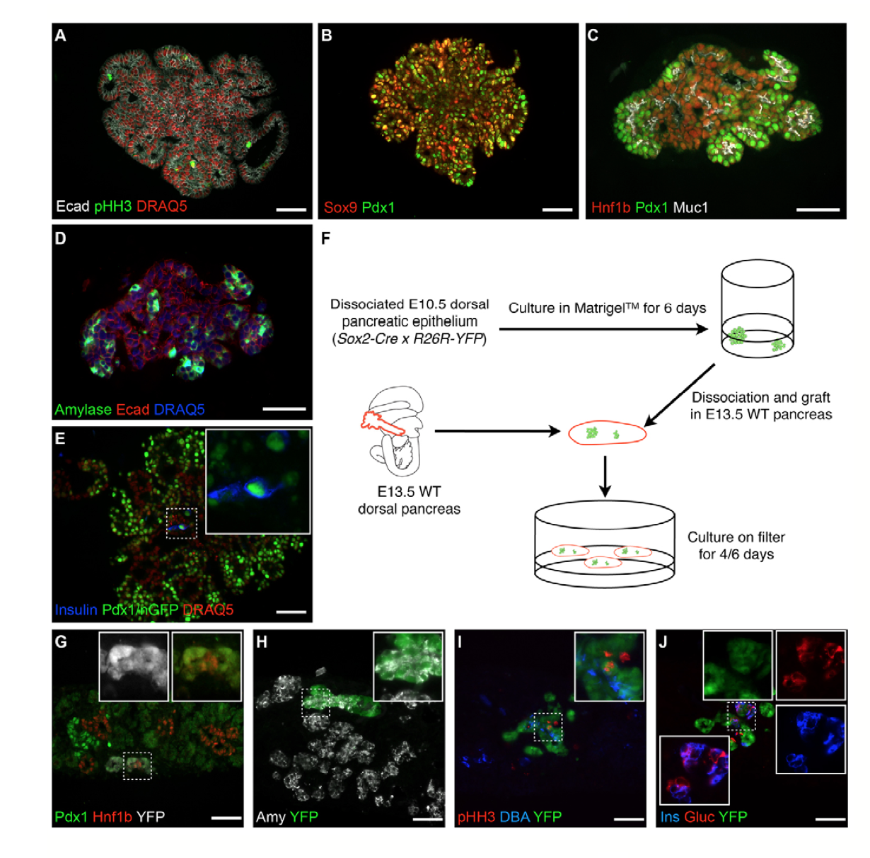
Fig. 3. Organoids recapitulate progenitor expansion and organized differentiation.
(A-E) Immunohistochemistry on sections of 7-day organoids showing that (A) all cells (DRAQ5, red nuclei) are epithelial (E-cadherin) and many proliferate [phospho-histone H3 (pHH3)] and (B, C) retain pancreatic markers PDX1, SOX9 and HNF1B. (C) Cells polarize and form tubes lined by mucin 1. (D) Exocrine differentiation (amylase) is seen at the periphery. (E) Endocrine differentiation (insulin) is detected in the center. The section in B is close to that in A, and the section in D is close to that in C. (F) Experimental scheme to test endocrine differentiation after back- transplantation of cells grown in organoid in a pancreatic niche. WT, wild type. (G-J) The cells that were first grown in vitro integrate into the host epithelium (white in G and green in H- J). Some remain progenitors (G; HNF1B), some become acinar (H; amylase) or ductal (I; DBA) and others become endocrine (glucagon or insulin). Insets are magnifications of the dashed boxes. Scale bars: 50 μm (Greggio et al., 2013)⁵³.

Figure 3 description – Figure 3 illustrates a schematic of 3D culture conditions that enabled efficient expansion of dissociated mouse embryonic pancreatic progenitors⁵³. By manipulating the medium composition, researchers generated either hollow spheres, which are mainly composed of pancreatic progenitors, or complex organoids that spontaneously undergo pancreatic morphogenesis and differentiation.
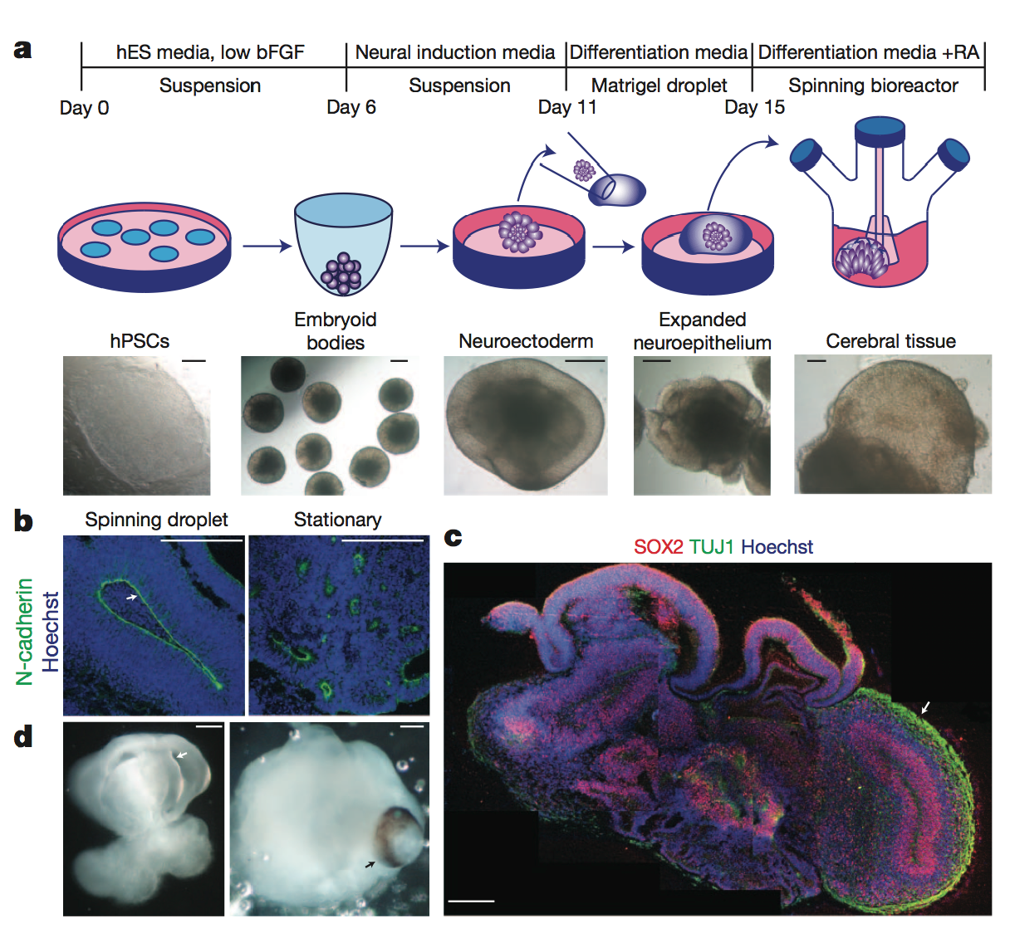
Figure 4 | Description of cerebral organoid culture system. A, Schematic of the culture system used to generate cerebral organoids. Example images of each stage are shown. bFGF, basic fibroblast growth factor; hES, human embryonic stem cell; hPSCs, human pluripotent stem cells; RA, retinoic acid. B, Neuroepithelial tissues generated using this approach (left) exhibited large fluid-filled cavities and typical apical localization of the neural N-cadherin (arrow). These tissues were larger and more continuous than tissues grown in stationary suspension without Matrigel (right). C, Sectioning and immunohistochemistry revealed complex morphology with heterogeneous regions containing neural progenitors (SOX2, red) and neurons (TUJ1, green) (arrow). D, Low-magnification bright-field images revealing fluid-filled cavities reminiscent of ventricles (white arrow) and retina tissue, as indicated by retinal pigmented epithelium (black arrow). Scale bars, 200 mm (Lancaster et al., 2013)⁵⁷.
Figure 4 description – Lancaster et al. generated cerebral organoids with remarkable structural similarity to brain tissue⁵⁷. These cerebral organoids grew larger than typical cellular spheroids and survived for weeks to months.

