Dear Editorial Board,

I would like to submit the revised manuscript entitled “Isolation and Detection of Telomeric DNA C-Circles from Mammalian Cells” for publication in the Journal of Visualized Experiments. In this manuscript we describe a technique used to determine whether a cancer cell relies on the Alternative Lengthening of Telomere pathway to promote telomere elongation.

The identification of cancer cells that promote telomere elongation in the absence of telomerase activity led to the identification of the alternative lengthening of telomeres (ALT) pathway. The ALT pathway is active in approximately 10-15% of all human cancers. However, ALT is most prevalent in some of the most aggressive forms of human cancer including, glioblastoma, osteosarcoma, and pancreatic neuroendocrine tumors. These cancers are highly refractory to common therapeutic strategies and have poor overall survival. Therefore, there has been a growing interest in understanding how, and under what conditions, the ALT pathway is active in an effort to identify therapies that uniquely target the ALT mechanism. These efforts necessitate the use of a robust biomarker to not only identify ALT positive cancers, but also to monitor ALT activity throughout treatment. Several cellular phenotypes have been identified and demonstrated to correlate with ALT activity including the production of extrachromosomal telomeric repeat (ECTR) DNA. ECTR exist in both linear and circular forms containing either C-rich or G-rich partially double-stranded telomeric sequences. To date, the circular C-rich telomeric sequences (C-circles) are the only ECTR DNA products that have been demonstrated to be exclusive to ALT positive cancer cells. In this protocol, we demonstrate a technique used to isolate and detect C-circles from mammalian cells highlighting the utility of this assay in the determination of ALT status.

Author Contribution: Emily Mason-Osann and Kelli E. Cox performed and analyzed the experiments. Emily Mason-Osann, Kelli E. Cox, and Rachel Litman Flynn wrote the manuscript

Please feel free to contact me if any additional information can assist you in evaluating this revised manuscript. Thank you again for your consideration.

Sincerely,
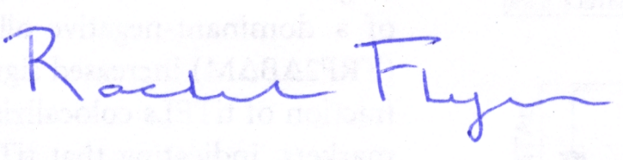

Rachel L Flynn

