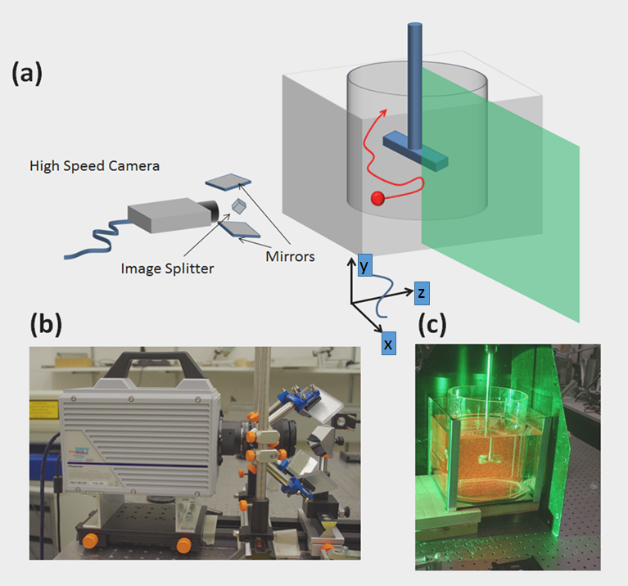

Figure 1
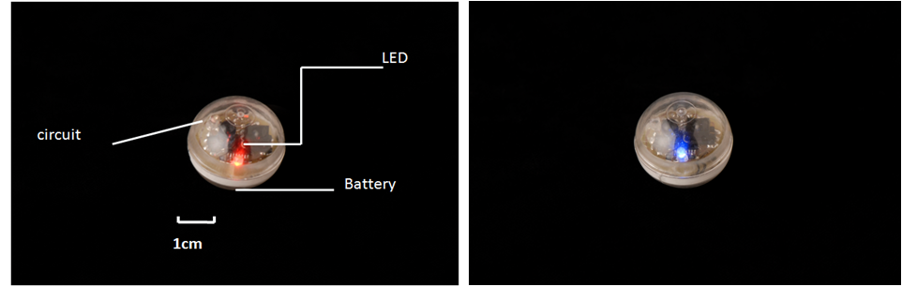

Figure 2

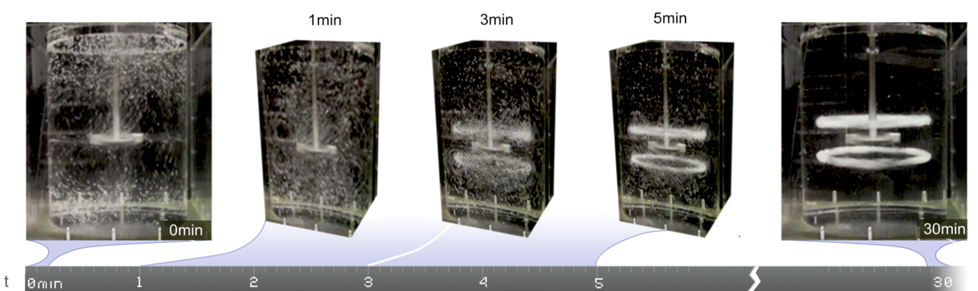
Figure 3
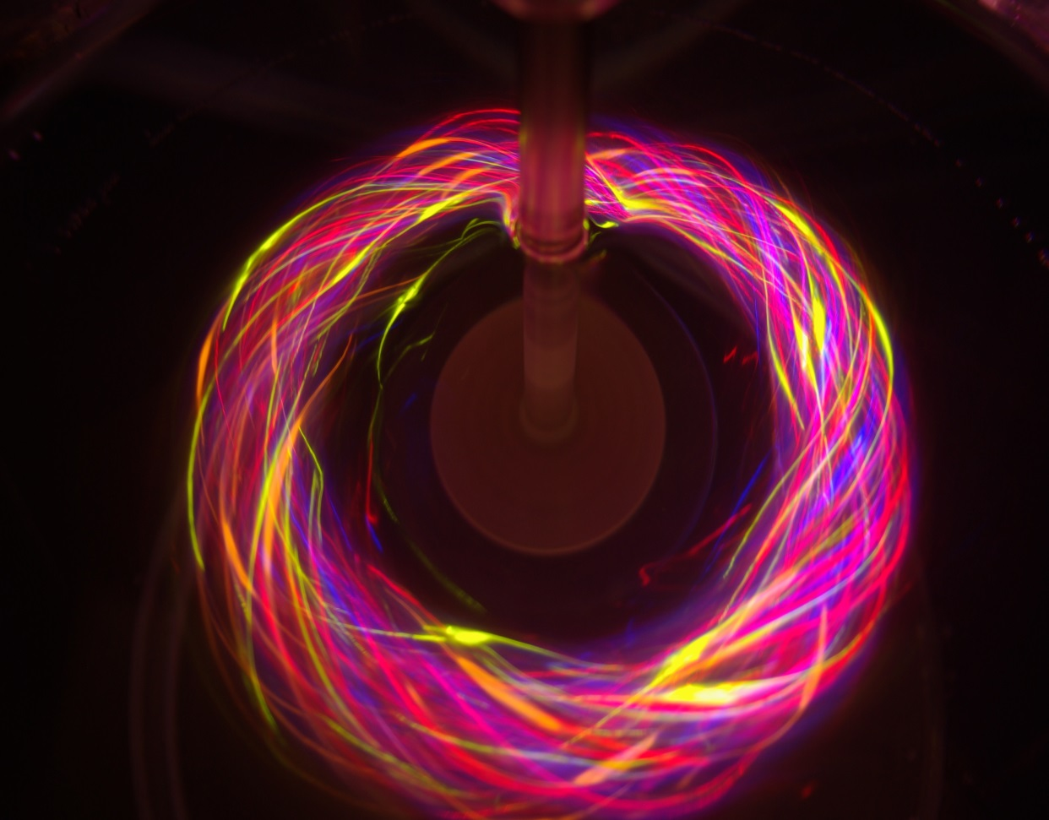

Figure 4
Figure 5
Figure 6
(b)
(a)
(b)
(a)
Figure 7

