Dear Ryan,

Here is a list of the missing shots you mentioned in your e-mail. Please find the media necessary for those shots in the dropbox folder shared with this link:
For each shot we list the file name were the relevant video or picture appears. I apologize for the long delay. We were unable to edit some of the videos using “Camtasia”, so we listed the time sections needed for each shot. Please cut the videos and use the relevant times for our movie. Parts of the movie that are not listed in my table are irrelevant and you can discard them.
Please find all the information in the table below.

Shot number | File name | Relevant times (h:mm:ss) | Comments
2.6.1 | alignment.trec | 1:05:00-1:05:08 | Description changed to screen capture of the sample being moved up to start the alignment.
2.6.2 | Shot_262.ppt |  | A single photo
2.7.2 | alignment.trec | 0:16:32-0:16:40  And  0:08:40 – 0:08:44 | Split the screen between the two parts to show both front and side angles  Side view: 0:16:32-0:16:40  Front view: 0:08:40 – 0:08:44  Can modify the speed to match the location above the sample (side view currently moves slower)
2.8.2 | alignment.trec | 1:08:00-1:08:30 | The description of the shot is changed to: screen capture of talent checking the front angles.
2.8.3 | alignment.trec | 0:12:17-0:12:45  And  0:11:20-0:11:40 | Split the screen between the two parts to show both front and side angles
2.9.1 |  |  | Was filmed by the videographer (as shot 2.5.2)
3.1.3 | Shot_313.trec | Entire video | Please crop the square below. We did not succeed to do that  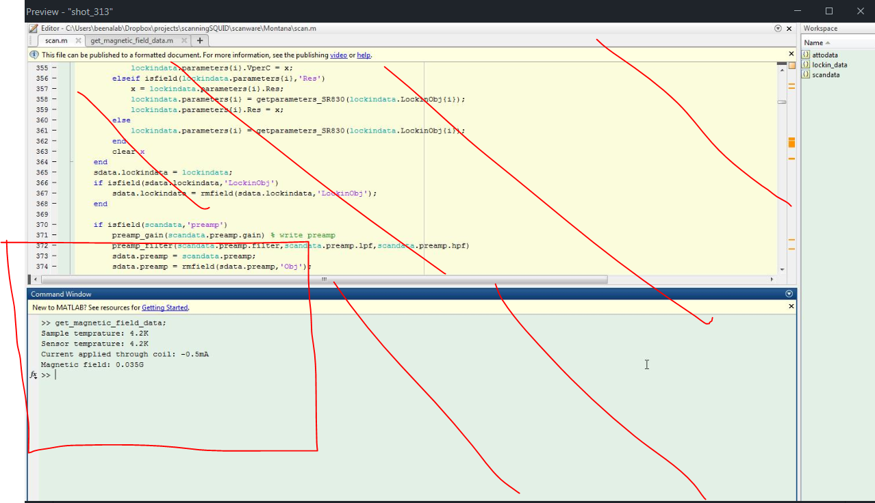
3.2.1 |  |  | Was filmed by the videographer
3.2.2 | Shot_322.ppt |  | A single photo. This shot now shows the reading from all the sensor’s channels during the approach.
3.3.1 | shot_331_332.trec | Entire video,  0:00:00-0:00:06 entire range  0:00:06-end cropped range | Shot 3.3.2 is the continuation of shot 3.3.1.  at first show entire window. After the command is entered (green window), the relevant frame is the window marked by a red circle, from second 6 to end please cut and use only that window.  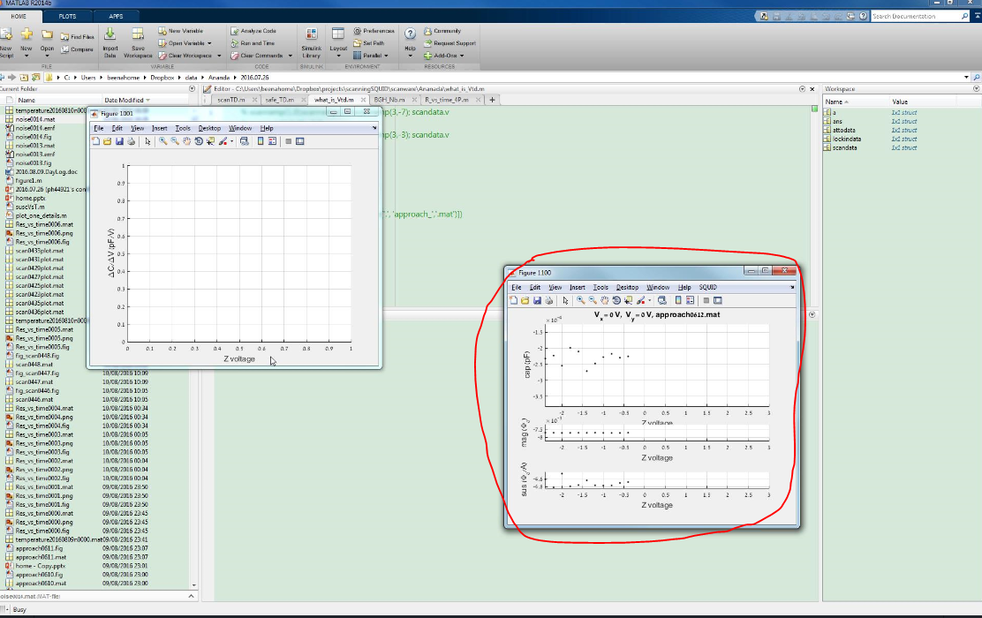
3.3.2 | shot_331_332.trec
3.5.1 | shot_351.trec | Entire video
3.6.1 | Shot_361.trec | Entire video | From second XX you can speed as desired
3.7.1 | shot_371.trec | 0:00:10-0:01:27 | Need to remove sound
3.8.2 | Shot_282.ppt |  | Two pictures showing the manipulation of the vortex due to the scan in contact. Show one after the other.

Best regards,
Eylon

