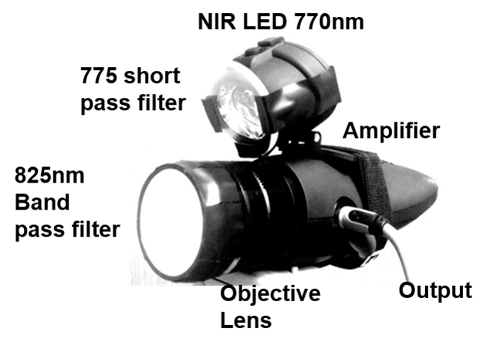

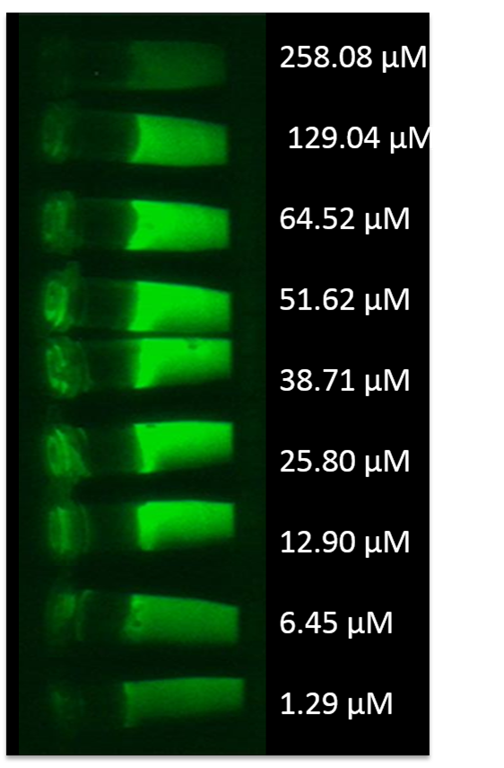

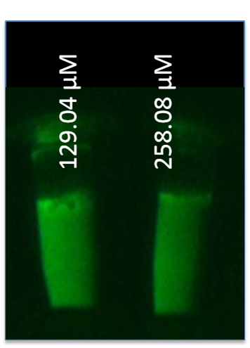

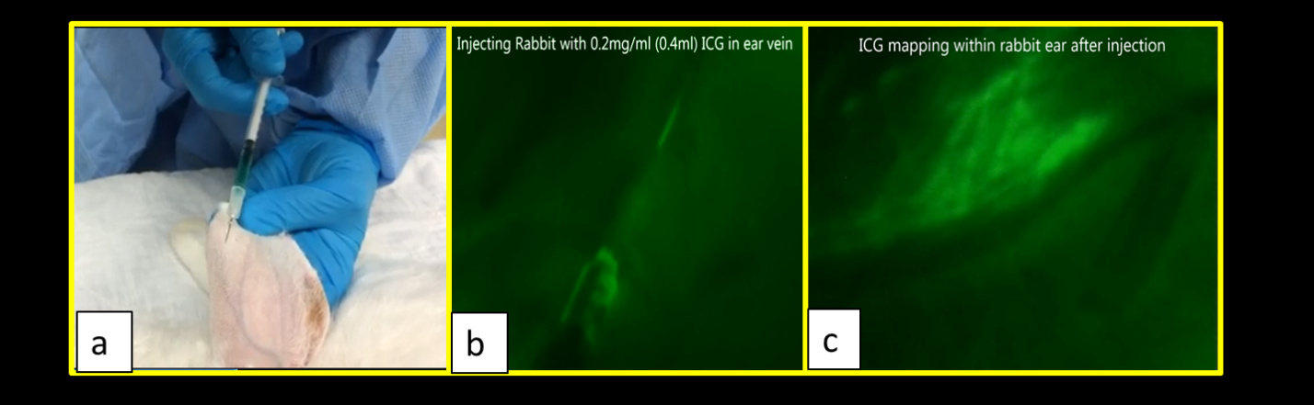

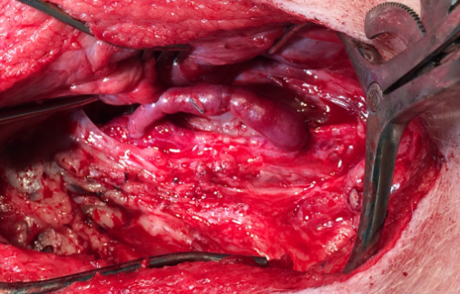
a
b
c

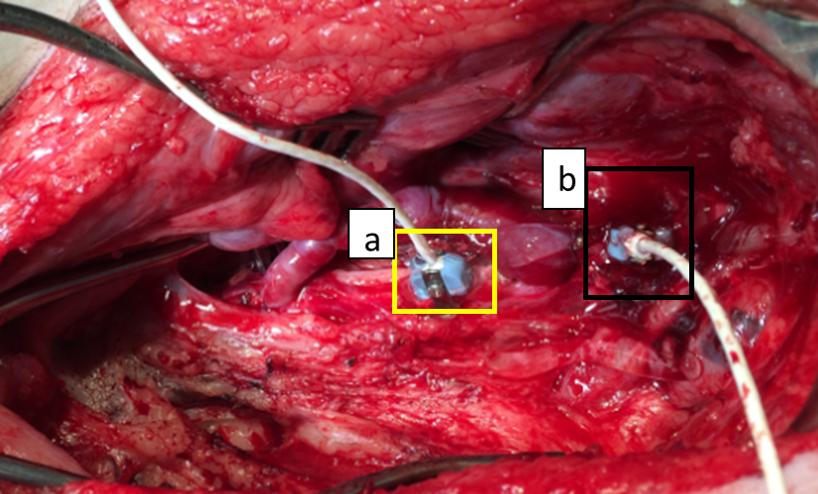

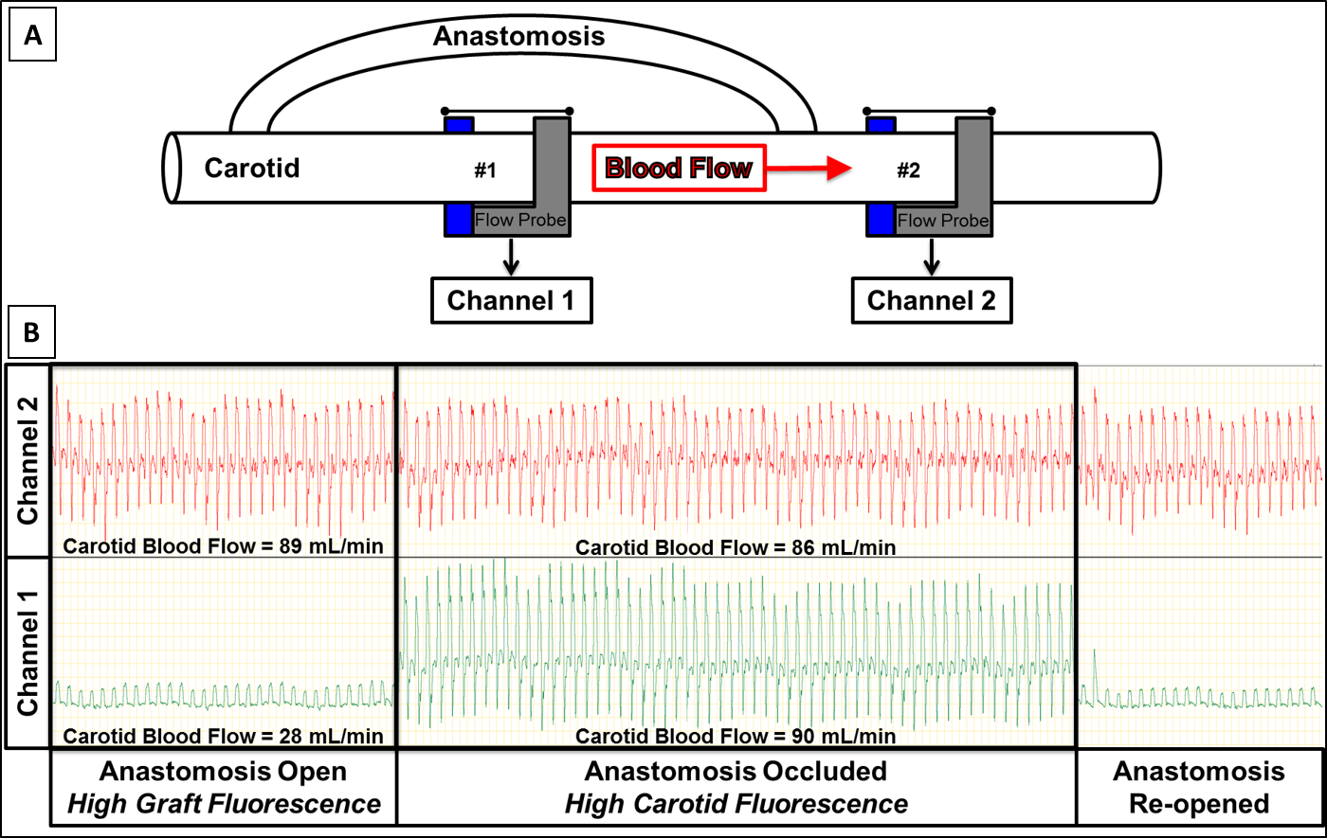

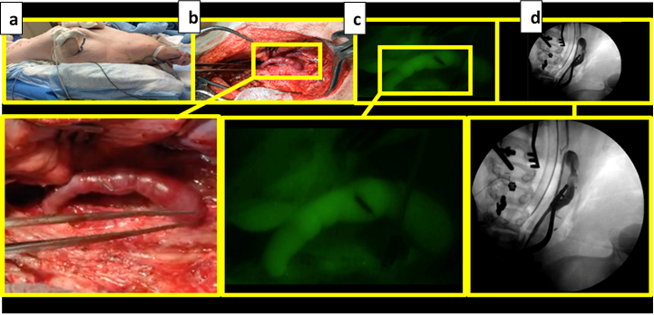

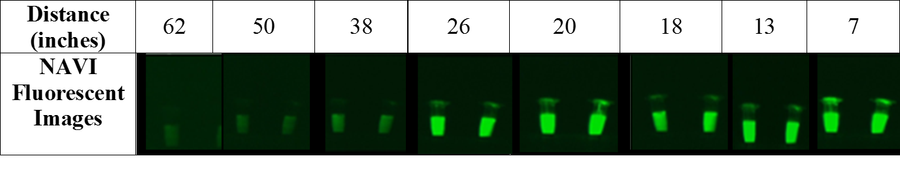

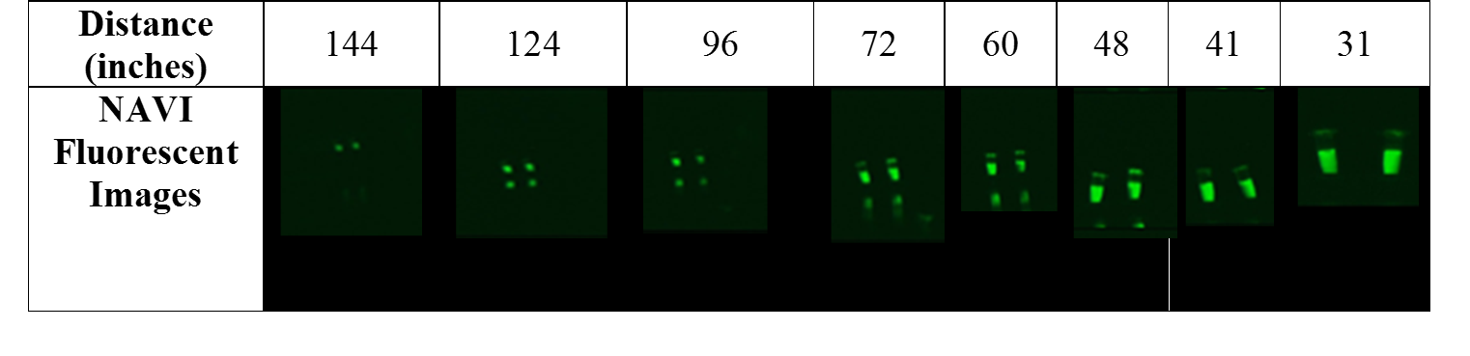

Table 1: Change in fluorescence upon varying distance between NIR source and ICG dye at two different concentrations – 12.90 μM (left) and 25.80 μM (right).

Table 2. Change in fluorescence upon varying distance between camera and ICG dye at two different concentrations – 12.90 μM (left) and 25.80 μM (right)

