Dear Author(s),
This document is divided into a number of sections in which you can add your comments to the video, voiceover, and online text/PDF. Please be aware that our policy is to do a single complimentary revision, so it is critical that all participants in this project offer their comments collectively. In addition, please make sure that your comments are easily interpreted and transparent.
Have fun!
Protocol Name: Assessment of Child Anthropometry in a Large Epidemiologic Study
Date: November 22, 2016

Authors and Affiliations
Please fill in any missing author information not included in the video.
Order | Author | Affiliation | Email
6 | Emily Oken (does NOT have a middle initial) | Harvard Medical School and Harvard Pilgrim Health Care Institute | All other information listed about this author is correct, but please remove the N from her name (Emily Oken)- Incorrectly labeled in the authorship announcement (under title) and in citation

Video Comments
Please fill in any comments you wish to make using the table below using the example as a guide. If you need more space to write, please do so below the table. DO NOT ADD CORRECTIONS TO THE NARRATION HERE. PLEASE DO THIS IN THE AUDIO COMMENTS SECTION.
 | Time code | Comment | Requested Change
Example | 2:52 | Onscreen text says use 0.25 mM Fluo-4 | Text should say use 0.50 mM Fluo-4
1. | 0:47-0:52 | Shot is blurry | If you have another shot of Marleny Ortega and Nicole Witham raising their hands, could you use that instead? If not, that’s okay.
2. | 1:31 | The image is a close-up view of the participant’s head, while the voiceover says ‘feet flat and arms hanging down’ | Can you use a zoomed out shot of the participant’s whole body, including his arms hanging down (similar to the shot of him standing straight up at time 1:44)
3. | 1:41 | Mid-axillary line is drawn while the participant is in process of being adjusted into proper position. | Mid-axillary line, should only be drawn after the participant has been placed correctly and is standing erect, at time 1:44. Red line shows proper placement of mid-axillary line at correct time  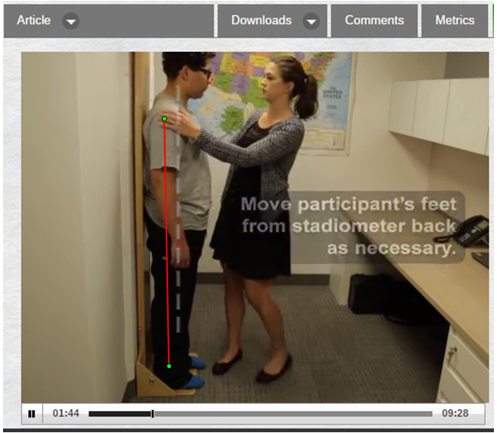
4. | 1:50 | Dotted line is drawn while participant’s head is in process of being adjusted. | Dotted line (indicating Frankfurt plane) should be drawn at time 1:54, when screen text says ‘i.e. Frankfurt plane.’ Red line on image below indicates where the line should be drawn at that time 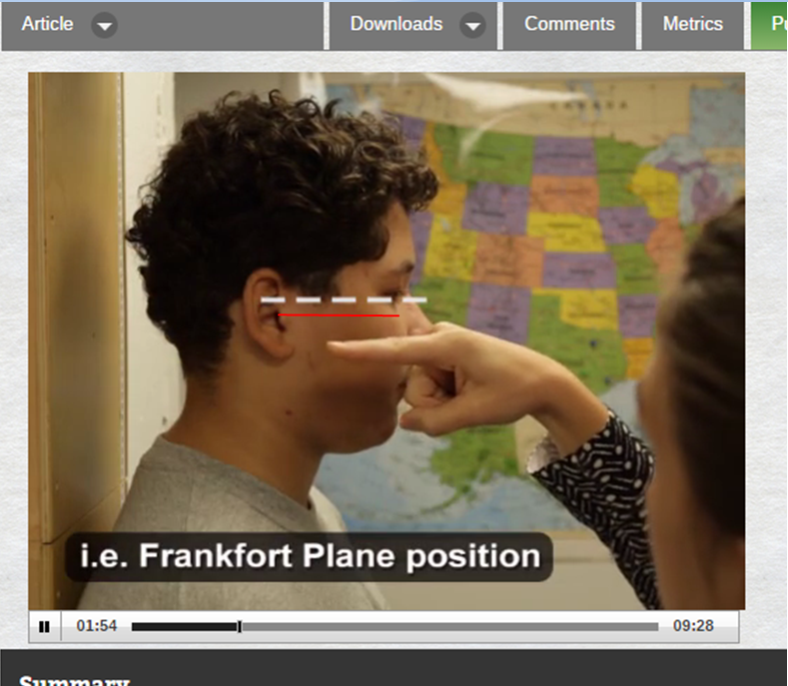
5. | 4:57 | 90° angle image | The 90° angle image is not well aligned with the child’s arm placement. Please remove the image of the 90° angle
6. | 6:45 & 6:49 | Shot of talent identifying lower point of scapula | Talent is simply repeating the same motion identification of lower most point of the scapula at 6:45 and 6:49. Instead there should be one shot of this action, preferably second shot of talent identifying lower point of scapula (time 6:49-6:54). After that shot is shown, use a separate shot of the talent pointing to a spot 2 centimeters below the scapula. Please align this imagine with the voice-over commentary “locate the measurement site 2 cms below the lower tip of the scapula’ (6:53). (Although I’m not sure what take it was, we filmed a take where the talent identified the scapula and slid her fingers 2 cm directly below scapula point.)
7. | 7:40 | Red box highlighting the mean column | Red box should highlight the Mean TEM column, highlighting values: 1.3, 0.6, 0.3, 0.6 and 0.9.
8. | 7:46 | Red box highlighting subscapular skinfold thickness and tricep skinfold thickness values under “TEM for each of the 6 research staff” | Red box highlighting subscapular skinfold thickness and tricep skinfold thickness values under “% TEM.” Red box should enclose only values 7.4 and 6.9.
9. | 9:19 | Screen reads “Harvard Medical School and Harvard Pilgrim Health Care” | Screen should read “Harvard Medical School and Harvard Pilgrim Health Care Institute”
10.
11.
12.
14.
15.
16.
17.
18.
19.
20.

Audio Comments
This section is used to specify the changes that need to be made to the narration. Please follow the example below as a guide to list your changes. If there is a pronunciation change, please provide a phonetic pronunciation key.

 | Time code | Comment | Step(s) in Shotlist | Rewritten Text or Corrected Pronunciation (highlight in bold)
Example | 1:49 | Original Script Text:  “Then, show the participant their electromyography, or EMG patterns, which correspond to eight specific and unique polar plots.” | 2.2 | Rewritten Script Text:  “Then, show the participant the unique and specific polar plots, which correspond to their electromyography, or EMG (pronounced E-M-G) patterns.”
1. | 7:15 | “Recording the thickness to the nearest zero point two tenths of a centimeter” | 4.7 | “Recording the thickness to the nearest two tenths of a centimeter”
2.
3.
4.
5.
6.
7.
8.
9.
10.
11.
12.
13.
14.
15.
16.
17.
18.
19.
20.

Online Text/PDF Protocol
Please use this table to address changes that need to be made to the online text/PDF document. Both the online text and PDF are generated from the HTML template of your article. Since the PDF is generated from the HTML by our conversion software, it may contain formatting errors. For major structural changes or more than 10 spelling or grammatical mistakes, we will require re-upload of the entire document.

 | Protocol Step | Comment | Requested Change (highlight in bold)
Example | 1.1 | Step says “Centrifuge lysate at 2,000 x g.” | Please correct to “Centrifuge lysate at 4,000 x g.”
1. | Citation of article | Louer, A. L., Simon, D. N., Switkowski, K. M., Rifas-Shiman, S. L., Gillman, M. W., Oken, E. N. Assessment of Child Anthropometry in a Large Epidemiologic Study. J. Vis. Exp. ( ), e54895, doi:10.3791/54895 (2016). | Is there a journal number? If not, remember to remove blank ( ).
2. | 3.6 | Visually verify that the mid-axillary line is perpendicular to the floor. Instruct the participant to move his/her feet away from the back of the stadiometer to achieve this position. | Visually verify that the mid-axillary line is perpendicular to the floor. Instruct the participant to move his/her feet away from the back of the stadiometer if necessary to achieve this position.
3. | 6.4 | While the participant stands perpendicular to the mirror, gently place the measuring tape around the waist on top of the two stickers. Using the mirror as a guide, adjust the tape so that it is on a level, horizontal plane across the front, back, and both sides. | While the participant stands perpendicular to the mirror, gently place the measuring tape around the waist on top of the two stickers, with the zero side (or base) of the tape measure below. Using the mirror as a guide, adjust the tape so that it is on a level, horizontal plane across the front, back, and both sides.
4. | 6.5 | Tighten the tape, without pulling the skin.As this is a fine balance, | Tighten the tape, without pulling the skin. (INSERT SPACE HERE) As this is a fine balance,
5. | 9.2 | NOTE: If the skinfold rolls easily between the fingers, it likely contains only skin and subcutaneous fat. If the skinfold does not roll easily or the grasp isparticularly painful for the participant, | NOTE: If the skinfold rolls easily between the fingers, it likely contains only skin and subcutaneous fat. If the skinfold does not roll easily or the grasp is (INSERT SPACE HERE) particularly painful for the participant,
6. | 10.4 | Record measurement to the nearest 0.2 tenth of a centimeter after 4 seconds. | Record measurement to nearest two tenths of a centimeter after 4 seconds
7. | Correspondence on PDF Version | Correspondence to: Amy L Louer at amy_louer@harvardpilgrim.org | Correspondence to: Emily Oken at emily_oken@harvardpilgrim.org
8.
9.
10.
11.
12.

