Dr. Jaydev Upponi, Ph.D.
Science Editor, JoVE
(Manuscript ID JoVE54235)

Response to the editor:
Thank you for your note and useful comments and suggestions on our manuscript. Enclosed please find a revised manuscript entitled “Probing C84-embedded Si substrate using scanning probe microscopy and molecular dynamics”. We thank you for your careful review and insightful comments on our manuscript. We have revised the manuscript and would like to resubmit it. Below are the comments of the reviewer addressed point-by-point along with an attached revised manuscript. We have red-lined the significant changes in the revised manuscript for easier tracking. Please let us know if there is anything else that we can address with respect to this manuscript. Thank you for the consideration and we look forward to hearing your response.

Sincerely,

Editor’s Comments to the Author
Authors have provided the stepwise instructions of software usage in section 5. We point out
Response to the Editor:

•There are several steps that will require additional detail in order to be filmed. These steps may be particularly difficult to visualize, given that they may involve manipulations in software. Because all of section 5 is computational, software manipulations must occur in a graphical user interface and stepwise detail regarding what is clicked on in the software must be provided.
-5.2.1/5.3.1/substeps of 5.4/5.5.1 – Please provide stepwise instructions of software usage in a graphical user interface. If this cannot be done, that is, scripting is involved, these steps should not be highlighted for filming. This applies to the entire section.
Response: Authors have provided the stepwise instructions of software usage in section 5. We point out that because the steps are too many, which would exceed the limitation of JoVE, the original highlight is canceled. We only highlight a paragraph in line 261-266.

•Protocol is discontinuous. Please highlight step 3.1.2 and 3.1.3 if 3.1.1 is to be filmed. 4.1.1 must be highlighted if 4.1.2 is to be filmed.
Response: Authors have highlighted step 3.1.2 and 3.1.3, and 4.1.1.

•Additional detail is required:
-1.3.1 – Which temperature is correct? 550 or 650?
Response: 650⁰C is a better set-up. Authors have corrected the temperature to 650⁰C.

-2.3.1- How is the system operated? Stepwise detail is required for filming.
Response: Authors have revised step 2.3.1 to make the process clear.
2.3.1) Place C₈₄-embedded Si substrate on a FE sample holder. Insert the holder into FE analysis chamber. Evacuate the chamber to a pressure of approximately 5 x10⁻⁵ Pa for FE measurement.

-2.4.1 – How is the equipment operated for photon collection and analysis? Stepwise detail is required for filming.
Response: Spectrometer is a wisely used tool. We used the spectrometer to collect photons and measure the intensity of light as a function of wavelength.
Authors have revised the manuscript as:
“2.4.1) Transfer testing substrate to an optical emission measurement system. Focus a He–Cd laser source with 325 nm emissions on the substrate that is located in the center of the sample compartment. Set up a spectrometer in a suitable position. Use a spectrometer to acquire the photoluminescence spectrum by collecting and analyzing emitting photons. The optoelectronic result is shown in Figure 2(d).”

-3.1.2, 3.1.3 – Please provide stepwise detail regarding how these actions are achieved if this section is to be filmed. If software is used, please indicate what is clicked on in the graphical user interface.
Response: 3.1.2 and 3.1.3 have been revised as:
3.1.2) Place the magnetized sample on an MFM sample stage. Click on “Obtain MFM topography” item. Observe the microstructure of the fullerene in the magnetic domain embedded within the Si substrate using MFM in lift mode with the application of magnetization perpendicular to the surface of the sample.
3.1.3) Use a nano-scale PPP-MFMR cantilever for MFM measurements (Figure 3 (a)). Determine the surface magnetism if MFM topography appears darker(brighter) when the magnetic moment of tip is in the same(opposite) direction of the substrate moment.

-3.2.2 – How is the substrate magnetized?
Response: 3.2.2) Magnetize samples of C₈₄-embedded Si and C₈₄ clusters on C₈₄ embedded Si substrate prior to SQUID experiments by applying a magnet with a field strength of approximately 2 kOe.

-3.2.3 – How are the magnetization loops acquired? Stepwise detail regarding equipment use is required.
Response: SQUID system is an automatic measuring system. We place the sample into SQUID. Apply a sweeping magnetic field. Then we obtain the magnetization loops. The 3.2.3 has been revised as:
3.2.3) Place the sample in an SQUID. Apply a sweeping magnetic field in a range of ~ 2 kOe. Obtain the magnetization loops plotted versus the external magnetic field in SQUID measurements at room temperature.

-4.1.1 – A sharp what? How is the tip moved across the substrate? Please be more detailed regarding operation of the equipment so it is clear how measurements were made.
Response: Thanks for the comment. We have revised it as “a sharp tip”. Tip movement is controlled using a scanner. We have revised step 4.1.1 as:
4.1.1) Place the substrate on an AFM sample stage. Drag a sharp tip over the substrates using a scanner. Monitor the displacements of the tip as a measure of tip-sample interaction forces. Record the movements at many tip-sample distances along vertical direction in a certain position by clicking on “force measurement” item.

•Formatting
-2.1, 2.1.1 – Should FB be FE?
Response: Authors have made a correction.
-2.1.2 must be split into two steps.
Response: 2.1.2 has been split into 2.1.2 and 2.1.3. The previous 2.1.3 has been moved to 2.1.4.
-A space is required between 2.4.1 and 3.
Response: We have made a space.

-Please fix the step numbering throughout the protocol. There are many mistakes including two steps 3.2.2 and 5.3.2, and step 5.1.7 appears after step 4.2.2.
Response: The previous 3.2.2 and 5.3.2 has been revised to 3.2.3 and 5.3.3. 5.1.7 is canceled.

-Please check that that the text is consistent throughout the Materials/Equipment Table. In addition, please check that all items have been included in this table (e.g., vacuum system).
Response: We have checked the tables.

-Please ensure that spaces are included between steps (e.g., 5.2 and 5.2.1, etc.).
Response: Authors have included the space between 5.2 and 5.2.1.

-Please provide doi information for references where applicable, and abbreviate all journal titles.
Response: We have put the doi information for each reference.

•The manuscript must be copyedited for grammatical and typographical errors prior to acceptance. (Example: 2.2.1 – should be ‘the following:')
Response: Authors have made a correction.

•Unnecessary branding should be removed from the Figure 2 legend - Keithley 237.
Response: “Keithley 237” has been removed.

•As written, the Discussion still focuses too heavily on the results, rather than the method. Please reformat this section to that it also emphasizes the future applications and advantages of this method over others.
Response: The discussion has been revised as:
In this study, a novel annealing process which is very much temperature-dependent to make substrate surface pre-melting for nanoparticles half-embedding into substrate without destroying nanoparticle structures is provided to fabricate a self-assembled monolayer of C₈₄ on a Si substrate (Figure 1). The improved process can be further suggested for preparing other nanoparticles embedded semiconductor substrates. The properties of a C₈₄-embedded Si substrate can be revealed in atomic scale using an UHV-SPM. The dI/dV curves corresponding to band gap measurements of proposed substrates are determined by UHV-STM (Figure 2). The field emission parameters, including field enhancement factor, turn-on electric field, and current density, are detected using a field emission spectrometer. The photoluminescence spectra, MFM and SQUID measurements reveal that the C₈₄-embedded Si substrate with UV light emissions and existence of ferromagnetism (Figure 3) is highly applicable in optoelectronic and dilute magnetic semiconductor(DMS) devices. .

If your figures and tables are original and not published previously, please ignore this comment. For figures and tables that have been published before, please include phrases such as “Re-print with permission from (reference#)” or “Modified from..” etc. And please send a copy of the re-print permission for JoVE’s record keeping purposes.
JoVE reference format requires that DOIs are included, when available, for all references listed in the article. This is helpful for readers to locate the included references and obtain more information. Please note that often DOIs are not listed with PubMed abstracts and as such, may not be properly included when citing directly from PubMed. In these cases, please manually include DOIs in reference information.
Response: We have made doi links.

Reviewers' comments:
Reviewer #1:
Manuscript Summary:
The submitted paper entitled "Probing C84-embedded Si substrate using scanning probe microscopy and molecular dynamics" reports a protocol for fabricating and measuring C84 arrays embedded Si substrate. The idea is interested and useful for the application of nanotechnology. The detail of both simulation and experiment skill are clearly described in the manuscript. I recommend this article to be published in JoVE after making the following revisions.

1.In protocol section (5.4.1 ~5.4.3 and 5.5.1), author should describe how do you make those procedure (by LAMMPS, OVITO, or programing,) in your simulation procedure.
Response: Authors have provided the stepwise instructions of software usage in section 5. We point out that because the steps are too many, which would exceed the limitation of JoVE, the original highlight is canceled. We only highlight a paragraph in line 261-266.

2.In representative result section (1st paragraph ), what is the abbreviation "PL" mean in 1st paragraph.
Response: Thanks for the suggestion. Authors has corrected “PL” as “Photoluminescence(PL)” to make it clearly.

3.In discussion section: (1)In 1st paragraph, what is the novel annealing process mean? How does the novel method compare to the old method ? what does it improve ? (2)In 4th paragraph, authors suggest the HA and CN to characterize the phase transformation. Do those applied in this work to analyze the simulation results? What is its limitation?
Response: (1) The novel annealing process means we have to take many steps repeatedly (Step. 1 in Protocol) which are very much temperature-dependent to make substrate surface pre-melting for nanoparticles half-embedding into substrate without destroying nanoparticle structures. The traditional process either makes nanoparticle just lie on surface, or dissociate to form amorphous structures with substrate atoms.
(2) HA and CN are not applied in this work for analyzing the simulation results. CN is used to identify the number of the most neighbor atom. Instead, HA provides very clear information about the local symmetry of atomic arrangement more than the common pair correlation function and coordination number, and has been used to simulate the grain boundary microstructure transition, local cluster structure, and glass forming of metallic alloys under the rapid cooling condition. Both indexes can provide the quantitative difference between different phases.

4.In Figure 1, please check the format.
Response: Authors have converted the Fig.1 again in their manuscript.

5.In Figure 6, please indicate the which curve correspond to Fz, and which curve correspond to the contact stress. In addition, label G is not shown.
Response: Authors have indicated the corresponding curves in the figure legends.

Major Concerns:
N/A
Minor Concerns:
N/A
Additional Comments to Authors:
N/A
Response: Thanks for the comments.

Reviewer #2:
Manuscript Summary:
This paper is an interesting manuscript,it gives an array-designed C84-embedded Si substrate fabricated method. The properties of the samples were measured by many kinds of technologies. On the other hand, the measured parameters were explained by Molecular dynamics (MD) siulations. Their results should be beneficial to the community interested in fabrication of FED,optoelectronical device, MEMS cutting tools. The fabricated and simulation method are technically correct.

Major Concerns:
N/A
Minor Concerns:
N/A
Additional Comments to Authors:
N/A
Response: Thanks for the comments.

Reviewer #3:
Manuscript Summary:
The authors reported on an array-designed C84-embedded Si substrate fabricated using a controlled self-assembly method in an ultra-high vacuum chamber. The characteristics of the C84-embedded Si surface, such as atomic resolution topography, local electronic density of states, band gap energy, field emission properties, nanomechanical stiffness, and surface magnetism, were examined using a variety of surface analysis techniques under UHV conditions as well as in an atmospheric system. The experimental findings have been duly supported through the relevant discussions.

Major Concerns:
N/A
Minor Concerns:
N/A
Additional Comments to Authors:
N/A
Response: Thanks for the comments.

Reviewer #4:
Manuscript Summary:
This article introduces the method of fabricating the material of C84 embedded Si substrate. The authors exploit different techniques, such as STM, field emission, photoluminescence, MFM, AFM, and SQUID to characterize the properties of this material. It turns out that C84 embedded Si substrate has wide band gap energy, high field emission current density, UV and near UV light emission, ferromagnetic property, and hardness comparable to that SiC and Si surfaces. Because of these properties, the authors expect that the material of C84 embedded Si substrate is possible to replace SiC, and has potential applications on field emission display, optoelectronic device fabrication, MEMS cutting tools.

Major Concerns:
1. It would be better if the authors demonstrate the evidence that C84 is embedded in Si substrate in Fig. 1 because it is an important point in this article. The current Fig. 1 just shows C84 on Si substrate.
Response: We thank reviewers for their very important comments. According to the instruction of JoVE, the editors suggested us to present detailed method, data analysis with certain technologies. The processes of experiments are the key issues in this article. The research results are not the major concerns in JoVE papers. Still we attach one TEM figure here for review’s reference. The cross-section SPM results along with TEM images indicated C84 embedment will soon publish in other journal.

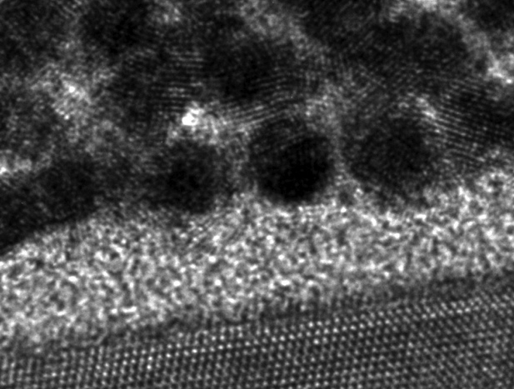
- A cross section TEM image of C84 embedded Si substrate
2. In 2.2.1), the authors state that I-V curves were obtained on Si(111)-7x7 surface, single individual C84 nanoparticles on Si, 7-19 C84 clusters on Si, 20-50 C84 clusters on Si, and a monolayer of C84 embedded within Si surface. However, in Fig. 2(a), only spectrum of single self-assembled layer of C84 is shown. I suggest the authors to show all of spectra in Fig. 2(a) for comparison.
Response: We thank reviewers for their comments. The editor office suggested us remove detailed results from previous version due to the policies and focuses of JoVE. We attached the figure here for review’s reference. The figure has been published in RSC Adv., 3 (24), 9234 – 9239 (2013).
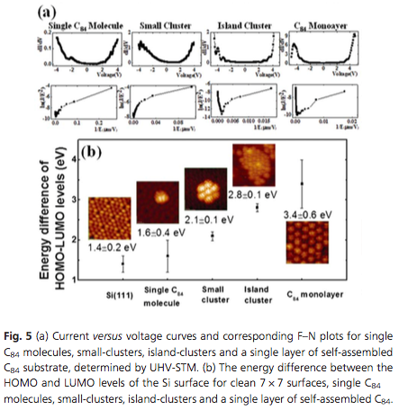
3. It is surprised that C84 embedded in Si reveals ferromagnetic property. However, the authors have no elucidation for this interesting finding. It would be better if the authors interpret why the contrast in MFM image in Fig. 3(a) can reflect the surface has the ferromagnetic property. In 3.2.2), the authors state that SQUID measurements were performed at room temperature and 5 K. However, in Fig. 3(b), only the loop at room temperature is shown. I suggest the authors to show the loop at 5K as well for comparison.
Response: We really thank for reviewer’s comments. The reviewer pointed out the very important issue in this research. However, in this manuscript we only focus on the protocol of fabricating C84 embedded Si substrate due to the journal policies. The detailed mechanism revealing surface ferromagnetism will be published soon in other journal paper.
The operating principle of MFM is the same as in AFM, but with lift mode scanning. If substrate surface has no ferromagnetism, the MFM image looks like a flat surface without any signal. If substrate surface has ferromagnetism, the MFM topography would appear darker(brighter) when the magnetic moment of tip is in the same(opposite) direction of the substrate moment. We revised the 3.1.3) as following:
3.1.3) Use a nano-scale PPP-MFMR cantilever for MFM measurements (Figure 3 (a)). Determine the surface magnetism if MFM topography appears darker(brighter) when the magnetic moment of tip is in the same(opposite) direction of the substrate moment.
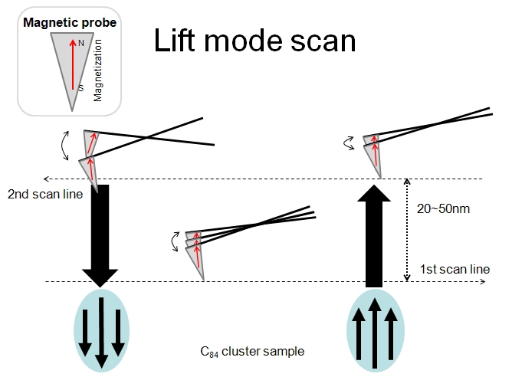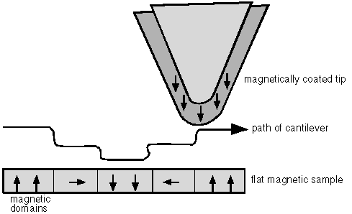

There is only limited space for presenting results. We removed the 5K description in our manuscript, but attached the SQUID result taken at 5K for reviewer’s reference. The figure will be published soon in other journal paper.
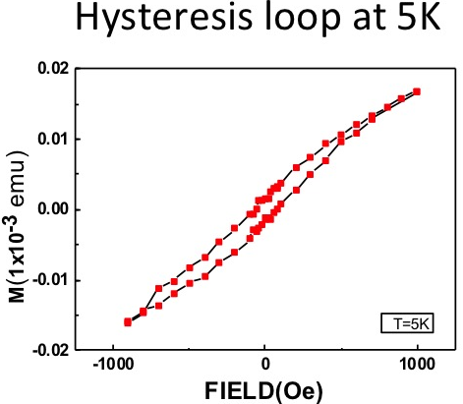
Minor Concerns:
1. Line 19: should be "Center" instead of "Carter"
Response: Authors have made a correction.
2. Line 30: should be "Center" instead of "Carter"
Response: Authors have made a correction.
3. Line 36: should be "Center" instead of "Carter"
Response: Authors have made a correction.
4. Line 164: should be "LUMO" instead of "LOMO"
Response: Authors have made a correction.
5. Line 167: should be "FE" instead of "FB"
Response: Authors have made a correction.
6. Line 169: should be "FE" instead of "FB"
Response: Authors have made a correction.

Reviewer #5:
Manuscript Summary:
The authors have revised the manuscript as Reviewers' comments. Therefore, it can be published as it.
Major Concerns:
N/A
Minor Concerns:
N/A
Additional Comments to Authors:
N/A
Response: Thanks for the comments.

