Figure 1
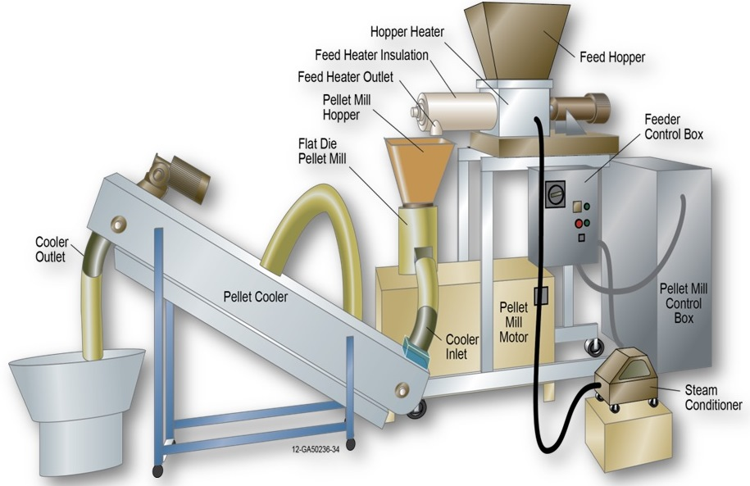

Figure 2
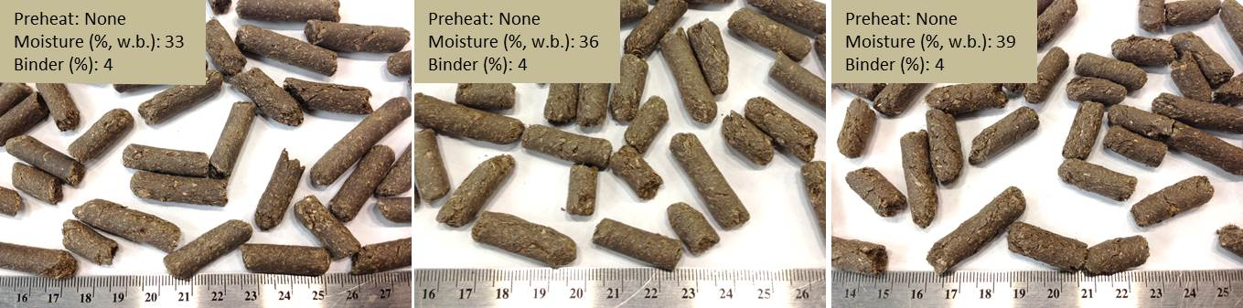

Figure 3
AB
CD
AB
A
AB
AB
BC
D
CD

Figure 4
A
AB
B
AB
AB
AB
AB
AB
AB

Figure 5
A
AB
AB
B
AB
AB
A
AB
AB

Figure 6
A
D
BC
E
AB
CD
CD
DE
E

Figure 7
I
G
L
A
E
A
A
H
E
B
CD
BC
E
BC
J
DE
F
K

Figure 8

Figure 9

