Supplemental information for JoVE scriptwriter
Step # | Text | Visual representation
1.1.1 | “Use the Circle command to draw a circle with a diameter of .3 mm. Use the Extrude function to make a cylinder with a length of 3 mm.” | Screenshot of AutoCAD, titled “AutoCAD_1” below.
1.1.2 | “Make a cross with two orthogonal cylinders with a common center;” | Screenshot of AutoCAD, titled “AutoCAD_cross” below.
1.1.2 | “make a jack with three mutually orthogonal cylinders with a common center;” | Screenshot of AutoCAD, titled “AutoCAD_jack” below.
1.1.2 | “make a tetrad with four cylinders sharing a common end at 109.5° angles to one another;” | Screenshot of AutoCAD, titled “AutoCAD_tetrad” below.
1.1.2 | “make a triad with three cylinders in plane sharing a common end at 120° angles to one another.” | Screenshot of AutoCAD, titled “AutoCAD_triad” below.
1.1.3 | “To tilt cylinders (hereafter called “arms” of the particles) with respect to one another, use the Rotate 3D command to draw a line across the diameter of the circle at one of its ends and then enter the desired angle of rotation.” | Screen recording of AutoCAD, titled “AutoCAD_makingtriad” below.
1.1.4 | “Use the Union command to join the different arms together into a single watertight object.” | Screen recording of AutoCAD, titled “AutoCAD_makingtriad” below.
1.1.5 | “Use the Rotate 3D command again to tilt the object so that no arms are along the vertical or horizontal axes, because arms that lie along these axes tend to have defects, break off more easily, or flatten out.” | Screen recording of AutoCAD, titled “AutoCAD_makingtriad” below.
2.1.1 | “Test average particle densities by immersing particles in solutions of water mixed with Calcium Chloride (CaCl₂) at densities around 1.20 g/cm³.” | Videographer footage of a lab member.
2.1.3 | “Mix about 400 kg of CaCl₂ into approximately 1600 L of water until the solution is at the density recorded in 2.1.1 – 2.1.2.” | Videographer footage of a lab member.
2.2 | “Manually loosen the support material in which the particles come encased by gently breaking the large pieces … into small sections … , then manually massage each section until much of the excess resin has come off” | Videographer footage of a lab member.
2.2.1 | “Place the remaining resin block in a 10% by mass Sodium Hydroxide (NaOH) solution immersed in an ultrasonic bath for one hour.” | Videographer footage of a lab member.
2.2.4 | “Filter out particles as in 2.2.1.1 and store in the density-matched solution separated in 2.1.4 while they harden. Handle the particles carefully because the NaOH solution temporarily softens them.” | Videographer footage of a lab member.
Note (after 2.2.4) | “If particles are not stored in a density-matched solution, some arms may bend.” | Picture of a particle with bent arms, titled “Bent_particles” below.
2.3.1 | “Prepare a 1 L solution of Rhodamine-B dye in water at a concentration of .5 g/L”. | Videographer footage of a lab member.
2.3.3 | “Put ~2,500 particles, enough to loosely fill ~25 mL in the density-matched storage solution, in the dye and keep all at 80 °C for two to three hours to allow the dye to absorb into the polymer. Remove the particles once they are pink”. | Videographer footage of a lab member.
CAREFUL (after 2.3.3) | “The heat will soften the particles temporarily.” | Videographer footage of a lab member.
3.1.3 | “Position the cameras with large (~90°) angles between each pair subject to the constraints of the apparatus. … Minimize optical distortions by building viewing ports into the apparatus perpendicular to each camera viewing direction.” | Videographer footage of a lab member and of the apparatus.
3.1.5.2 | “Place an image calibration mask in the tank, fill the tank with the bulk solution from 2.4, and illuminate the mask.” | Videographer footage of a lab member.
3.1.5.3 | “Adjust the cameras so that they each have the mask in view and they are all focused on the same point on the mask. Carefully align the cameras to optimize the shape of the detection volume.” | Videographer footage of a lab member.
3.2.1 | “Split the light from the laser using a beam splitter and use mirrors to guide one beam into the front of the tank and the other, orthogonal to the first, into the side of the tank.” | Videographer footage of a lab member and the apparatus.
3.2.2 | “Place two additional mirrors outside of the tank, opposite where the beams are entering, in order to reflect light back into the tank and create more uniform illumination, dramatically decreasing shadowing effects.” | Videographer footage of a lab member and the apparatus.
4.2 | “Prepare the turbulent flow in a 1 x 1 x 1 m³ octagonal tank using two parallel 8 cm mesh grids oscillating in phase.” | Figure 2.
4.4 | “Choose one particle type (tracer particles, jacks, crosses, tetrads, or triads) to be used for the first round of experiments and add all 10,000 of those particles into the water through a port at the top of the apparatus. Close this port after adding particles.” | Videographer footage of a lab member.
4.4.1 | “Turn the laser on.” | Videographer footage of a lab member.
4.4.3 | “Open the laser aperture.” | Videographer footage of a lab member.
4.4.4 | “Set the grid to the chosen frequency (1 or 3 Hz) and start it running. Before starting data acquisition, run the grid for about 1 minute to allow turbulence to fully develop.” | Videographer footage of the apparatus.
4.4.5 | “Record 10⁶ frames in order to keep the file size manageable and to keep any errors that may occur in the image compression systems from compromising too much data.” | Videographer footage of the apparatus.
4.4.6 | “Close the laser aperture and stop the camera trigger. Reset the image compression systems and the cameras.” | Videographer footage of a lab member.
4.6 | “Empty the tank and filter the water to remove all particles. Save particles in the storage water from 2.4 if desired.” | Videographer footage of a lab member.
5.1.3 | “Create a numerical model of the particle that can be projected onto each camera to model the intensity in the image from that camera.” | Screenshot of MATLAB, titled “MATLAB_tetrad_rods” below.
5.1.3.1 | “Model the particle as a composite of rods. Using the camera calibration parameters from 3.1.5.7 and 3.1.5.8, project the two end points of each rod onto the cameras and then model the distribution of light intensity in two dimensions, with a Gaussian function across the width of the rod and a Fermi-Dirac function across its length according to a software protocol.” | Screenshot of MATLAB, titled “MATLAB_tetrad_rods_oncamera” below.
5.1.5 | “Perform a nonlinear least-squares fit to determine the particle orientation.” | Screen recording of MATLAB, titled “MATLAB_min” below.  Note to scriptwriter: This can and should be sped up for the actual video.
5.1.5.1 | “Optimize the three 3D position coordinates and the three Euler angles such that the squared difference between the measured intensity and the 2D projection of the model is minimized on all four cameras.” | Screen recording of MATLAB, titled “MATLAB_min_opt” below.
5.1.6 | “For a jack, the Euler angles found give one of the 24 symmetric orientations;” | MATLAB figure, titled “MAT_jacks1to12” below.
5.1.6 | “For a jack, the Euler angles found give one of the 24 symmetric orientations;” | MATLAB figure, titled “MAT_jacks13to24” below.
5.1.6 | “for a tetrad it is one of 12 symmetric orientations;” | MATLAB figure, titled “MAT_tetrads” below.
5.1.6 | “for a cross, it is one of 8 symmetric orientations;” | MATLAB figure, titled “MAT_crosses” below.
5.1.6 | “and for a triad it is one of 6 symmetric orientations.” | MATLAB figure, titled “MAT_triads” below.
5.1.6 | “Choose the orientation that requires the smallest rotation with respect to the previous frame.” | Schematic.

Screen Shots: (Please copy and paste or insert the required screen shots here, in the order they are listed above.)

Screenshot 1 – AutoCAD_1

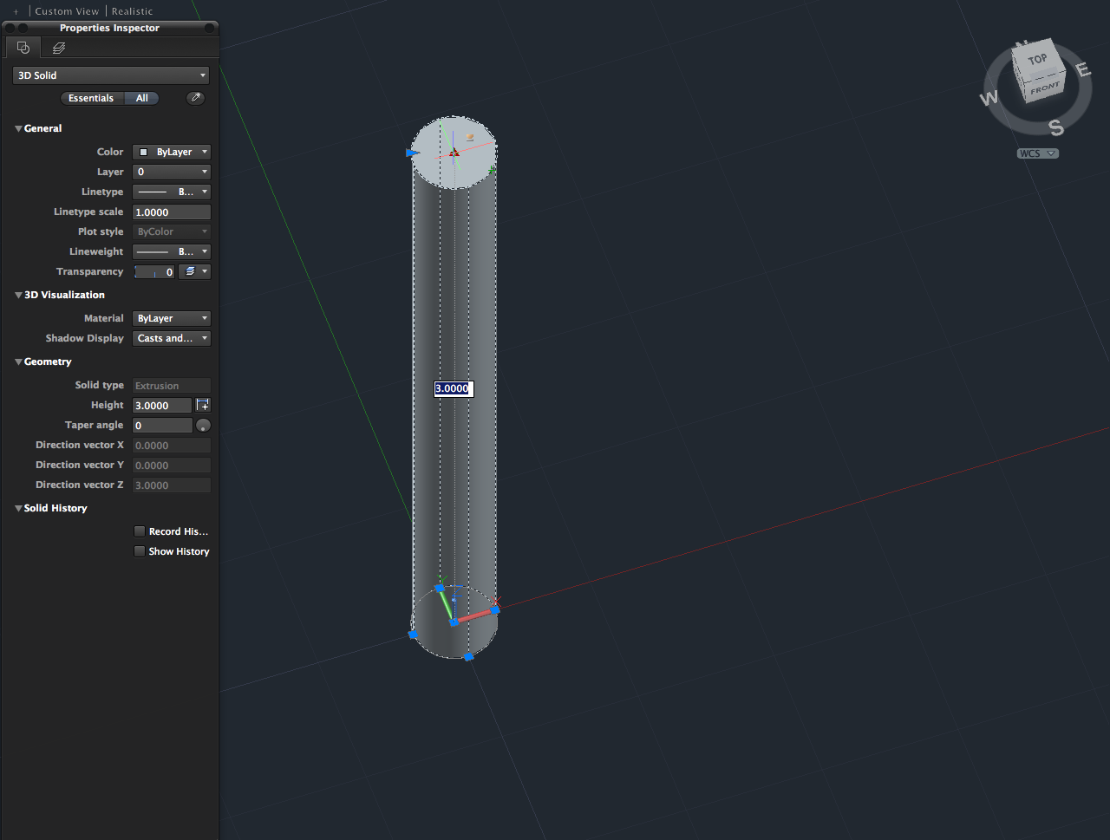

Screenshot 2 – AutoCAD_cross
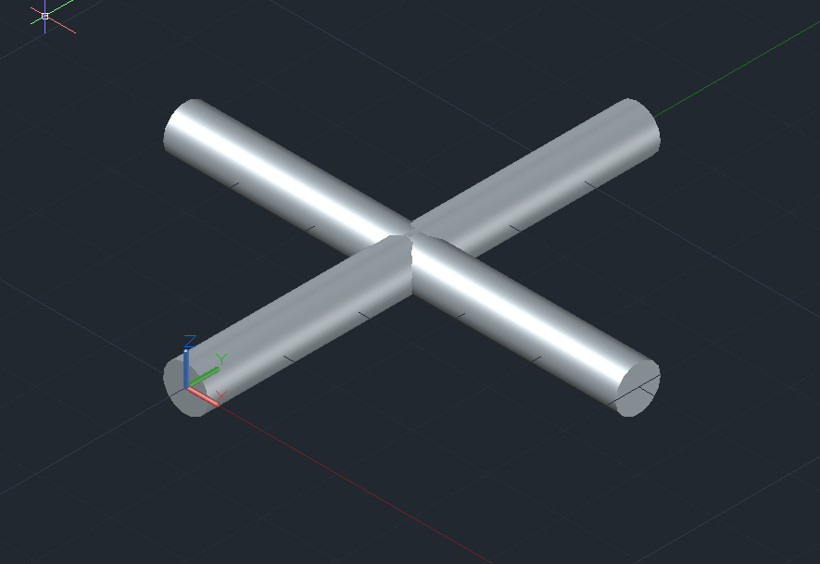
Screenshot 3 – AutoCAD_jack
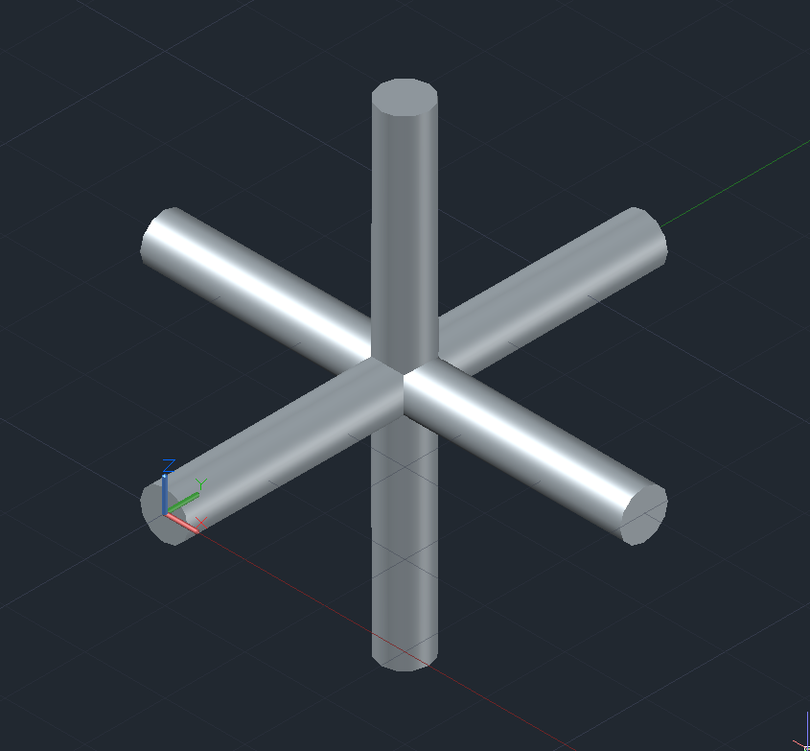
Screenshot 4 – AutoCAD_tetrad
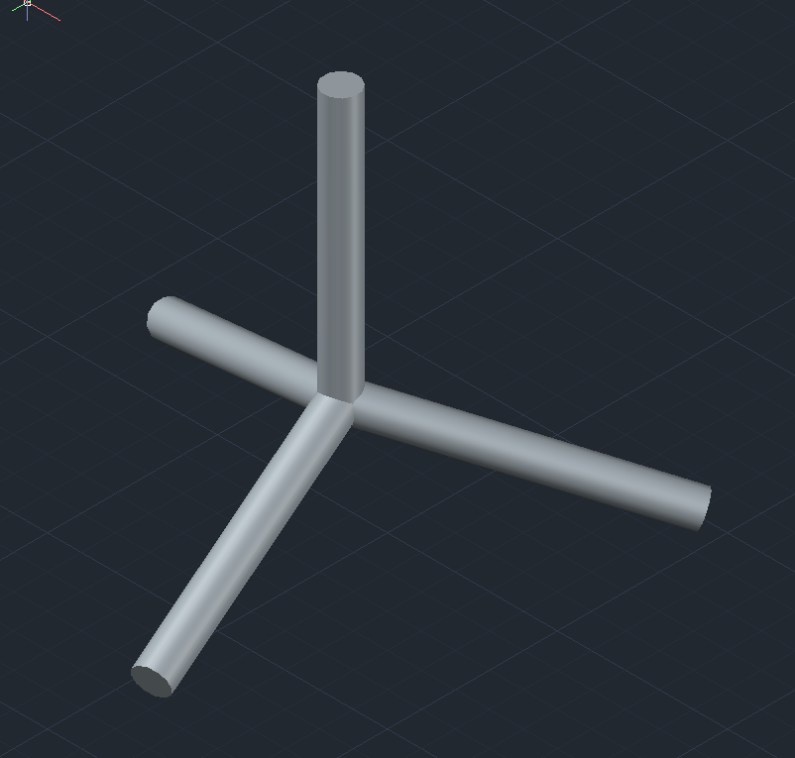

Screenshot 5 – AutoCAD_triad
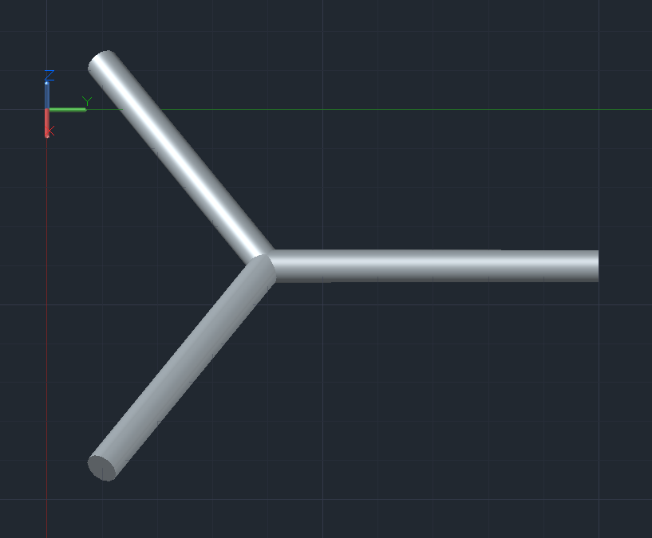

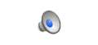
Screen Recording 1 – AutoCAD_makingtriad

Photo 1 – Bent_particles

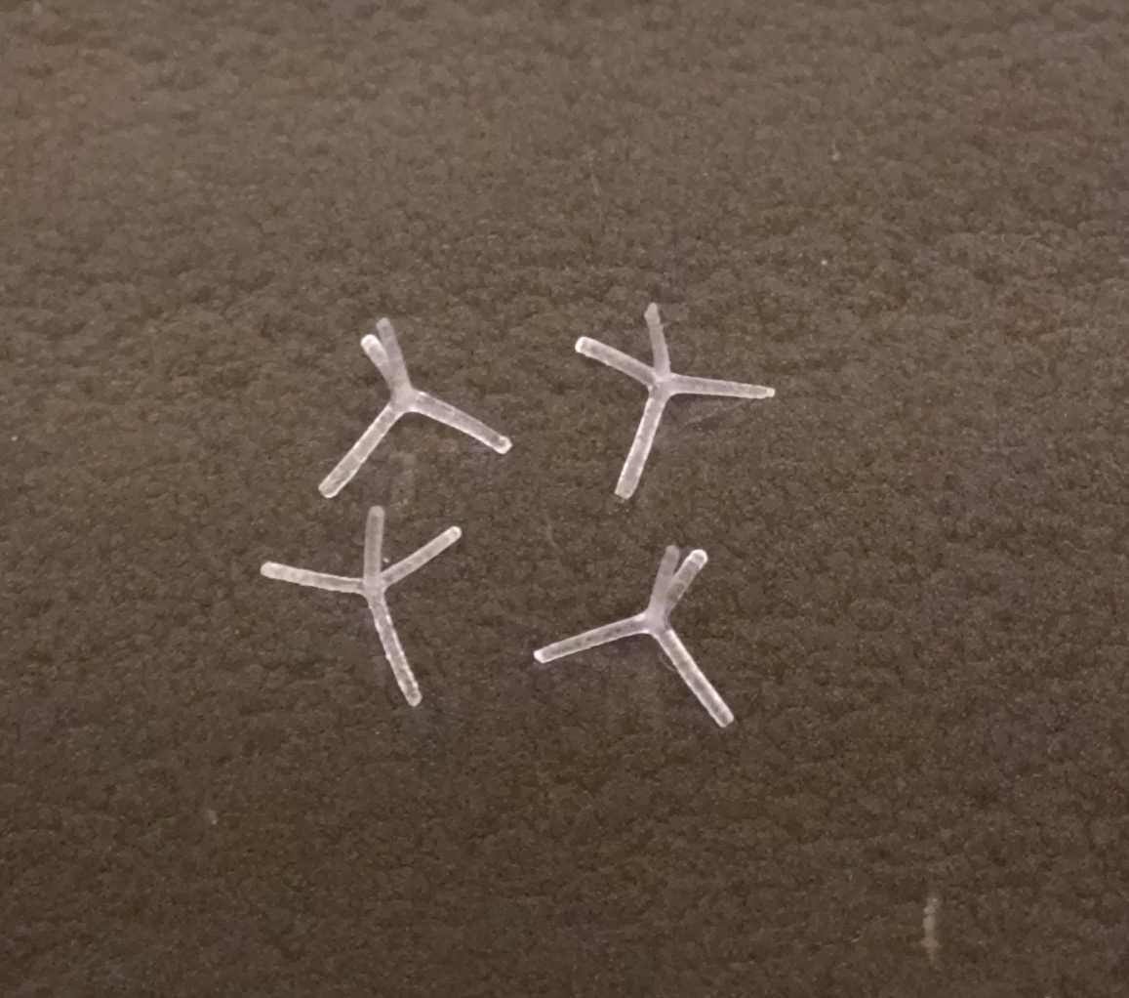

Screenshot 6 – MATLAB_tetrad_rods
Screenshot 7 – MATLAB_tetrad_rods_oncamera
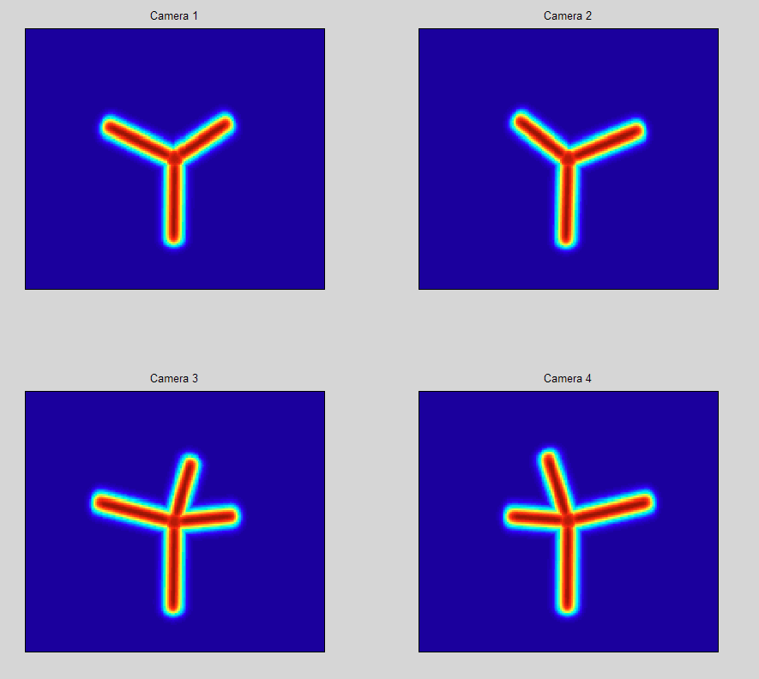
Screen Recording 2 – MATLAB_min
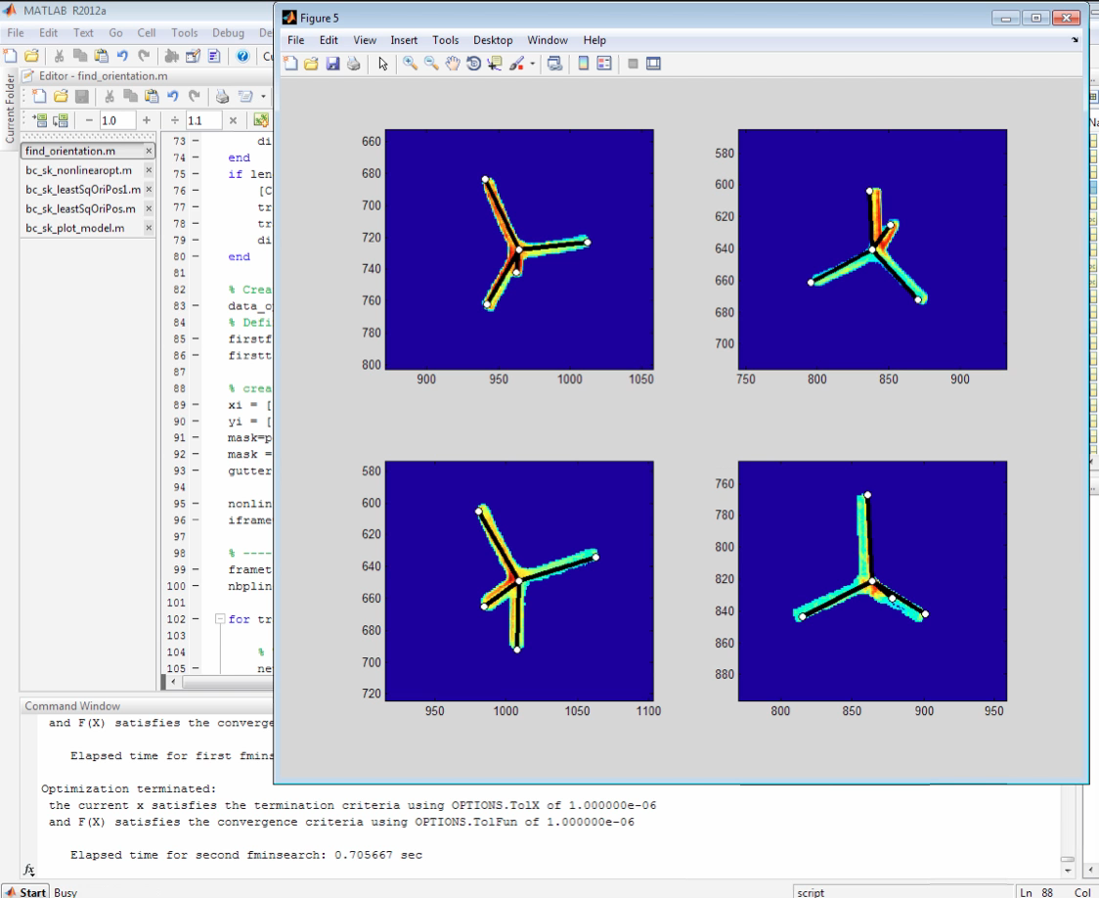

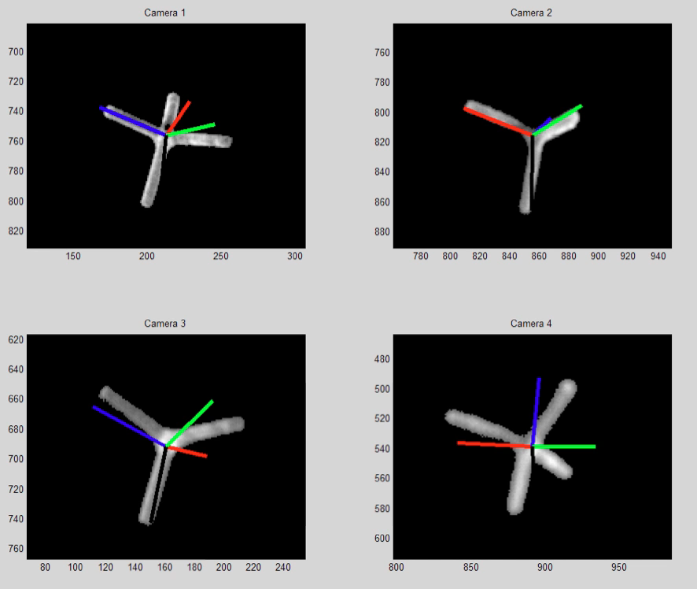
Screen Recording 3– MATLAB_min_opt

MAT_jacks1to12

MAT_jacks13to24

MAT_tetrads

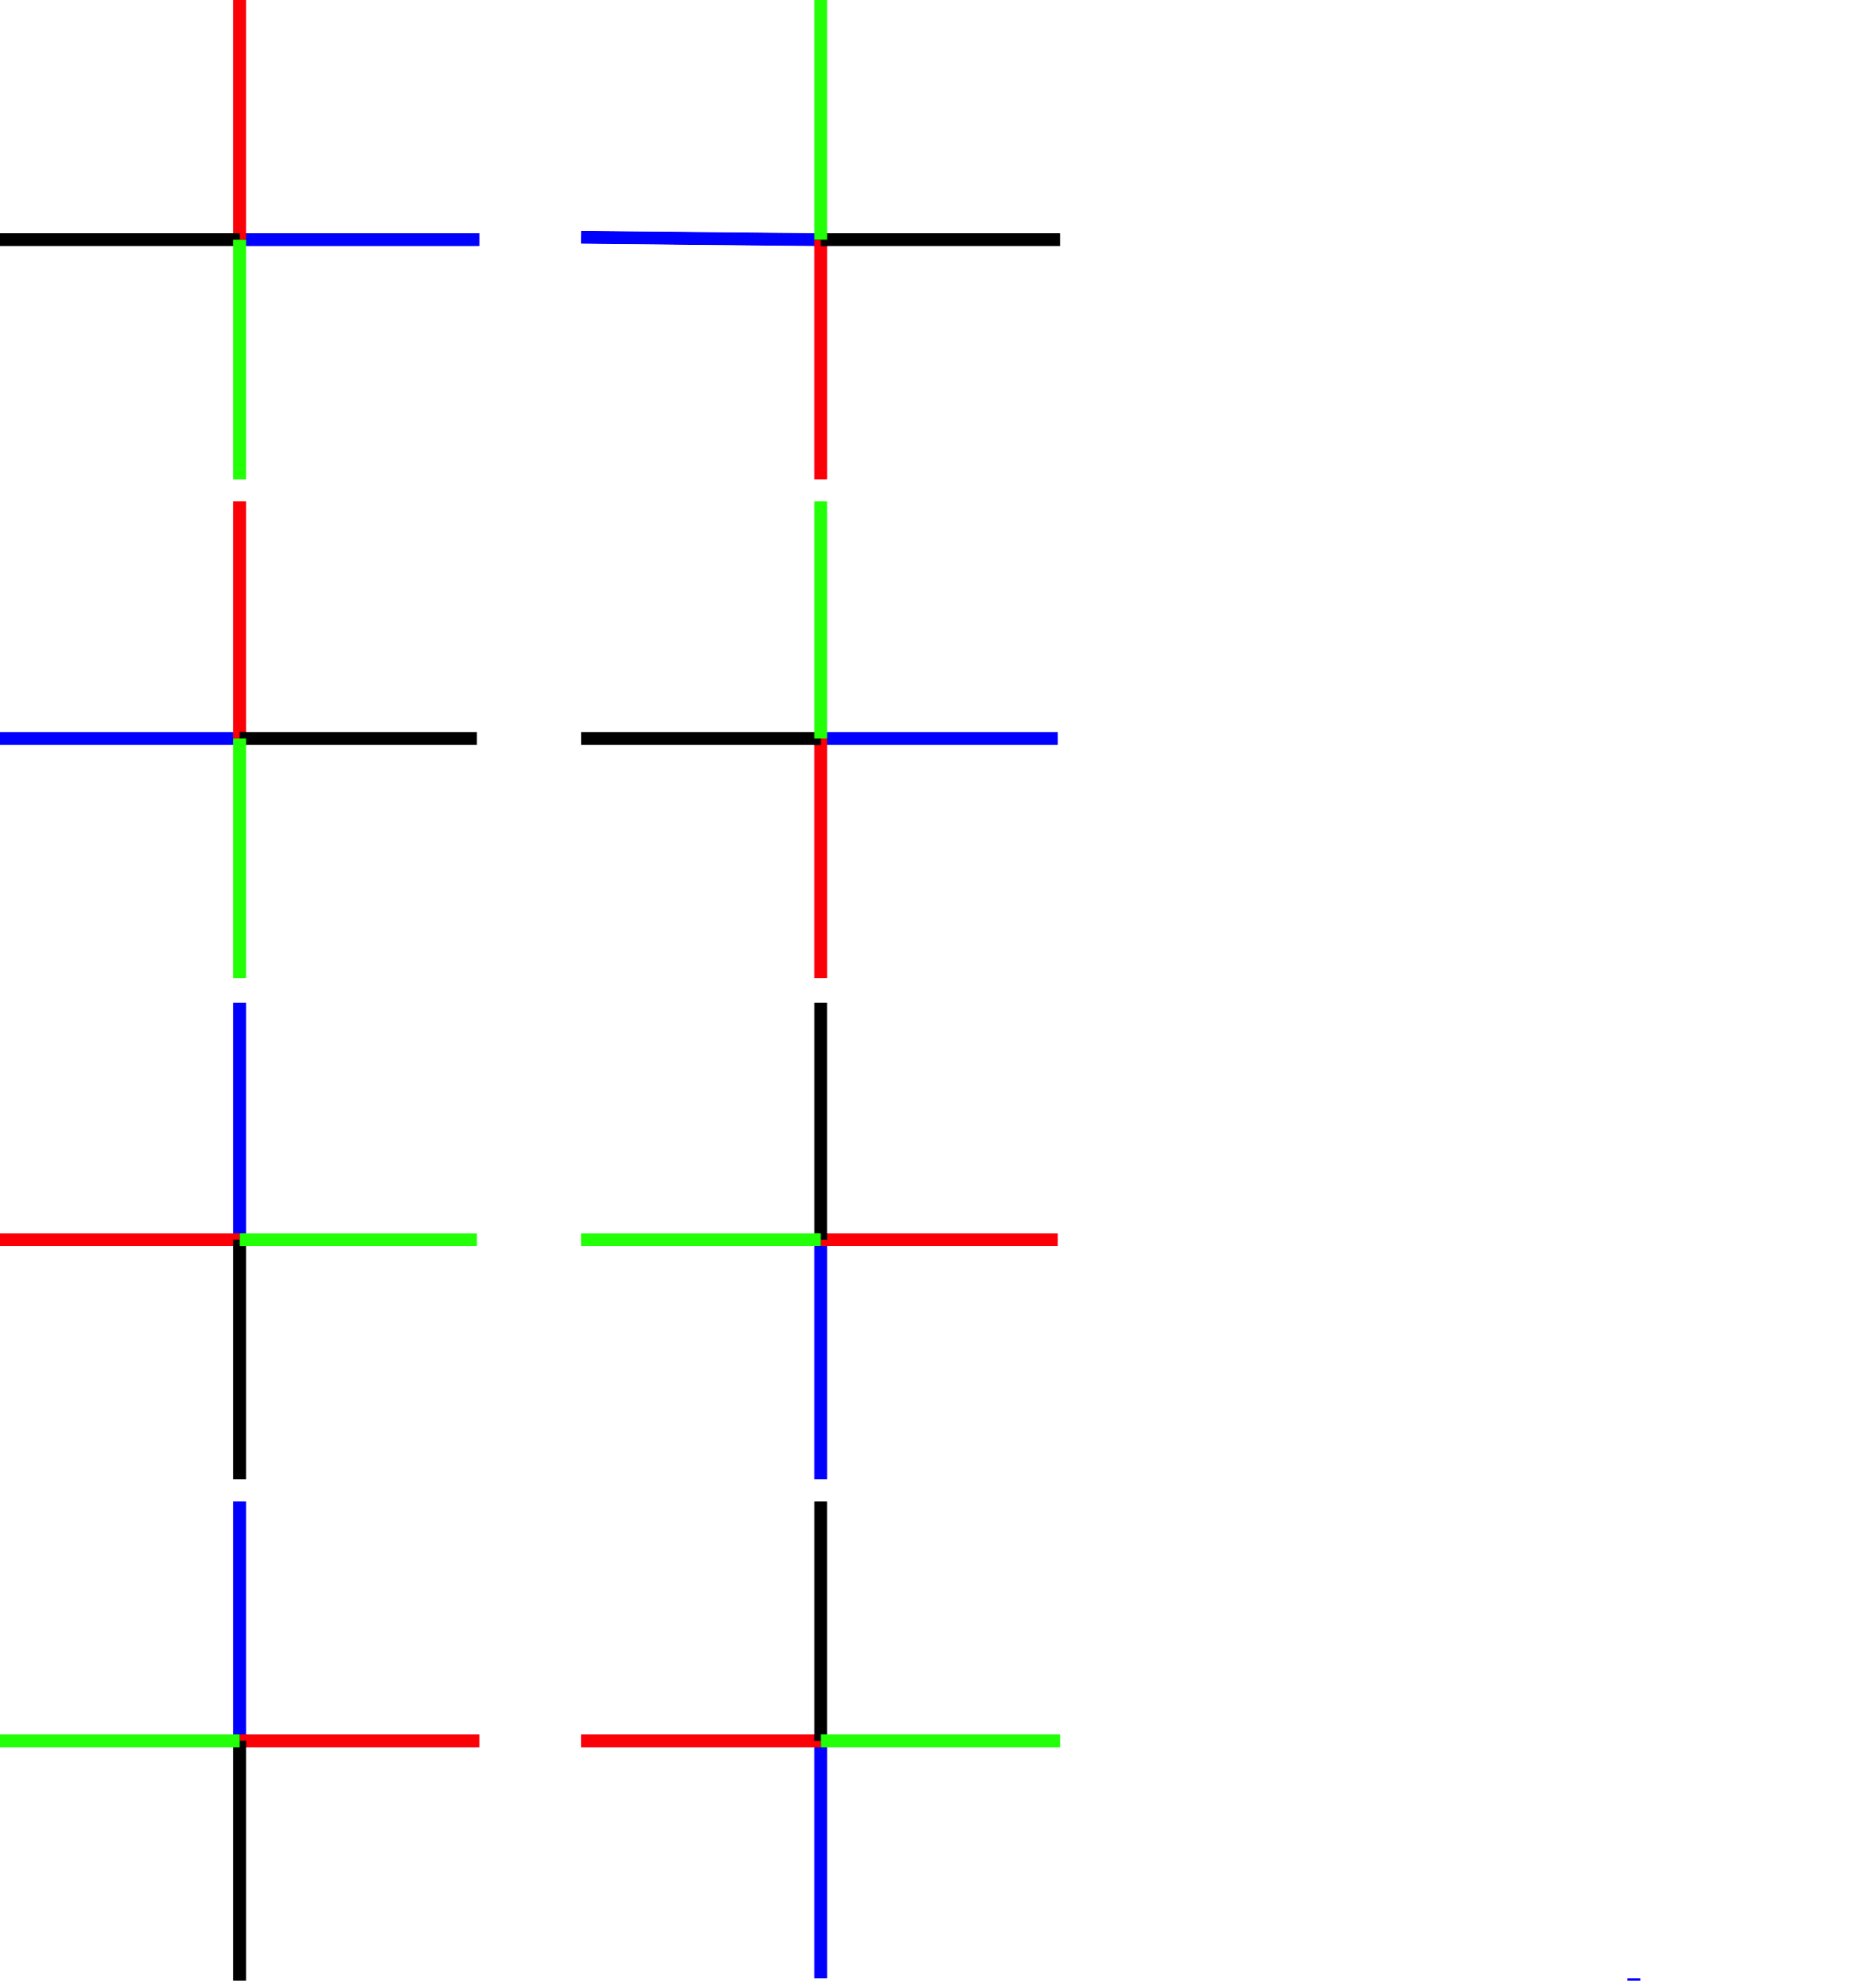
MAT_crosses

MAT_triads

