Request for additional information to guide script writing for your JoVE submission

In order to facilitate the proper filming of your video, a script writer will prepare both a script and a story board from your protocol prior to filming. For many protocols, steps are straight forward and intuitive, describing actions like mixing solutions, turning on equipment, and so forth. In some instances, however, it is not immediately clear from the protocol itself exactly what the best way would be to represent the action / step in the video. This is especially true for steps describing less common equipment, theoretical processes, image processing or data analysis, and the use of computer programs or software.

When the script writer begins planning your video the protocol will act as a rough guide for the video voiceover. Please consider your protocol in this context and ensure that there are no long sections of text that would be awkward or not-feasible to be incorporated into a voiceover. Please note at this time, if you have not already done so, that text highlighting can be used to indicate to the JoVE staff what you would like to include in the video. Highlighting is used for longer protocols due to length constraints, but can also be useful for protocols of any length if there are sections of introductory or explanatory information that you would like to include in the written protocol but may not need to be included in the video (may be too bulky / time consuming). If you are using highlighting in this way, please use yellow text background and highlight a maximum of 2.75 pages total (including spaces between steps). Please contact your editor with any questions regarding protocol highlighting.
Generally, there are three types of visuals that can represent a protocol step in your video: (1) Videographer footage (for instance, a lab member performing the action, footage of a process occurring as recorded from videographer’s microscope attachments) ; (2) screen shots that display the action or the result of the action (for instance, if you describe setting parameters in software, screenshots can demonstrate the interface; if you describe utilizing a program to perform a step a screen shot of the code can accompany the step); (3) a schematic or figure can be displayed to represent the step.
As the goal of JoVE is to visualize methods that cannot be represented optimally in written protocols, we try to avoid having videos with too many screen shots or schematic representations of steps. It is best if actions are filmed live when possible. We understand that many aspects of your work may involve software / programing and the best way to present the protocol may be a combination of both live demonstration and static / animated images. Also please note that an action describing computer / software use should be demonstrated via screen shots, not via videographer footage of a lab member at a computer.
In most cases the determination of the shot list for your video happens later in the JoVE process. However, since there are some steps in your protocol that we are a bit unsure of, we ask that you provide some guidance for us at this time as described below. This way if any changes need to be made to the way the protocol is written or presented, to ensure the best version of your video is made, this can be done prior to peer review. We appreciate you taking the time to provide this information for us and please do not hesitate to contact your editor with any clarifications or questions.
Please note: this request only applies to certain steps in your protocol as listed in the editorial comments.
Please fill in the work sheet below, replacing the examples. For each of the steps requested, please designate which of the options would be the optimal representation for visualizing the step (videographer footage, screen shot or figure). If a single step requires two options (for instance part will be filmed in the lab, part will be shown via a screen shot) please separate the step accordingly in the table (not in the protocol). If a figure from the manuscript will be used please refer to it by number and panel letter. If a screen shot will be used, please add the screen shot after the table along with an identifying title. If the screen shot is not currently available a low resolution version or a brief description of it can be used instead. (Screen shots will not be sent to peer review.)
If edits are made to the protocol later in the review process this guide will not need to be updated unless major changes to the protocol are made. Edits to text segments in this guide will not be reflected in the manuscript.
* Please upload this completed work sheet under the file designation “Supplemental files (as requested by JoVE).*
Supplemental information for JoVE scriptwriter
Step # | Text | Visual representation
3.1. | Turn on the power supply to the electronics | Videographer footage of lab member
3.2 | - For mouse skin, set the signal parameters for the acquisition software by typing in 25 ms for collection time, 25 for signal averages and 1 for boxcar filter width. | Screen shot 1  Screen shot 2  Videographer footage of lab member
3.3 | - Using custom programmed acquisition software, automatically acquire a background reading, R_{bg} (LED off) and diffuse reflectance at two source-detector separation distances, R_{meas} (260 μm, 520 μm) by clicking the “Acquire” button. The total acquisition time is ~ 2 s. | Screen shot 3  Videographer footage of lab member
4.3 | Quickly move one mouse onto the sterilized DOS probing area, place it on its side, fasten its snout into the nose cone and open the nose cone tubing to the flow of anaesthesia (2% isoflurane). | Videographer footage of lab member
4.4 | Before acquiring mouse skin measurements, sterilize the probe by wiping with 70% ethanol. | Videographer footage of lab member
4.5 | Place the probe gently on the flank skin making sure to avoid dispersing the local vasculature. The skin is not sterilized and the probe should be held by hand for the duration of the measurement. | Screen shot 4  Videographer footage of lab member
4.6 | Acquire reflectance data by probing a flank skin area of about 2 cm by 2 cm (the area to be irradiated) with the figure 5 dot formation on a die/ perform a 5 point quadrant scan along the mouse flank. | Videographer footage of lab member
4.7 | Move the mouse into a recovery cage, and move the next mouse over to the DOS probing area. | Videographer footage of lab member
5.2 | Remove the mouse from the induction chamber, gently pinch the flank skin and place tape over and below the stretched skin, forming a flap. | Videographer footage of lab member
5.3 | - Place the mouse onto a plexiglass stage and cover the body with a custom lead jig (a working design is a rectangular box with the bottom and at least one end open, along with a side window to allow flank skin to be pulled through). Pull the skin flap through the jig window and gently tape the flap onto the stage. | Videographer footage of lab member
5.4 | - Place the plexiglass stage with the jig and mouse into the irradiator. Determine the settings (skin distance from x-ray source, voltage, duration and amperage) and deliver the desired dose (e.g. 11 cm from a 160 kVp x-ray source for 2.5 min with 6.3 mA). Use CAUTION with the x-ray source by following machine use guidelines to avoid burns and DNA damage. | Videographer footage of lab member
5.5 | Take the apparatus and mouse out of the irradiator, remove the shielding, remove the tape and place it into an individual recovery cage. Return the mouse to its normal shared cage after it has recovered from the anaesthesia. | Videographer footage of lab member

Screen Shots: (Please copy and paste or insert the required screen shots here, in the order they are listed above.)
Screen shot 1:
Screen shot 2:
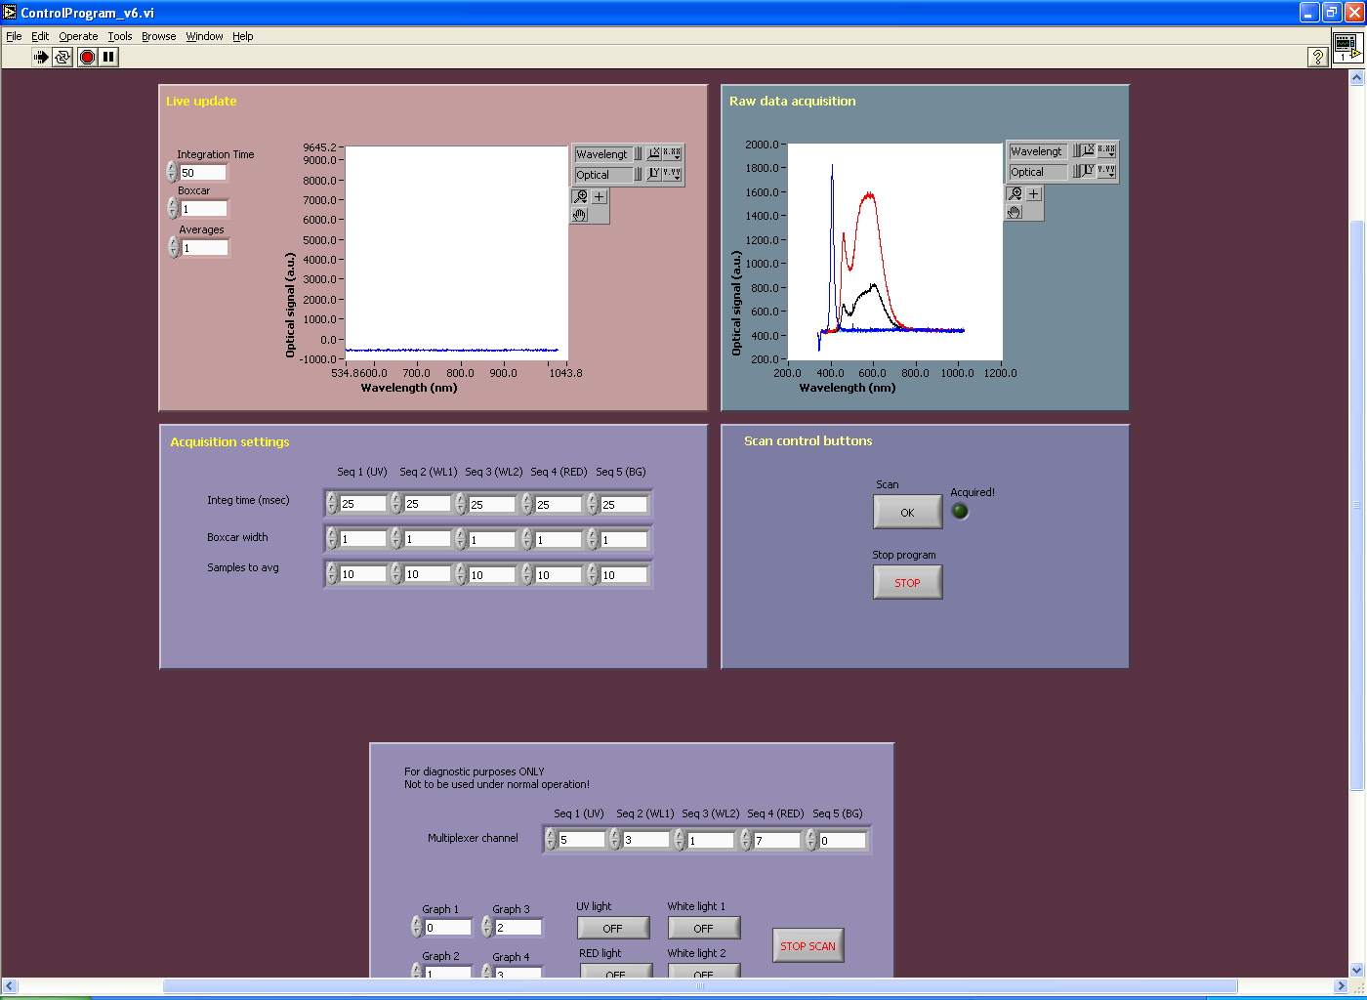

Screen shot 3.
Step 4.5: Screen shot or video footage
