Request for additional information to guide script writing for your JoVE submission

In order to facilitate the proper filming of your video, a script writer will prepare both a script and a story board from your protocol prior to filming. For many protocols, steps are straight forward and intuitive, describing actions like mixing solutions, turning on equipment, and so forth. In some instances, however, it is not immediately clear from the protocol itself exactly what the best way would be to represent the action / step in the video. This is especially true for steps describing less common equipment, theoretical processes, image processing or data analysis, and the use of computer programs or software.

When the script writer begins planning your video the protocol will act as a rough guide for the video voiceover. Please consider your protocol in this context and ensure that there are no long sections of text that would be awkward or not-feasible to be incorporated into a voiceover. Please note at this time, if you have not already done so, that text highlighting can be used to indicate to the JoVE staff what you would like to include in the video. Highlighting is used for longer protocols due to length constraints, but can also be useful for protocols of any length if there are sections of introductory or explanatory information that you would like to include in the written protocol but may not need to be included in the video (may be too bulky / time consuming). If you are using highlighting in this way, please use yellow text background and highlight a maximum of 2.75 pages total (including spaces between steps). Please contact your editor with any questions regarding protocol highlighting.
Generally, there are three types of visuals that can represent a protocol step in your video: (1) Videographer footage (for instance, a lab member performing the action, footage of a process occurring as recorded from videographer’s microscope attachments) ; (2) screen shots that display the action or the result of the action (for instance, if you describe setting parameters in software, screenshots can demonstrate the interface; if you describe utilizing a program to perform a step a screen shot of the code can accompany the step); (3) a schematic or figure can be displayed to represent the step.
As the goal of JoVE is to visualize methods that cannot be represented optimally in written protocols, we try to avoid having videos with too many screen shots or schematic representations of steps. It is best if actions are filmed live when possible. We understand that many aspects of your work may involve software / programing and the best way to present the protocol may be a combination of both live demonstration and static / animated images. Also please note that an action describing computer / software use should be demonstrated via screen shots, not via videographer footage of a lab member at a computer.
In most cases the determination of the shot list for your video happens later in the JoVE process. However, since there are some steps in your protocol that we are a bit unsure of, we ask that you provide some guidance for us at this time as described below. This way if any changes need to be made to the way the protocol is written or presented, to ensure the best version of your video is made, this can be done prior to peer review. We appreciate you taking the time to provide this information for us and please do not hesitate to contact your editor with any clarifications or questions.

Please note: this request only applies to certain steps in your protocol as listed in the editorial comments.
Please fill in the work sheet below, replacing the examples. For each of the steps requested, please designate which of the options would be the optimal representation for visualizing the step (videographer footage, screen shot or figure). If a single step requires two options (for instance part will be filmed in the lab, part will be shown via a screen shot) please separate the step accordingly in the table (not in the protocol). If a figure from the manuscript will be used please refer to it by number and panel letter. If a screen shot will be used, please add the screen shot after the table along with an identifying title. If the screen shot is not currently available a low resolution version or a brief description of it can be used instead. (Screen shots will not be sent to peer review.)
If edits are made to the protocol later in the review process this guide will not need to be updated unless major changes to the protocol are made. Edits to text segments in this guide will not be reflected in the manuscript.
* Please upload this completed work sheet under the file designation “Supplemental files (as requested by JoVE).*

Supplemental information for JoVE scriptwriter
Step # | Text | Visual representation
1.1 | “To create carbon nanoparticles use a horizontal tubular quartz reactor with Ar and CH3 containers attached into the inlet direction as described in 48.(see Figure 2a)” | Videographer footage of a lab member.
1.1.1 | “Heat the reactor to 1000°C at 10°C/min, at the same time flow argon through between 20-40 ml/min. The rates are controlled by the mass flow controllers.” | Videographer footage of a lab member.
1.1.2 | “When the reactor reaches 1000°C, add the bubbled argon at a rate of 240-300ml/min and bubbled toluene at a rate of 90-300ml/min. Allow this run for 60mins.” | Videographer footage of a lab member.
1.1.3 | “Collect the resulting carbon nanoparticles from the wall of the quartz reactor after the furnace has cooled to room temperature using metal tweezers.” | Videographer footage of a lab member.
1.2 | “Next, place the carbon nanoparticles as well as a 1:1 molar ratio of silicon and silica into a 5mm diameter alumina crucible. (See Figure 2b). Let the carbon nanoparticles be close to the gas outlet direction.” | Videographer footage of a lab member.
1.2.1 | “Place the crucible in the resistance heating furnace. Heat the crucible in the temperature range on 1300⁰C as well as inlet Ar at 40ml/min. | Videographer footage of a lab member.
1.3 | “Finally, oxidized the powder at 600 ˚C in air for 2h to eliminate the carbon core using a temperature plate to get the accurate temperature reading.” | Videographer footage of a lab member.
1.5 | “Then put SiC micro/nano-spheres through a PECVD coating process using the PECVD machine. (see Figure 5). Wait for the machine to heat up to about 300°C after initiating start up. Vent the chamber of the air; this may take a few mins. Then load the SiC nano particles on the substrate inside the chamber.” | Videographer footage of a lab member.
2.1.1 | “After fabrication, attach the single/coated micro/nano-sphere to the free end of the micro-cantilever (thickness: 20 μm, length: 200 μm, material: Si3N4), as described below and shown in Figure 6.55” | Videographer footage of a lab member.
2.1.1.1 | “Draw silica fibers from micropipettes using butane fuel laboratory burner.” | Videographer footage of a lab member.
2.1.1.2 | “Position the micro-cantilever under the optical microscope with the non-reflective side facing upward and clamp the glass chip (micro-cantilever protrudes from glass chip) to fixate the cantilever. Then, focus the microscope on the tip (free end) of the micro-cantilever. (See Figure 6a).” | Videographer footage of a lab member.
2.1.1.3 | “Touch the tip of the micro-cantilever carefully with the fiber with thermal epoxy coating to deposit glue onto the cantilever. | Videographer footage of a lab member.
2.1.1.4 | “Pick a micro/nano-sphere with another clean fiber. | Videographer footage of a lab member.
2.1.1.5 | “Transfer the sphere, which is attached to the clean fiber, onto the tip of the micro-cantilever where the thermal epoxy is applied. (See Figure 6d).” | Videographer footage of a lab member.
2.1.1.6 | “Once the micro/nano-sphere is attached to the micro-cantilever, transfer the micro-cantilever to a hot plate with a temperature 65 ˚C to cure for 10 minutes, so that the sphere is bound rigidly to the tip of the micro-cantilever.” | Videographer footage of a lab member.
2.1.2 | “Depending on the required sample temperature, either mount the cantilever with attached sphere in an emission adapter (T<400 ˚C) or a high temperature cell (T<800 ˚C).” | Videographer footage of a lab member.
2.1.3 | “For self-made black body reference samples, heat the surface of a roughened metal sheet evenly with the butane fuel laboratory burner for 1 minute, so that a sufficiently thick soot layer appears on the surface.” | Videographer footage of a lab member.
2.2.1 | “Connect the external platform with the blackbody cavity source to the FTIR spectrometer.” | Videographer footage of a lab member.
2.2.2 | “Connect either the emission adapter or the high temperature cell to the second source position.” | Videographer footage of a lab member.
2.3.1 | “Switch FTIR spectrometer on and wait at least 10 minutes for the electronics and the source to stabilize thermally. Check the HUMIDITY, LASER, and STATUS LED lights on FTIR spectrometer (see Figure 8).” | Videographer footage of a lab member.
2.3.2 | “If needed, purge the spectrometer with dry air or nitrogen gas (indicated by a red HUMIDITY LED).” | Videographer footage of a lab member.
2.4 | “Conduction of Measurements”,” The red line represents radiation of the blackbody source. The blue line represents radiation of the nano-sphere.” | Animation 1: Animation of the radiation paths of the blackbody source and the sample, titled “Setup and radiation path of FTIR measurement”
2.4.1 | “Click on “Measuring Menu”, so that main menu for the conduction of measurements opens”, “Click on “Start Measurement”. Observe the “Measuring Status Menu” opens.” | Screenshot 1: Screenshot of measurement menu titled, “Measurement menu of FTIR server” (provided below)
2.4.4 | “Set the automated mirror in position for measuring the reference blackbody radiation, to run reference blackbody radiation measurement with the blackbody cavity source.” | Figure 10: Figure of the radiation paths of the blackbody source, titled “Blackbody radiation measurement” (provided below)
2.4.5 | “Click on “Start Measurement”. Observe the “Measuring Status Menu” opens. If the measurement is conducted, click on the “file name” to download the file.” | Screenshot 2: Screenshot of measurement status and how to download the file with the measurement data from FTIR server titled, “Measurement status and file download” (provided below)
2.4.6 | Replace the micro-cantilever by a micro-cantilever with an attached micro/nano-sphere to measure the sample radiation. Run the sample radiation measurement with the micro/nano-sphere in 2nd source position (see Figure 12). | Figure 12: Figure of the radiation paths of the sample source, titled “Micro/nano-sphere radiation measurement” (provided below)
2.4.9 | “Click on “File” and then on “Load File” load the downloaded files with the measured data to the software” | Screenshot 3: Screenshot of FTIR software main screen and how to load the downloaded file with the measurement data titled, “FTIR software main screen” (provided below)
2.4.9 | Observe the measured spectra. Subtract the spectral emissivity data of the cantilever from the total spectral emissivity measurement of the cantilever with attached micro/nano-sphere (noise-correction). An arbitrary spectrum is shown in Figure 14. | Screenshot 4: Screenshot of arbitrary example spectrum loaded in the FTIR software titled, “Example spectrum” (provided below)

Animated Figures:

Figure 10 – Blackbody radiation measurement
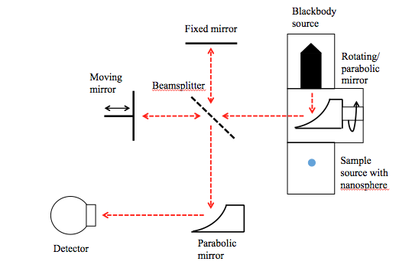

Figure 12 – Micro/nano-sphere radiation measurement
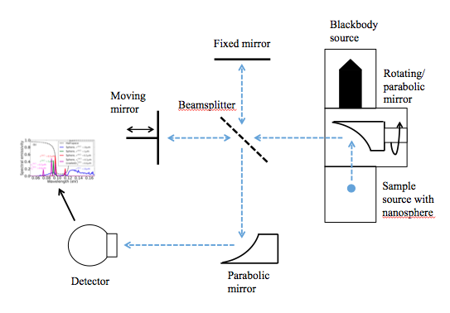

Screen Shots:

Example Screenshot 1 – Measurement menu of FTIR server
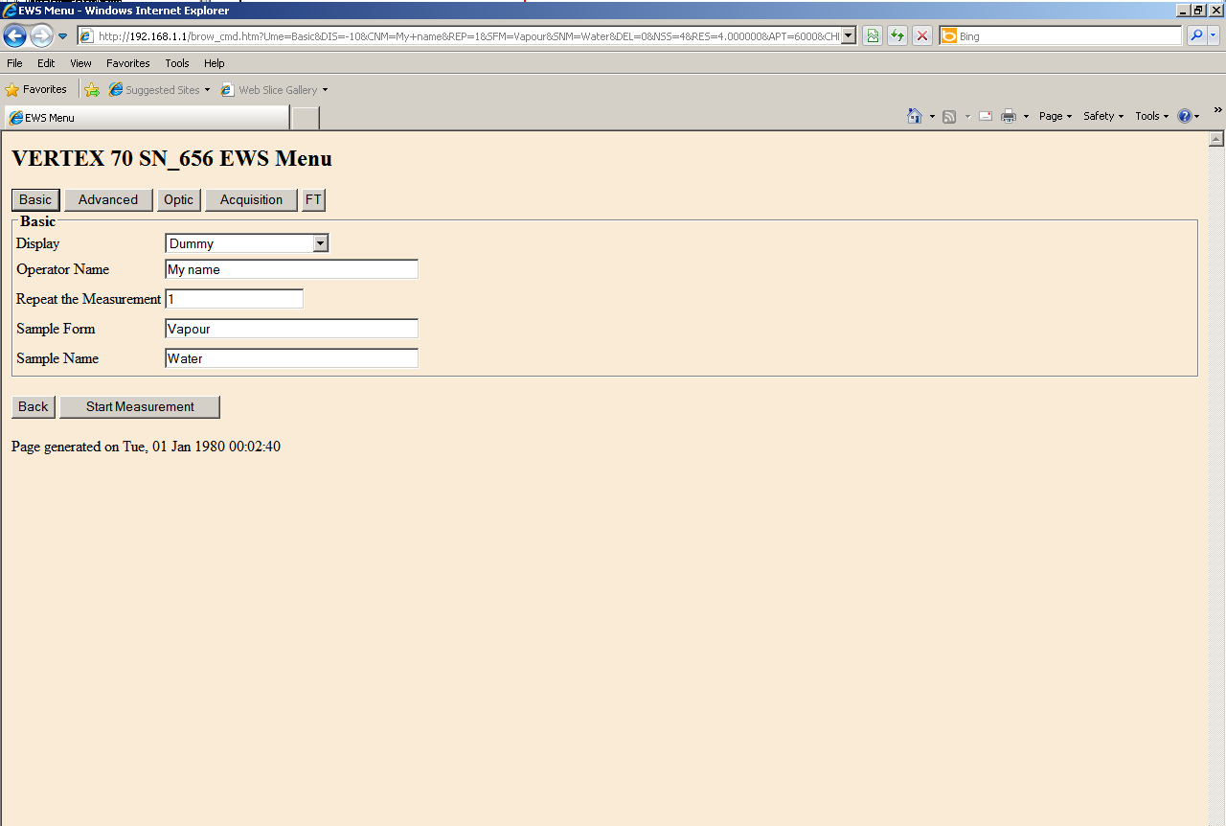

Example Screenshot 2 – Measurement status and file download
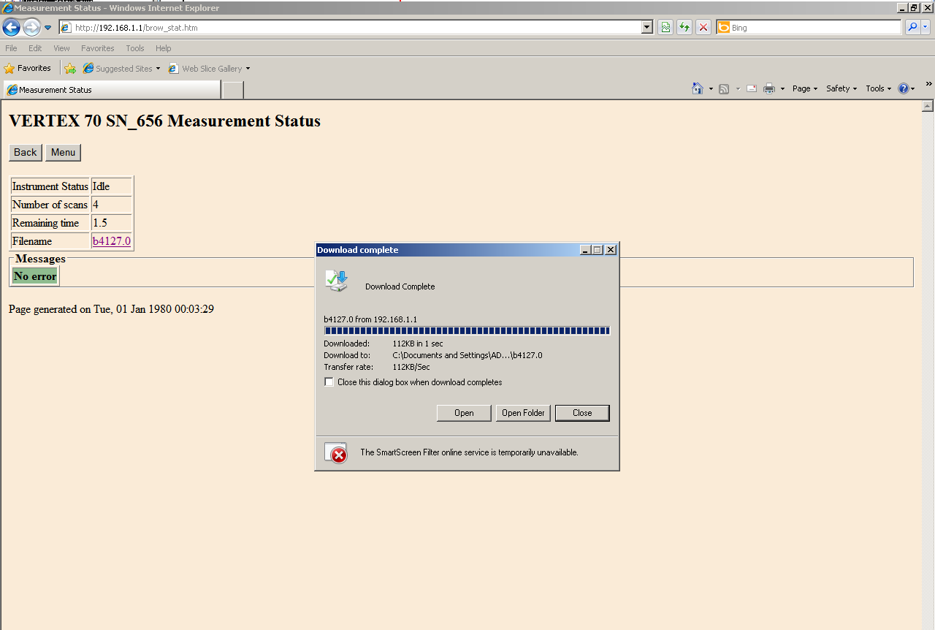

Example Screenshot 3 – FTIR software main screen and load file
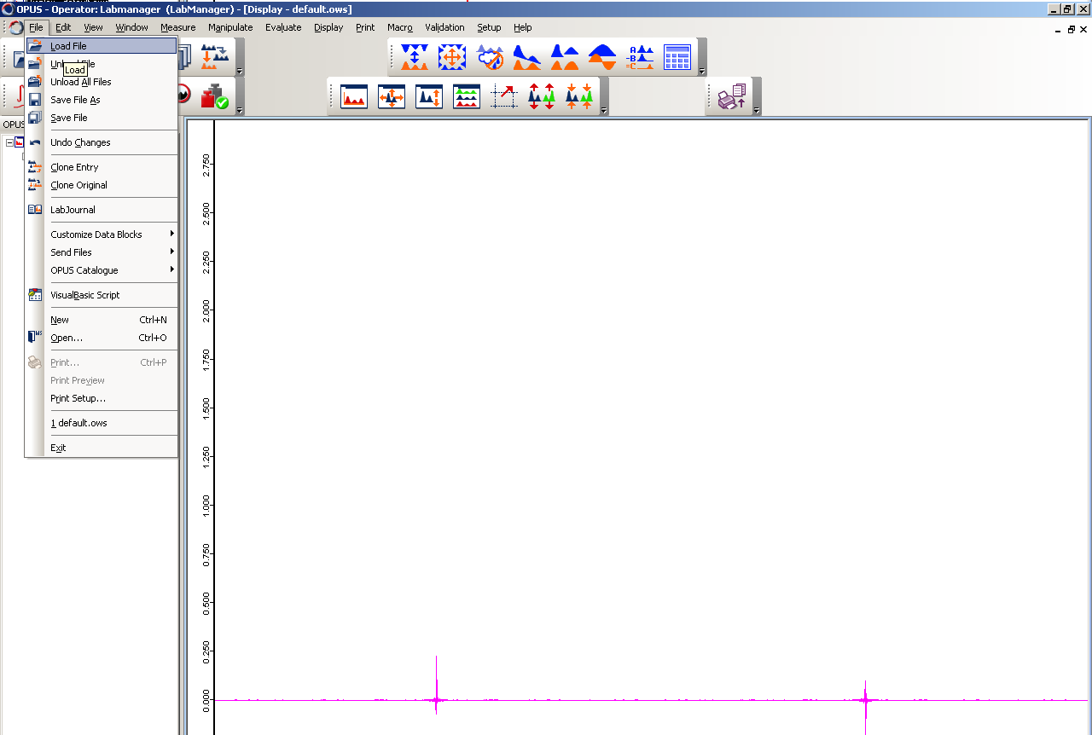

Example Screenshot 4 – Example spectrum
