From
Sajikumar Sreedharan. Ph.D 13 April 2015
Assistant Professor Singapore
Department of Physiology
Centre for Life Sciences (CeLS)
28 Medical Drive
National University of Singapore
Singapore 117456
Tel: (65)65165886 Fax: (65)67773271
E.mail: phssks@nus.edu.sg
Web: http://medicine.nus.edu.sg/phys/lab/Saji_Lab/index.html

To
The Editor
JoVE

Dear Editor
Thank you very much for the helpful suggestions on our video manuscript entitled “Investigation of synaptic tagging/capture and cross-capture using acute hippocampal slices from rodents” (JoVE53008R3).
We have now carefully revised the manuscript based on both the editorial and reviewers’ suggestions. The point by point responses to reviewers are included as separate file and the changes in the manuscript are highlighted in green. The text for video script is highlighted in yellow. We thank the editors and reviewers for the insightful comments on our manuscript that substantially increased the quality and we hope our manuscript is now suitable for publication in JoVE.
Response to Editorial comments:
1. The length is >2.75 (~3.5) pages highlighted and must be reduced to fit within filming limits.
Response: Done
2. Replace Anesthetize with "Euthanize" in step 3.1.4

Response: Done
3. What level of ACSF is ideal in 3.3.5?
Response: we have now rephrased the sentence to make it clear.

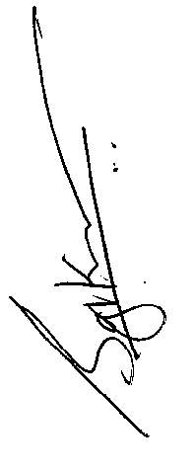
Thanking you
Sincerely

Dr. Sreedharan Sajikumar

