6th July 2015

Immunology and Infection Editor
JoVE
One Alewife Center
Cambridge, MA 02140

Dear Dr. Zaman,
JoVE 53269R3: Revision 3

Please accept our revised manuscript titled, “Modeling Asthma and Influenza Co-morbidity in C57BL/6 Mice” for consideration for publication in JoVE. We have revised the manuscript based on the editorial comments and those of the two Reviewers. We thank you and the Reviewers for taking the time to help us improve the quality of our paper. All comments have been addressed in the manuscript (track changes) and Rebuttal Letter.
Thank you for your interest in our work and please let me know if you should need additional information to help with your decision.

Sincerely,
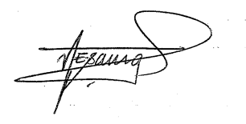
Amali E. Samarasinghe
Assistant Professor
Division of Infectious Diseases

