PI Name: Sten Vollebregt
Corresponding Video Article Title: Fabrication of low temperature carbon nanotube vertical interconnects compatible with semiconductor technology
Chemistry Education Title: Raman micro-spectroscopy of solid-state materials
Overview:
Raman spectroscopy is a technique for analyzing vibrational and other low frequency modes in a system. In chemistry it is used to identify molecules by their Raman fingerprint. In solid-state physics it is used to characterize materials, and more specifically to investigate their crystal structure or crystallinity. Compared to other techniques for investigating the crystal structure (e.g. transmission electron microscope and x-ray diffraction) Raman micro-spectroscopy is non-destructive, generally requires no sample preparation, and can be performed on small sample volumes.
For performing Raman spectroscopy a monochromatic laser is shone on a sample. If required the sample can be coated by a transparent layer which is not Raman active (e.g. SiO₂) or placed in DI water. The electromagnetic radiation (typically in the near infrared, visible, or near ultraviolet range) emitted from the sample is collected, the laser wavelength is filtered out (e.g. by a notch or bandpass filter), and the resulting light is send through a monochromator (e.g. a grating) to a CCD detector. Using this, the inelastic scattered light, originating from Raman scattering, can be captured and used to construct the Raman spectrum of the sample.
In the case of Raman micro-spectroscopy the light passes through a microscope before reaching the sample, allowing it to be focused on an area as small as 1 um². This allows accurate mapping of a sample, or confocal microscopy in order to investigate stacks of layers. Care has to be taken, however, that the small and intense laser spot does not damage the sample.
In this video we will briefly explain the procedure for obtaining a Raman spectra, and an example of a Raman spectrum captured from carbon nanotubes will be given.
Principles:
Raman spectroscopy depends on Raman scattering, which is the inelastic scattering of a photon with low frequency modes (e.g. vibrational or rotational modes) in a system of atoms or within molecules. This is in contrast to IR spectroscopy, which depends on the absorption of IR light by low frequency modes in a system. Both techniques provide similar, but complementary, information. However, this does not mean that vibrational features are both Raman and IR ‘active’, that is, they appear when probed. For molecules a vibration is Raman active when it causes a change in polarizability, while for IR spectroscopy a vibration is visible when it causes a change in dipole moment. This means that for Raman spectroscopy no permanent dipole moment is required. For molecules with a center of symmetry both spectroscopic methods are mutual exclusive. Polar bonds generally give a weak Raman signal, while neutral bonds generally are Raman intense as they involve a large change in polarizability during vibrations. Finally, two draw-backs of IR spectroscopy are that water cannot be used as solvent and sample preparation is more complex. A Raman spectroscope is, however, more expensive.
The emitted photon after scattering has a lower or higher frequency than the incident photon, which is called Stokes and anti-Stokes scattering, respectively. The Stokes and anti-Stokes lines have the same shift in energy, but their magnitude differs depending on for instance the substrate temperature. For molecules the photons interact with the bonds and vibrations in a molecule which are sensitive to the used laser wavelength. This causes the molecule to be exited into a virtual energy state for a short time, after which it inelastically emits a photon. In case of solid-state materials the incoming photon creates and electron-hole pair, which can scatter with a phonon in the crystal lattice. A phonon is a quasiparticle, which describes a collective quantized vibrational motion in a lattice of atoms or molecules in condensed matter. After this scattering event the electron-hole pairs decays and emits a photon with a shifted frequency.
The spectrum of these scattered photons is the Raman spectrum, which shows the intensity of the scattered photons versus the frequency difference (measured in wavenumbers with units cm⁻¹) to the incident photons. Peaks only appear in the Raman spectrum if vibrational modes in the system are sensitive to the laser wavelength used, and their intensity and location can differ between laser wavelengths. Typically, the peaks fall within a range of 500-2000 cm⁻¹, and higher order peaks can be found around multiples of the wavenumber of the first-order Raman peak. The intensity of the peaks depends on many factors, including the power of the laser, focus, acquisition time and the probability of the scattering to occur. Thus, intensities between spectra cannot be compared directly, and should always be converted into intensity ratio’s. The full-width at half maximum (FWHM) of a peak can directly be compared between different measurements.

Procedure:
- Turn on the required laser and select the correct optics for the wavelength used. Let the laser warm up to get a stable emission over time.

- Perform the required calibration of the Raman spectroscope. This depends on the instrument, but here an internal Si reference sample is used to calibrate the Raman shift to the known position of the crystalline Si Raman peak. Si is often used as it gives a strong sharp peak at a known position which is insensitive to the laser wavelength. First, the Raman spectrum of the reference sample is obtained using an appropriate exposure energy and time. The wavenumber of obtained spectrum is compared to values from the literature (in the case for Si a strong peak at 520.7±0.5 cm⁻¹ should be observed). In case of a mismatch, the position of the CCD with respect to the monochromator (often a grating) has to be changed. Most commercially available Raman tools include calibration routines to achieve this.

- Place the sample underneath the microscope and focus on the layer which has to be investigated. In general, a close-able dark enclosure is used to remove stray light. Make sure the path of the laser is not obstructed by light absorbing or Raman active layers in order to obtain a clean spectrum. In the literature Raman spectra can be found taken from many materials, which can be used to determine which materials might influence the experiment. If unknown peaks appear beside the peaks known to originate from the sample, they can either by cosmic rays (which are generally only a few wavenumbers wide and very intense), or other layers interfering with the measurement. If the layer is thin compared to the attenuation length of the laser in the material, it is likely that the substrate underneath will also be probed.

- Select the range of wavenumbers which should be scanned by the monochromator. This is highly sample dependent. Generally in the literature the regions at which the interested Raman peaks will appear can be found. For completely unknown samples a wide range (e.g. 100-2000 cm⁻¹) test scan can be performed. Extended scans will consume more time, though. Select a laser intensity which produces sufficient signal, but which doesn’t damage the crystal lattice of the material under investigation (e.g. if amorphous Si is investigated a high intensity laser can crystallize the sample). This can be checked by imaging the same spot twice, if the spectrum changes damage might have occurred. If the signal is too weak the exposure time can be increased.

- Acquire the spectrum of the sample. This is generally done automatically by the instrument while scanning the monochromator and reading the CCD output. No background scans have to be performed if the sample is in a completely dark enclosure, otherwise stray light will influence the measurement.

- Investigate the data using appropriate software and by using the literature. This can include the removal of cosmic rays, which appear as very sharp and intense lines in the spectrum and can generally be completely removed.. Interference with the substrate or contaminants can result in a baseline, which can be removed by fitting a appropriate curve (e.g. linear line or spline) to the regions of the spectrum which are expected to be flat (i.e. do not contain Raman peaks originating from the sample). For some materials the different Raman peaks can appear so close to each-other that peak deconvolution might be necessary, for this check the literature on the material under investigation.

Representative Results:
The Raman spectrum taken from multi-walled carbon nanotubes using a 514 nm laser is shown here. The linear baseline has been removed and the data has been normalized to the most intense feature around 1582 cm⁻¹.
Several peaks can be observed, which originate from different crystalline features of the sample. The D-peak at 1350 cm⁻¹ originates form double resonance elastic phonon scattering with a defect in the crystal lattice. The G-peak (1582 cm⁻¹) is related to the sp² hybridized C-C bond and can be found in any graphitic material. This strong peak actually has a shoulder on the right side of the spectrum, which is the D’ peak around 1620 cm⁻¹. This peak is again defect related.
At higher wavenumbers several other peaks can be observed. The G’ (or 2D) peak around 2700 cm⁻¹ is the overtone of the D band, and is caused by two inelastic phonon scattering processes. Because of this it does not need defects and can be found in high crystalline samples. The same is true for the 2D’ band around 3240 cm⁻¹, which is the overtone of the D’ band. Finally the D+G around 2930 cm⁻¹ is the combined overtone of the D and G band.
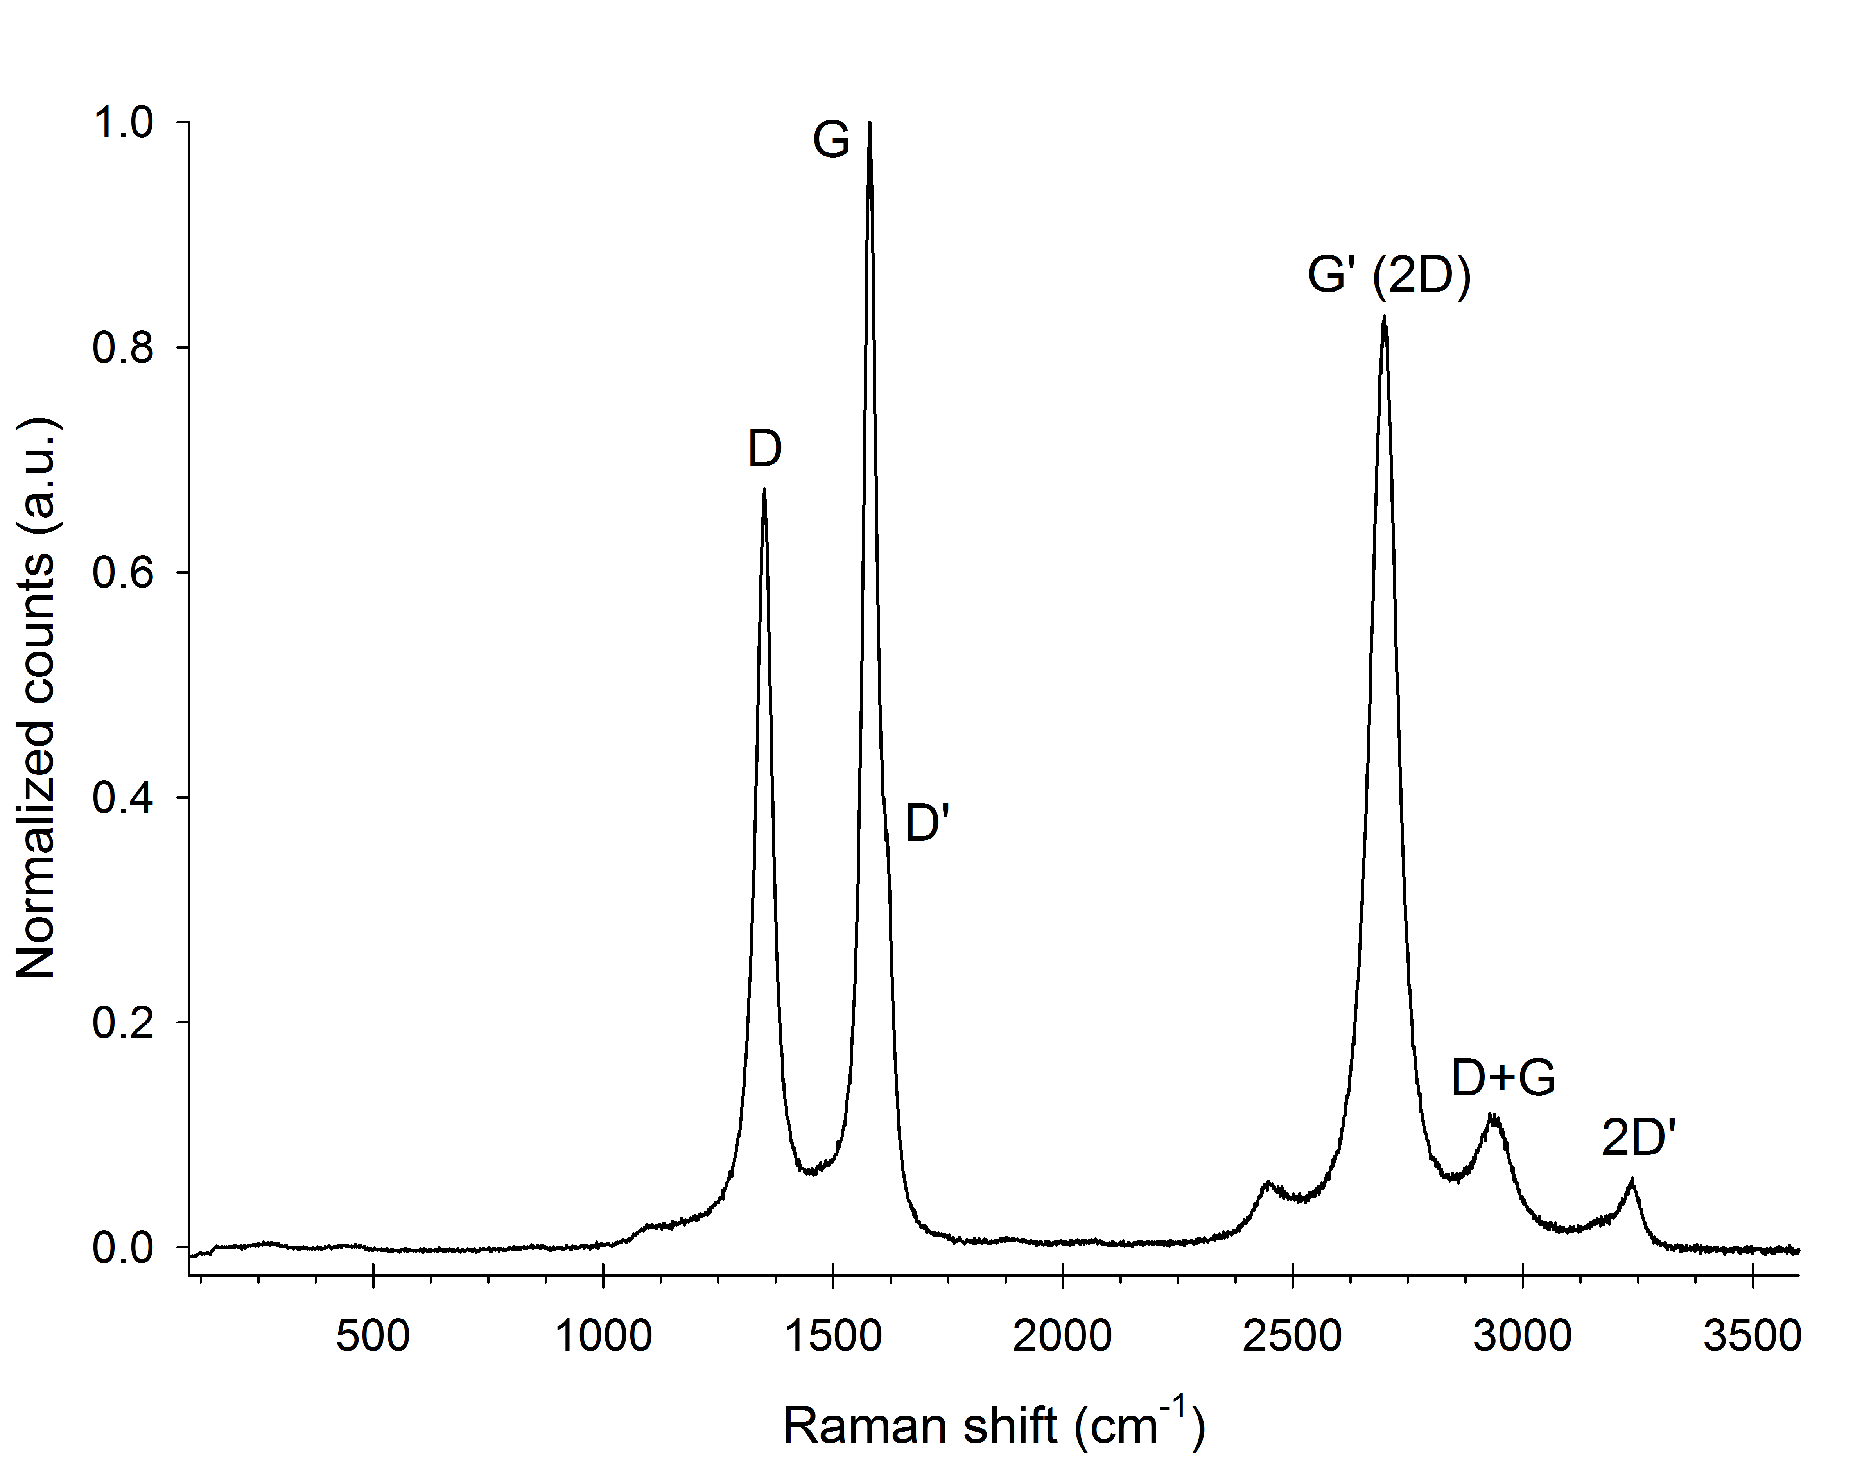
Figure 1. Raman spectrum of multi-walled carbon nanotubes. The spectrum was obtained using an 514 nm laser, the linear baseline was removed by fitting to the flat areas of the spectrum and the spectrum is normalized to the G-peak.

Applications:
Raman spectroscopy can be applied in a wide range of fields, ranging from (bio)chemistry to solid-state physics. In chemistry Raman spectroscopy can be used to investigate changes in chemical bonds and identify specific (organic or inorganic) molecules by using their Raman fingerprint. This can be done in either the gas, liquid or solid-state phase of the material. It has been for instance used in medicine to investigate the active components of drugs, and Raman gas analyzers are used for real-time monitoring of respiratory gases during surgery.
In solid-state physics Raman spectroscopy is used to characterize materials and determine their crystal orientation, composition, stress, temperature, and crystallinity. It has been used to identify mineral compositions, and can be used in forensic trace evidence analyses. It is also possible to observe plasmons, and other low frequency excitations of the solid using Raman spectroscopy. Specifically for graphitic materials it has been used to investigate the crystallinity, the diameter of single and double-walled nanotubes and their chirality. For graphene it can also be used to identify the number of graphene layers.
A big advantage of Raman spectroscopy over other spectroscopic methods is that it typically requires no sample preparation if you can focus on the sample with a microscope, can analyze µm-size samples, requires no contact, and is non-destructive.

