Submission ID #: 53257

Editor Name: Michael Linnes

Videographer name: Kai-Jae Wang

Film Date: 5-21-15

Authors and Affiliations: Hatzipetros Theo, Kidd Joshua D, Moreno Andy J, Thompson Kenneth, Gill Alan and Vieira Fernando G

ALS Therapy Development Institute, Cambridge, Massachusetts, USA

Title: A Quick Phenotypic Neurological Scoring System for Evaluating Disease Progression in the SOD1-G93A Mouse Model of ALS

Corresponding Author:
Hatzipetros, Theo, Ph.D.
ALS Therapy Development Institute,
Cambridge, Massachusetts, USA
thatzipetros@als.net
(617) 441-7260

Co-authors:
fvieira@als.net

A. Will you require JoVE to record video microscopy, such as filming a complex dissection or microinjection technique? (Y/N)_____N___ (If you can record images/videos using your own camera/software, then mark No) If yes, please list make and model of your microscope: _____________________________________________
B. Does your protocol include detailed, step-by-step, descriptions of software usage? (Y/N)_____N__ If yes, we will need you to record using screen recording software to capture the steps. If you use a Mac, QuickTime X also has the ability to record the steps.
C. Which steps of your protocol will viewers benefit most from having filmed? Please list 4-6 steps using the step numbers listed in this document. ______________4__________________________
D. What is the single most difficult aspect of this procedure and what do you do to ensure success? Please list the steps using the step numbers listed in this document. The most difficult aspect of the procedure is delineating scores at phenotypic transition points between NS 1 & NS 2 and NS 2 & NS 3. The steps are encompassed under Items 4.3-4.9.
E. Will the filming need to take place in multiple locations? (Y/N) ____Y__ If yes, how far apart are the locations? One location in the animal facility and one outside. The locations are both on the same floor in our building.
1. Introduction (Schematic Overview and Interview)

A. Schematic Overview (read by voice talent at JoVE):

Procedural Narrative:
The overall goal of this procedure is to quickly and reliably evaluate the neuromuscular function of SOD1-G93A (pronounced: sawed-one G-ninety-three-a) mice, by daily assessment of their hindlimb function using a simple phenotypic neurological scoring system. (Intro)

This is accomplished by first observing the hindlimbs of the mice while suspending them by the tail. (P1)

The second step is to allow the mice to walk while observing their gait. (P2)

Next, the mice are placed on their sides to test for the presence or absence of the “righting reflex”. (P3)

The final step is to perform the data analysis by fitting neurological score data of mouse cohorts into an ordinal logistic regression model. (P4)

Ultimately, our phenotypic neurological scoring system is used to assess disease progression in the SOD1-G93A mouse model of ALS for the purpose of discerning the efficacy of therapeutic interventions. (P5)

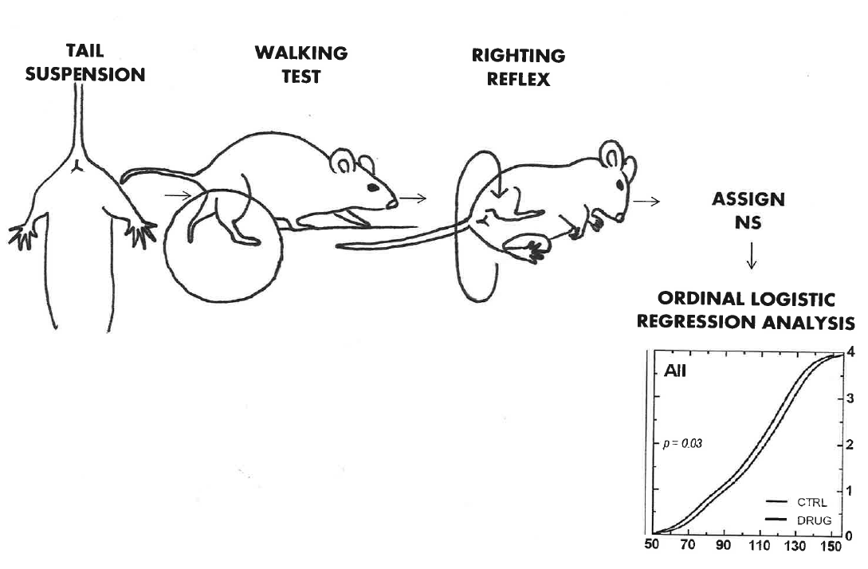
B. Interview: (Said by you on camera. Don’t forget to smile!)
  - Joshua Kidd: The main advantage of this method over all other existing techniques, is that it is quick, simple, reliable and minimally stressful for the mice.
  - Andy Moreno: The implications of this method extend toward therapy of amyotrophic lateral sclerosis, or ALS, because it allows for the quick assessment of therapeutic interventions in the most common mouse model of the disease.
  - Joshua Kidd: Visual demonstration of this method is critical as the neurological scoring method is difficult to learn, because the neurological differences can be subtle.

Protocol (read by voice talent at JoVE):

- Mouse Housing and Weighing

2.0. *IACUC Card
  - Begin by housing male SOD1-G93A mice so that there is one mouse per cage. House female SOD1-G93A mice up to two per cage. [2.1.1 - MED] Provide environmental enrichment for the mice in the form of plastic huts. [2.1.2 - CU]
    - Talent with 2 cages in front of them adds 1 male mouse to the left cage and 2 female mice to the right cage.
    - Talent places plastic huts into each cage.
  - Provide the mice with food and water ad libitum. (pronounce: ad LI-bit-um) [2.2.1 - MED]
    - Talent places the top on the cage housing the food and puts the water bottle in place.
  - Record body weights for all mice in studies at the same time daily. Body weight is a sensitive indicator of disease progression and of any malaise that might result from chronic drug treatment. [2.3.1 - MED]
    - Talent places mouse on scale, writes down its weight, then returns it to its cage and begins to weigh a 2nd mouse.
- Neurological Test Descriptions
  - Andy Moreno: “During the study, assess the neurological scores for each mouse daily through a regimen of 3 tests that are performed sequentially. Watch carefully as delineating scores at phenotypic transition points is very difficult.” [3.1.1 - INT]
    - Interview style: Author saying the above
  - In the first test, the tail suspension test, hold the mouse approximately 1.5 inches from the base of the tail over the wire top of the home cage. [3.2.1 - MED] Observe the function of the hind limbs for a period of 1 to 2 seconds and repeat the test 3 times. [3.2.2 - CU] Set the mouse down briefly in-between each repetition. [3.2.3 - CU]
    - *Film as written
    - Close up of mouse as it is dangling.
    - *Film as written
  - For the walking test, place the mouse on a clean surface that provides some traction and has a walking distance of at least 25 cm. [3.3.1 - CU] Allow the mouse to walk up to 75 cm while observing its gait. [3.3.2 - CU]
    - *Film as written
    - *Film as written
  - For the righting reflex test, place the mouse on its side and use a stop-watch to measure the time it takes to right itself unassisted, from both sides. Only one trial of this test is required. [3.2.1 - CU]
    - *Film as written
- Neurological Scoring System
After each scoring procedure below, can we please flash the appropriate neurological score on the screen.
  - Score each hindlimb, left or right, independently [4.1.1 - CU] on a scale from 0 to 4 based on the collective outcome of the three phenotypic observation tests. [4.1.2 - Med Over the Shoulder]
    - Mouse performing walking test. talent writing down score for left and right hindlimb
    - Talent writing down the result of the test.
  - Assign a score of 0, indicating the mouse is pre-symptomatic, when during the suspension test, the hindlimbs are fully extended away from the lateral midline and stay in this position for 2 seconds or longer. [4.2.1 - CU] Also, during the walking test, a normal gait is observed. [4.2.2 - CU]
    - Mouse displaying a score of 0 in the suspension test. Film all 3 trials
    - Mouse walking with normal gait.
  - Assign a score of 1, indicating the appearance of first symptoms, if during the suspension test the hindlimb is either [4.3.1 - MED Over the Shoulder] collapsed towards the lateral midline… [4.3.2- CU] partially collapsed towards the lateral midline…[4.3.3- CU] trembling…[4.3.4- CU] or abnormally splayed in some other fashion…[4.3.5- CU]
    - Talent watching the suspension test take place.
    - Mouse during suspension whose hindlimb is collapsed towards the lateral midline.
    - Mouse during suspension whose hindlimb is partially collapsed toward the lateral midline.
    - Mouse during suspension whose hindlimb is trembling.
    - Mouse during suspension whose hindlimb is abnormally splayed in another way.
  - In addition to the suspension test symptoms just shown, the gait of a mouse that should receive a score of 1 should still appear normal or slightly slower. [4.4.1- CU]
    - Mouse during the walking test that shows symptoms as described in the above statement.
  - Assign a score of 2, indicating the onset of paresis, if during the suspension test the hindlimb is partially or completely collapsed… [4.5.1- CU] and in addition during the walking test, the hindlimbs are used for forward motion, however the toes either curl downwards at least twice during a 75 cm walk …[4.5.2- CU] or any part of the foot drags. [4.5.3- CU]
    - Suspension test showing a mouse whose hindlimb is partially or completely collapsed
    - Mouse during the walking whose toes curl downwards at least twice during a 75 cm walk.
    - Mouse during the walking whose foot drags.
  - To get a score of 2, the mouse must also still be able to right itself after being placed on both of its sides within 10 seconds. [4.6.1 - CU]
    - Mouse with a score of 2 in the previous tests that is still able to right itself.
  - Assign a score of 3, indicating paralysis, if during the suspension test the mouse shows rigid paralysis in the hindlimb…[4.7.1 - CU] or has minimal joint movement. [4.7.2 - CU] The mouse may still show forward motion during the walking test, however, not by using its hindlimbs. [4.7.3 - CU]
    - Mouse showing rigid paralysis in the hindlimb during the suspension test.
    - Mouse showing minimal joint movement during the suspension test.
    - Mouse that shows forward motion in the walking test, but does not use its hindlimbs.
  - In addition, to assign a score of 3, the mouse must still be able to right itself after being placed on both of its sides within 10 seconds. [4.8.1 - CU]
    - Mouse with a score of 3 in the previous tests that is still able to right itself.
  - Finally, assign a score of 4, defining the humane end-point, whenever the mouse shows rigid paralysis during the suspension test… [4.9.1 - CU] shows no forward motion during the walking test using the hindlimbs… [4.9.2 - CU] and is also unable to right itself within 10 seconds after being placed on either side. [4.9.3 - CU]
    - Mouse showing rigid paralysis during suspension test.
    - Mouse with no forward motion using the hindlimbs during the walking test.
    - Mouse that is unable to right itself during the righting reflex test.
- Results: Evaluating Disease Progression
  - Male mice typically have a more aggressive disease progression than female mice, as evidenced by a greater proportion of their lifespan displaying symptoms that can be classified with a neurological score of 1 compared to females. [5.1.1 - LM] As symptoms increase into the range of a neurological score of 2 or 3, the number of days spent at each score is equal in frequency across genders. [5.1.2 - LM]
    - Figure 1 (Video Editor: Highlight the NS1 column and emphasize the Male column when mentioned.
    - Figure 1 (Video Editor: Highlight the NS2 and NS3 columns)
  - Shown here are ordinal logistic statistical analysis graphs generated using the NeuroScore protocol that was just described. These data are from a drug-efficacy pharmacology study in which a cohort of SOD1-G93A mice receiving the test compound TDI173 (pronounced: Tee Dee eye One Seven Three) is compared to a cohort of mice receiving vehicle.
    - Figure 2 (Video Editor: With mention of “test compound TDI173” highlight the blue lines / drug label.)
  - No statistically significant differences were observed when genders were separately analyzed but statistical significance was reached when genders were merged [5.3.1 - LM] Though showing similar trends, Kaplan-Meier analysis of survival was not sensitive enough to reveal significant differences even when genders were merged. [5.3.2 - LM]
    - Figure 2
    - Figure 3

(Video Editor: For 5.2 and 5.3, feel free to use only the “All” graph/plots to illustrate the point if they fit better on the screen.)

- Conclusion (said by authors on camera)
  - Andy Moreno: Once mastered, this scoring system can be applied in less than a minute per mouse if it is properly performed.
  - Joshua Kidd: After watching this video, you should have a good understanding of how to assess the disease progression in the SOD1-G93A mouse model of ALS by using the NeuroScore system.

Provided Media

Authors, Please list all images, movie files, or 3-D rendered animations that can be included in the video per editor’s request. The step in the script/video where these images will be inserted should be specified. For example:

6.2 – 0123_PIname_Figure1.tif - dual color imaging of tumor angiogenesis at 40X
6.2 – 0123_PIname_Figure2.tif - dual color imaging of tumor angiogenesis at 100X

Formats: For static images we prefer .tiff, .eps, Illustrator, Powerpoint or Photoshop files at dimensions of at least 720X480 pixels and 300 dpi. The higher resolution, the better. Likewise any exported movie files should have at minimum these dimensions and be rendered to .mov, .mp4, or .avi files.

Insert your media filenames here.

General Preparation

It’s critical for a smooth and organized shoot that all reagents are accounted for, in advance.

Any overnight or long incubation steps should be recognized and specimens/samples be prepared in advance so that prior steps can be recorded and shooting can continue with pre-prepared specimens/samples.

All tubes/flasks should be pre-labeled neatly before we arrive.

Ex. Luciferase assay done in 96 well plates should be labeled with negative/positive control wells and experimental samples are labeled accordingly.

You will receive more detailed preparation instructions, as well as an introduction to your videographer, closer to your filming date.

