Submission ID #: 53202

Editor Name: Michael Linnes

Videographer name: Kristoffer Hamilton

Film Date: May 26th

Authors and Affiliations: Shahrzad Shirazi Fard, Maria Blixt, and Finn Hallböök

Department of Neuroscience, Uppsala University, Biomedical Center, Uppsala, Sweden

Title: Whole Retinal Explants from Chicken Embryos for Electroporation and Chemical Reagent Treatments

Corresponding Author:
Finn Hallböök
Tel +46 18 471 4944
finn.hallbook@neuro.uu.se

Co-authors:
shahrzad.shirazifard@neuro.uu.se
maria.blixt@neuro.uu.se

A. Will you require JoVE to record video microscopy, such as filming a complex dissection or microinjection technique? (Y/N) Yes (If you can record images/videos using your own camera/software, then mark No) If yes, please list make and model of your microscope: Zeiss Stemi SV11. We do not have a camera.
B. Does your protocol include detailed, step-by-step, descriptions of software usage? (Y/N) No. If yes, we will need you to record using screen recording software to capture the steps. If you use a Mac, QuickTime X also has the ability to record the steps.
C. Which steps of your protocol will viewers benefit most from having filmed? Please list 4-6 steps using the step numbers listed in this document. 3.2, 3.3, 3.4, 4.11, 4.12
D. What is the single most difficult aspect of this procedure and what do you do to ensure success? Please list the steps using the step numbers listed in this document. Steps 3.2-3.4 are the most crucial. Success is ensured by working slowly and with a steady hand.
E. Will the filming need to take place in multiple locations? (Y/N) Yes. If yes, how far apart are the locations? Step 4.16 will take place in our cell culture room located just next to the lab.

1. Introduction (Schematic Overview and Interview)
A. Schematic Overview (read by voice talent at JoVE):

Procedural Narrative:
The overall goal of this procedure is to dissect, experimentally manipulate and culture whole retinal explants from chicken embryos. (Intro)

This is accomplished by first collecting both eyes from a chicken embryo and placing them in a Petri dish. (P1: Use chicken from DAM ID 5156 that matches the one shown in P1. Remove the eye portion of it and place 2 into a petri dish such as DAM ID 3653)

The second step is to remove the scleral anlage and the pigment epithelium, using fine forceps. (P2: Use eye cross section from DAM ID 1749 (left part). Remove the pink and black layers (look at the label to know which to remove) from the eye using a pair of forceps (DAM ID 299) when indicated.)

Next, the whole retinal explant is subjected to electroporation of plasmid DNA with flat circular electrodes. (P3: Place the remaining portion of the eye into a well like the one shown in P3. Add a solution around the eye containing small plasmids (DAM ID 3748) so that the eye is covered. Then, add the paddles to either side of the eye and indicate electricity running between them somehow.)

The final step is to incubate the retinal explant in culture medium in a 24-well plate in an incubator. (P4: Place multiples of the eye into wells of a 24-well plate such as DAM ID 4307 and place the plate in an incubator (DAM ID 2560))

Ultimately, the whole retinal explants are fixed, cryo-sectioned and analyzed by immunofluorescence microscopy to visualize the retinal neurons. (P5: Show Figure 2b-c)

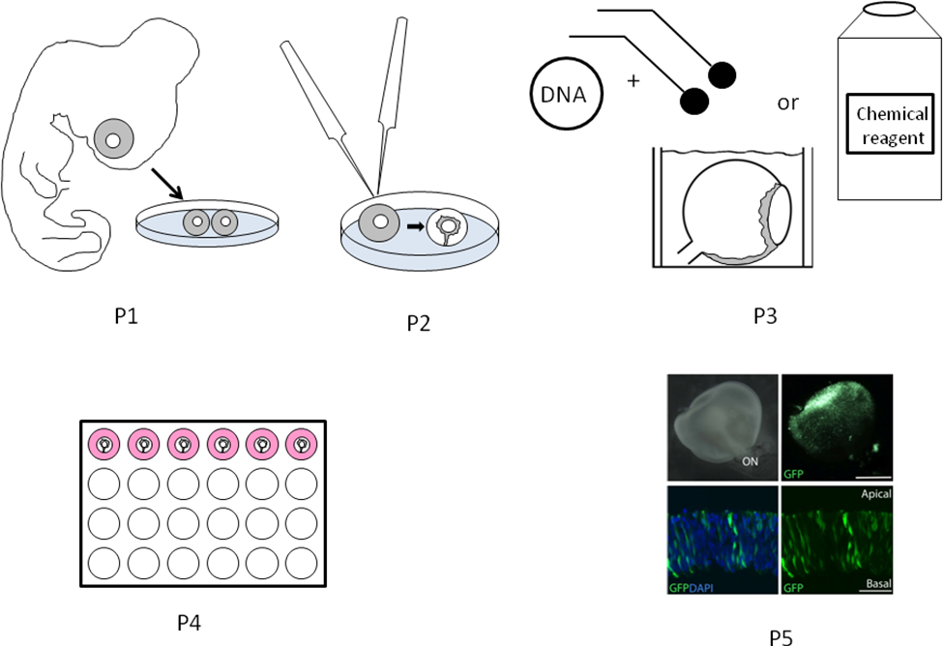

B. Interview: (Said by you on camera. Don’t forget to smile!)

Only one statement should be chosen and completed per author. I have chosen 2 statements since only one author will be speaking, but the limit is typically 1 per author as stated in the script draft instructions.
  - Maria: The main advantage of this technique over existing methods, like in ovo electroporations, is that it is rapid, easy to perform, and ensures reproducible results.
  - Maria: This method can help answer key questions in the field of central nervous system development, such as how neurogenesis is affected by specific chemical reagents like enzyme inhibitors, or gene products that target the cell cycle.

Maria: Though this method can provide insight into retinal development in the chicken, it can also be applied to other species.

Maria: Generally, individuals new to this method may find the removal of the pigment epithelium to be difficult. It demands a steady hand and some practice.

Maria: We first had the idea for this method, when we needed a reliable way of investigating the effect of new chemical reagents, or to investigate reporter gene expression from newly constructed DNA plasmids.

Maria: Visual demonstration of this method is critical as the dissection and electroporation steps are difficult to learn from written instructions.

Protocol (read by voice talent at JoVE):

- Egg Handling and Eye Collection
  - Following incubation, place eggs at the desired embryonic age into the laminar flow hood and wipe the eggshells with 70% ethanol to avoid contamination of the embryo. [2.1.1 - MED]
    - Talent wipes eggshells with 70% ethanol.
  - Tap the side of the egg firmly against a hard surface to crack open the egg and then place the contents into a 100 mm Petri dish. [2.2.1 - CU] Use a small spoon to transfer the embryo to a 35 mm Petri dish containing pre-warmed PBS at 37 °C to prevent the tissue from drying. [2.2.2 - CU]
    - *Film as written
    - *Film as written
  - Next, decapitate the embryo and place the 35 mm Petri dish containing the embryonic tissue onto a binocular stereovision dissecting microscope in the laminar flow hood. [2.3.1 - MED]
    - Talent places petri dish with chicken head under dissecting scope
  - Use fine forceps to make an incision through the mouth, ventral to the eye. Starting at the site of incision, tear open the tissue surrounding the entire eye. [2.4.1 - SCOPE]
    - *Film as written
  - Next, pinch off the optic nerve and remove the intact eye from the eye socket. Collect both the left and right eye from the same embryo for use as either the control or the treated eye. [2.5.1 - SCOPE]
    - *Film as written
  - Use a small spoon to transfer the eyes to a new 35 mm Petri dish containing pre-warmed PBS. [2.6.1 - CU]
    - *Film as written
- Preparation of Whole Retinal Explants
  - Using fine forceps, remove all the tissue around the eye including the scleral anlage. [3.1.1 - SCOPE]
    - *Film as written
  - Next, pinch a small incision in the pigment epithelium at the dorsal part of the eye, taking care not to damage the neural retina. [3.2.1 - SCOPE]
    - *Film as written
  - Then, gently tear open the pigment epithelium starting at the site of incision. Leave the lens and the entire retina attached to the vitreous body. [3.3.1 - SCOPE]
    - *Film as written
  - Remove the pigment epithelium, taking special care along the ciliary body around the pupil… [3.4.1 - SCOPE] in the anterior region of the eye… [3.4.2 - SCOPE] and along the choroid fissure as it is difficult to remove from these locations. [3.4.3 - SCOPE]
    - [3.4.1 to 3.4.3 combined] *Film as written
    - *Film as written
    - *Film as written
- Electroporation of Whole Retinal Explants
  - Turn on the electroporator [4.1.1 - MED] and set the voltage to 15 volts for a Hamburger and Hamilton stage 20 to 25 retina or to 20 volts for a stage 26 to 27 retina. [4.1.2 - CU]
    - *Film as written
    - Talent sets voltage to the appropriate value for the example sample.
  - Next, set the pulse-repeats to 5 pulses of 50 msec pulse-length with 1 sec intervals. [4.2.1 - CU] Use a pulse generator that can be controlled by a foot-pedal on the floor as both hands will be needed to hold the electrodes in place. [4.2.2 - MED]
    - *Film as written
    - Talent demonstrates using the foot-pedal
  - Connect two custom made paddle shaped platinum electrodes to the output socket on the pulse generator. [4.3.1 - CU] The electrodes shown here were made from 0.1 mm platinum plate “rondelles” and the 0.8 mm connecting wire was insulated using plastic tubing. [4.3.2 - CU]
    - *Film as written
    - Talent rotates the electrodes and then displays the connecting wire.
  - Carefully transfer the whole retinal explant to a cuvette using a polyethylene Pasteur pipette that has had the end cut off. Avoid using pipette tips as the retina tends to attach to the plastic and tear apart. [4.4.1 - CU/ECU]
    - Talent draws up retinal explant and places it into the cuvette.
  - Next, use a 100 μL pipette to gently remove all of the PBS surrounding the retinal explant. [4.5.1 - MED] Take care not to touch the retina in order to avoid tearing it. [4.5.2 - CU]
    - *Film as written
    - Talent removes last bit of the PBS from the cuvette.
  - Add 100 μL of the diluted plasmid solution to the cuvette and ensure that the whole retinal explant is covered with solution. [4.6.1 - CU]
    - *Film as written
  - Gently push down the retinal explant with forceps if it floats to the top. [4.7.1 - CU] Use forceps or electrodes to position the lens to face any one side of the cuvette and direct the optic nerve to the bottom of the cuvette. [4.7.2 – ECU SCOPE]
    - *Film as written
    - [4.7.2 and 4.8.1 combined] *Film as written
  - Next, place the positive electrode in front of the lens and the negative electrode behind the retina, without touching the tissue. [4.8.1 - CU]
    - *Film as written
  - Apply the current by pressing down the foot-pedal. [4.9.1 - MED] Check for bubbles at the electrodes, indicating a successful discharge. [4.9.2 – ECU SCOPE]
    - Talent depresses foot pedal
    - *Film as written
  - Use a 100 μL pipette to remove all the plasmid mix from the cuvette without damaging the retina. The plasmid mix can be reused three to five times. [4.10.1 - CU]
    - *Film as written
  - After removing the plasmid, fill up the cuvette with pre-warmed PBS. [4.11.1 - CU] Use forceps to gently detach the retinal explant from the wall of the cuvette. [4.11.2 - ECU]
    - *Film as written
    - *Film as written
  - Then, use the polyethylene Pasteur pipette to transfer the whole retinal explant into a 24-well plate containing 1 mL of pre-warmed culture medium. Incubate only one retinal explant per well. [4.12.1 - CU]
    - *Film as written
  - Incubate the retinal explant at 37 °C and 5% CO₂ on a rotator shaker, with a constant speed of 50 rpm. [4.13.1 - MED] The rotation ensures maximum exposure to the medium and to prevent adhesion of the retina to the bottom of the 24-well plate. [4.13.2 - CU]
    - Talent places plate on shaker and turns it on.
    - Top view of plate on shaker.
- Results: Uses of Cultured Whole Retinal Explants
  - After 24 hours of culturing, GFP positive cells were visible in a large part of the intact retina as electroporation resulted in a large retinal area taking up the plasmid and expressing the reporter gene. [5.1.1 - LM] After sectioning, single GFP positive cells were easily detected along the apico-basal axis of the retina.[5.1.2 - LM]
    - Figure 2b (Video Editor: Highlight the green labeled area with the words “large retinal area”.)
    - Figure 2c
  - The whole retinal explants can be cultured for approximately 24 hours [5.2.1 - LM]. Longer incubation times may lead to developmental delay, morphological malformations, apoptosis and eventually disintegration of the retina. [5.2.2 - LM]
    - Figure 3a-b
    - Figure 3b-c
  - A section from a whole retinal explant, cultured for 24 hours, was immunostained with Phospho-Histone 3, appearing here in the red channel. Phospho-Histone 3 labels cells in late G2/M-phase. The PH3 positive cells were found on the apical side of the retina, consistent with normal retinal development. [5.3.1 - LM]
    - Figure 3d (Video Editor: Point out the red staining when mentioned.)
  - As shown here, this development can be blocked by the addition of a Cdk1/2 inhibitor. Incubation with the inhibitor for 4 hours prior to imaging significantly reduced the number of PH3 positive cells in the retina. [5.4.1 - LM]
    - Figure 3e (Video Editor: Highlight the graph with the words “significantly reduced the number of PH3 positive cells in the retina”.)

- Conclusion (said by authors on camera)
  - Maria: After its development, this technique has been successfully used to investigate reporter gene expression from new DNA plasmids and to treat retinal explants with chemical reagents, including regulators of the DNA damage pathway and the cell cycle.
  - Maria: Following this procedure, other methods like in ovo electroporations can be performed in order to further confirm the results.

Maria: After watching this video, you should have a good understanding of how to dissect, experimentally manipulate and culture whole retinal explants from chicken embryos.

Maria: Once mastered, it takes approximately 15 minutes to dissect and electroporate both eyes from an embryo.

Maria: While attempting this procedure, it’s important to remember to avoid damaging the retina when removing the pigment epithelium.

Provided Media

Authors, Please list all images, movie files, or 3-D rendered animations that can be included in the video per editor’s request. The step in the script/video where these images will be inserted should be specified. For example:

6.2 – 0123_PIname_Figure1.tif - dual color imaging of tumor angiogenesis at 40X
6.2 – 0123_PIname_Figure2.tif - dual color imaging of tumor angiogenesis at 100X

Formats: For static images we prefer .tiff, .eps, Illustrator, Powerpoint or Photoshop files at dimensions of at least 720X480 pixels and 300 dpi. The higher resolution, the better. Likewise any exported movie files should have at minimum these dimensions and be rendered to .mov, .mp4, or .avi files.

Insert your media filenames here.

1A – 53202_Hallböök_procedural overview.pptx - Schematic overview of procedure
5.1.1 – 53202_Hallböök_Figure2b.tif - image of whole retinal explant and fluorescent cells in whole retinal explant after 24 hours of culturing
5.1.2 - 53202_Hallböök_Figure2c.tif – image of cryo-sectioned retina with GFP positive cells
5.2.1 - 53202_Hallböök_Figure3a-b.tif – image of whole retinal explant and cryo-sectioned retina after 24 hours of culturing
5.2.2 - 53202_Hallböök_Figure3b-c.tif – image of cryo-sectioned retinas after 24 and 48 hours of culturing
5.3.1 - 53202_Hallböök_Figure3d.tif – image of cryo-sectioned retinas after 24 of culturing stained with PH3 antibody
5.4.1 - 53202_Hallböök_Figure3e.tif –graph and image of retina treated with the Cdk inhibitor

General Preparation

It’s critical for a smooth and organized shoot that all reagents are accounted for, in advance.

Any overnight or long incubation steps should be recognized and specimens/samples be prepared in advance so that prior steps can be recorded and shooting can continue with pre-prepared specimens/samples.

All tubes/flasks should be pre-labeled neatly before we arrive.

Ex. Luciferase assay done in 96 well plates should be labeled with negative/positive control wells and experimental samples are labeled accordingly.

You will receive more detailed preparation instructions, as well as an introduction to your videographer, closer to your filming date.

