29 December 2014

Allison Diamond
Associate Editor, Journal of Visualized Experiments

Dear Ms. Diamond,

Please find attached our manuscript entitled “MRI-guided dmPFC-rTMS as a treatment for treatment-resistant major depressive disorder.” We wish to submit this manuscript for consideration as a JoVE-produced methods article in the Journal of Visualized Experiments. We have not previously published any manuscript on or related to this submission.

Neurostimulation treatments are steadily gaining interest in psychiatry, not only as effective treatment options for illnesses refractory to medications and therapy, but also as anatomically targeted ‘intervention-probes’ that can illuminate the neurobiological mechanisms of the pathologies themselves. Given the rapid increase in the use of neurostimulation treatments, it is crucial these medical devices in the research setting are safely used. Here, we outline the protocol for repetitive transcranial magnetic stimulation (rTMS) using a novel cortical target to treat major depressive disorder. A multimedia format, therefore, allows us to better explain the detailed treatment methods than with text alone.

Our protocol also highlights four key details crucial for successful stimulation. First, an angled, double-cone coil allows for optimal stimulation of deeper structures within the medial aspect of the prefrontal cortex. Second, treatment stimulation at 120% resting motor threshold, a significantly higher intensity than conventional stimulation, was used without serious adverse events. Third, magnetic resonance imaging guidance was used for precise, individualized anatomical localization. Finally, adaptive titration of stimulation intensity was used to aid in rTMS-related discomfort adaptation.

All authors contributed to the rTMS treatment protocol design, revised the manuscript, and made final approval for submission. Authors KD, PG, and JD also drafted the manuscript, and analyzed and interpreted data included in the representative results section of the manuscript.

Two editors have assisted us with the submission process: yourself and Dr. Nandita Singh. We would like to thank both editors for their assistance.

We hope you will agree that our rTMS protocol has important implications for the treatment of major depression, and that it meets the necessary criteria for JoVE’s multimedia format.

We look forward to receiving your response.

Sincerely,
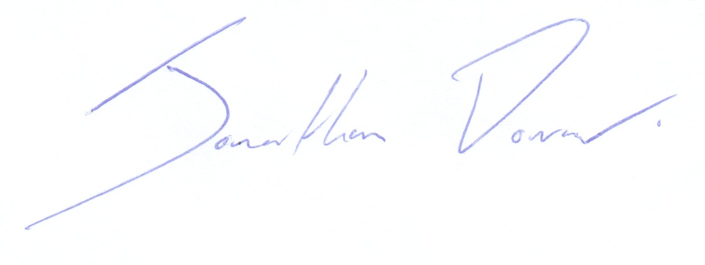
Jonathan Downar, MD PhD FRCPC
Scientist, Toronto Western Research Institute
Director, MRI-Guided rTMS Clinic, University Health Network and
Assistant Professor, Department of Psychiatry, University of Toronto

Suggested Referees:
Ziad Nahas, MD, Medical University of South Carolina
Email: nahasz@musc.edu

Helen Mayberg, MD, Emory University
Email: hmayber@emory.edu

Ben Harrison, PhD, University of Melbourne
Email: habj@unimelb.edu.au

Joan Camprodon, MD, Harvard Medical School
Email: jcamprodon@partners.org

Oliver Robinson, PhD, University College London
Email: o.robinson@ucl.ac.uk

Paul Holtzheimer, MD, Dartmouth Medical School
Email: paul.e.holtzheimer@hitchcock.org

