PI/Author Name: Dr. Luisa A. Ikner, Bradley Schmitz, Dr. Charles P. Gerba, and Dr. Ian L. Pepper
Environmental Science Education Title: Gram Staining of Bacteria and Visualization via Microscopy: Visualizing Bacteria Using the Gram Stain Technique
Overview: The spectrum of research in environmental microbiology is broad in scope and application potential. Whether the work is bench-scale with known bacterial isolates, or in the field collecting soil or water samples containing unknown bacterial isolates, the ability to quickly and visually discern culturable populations of interest remains of great import to environmental microbiologists even today with the abundance of molecular techniques available for use.
The Gram stain is a classical and important staining technique that remains widely utilized by environmental microbiologists. Similar to a simple stain, it allows for assessment of bacterial cell morphology (i.e. cocci, rods, spore-formers), size, and arrangement (e.g. chains, clusters). In addition, it allows for differentiation of bacteria into two principle, distinct groups (Gram-negative and Gram-positive) according to cell wall composition and structure (Figure 1).
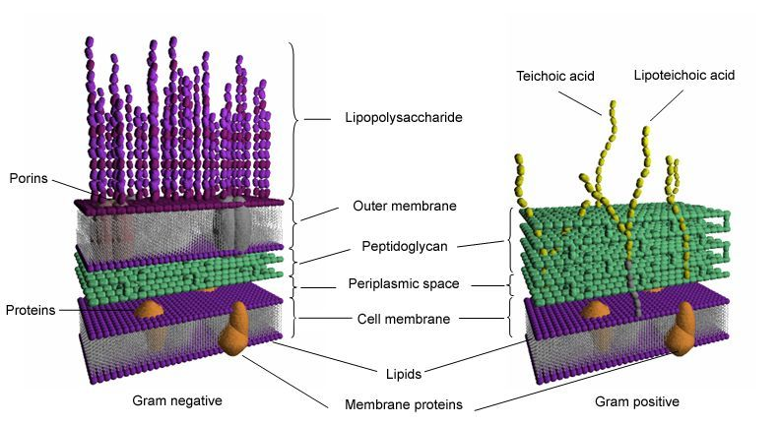
Figure 1. Comparative cross-section of Gram-negative and Gram-positive cell wall
The Gram stain is a multi-step process. Prior to staining, a bacterial smear is prepared using a plate, slant, or broth culture. The smear prep is dried and fixed onto a clean, glass slide. A primary stain of crystal violet is then applied to the fixed smear and held for 2 to 3 minutes. Crystal violet is a basic stain comprised of positively-charged colored ions (i.e. chromophores) that form weak ionic bonds with negatively-charged functional groups present in the bacterial cell wall. After gently rinsing the slide with water, Gram’s iodine is applied for 2 minutes, and forms insoluble complexes with the crystal violet in the cell wall. The crystal violet-iodine complex further binds with peptidoglycan, a principle component of bacterial cell walls. Following a second water rinse, a decolorizing agent (e.g. ethyl alcohol) is briefly applied to the smear for 15 to 20 seconds. For Gram-negative bacteria, the crystal violet-iodine complex is washed away during the decolorizing step, with Gram-positive bacteria retaining the purple stain. A third and final water rinse is followed by a counterstain of safranin that colorizes Gram-negative bacteria pink or red.
This video will start by briefly showing a dilution and plating of a soil sample which will yield a number of colonies of varying morphology. It will then demonstrate a scientist selecting 2 to 3 colonies for isolation streaks onto a Petri plate containing an appropriate growth medium. From these culture isolation streak plates, bacterial smears will be prepared, dried, and fixed onto clean glass slides. Each step of the Gram stain technique will then be demonstrated and explained, in addition to many of the “do not’s” for the technique such as improper heat fixing, stain application, slide rinsing, and decolorization. The importance of culture age will also be discussed and demonstrated. Finished slides from the soil sample will be prepared for Gram-positive and Gram-negative bacteria and spore-formers [Photo A (courtesy of ASM Microbe Library)]:
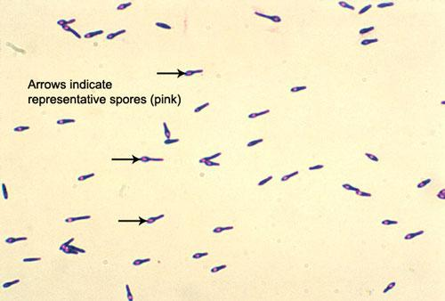
Photo A
Photo A: Gram-positive, endospore-forming soil bacterium Clostridium botulinum (Courtesy of ASM Library)

Procedure: (The concept for this video could be something along the lines of “from sampling to staining”, where initially the video shows the sampling of a soil, the dilution and plating of the soil, the resulting growth plates, streaking for isolation – all of these tasks fast-tracked to under 3 minutes in effort to demonstrate how this the Gram stain technique is beneficial to environmental microbiologists.)
- Fast-Track Portion

  - Collect soil sample and transport to the laboratory for microbial analysis.

  - In the lab, weigh a 10 gram sample using an analytical balance.

  - Dilute the sample (1:10) into 95 ml of phosphate-buffered saline (10 parts soil is equivalent to 5 parts of aqueous liquid), and vortex to mix (Figure 1, Step 1).

  - Perform subsequent 1:10 dilutions for at least 10⁻⁵ g soil per ml, and spread-plate selected dilutions in replicates of two or three onto a low nutrient-agarose medium (e.g. R2A) (Figure 2, Steps 2 and 3a/3b).

  - Incubate the plates for one week at room temperature (Figure 1, Step 4).

  - Select one or two colonies for isolation, and strike onto fresh agarose medium plates (Figure 3, Steps 1 through 3).

  - Incubate the streak plates for two to three days at room temperature (Figure 3, Step 4).

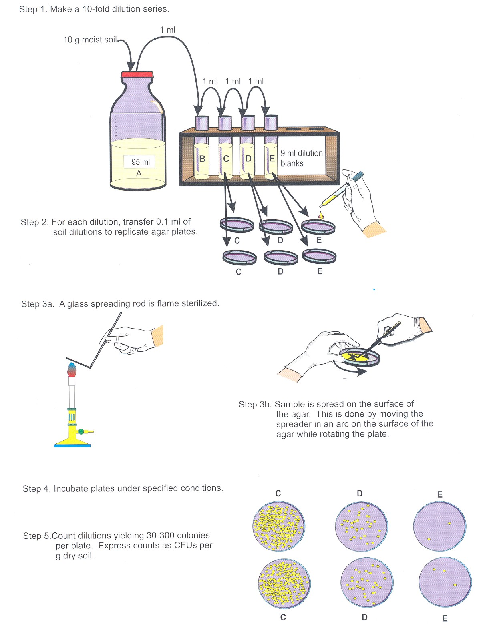

Figure 2. Dilution and Spread-Plating Technique

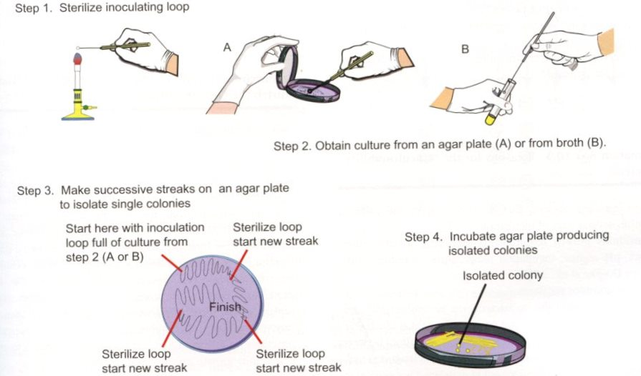

Figure 3. Colony Isolation Using the Streak Plate Technique

- Preparation of Bacterial Smears

  - Observe the streak plates (previously prepared as described in Sections 1.6 to 1.7) for isolated colonies.
  - For each smear prep, dip an inoculating loop into ethanol, flame-sterilized, and place 1 to 2 loopfuls of sterile distilled water on the center of pre-cleaned glass slides.
  - Sterilize the inoculating loop again as previously described. Once cooled, remove a small amount of culture from a single isolated colony and mix it with the water droplets on the slide (the smear should resemble diluted skim milk). [The inoculating loop must be cooled prior to colony isolation. A loop that is too hot will cause the colony and/or medium to spatter, which may facilitate aerosolization of bacteria. Generally, when the loop is too hot for use, a “hissing” sound will be heard when applied to the agar or colony. Improper cooling of the loop may also result less efficient culture-to-slide transfer, and distortion of cell morphology.]
  - Spread the smear over the surface of the slide measuring approximately 1” x 1”, and allow it to air dry. [Air drying is very important. Laminar flow conditions are fine, however slides should not be blown to dry so as not to disrupt the smear. Also, slides must not be flame-dried in order to maintain cell morphology.
  - After drying, heat fix the smear by passing the slide quickly through a flame two to three times [The slide is not held in the flame during the heat fixing process to prevent distortion of cell morphology and/or damage to the glass slide.]

- Gram Stain
  - Secure the slide on one end using a clean clothespin.
  - Cover the smear with crystal violet (primary stain) and hold for 2 to 3 minutes.
  - Carefully wash the slide with distilled water. [The water stream is not directed at the smear in order to prevent damage and/or detachment from the glass slide.]
  - Cover the smear with Gram’s iodine and hold for 2 minutes, then gently rinse the slide with water.
  - Decolorize the smear using 95% ethanol until stain no longer washes from the slide (usually no more than 20 seconds depending on the thickness of the smear), then immediately rinse with distilled water. [This step is critical as it is important not to over decolorize the slide – which may lead to a false Gram stain designation (i.e. Gram-variable).]
  - Add the counterstain (safranin) to the smear and hold for 30 seconds. Then gently rinse the slide with distilled water and blot dry using absorbent paper.
- Microscopic Observation of Slides
  - Observe the slides using low (e.g. 4X or 10X), high-dry (e.g. 40X), and oil immersion objectives (100X). For oil immersion, add the oil directly to the smear.
  - Representations of Gram-positive and Gram-negative soil bacteria are shown.

Representative Result: The outcome of the procedure will be at least one Gram-negative and one Gram-positive bacterial smear prep. The smears must be viewed microscopically using oil immersion for the best magnification and resolution. Representative stains of common soil bacteria are shown below (courtesy of ASM Microbe Library):
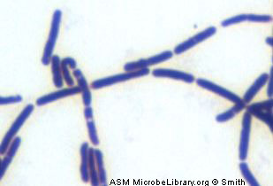
Photo B

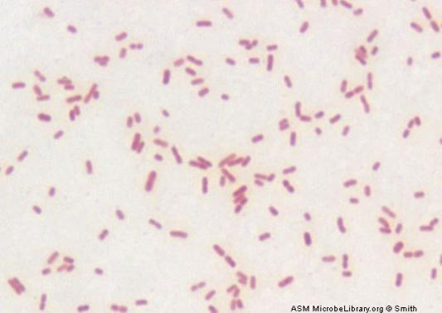
Photo C

Photo B: Gram-positive soil bacterium Bacillus subtilis (Courtesy of ASM Library)
Photo C: Gram-negative soil bacterium Alcaligenes faecalis (Courtesy of ASM Library)

Applications:
The Gram stain is used in the many sub-fields of both environmental and clinical microbiology. Water quality scientists may use the Gram stain as a confirmatory tool for the detection of fecal bacteria in water samples. Bacterial isolates from soils are Gram stained in order to further characterize culturable soil communities. For environmental microbiologists, Gram stains aid in the categorization of bacterial populations according to cell wall structure. This, in turn, provides information as to the general ability of a given microbial community to withstand desiccation and other environmental stressors. Knowledge of Gram-stain designation is also of importance in the research and development of disinfectants and other antimicrobials, as Gram-positive bacteria tend to be more resistant to inactivation by particular chemistries than Gram-negative bacteria.
For clinical microbiology applications, the Gram stain is used to confirm the identity of bacteriological disease agents along with traditional diagnostic methods. It is also of great assistance when culturing has failed, or is not an option. Gram staining of clinical specimens can reveal the presence of etiologic agents that may not have been observed otherwise.

Figure 1. Comparative cross-section of Gram-negative and Gram-positive cell wall Figure 2. Dilution and Spread-Plating Technique
Figure 3. Colony Isolation Using the Streak Plate Technique
Photo A: Gram-positive, endospore-forming soil bacterium Clostridium botulinum (Courtesy of ASM Library)
Photo B: Gram-positive soil bacterium Bacillus subtilis (Courtesy of ASM Library)
Photo C: Gram-negative soil bacterium Alcaligenes faecalis (Courtesy of ASM Library)

