The authors thank the referees for their thorough review, which has helped to significantly improve the quality of our manuscript.

Editorial comments:
A number of grammar/typo issues need to be addressed:
Please fix the grammar and typographical errors in both abstracts.
Please copyedit the manuscript to remove frequent errors grammar and in spacing. These errors typically occur after a unit of time.
Line 327: Preferential what of nanoparticles?
Answer: Preferential uptake of nanoparticles
2. There are some formatting issues to be corrected:
PDT should be defined at first mention (Line 55), not second (Line 65).
Answer: ‘Photodynamic Therapy’ added on line 55 and deleted from line 65
Are there better descriptors for the solvents to replace “good” and “bad?”
Answer: The good and bad words are replaced by compatible and non-compatible respectively.
Please define HBSS, PI
Answer: HBSS: Hank’s Balanced Salt Solution, and PI: Propidium iodide
5.1.7: Please cite steps by step name (eg. 4.2.1)
Answer: Steps are now cited by name
References: Please make sure all journal titles are abbreviated.
Answer: All journal titles are now abbreviated
3. Addtitional detail is required:
1.1: Please provide a reference on how these cells are cultured, or else provide more stepwise detail.
Answer: More stepwise detail has been provided in the paper, marked here as yellow highlight
1.1) Thaw TE 71 (Mouse thymic epithelial cells), MDA-MB-231 (Human breast cancer cells), A549 (Human lung cancer cells) and OVCAR3 (Human ovarian tumor cells) by holding the cryogen vials in warm water for less than 2 minutes. Add 10 ml DMEM media supplemented with 10% FBS to each cell line and centrifuge for 6 min at 1000 rpm.
1.2) Remove the suspension and add 3ml media to the pellet. Mix the cells properly by pipetting several times. Add this cell solution to pre-warmed 7 ml DMEM media supplemented with 10% FBS in T75 flasks and keep the flasks in humidified atmosphere of 95% air/ 5% CO₂ at 37 ⁰C. Label this flask as Passage 0.
1.3) When the confluency of the cells reaches 80%, harvest the cells by incubating them with 0.05% trypsin for 10 min. Neutralize the trypsin by adding equal amount of media. Centrifuge this solution for 6 min at 1000 rpm. Remove the suspension and add 3 ml fresh media to it. Mix well and transfer small amount (100 µl) to a culture flask containing 7 ml media. Incubate the culture flask in incubator. Label the flask as Passage 1.
1.4) Culture the cell lines until passage 11 or 12.
2.1.3: What wavelength is used?
Answer: The wavelength used is 495 nm, added in the paper.
2.4.2: Are the nanoparticles processed after injection?
Answer: The nanoparticles are not processed after injection. Statement added to paper
3.3.5: How much annexin V FITC and PI?
Answer: 20 µl annexin V FITC was used from the purchased stock solution. 300 nM PI was used. Details added to paper.
Figure legends: Please provide titles for Fig. 1 & 3. Also, please define the error in these figures.
Answer: The titles for Figure 1 and 3 are: Figure 1A- Fabrication of nanoparticles, Figure 1B: Uptake of nanoparticles by different cell lines, Figure 1C: Intrinsic cytotoxicity of nanoparticles, Figure 3: Cell viability after PDT.
The error in Figure 1C and in Figure 3 are the standard deviations for results from 3 separate experiments (n=3). Statement added to respective figure captions.
4. There is unnecessary branding in step 3.2.3: FSQ-GG400.
Answer: FSQ-GG400 is deleted.
5. Discussion: What are the limitations of this protocol?
Answer: Limitations of this protocol:
- The nanoparticle size is hard control due to the preparation method used. As the injection of solution to make nanoparticles is performed manually with hands, the injection rate is hard to control from person to person. This can pose as a limitation to this protocol.
- During PDT the cells have to be kept outside the incubator for several hours which imposes some stress on the cells.
Statements were added to the discussion section of the paper.
6. Please keep the editorial comments from your previous revisions in mind as you revise your manuscript to address peer review comments. For instance, if formatting or other changes were made, commercial language was removed, etc., please maintain these overall manuscript changes.
7. Please take this opportunity to thoroughly proofread your manuscript to ensure that there are no spelling or grammar issues. Your JoVE editor will not copy-edit your manuscript and any errors in your submitted revision may be present in the published version.
8. If your figures and tables are original and not published previously, please ignore this comment. For figures and tables that have been published before, please include phrases such as “Re-print with permission from (reference#)” or “Modified from..” etc. And please send a copy of the re-print permission for JoVE’s record keeping purposes.
* JoVE reference format requires that DOIs are included, when available, for all references listed in the article. This is helpful for readers to locate the included references and obtain more information. Please note that often DOIs are not listed with PubMed abstracts and as such, may not be properly included when citing directly from PubMed. In these cases, please manually include DOIs in reference information.

Answer: DOI added to all the references.

Reviewer 1:
No manuscript summary
No major comments
Minor comments:
- Page 1, lines 36-37: "… the fabrication of blended conducting polymer nanoparticles blended with fullerene as the next generation photosensitizers …"
Could the first "blended" be deleted?
Answer: first ‘blended’ is deleted
- Page 1, line 48: " … and efficient and charge and energy transfer to the fullerene PCBM …"
Delete the second "and".
Answer: The second ‘and’ is deleted
- Page 2, lines 59-61: "… however, significant issues with dark toxicity of the sensitizers, patient sensitivity to light due to non-selective distribution of the sensitizer, and hydrophobicity of the sensitizers which leads to reduced bioavailability and potential acute toxicity remain..."
This sentence seems problematic in term of grammar.
Answer: sentence was split and further edited.
- Page 2, lines 67-68: "… when these materials dissolved in a good solvent are rapidly injected into a bad solvent …"
Please reword this sentence.
Answer: The words compatible-non-compatible solvents are used instead of good and bad solvents.
- Page 4, line 183, Section 3.2.3
Is a power meter used for measuring the light irradiance here?
It would better to measure the irradiance at the surface of the cell culture instead of the surface of the pertri dish.
Answer: A calibrated reference photosensor was used to measure the light irradiance.
The distance between surface of cell culture and surface of petri dish is negligible and the irradiance was not observed to change at these small distances.
- Page 5, lines 185-186: "… the surface of the petri dish/96-well plate…"
The authors may want to delete "/96-well plate", because in this section only petri dishes are used.
Answer: ‘/96 well plate’ is deleted

Reviewer 2:
No comments

Reviewer 3:
Manuscript summary:
This paper describes the use of a semi-conducting polymer (MEH-PPV) to solubilize a C60 fullerene derivative (phenyl c61 butyric acid methyl ester) to act as a photosensitizer to mediate PDT killing of 3 cancer and 1 normal cell line.

Major comments:
- They claim that the polymer acts as "high extinction coefficient that leads to high rates of triplet formation, and both efficient and ultrafast charge and energy transfer to the fullerene" but no evidence is presented to back up this claim, only a citation to a paper.
The study of charge and energy transfer from MEH-PPV to PCBM was not performed in our lab but has been extensively reported in literature since the early nineties. Further study would add no new information to the existing body of work.
- It is very premature to claim that the complex "shows unexpected specificity to cancer cell lines. " They basically have 1 "normal cell" and 3 cancer cells. Only the OVCAR3 cell is highly susceptible to PDT (see figure 3). This might be explained by the fact that OVCAR3 is a non-adherent cell line while the other cells are adherent. In order to substantiate the claim for specificity for cancer cells they would need at least 3 of each with comparable levels of adherence.
Cell adherence was verified by phase imaging and was found to be excellent and consistent across the cell lines studied here. The difference in PDT efficiency is due to differences in extent of nanoparticle uptake. The ROS formation is directly proportional to amount of nanoparticles uptaken. The uptake of nanoparticles depends on the metabolic rate of the cell lines and it is well established that OVCAR3 has a high metabolic rate compared A549 or MDA-MB-231. Figure 1 supports that OVCAR3 has taken more nanoparticles.
- In order to demonstrate in vitro PDT they need to carry out a light-dose response experiment as well as the PS dose response experiment shown in Figure 3.
We have carried out the light-dose response experiments as the referee suggests. We have used 60, 120 and 180 J/cm² light doses and observed that the PDT effect increases with increasing light dose. We opt to not include these data in order to keep the paper sufficiently brief. Furthermore, the methods described herein will not be further developed by including this information. The Figure below shows cell viability as a function of light dose for each cell line, plotted for each nanoparticle dose.

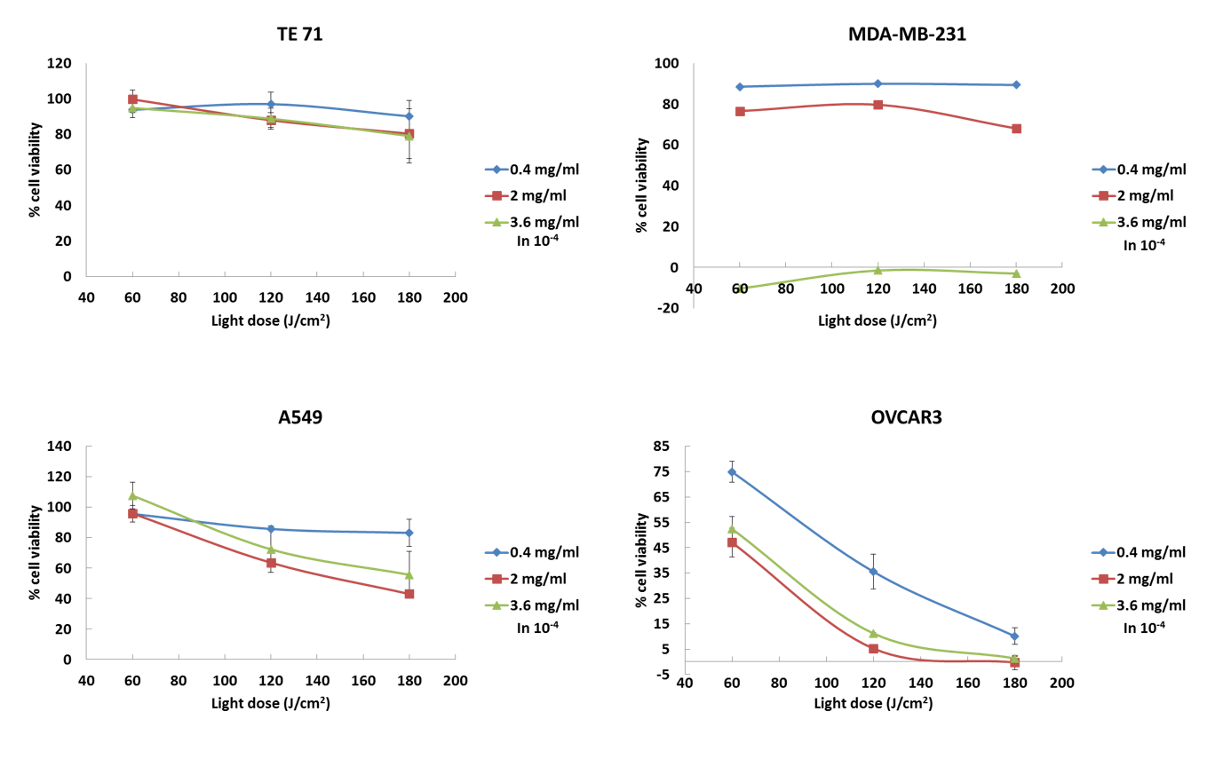

- Apparently they used the CellRox kit to determine ROS produced inside cells. The Methods section does not give details of how this kit was used. However I believe what is happening is that the kit is detecting ROS produced from mitochondria in the PDT damaged cells NOT ROS produced from the PDT. This can be seen from the fact that there is higher fluorescence at 2 hours after light delivery than there is immediately (see Figure 2).
CellRox is received as a concentrated solution. The methods section describes the appropriate dilution into culture media, the incubation time and incubation temperature. No further steps are necessary for this assay.
The data in Figure 2 show that the ROS are formed from the nanoparticles. Panel B shows the control experiment where the samples went to the full PDT treatment, but in the absence of nanoaparticles. In that case no ROS formation is detected, which eliminates the hypothesis of detecting ROS produced directly from mitochondria. Although we cannot fully eliminate that mitochondria in dying /dead cells have released ROS, CellRox emission is detected throughout the whole cell body. Based on these two observations it is reasonable to speculate that most of the observed ROS formation is due to the nanoparticles, and that the difference between panels D and E is more likely due to a heterogeneous distribution of nanoparticles across different cells. In addition, lipid peroxidation reaction could continue during the 2 hour period since this is basically a continuously propagating radical chemistry, which can further explain the observations in panel E.
- It is not clear what the fluorescence of the nanoparticles in the cells in Figure 1 is actually due to. There is no excitation and emission details given and no fluorescence of the prepared nanoparticles is given. Presumably the MEH-PPV as the fullerene has no fluorescence?
The fluorescence of nanoparticles in the cells in Figure 1 is due to MEH-PPV emission at 589 nm. The excitation and emission details are given by the graph shown below:

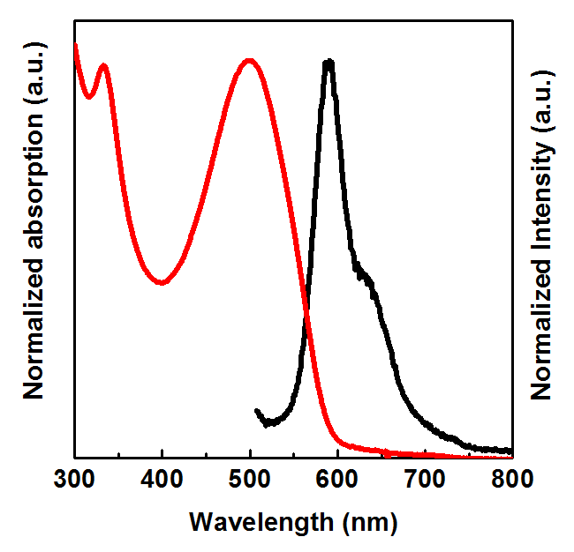

Minor comments:
- It is not correct to state regarding fullerenes "However, severe cytotoxicity has hampered further development". By and large fullerenes are considered only of low toxicity compared to other classes of nanomaterials. There can be some toxicity depending on the functionalization and delivery vehicle, but it is not clear that the MEH-PPV has any effect on the dark cytotoxicity.
Per the referees suggestion we have completed dark cytotoxicity studies on undoped MEH-PPV nanoparticles, which show that MEH-PPV has no statistically significant effect on dark toxicity. Please see the Figure below. Fullerene cytotoxicity has been reported in literature, although there are broad discrepancies in the reported dose dependencies. A couple of representative references are include below.
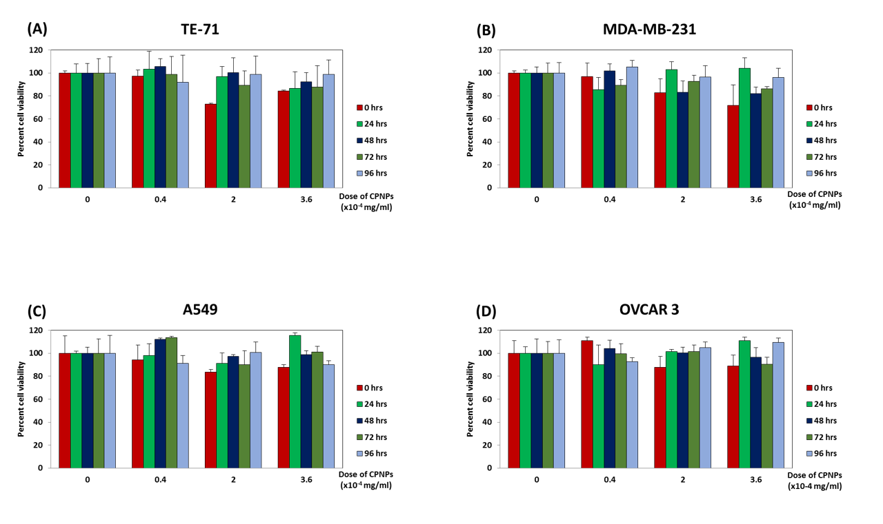
(1) Sayes, C. M.; Gobin, A. M.; Ausman, K. D.; Mendez, J.; West, J. L.; Colvin, V. L. Nano-C-60 cytotoxicity is due to lipid peroxidation. Biomaterials 2005, 26, 7587-7595.
(2) Zhang, B.; Bian, W. L.; Pal, A.; He, Y. L. Macrophage apoptosis induced by aqueous C-60 aggregates changing the mitochondrial membrane potential. Environ. Toxicol. Pharmacol. 2015, 39, 237-246.

- The statement "AFM was not used for size determination as during the sample preparation the nanoparticles become flat due to vacuum drying." is somewhat strange. What is going on here? Moreover TEM is universally used for characterizing nanoparticles.
The nanoparticles are soft and spherical in suspension. When vacuum is applied to dry the sample for AFM imaging, the nanoparticles collapse and become disc like. The AFM tip was also found to push down on the nanoparticles. Hence AFM was not used in this study. This was mentioned as an additional guide to readers, but as the sentence appears confusing we have deleted it from the manuscript.

Reviewer 4:
No manuscript summary

Major comments:
The authors explained the differences in PDT results between the cancer cell lines by the difference in aggressiveness (metabolism and rate of endocytosis) between these cell lines. But how to explain that both mouse thymic epithelial (not cancer and not aggressive) cells and human breast cancer cells (cancer and aggressive) are not sensitive to PDT?
The aggressiveness (metabolism and rate of endocytosis) of the cell lines directly determines the extent of uptake of nanoparticles by each cell lines. The aggressive cell lines (OVCAR3 followed by A549) take up high amounts of nanoparticles. ROS formation can be assumed to be relatively proportional to the amount of nanoparticles available. Thus, higher levels of ROS are generated for OVCAR3 and A549, resulting in better PDT efficacy. On the other hand MDA-MB-231 is not as aggressive and takes up less nanoparticles. TE71 is a normal control and should not take nanoparticles, and should not be showing PDT effects.

Minor comments:
In legend to Fig. 1B the time of cells incubation with nanoparticles and in legend to Fig. 4 the nanoparticles concentration and the time after photoexcitation should be indicated.
Legends to figure 1B and figure 4 added.

