Submission ID #: 52970

Editor Name: Sanjukta Ghosh

Videographer name: Kai-Jae Wang

Film Date: 6/9/15

Authors and Affiliations:
Karolina Chwalek, Disha Sood, William L. Cantley, James D. White, Min D. Tang-Schomer, David L. Kaplan

Department of Biomedical Engineering, Tufts University, Medford, MA, USA

Title: Engineered 3D silk-collagen-based model of polarized neural tissue

Corresponding Author:

David L. Kaplan

Department of Biomedical Engineering
School of Engineering, Tufts University

4 Colby Street

Medford, MA, USA.

Email Address: David.Kaplan@tufts.edu

Phone: 617-627 3251

Co-authors:

Karolina Chwalek Karolina.Chwalek@tufts.edu

Disha Sood Disha.Sood@tufts.edu

William L. Cantley William.Cantley@tufts.edu

James D White James.White@tufts.edu

Min D. Tang-Schomer Min.Tang-Schomer@tufts.edu

A. Will you require JoVE to record video microscopy, such as filming a complex dissection or microinjection technique? (Y/N)__No_______ (If you can record images/videos using your own camera/software, then mark No) If yes, please list make and model of your microscope: _____________________________________________
B. Does your protocol include detailed, step-by-step, descriptions of software usage? (Y/N)__No______ If yes, we will need you to record using screen recording software to capture the steps. If you use a Mac, QuickTime X also has the ability to record the steps.
C. Which steps of your protocol will viewers benefit most from having filmed? Please list 4-6 steps using the step numbers listed in this document. 2.3; 2.6; 3.4; 3.8 ___________________________________________
D. What is the single most difficult aspect of this procedure and what do you do to ensure success? Please list the steps using the step numbers listed in this document._3.6 – 3.8 __________________________
E. Will the filming need to take place in multiple locations? (Y/N) ___No____ If yes, how far apart are the locations? ___________________________________________________

1. Introduction (Schematic Overview and Interview)

A. Schematic Overview (read by voice talent at JoVE):

Procedural Narrative:
The overall goal of this procedure is to demonstrate the engineering process of 3D brain-like tissues. (Intro)

This is accomplished by first preparing the porous scaffolds from silk solution using a salt-leaching technique. (P1: First start with the blank petridish on the left side of screen and make the next two petridish with Text label Pour silk, and Pour salt appear in succession. Along with the narration “salt leaching..”, make the fourth figure of uncut silk scaffold appear from within the third petridish diagram in the supplied graphic overview. Add Text Leach out salt.)

The second step is to precut the scaffolds into donut shapes and prepare them for cell culture by sterilization and coating with poly-D-lysine, or PDL. (P2: Show the cut scaffold with Text labels 5 mm as the outer diameter and 2 mm as the diameter of the inner hollow. Next show the coating of the scaffold with the polylysine. Text label Surface coating below the scaffold to which liquid is added).

Next, the prepared scaffolds are seeded with freshly isolated primary rat cortical neurons. (P3: Show the next step in the diagram. Insert the text label Cell seeding below)

The final step is collagen embedding of the scaffolds and transfer to the culture plates. (P4: Show the last figure in the diagram. Insert the text label Collagen embedding.)

Ultimately, immunofluorescence microscopy is used to show the neural growth and development of neural networks. (P5: LABMEDIA_JoVE52970_Figure2.TIF, show only B, two panels. Remove the text B)

Paste a copy of your graphic overview here. The original file should be Adobe Illustrator (preferred) or PowerPoint (see instructions) and should be uploaded through your online submission on the JoVE website. Please keep all layers in the file (i.e., do not flatten the file).

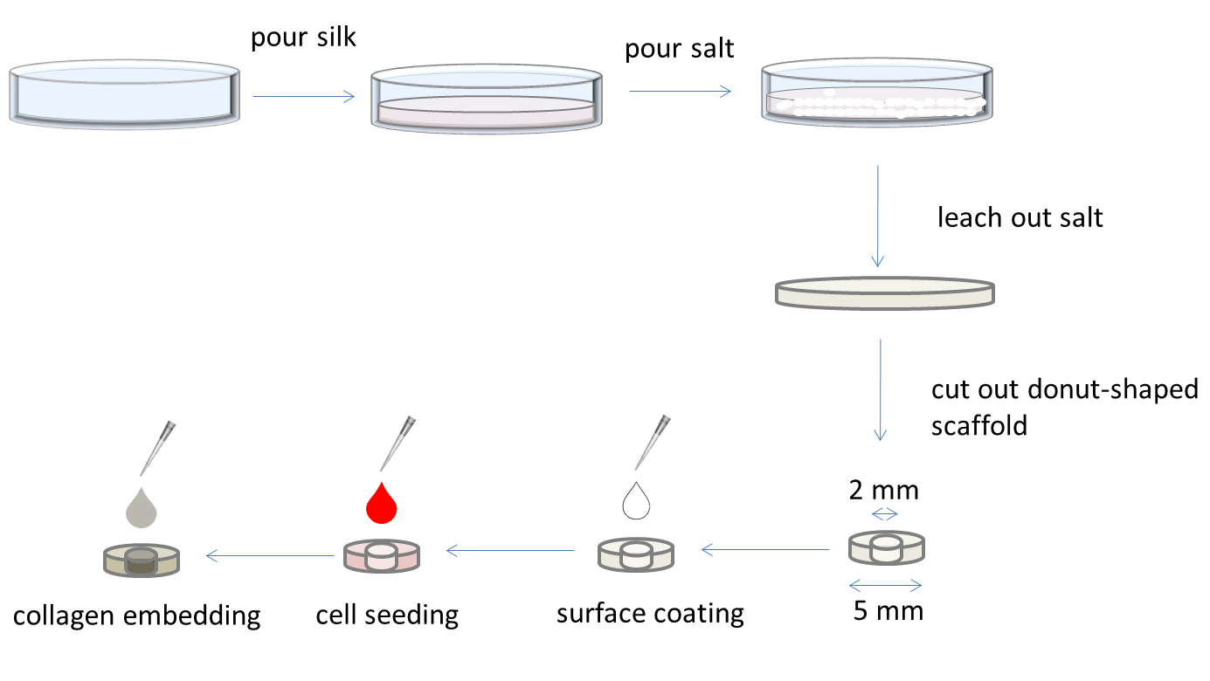
B. Interview: (Said by you on camera. Don’t forget to smile!)

  - Karoline Chwalek: The implications of this technique extend toward therapy or diagnosis of brain-affecting diseases, because it can be utilized as a basis for new brain disease models such as Parkinson’s or Alzheimer’s.

Protocol (read by voice talent at JoVE):

Note to the Authors: Our formatting standards specify a space between the number and the units for temperature.
- Preparation of porous scaffolds from silk solution
  - Before beginning, prepare the 6% silk solution as described in the text protocol and store it at 4 ºC.

2.1.1 MED: Talent takes out 6% silk solution bottles from 4 ºC refrigerator or deli box and walks with it towards the bench.

2.1.2 CU: Set the bottle of 6% silk solution on work bench.
  - To prepare porous scaffolds, first sieve the granular sodium chloride and collect granules between 500 and 600 mm in diameter.

2.2.1 MED: Talent sieving sodium chloride
  - Pour 30 ml of the silk solution into the polytetrafluoroethylene, or PTFE, mold and then scatter 60 grams of sieved sodium chloride evenly over the solution. Incubate for 48 hours at room temperature to polymerize the silk.

2.3.1 MED: Talent pouring silk solution into the mold.

2.3.2 CU: Talent scattering the salt evenly on the solution.

2.3.3 MED: Talent setting the solution at a suitable undisturbed area on workbench for incubation.
  - Place the scaffold-containing mold in an oven set at 60 ⁰C for 1 hour to finalize the polymerization of silk and to evaporate any remaining liquid.

2.4.1 WIDE: Talent taking the scaffold to the 60 ºC oven and setting it inside.

2.4.2 CU: Show the temperature of the oven is set at 60 ºC. [TEXT: 1 hr]
  - Next, immerse the mold and scaffold combination in a 2 Liter beaker of distilled water for 48 hours to leach out the salt. Change the water 2 to 3 times per day.

2.5.1 CU: Talent immersing the mold + scaffold in the 2 liter beaker of water.

2.5.2 MED: Talent changing the water of the beaker, keeping the scaffold safe.
  - Remove the scaffold from the mold… and cut it into small pieces, first with a 5 mm diameter biopsy punch. Then cut the scaffold to be 2 mm in height, and remove the center from each piece with a 2 mm biopsy punch.
    - MED: Talent removes the silk scaffold from its mold and sets it aside.
    - CU: Talent punching scaffold into 5 mm discs.
    - CU: Talent cutting scaffold to correct height.
    - CU: Then punching one scaffold disc further with a 2 mm punch to remove an inner hole. [TEXT: Dimensions of scaffold: 5 mm outer diameter, height 2 mm, inner diameter 2 mm].
  - Autoclave the scaffolds in a wet cycle for 20 minutes.
    - MED: Talent putting the scaffolds inside autoclave.
- Seeding the scaffold with cells and collagen overlay
  - Inside a cell culture hood, place a pair of sterilized forceps, cell culture media, and the autoclaved scaffolds. Remove a 96 well plate from its wrapping and place inside.

3.1.1 WIDE: Show that there are items neatly placed inside the sterilized hood. Then talent sits down.

3.1.2 MED. Talent opens a 96 well plate and sets it on the hood workspace.
  - To seed the scaffolds, first place one sterile scaffold per well in the 96 well plate.

3.2.1 CU/ECU: Talent places each scaffold in each well with forceps.
  - Add cell culture medium to immerse the scaffolds and incubate at 37 ⁰C in a tissue culture incubator to equilibrate them for at least 30 min.
    - CU: Talent adds cell culture medium to a scaffold.
    - MED: Talent places the 96 well plate into the incubator [TEXT: 30 min]
  - Following incubation, aspirate the excess medium from the scaffolds. Then add 2 times 10⁶ rat cortical neuronal cells in 100 μl of neurobasal medium per scaffold.
    - MED: Talent aspirating medium from the scaffold. Show labeled container of the cell suspension kept inside the hood.
    - CU: Talent adds 100 μl per well. [TEXT: Neurobasal Medium: 1X B27 supplement, 1 X L-Glutamine, 1% Penicillin and Streptomycin]

Note to the Authors: Please label all tubes in advance.
  - Return the plate to the incubator and leave overnight to allow the cells to attach to the scaffold.
    - WIDE: Talent carefully places plate in the incubator. [TEXT 37⁰ C, 5% CO₂]
  - On the following morning, carefully aspirate the non-attached cells and replace with 200 μl of fresh cell culture medium. Incubate at 37 ⁰C for a brief period.

3.6.1 CU {or - ECU if possible}: Talent removes the medium from the wells without disturbing attached cells.

3.6.2 CU: Adds 200 μl of medium. This is a critical step.

3.6.3 WIDE: Talent returns the plate into the incubator. [TEXT: Incubate 10 minutes].
  - Next, aspirate the medium from the wells. Using sterile forceps, transfer the scaffolds containing cells to empty wells of the 96 well plate.

3.7.1 CU: Inside the hood, talent aspirates the medium.

3.7.2 ECU: Then transfers one scaffold to an empty well with the forceps.
  - Then, to each scaffold, add 100 μl of freshly diluted ice-cold 3 mg/ml rat tail collagen solution.
    - MED: Talent removes tube of collagen from ice and pipets from tube. [TEXT: See text protocol for preparation of collagen solution]
    - ECU. Talent adds collagen solution at the center of the donut shaped scaffold. This is a critical step.
  - Return the cells to the 37 ⁰C incubator to allow polymerization of collagen for 30 minutes.

3.9.1 MED: Talent placing the plate inside 37 ⁰C incubator. [TEXT: 30 minutes].
  - Remove the plate from the incubator, and add 100 μl of pre-warmed cell culture medium per well.

3.10.1 WIDE: Talent takes the plate inside the hood.

3.10.2 MED: Talent adds medium to the wells.
  - Return the plate to the incubator for the desired period of cell growth, replacing half of the medium from each well with fresh medium every day, for up to one week.

3.11.1 MED: Talent returns the plate to the incubator.
- Results: A 3D brain­like tissue model.
  - In these highly porous scaffolds, neuronal cells can be cultured to a high density. Shown here are the cell viability results, one day after seeding. Fluorescent diacetate-labeled live cells appear in green and propidium iodide-labeled dead cells, red. Note the high percentage of live cells seen under low magnification.
    - LABMEDIA : JoVE 52970_Figure 2.TIF [Editor: Remove Text labels A, B. Please insert arrowheads onto a couple of green cells in Figure 2B right panel with the narration cue "live cells" and insert short arrows on a couple of red cell on the right hand panel of Figure 2B along with the narration cue "dead cells". Please run an arrow partially over the green donut shaped structure on Figure 2B, left panel with the narration cue "live cells as seen under low magnification"].
  - This figure shows compartmentalization of neuronal cell bodies and axonal processes within the donut shaped scaffold.
    - LABMEDIA: JoVE 52970_Figure 3.TIF ; Show A only (Without squares. Please remove text label A.)
  - Neuronal cell bodies remain attached to the silk scaffold as seen here, 1 day after seeding. Cells are immunostained for BetaIII Tubulin and appear green.
    - LABMEDIA : JoVE 52970_Figure 3.TIF; Show A, B. [Editor, Please start with Panel 3A without any squares, then trace the red square on Figure 3A over the scaffold part and make Figure 3B pop out of the square. Insert text of “Day 1” on Figure 3B. Please remove text labels A, B.]
  - As expected, the cells have densely populated the scaffold by day 7 of culture.
    - LABMEDIA : JoVE 52970_Figure 3.TIF; Show A-B-C [Editor, please bring Figure 3C into view. Add text of “Day 7” on Figure 3C left panel. Add text of “Phase Contrast” on 3C (right). Please remove text labels A, B, C]
  - In contrast, the collagen matrix in the central hollow of the scaffold provides support for extensive axonal growth. Shown here is the axonal meshwork 7 days after seeding.
    - LABMEDIA : JoVE 52970_Figure 3.TIF Show A-D. [Editor, At this point, Figures 3B-C disappear. Start with Figure 3A in view, make the box appear on 3A and draw extension to reveal Figure 3D. Insert text of “7 Days” on Figure 3D. Please remove text labels A-D.]
  - This movie shows a confocal Z-scan of the central collagen window of the scaffold containing the neural network. Cells were labeled by staining for Beta-III-Tubulin.
    - LABMEDIA: JoVE 52970: 0123_Kaplan_Movie 1.avi.

5. Conclusion (said by authors on camera)

5.1 Karoline Chwalek: After watching this video, you should have a good understanding of how to set up the 3D brain-like tissue constructs.

Provided Media

Authors, Please list all images, movie files, or 3-D rendered animations that can be included in the video per editor’s request. The step in the script/video where these images will be inserted should be specified. For example:

6.2 – 0123_PIname_Figure1.tif - dual color imaging of tumor angiogenesis at 40X
6.2 – 0123_PIname_Figure2.tif - dual color imaging of tumor angiogenesis at 100X

Formats: For static images we prefer .tiff, .eps, Illustrator, Powerpoint or Photoshop files at dimensions of at least 720X480 pixels and 300 dpi. The higher resolution, the better. Likewise any exported movie files should have at minimum these dimensions and be rendered to .mov, .mp4, or .avi files.

Insert your media filenames here.

General Preparation

It’s critical for a smooth and organized shoot that all reagents are accounted for, in advance.

Any overnight or long incubation steps should be recognized and specimens/samples be prepared in advance so that prior steps can be recorded and shooting can continue with pre-prepared specimens/samples.

All tubes/flasks should be pre-labeled neatly before we arrive.

Ex. Luciferase assay done in 96 well plates should be labeled with negative/positive control wells and experimental samples are labeled accordingly.

You will receive more detailed preparation instructions, as well as an introduction to your videographer, closer to your filming date.

