Submission ID #: 52968

Editor Name: Nadeeka Dias

Videographer name: Bruno Behnam

Film Date: 6/8/15

Authors and Affiliations: Aidan D Roche^{1,2}, Ivan Vujaklija³, Sebastian Amsuess³, Agnes Sturma², Peter Göbel⁴, Dario Farina³, Oskar C Aszmann^{1,2}

¹Division of Plastic and Reconstructive Surgery, Department of Surgery, Medical University of Vienna, Vienna, Austria
² CD Laboratory for the Restoration of Extremity Function, Department of Surgery, Medical University of Vienna, Austria
³ Department of Neurorehabilitation Engineering, University Medical Center Göttingen, Georg-August University, Göttingen, Germany
⁴ Clinical Research, Research & Development, Otto Bock Healthcare Products GmbH, Vienna, Austria

Title: A structured rehabilitation protocol for improved multifunctional prosthetic control: A case study

Corresponding Author:
Aidan D. Roche
aidan.roche@meduniwien.ac.at

Co-authors:
Ivan Vujaklija
ivan.vujaklija@bccn.uni-goettingen.de

Sebastian Amsuess
sebastian.amsuess@bccn.uni-goettingen.de

Agnes Sturma
agnes.sturma@meduniwien.ac.at

Peter Göbel
peter.goebel@ottobock.com

Prof. Dario Farina
dario.farina@bccn.uni-goettingen.de

Prof. Oskar C Aszmann
oskar.aszmann@meduniwien.ac.at

A. Will you require JoVE to record video microscopy, such as filming a complex dissection or microinjection technique? No
B. Does your protocol include detailed, step-by-step, descriptions of software usage? Yes.
If yes, we will need you to record using screen recording software to capture the steps. If you use a Mac, QuickTime X also has the ability to record the steps.
C. Which steps of your protocol will viewers benefit most from having filmed? Please list 4-6 steps using the step numbers listed in this document.
Steps 2.3-2.5 Compared against Steps 3.4-3.6 with final outcome demonstrated by step 3.11
D. What is the single most difficult aspect of this procedure and what do you do to ensure success? Please list the steps using the step numbers listed in this document. While not difficult to apply, steps 3.4-3.6 are the crucial steps in the protocol. These are clearly outlined in the manuscript, and for success we ensure clear instructions from the demonstrator and complete understanding from the participant before commencing the experiments.
E. Will the filming need to take place in multiple locations? University Medical Center Göttingen, Germany

1. Introduction (Schematic Overview and Interview)

A. Schematic Overview (read by voice talent at JoVE):

Procedural Narrative: Use JOVE_Schematic3.psd
The overall goal of this procedure is to train upper limb amputees to use advanced prosthetic limbs. (Intro)

This is accomplished by using the amputees’ inherent learning strategies to guide rehabilitation. (P1: Show only the three circle graphs from panel #1.)

The first step is to have the patient imitate and repeat movements performed by a demonstrator. (P2: Begin with items from panel #1. First show the amputee with the blue hand, then the researcher with the computer and blue signals, then the red box with EMG signals.

Next, the patient engages with a computer system to reinforce learning, and to train algorithms for prosthetic control. (P3: Show panel #2. Show amputee and computer first. Then show other half of panel with wrist picture and graph.)

The final step is for the patient to independently control an advanced prosthetic limb. (P4: Show panel #3. Start with amputee on left, then show graph on right.)

Ultimately, structured rehabilitation training is used to show that using amputee’s inherent learning strategies improves advanced prosthetic control. (P5: Show Figure 5; introduce one cluster of bars at a time)

Paste a copy of your graphic overview here. The original file should be Adobe Illustrator (preferred) or PowerPoint (see instructions) and should be uploaded through your online submission on the JoVE website. Please keep all layers in the file (i.e., do not flatten the file).

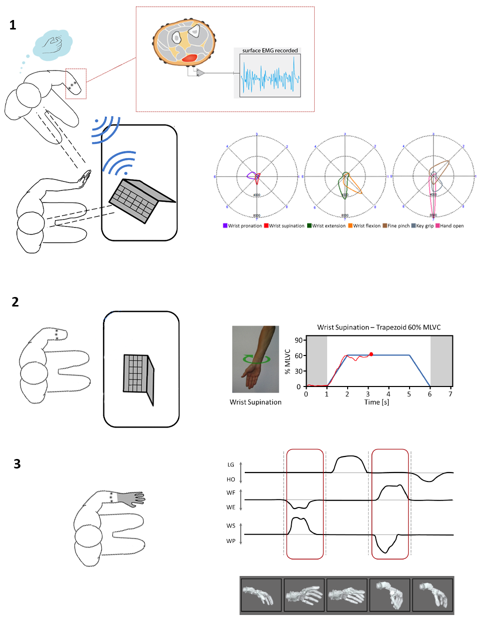

B. Interview: (Said by you on camera. Don’t forget to smile!)
  - Aidan Roche: I first had the idea for this method when we were attempting to train a patient to use an advanced prosthetic hand using traditional pattern recognition methods, which were not effective.
  - Dario Farina: The implications of this technique may extend toward therapy of upper limb patients with different levels of amputations, as it takes advantage of the patients built-in learning strategies irrespective of the type of injury.
  - Ivan Vujaklija: Visual demonstration of this method is critical as the training method is entirely visual, and it will be beneficial for both clinicians and engineers alike when considering the challenges of training a patient and not just a computer algorithm.

Protocol (read by voice talent at JoVE):
- Naïve Session
  - Begin, by fitting a customized socket and prosthesis to the participant [2.1.1-MED]. Calibrate the prosthetic hardware, and use the collected calibration data for real-time prosthetic control [2.1.2-MED-over shoulder].
    - *Film as written
    - *Film as written
  - Do not give the participant any formal training; however, instruct them that they will perform 8 actions with the prosthetic limb that will allow control of a visual target on a computer screen [2.2.1-MED].
    - *Film as written
  - Display a static picture of the movement on the screen and ask the participant to follow a visual cue [2.3.1-MED].
    - *Film as written
  - Then, show the participant their Electromyography, or EMG (pronounced E-M-G) patterns [2.4.1-MED], which correspond to eight specific and unique polar plots [2.4.2-LM].
    - *Film as written
    - Figure 2 [Video editor: Highlight the 8 numbers around the polar plot in the middle]
  - Encourage the participant to follow the visual cue by pointing to the screen [2.5.1-MED].
    - *Film as written
  - Repeat the task three times with different arm positions: relaxed…, reaching in front…, and reaching across…, to enhance system training [2.6.1-MED].
    - *Film as written
  - Complete all 8 actions and three force levels for each arm position, to collect a total of 72 individual samples of system training [2.7.1-MED-TXT].
    - Participant should demonstrate only 1 or 2 actions; TEXT: 8 Actions x 3 Force Levels x 3 Arm Positions = 72 samples
  - Once the training is complete, use the training data sets from this session to calibrate and adjust the prosthesis so the participant may practice real-time control [2.8.1-MED].
    - *Film as written
  - Allow the participant to control the prosthesis by sequential proportional control, or one movement at a time, with the speed of the device proportional to the levels of muscular contractions [2.9.1-MED].
    - *Film as written (multiple shots with different angles – will be repeated later) use Take 2
  - Once each of the eight actions is performed in a repeatable, reliable manner, switch the control scheme to proportional and simultaneous control, allowing more than one movement of the wrist at a time [2.10.1-MED].
    - *Film as written (multiple shots with different angles– will be repeated later)
  - Then, have the participant practice simple tasks, such as picking up a simple object and laying it on its side [2.11.1-MED].
    - *Film as written (multiple shots with different angles– will be repeated later)
  - Allow 2 hours of rest before completing the outcome assessment [2.9.1-CU].
    - Show participant resting and then show a clock.
  - Assess the participants’ performance using the Southampton Hand Assessment Procedure, or SHAP (pronounced shap), outcome measure [2.13.1-MED]. Compare SHAP scores to a baseline measure using the participants’ standard prosthesis [2.13.2-MED-over shoulder].
    - *Film as written
    - *Film as written
  - Ensure that the participant does not have access to the customized prosthesis and control algorithms after the completion of the naïve session [2.14.1-MED].
    - Show talent putting the prosthesis away.
- Structure Training Session
  - Three months after the Naïve Session, perform the structured training session [3.1.1- MED-over shoulder].
    - Talent flipping through 3 months in a calendar.
  - Structure the training session in the following order: Imitation, Repetition, Reinforcement, and Prosthetic control [3.2.1-LM].
    - Figure 3 [Video editor: Highlight each step as mentioned in the VO]
  - For imitation, instruct the participant to directly imitate the desired eight actions performed by the demonstrator in real-time [3.3.1-MED].
    - *Film as written
  - To do this, seat the participant at a 45º angle from the demonstrator and provide an unobstructed view of the demonstrators’ hand matching the affected side of the participant [3.4.1-MED]. Execute each action for 3s [3.4.2-MED].
    - *Film as written
    - *Film as written
  - For repetition, ask the participant to repeat the action that has been imitated 10 times for 30 seconds without any visual cues [3.5.1-MED]. Observe the corresponding EMG activity as represented by the polar plots of each movement [3.5.2-MED-over shoulder].
    - *Film as written
    - *Film as written
  - Then, for reinforcement, present the participant with visual feedback of their eight actions, exactly as was seen in the naïve session [3.6.1-MED].
    - *Film as written
  - Ask the participant to perform the actions while viewing the real-time polar plots with recorded motion overlays to reinforce learning. Ensure that the reinforcement training is exactly the same as the training given during the naïve session [3.7.1-MED].
    - *Film as written
  - Once the training is complete, use the training data sets from this session to calibrate and adjust the prosthesis so the participant may practice real-time control [3.8.1- MED].
    - *Film as written there are two takes, either combine or choose one
  - Allow the participant to freely control the prosthesis by sequential proportional control, or, one movement at a time, with the speed of the device proportional to the levels of muscular contractions [3.9.1-MED].
    - Use shot 2.9.1.
  - Once each of the eight actions is performed in a repeatable reliable manner, switch the control scheme to proportional and simultaneous control, allowing more than one movement of the wrist at a time [3.10.1-MED].
    - Use shot 2.10.1.
  - Have the participant practice simple tasks, such as picking up a simple object and laying it on its side [3.11.1-MED].
    - Use shot 2.11.1.
  - Allow 24 hours of rest before completing the outcome assessment [3.12.1-CU].
    - Show participant at rest, and then show a clock.
  - Finally, assess the participants’ performance using the SHAP outcome measure [3.13.1-MED]. Compare SHAP scores to a baseline measure using the participants’ standard prosthesis [3.13.2-MED-over shoulder].
    - *Film as written
    - *Film as written
- Results: SHAP score improved following structured training with prosthesis
  - This protocol describes a structured rehabilitation method, which includes imitation, repetition, and reinforcement learning strategies, for improved multifunctional prosthetic control [4.1.1-LM]. Here, SHAP scores are compared between the baseline, naïve session and structured training session [4.1.2-LM]. The results of the SHAP outcome test showed that the greatest improvements were during tasks that used flexion and extension movements of the wrist, which this new control scheme and customized prosthesis provided over the participants’ standard prosthesis [4.1.3 – LM].
    - Figure 4: Highlight right person’s left hand during ‘imitation’ VO. Then highlight left person’s left hand during ‘repetition’ VO. Then highlight the computer.
    - Figure 5: Highlight y-axis when SHAP is mentioned in the VO. Highlight, in the legend, BL with baseline VO, NS with naïve session in VO, and STS with structure in VO.
    - Figure 5: Put a box around the bar graphs for ‘Extension’.

- Conclusion (said by authors on camera)
  - Aidan Roche: Following this procedure, an upper limb amputee can quickly learn to perform simultaneous movements of an advanced prosthetic hand, while at the same time having the safety of traditional proportional control across all actions.

Provided Media

Authors, Please list all images, movie files, or 3-D rendered animations that can be included in the video per editor’s request. The step in the script/video where these images will be inserted should be specified. For example:

6.2 – 0123_PIname_Figure1.tif - dual color imaging of tumor angiogenesis at 40X
6.2 – 0123_PIname_Figure2.tif - dual color imaging of tumor angiogenesis at 100X

Formats: For static images we prefer .tiff, .eps, Illustrator, Powerpoint or Photoshop files at dimensions of at least 720X480 pixels and 300 dpi. The higher resolution, the better. Likewise any exported movie files should have at minimum these dimensions and be rendered to .mov, .mp4, or .avi files.

Insert your media filenames here.

General Preparation

It’s critical for a smooth and organized shoot that all reagents are accounted for, in advance.

Any overnight or long incubation steps should be recognized and specimens/samples be prepared in advance so that prior steps can be recorded and shooting can continue with pre-prepared specimens/samples.

All tubes/flasks should be pre-labeled neatly before we arrive.

Ex. Luciferase assay done in 96 well plates should be labeled with negative/positive control wells and experimental samples are labeled accordingly.

You will receive more detailed preparation instructions, as well as an introduction to your videographer, closer to your filming date.

