
UNIVERSITY OF CALIFORNIA, BERKELEY

BERKELEY • DAVIS • IRVINE • LOS ANGELES • MERCED • RIVERSIDE • SAN DIEGO • SAN FRANCISCO SANTA BARBARA • SANTA CRUZ

Professor Nitash P. Balsara Department of Chemical and Biomolecular Engineering
201-C Gilman Hall Phone: (510) 642-8973
University of California Fax: (510) 642-4778
Berkeley, CA 94720-1462

March 4, 2015

Dear Dr. Nam Nguyen,

A revised manuscript entitled “Failure analysis of batteries using synchrotron-based hard X-ray microtomography” is enclosed. We have responded to each of the comments from the editors.

Yours sincerely,

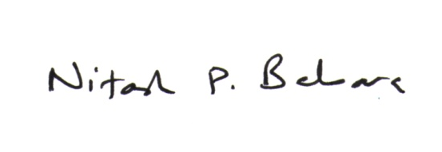
Nitash P. Balsara
Professor of Chemical and Biomolecular Engineering

RESPONSE TO REFEREE'S REPORTS
Editorial comments:

Comment 1: Please take this opportunity to thoroughly proofread the manuscript to ensure that there are no spelling or grammar issues. The JoVE editor will not copy-edit your manuscript and any errors in the submitted revision may be present in the published version.

The manuscript was proofread before submission.
Comment 2. Please be consistent with Journal titles, either abbreviate them all or spell them out entirely.

The references section was edited so that all of the journal titles appear as abbreviations.
Comment 3. Please ensure that all text in the protocol section is written in the imperative tense as if telling someone how to do the technique (e.g., “Do this,” “Ensure that,” etc.). The actions should be described in the imperative tense in complete sentences wherever possible. Avoid usage of phrases such as “could be,” “should be,” and “would be” throughout the Protocol. Any text that cannot be written in the imperative tense may be added as a “Note.” However, notes should be concise and used sparingly. Please include all safety procedures and use of hoods, etc.

The steps of the procedure were reworded to the imperative tense. Notes were used sparingly and only when expressly relevant to the procedural call.
Comment 4. The Protocol should contain only action items that direct the reader to do something. Please move the discussion about the protocol to the Discussion.

The steps of the protocol were reworded to only contain action items for the reader.
Comment 5. The Figure Legends should include a title and a short description of the data presented in the Figure and relevant symbols. The Discussion of the Figures should be placed in the Representative Results. Details of the methodology should not be in the Figure Legends, but rather the Protocol.

The Figure Legends were shortened to include only descriptions of the data shown in the Figure.

