Submission ID #: 52914

Editor Name: Michael Linnes

Videographer name: Justin Eeles

Film Date: Sept. 18th, 2015

Authors and Affiliations: Himanshu Kathuria¹, Jaspreet Singh Kochhar¹, Hui Min Michelle Fong¹, Michinao Hashimoto², Ciprian Iliescu³, Hanry Yu^{3,4,5} and Lifeng Kang¹

¹ Department of Pharmacy, National University of Singapore, ² Singapore University of Technology and Design, ³ Institute of Bioengineering and Nanotechnology Agency for Science, Technology and Research, ⁴Department of Physiology, Yong Loo Lin School of Medicine, National University of Singapore, ⁵ Mechanobiology Institute, National University of Singapore

Title: Polymeric Microneedle Array Fabrication by Photolithography

Corresponding Author:
Kang, Lifeng
Department of Pharmacy
National University of Singapore
Singapore 117543
lkang@nus.edu.sg
Tel.: +65 6516 7519
Fax: +65 6516 6779

Co-authors:
himanshukathuria01@nus.edu.sg

A. Will you require JoVE to record video microscopy, such as filming a complex dissection or microinjection technique? (Y/N)__NO
B. Does your protocol include detailed, step-by-step, descriptions of software usage? (Y/N)__No
C. Which steps of your protocol will viewers benefit most from having filmed? Please list 4-6 steps using the step numbers listed in this document. ___3.3 to 3.7___________________________
D. What is the single most difficult aspect of this procedure and what do you do to ensure success? Please list the steps using the step numbers listed in this document.____2.10_______________
E. Will the filming need to take place in multiple locations? (Y/N) __YES___ If yes, how far apart are the locations? _5-10 min walk way_

1. Introduction (Schematic Overview and Interview)

A. Schematic Overview (read by voice talent at JoVE):

Procedural Narrative:
The overall goal of this procedure is to fabricate a sharp polymeric micro-needle array which may provide potential applications in the painless delivery of low molecular and macromolecular therapeutic agents through the skin. (Intro)

This is accomplished by first fabricating a photomask consisting of embedded micro-lenses via patterned isotropic etching. (P1: Show the described animation spaced evenly throughout the first statement. Start with the Glass wafer only, then add the red layer and label it “Cr/Au Layer”, then add a blue layer and label it “Positive Photoresist”. Next, add the green layer and label it “Photoresist”. Then, add the arrows and label them “UV Irradiation”. Have the blue and red layer beneath the arrows disappear as shown in the 4th step of the process. Then add the silicon wafer (grey) and label it “Dummy Silicon Wafer”. Next growth the lenses in the yellow layer as shown in the 6th and 7th steps to form the lenses. Label them “Micro-lenses”)

The second step is to fabricate microneedle shafts by placing the embedded photomask over a bath of prepolymer solution and focusing UV light into the solution through the microlenses, polymerizing the exposed solution. (P2: Flip the “photomask” over and show it shrinking into the black rectangle with white circles. Place this black rectangle with white circles over the prepolymer solution which should fill the space between the mold that is shown. This point should be completed by the words “prepolymer solution”. Next, show arrows coming down from above and label them “UV light”. When the arrows appear show a blue triangle forming below each circle on the bottom row of the photomask. Make this triangle a darker blue than the “prepolymer solution”.)

The final step is to fabricate the backing layer to support the microneedle shafts. This is accomplished by placing the micro-needles, pointy side up, into a plate, then adding a prepoymer solution and polymerizing the solution with UV light. (P3: Remove the black rectangle with pointy blue triangles from the mold as shown and place it into the beaker by the word “into a plate. Then add a liquid on top of the microneedles by the word “solution”. Again add arrows pointing straight down onto the sample and label them “UV Light”. At the end, remove the outline of the dish and shown the microneedles with the attached backing.)

Ultimately, the characteristic properties of the micro-needles including length, diameter, and the apex angle can be observed using a stereomicroscope. (P4: Show the long needle example on the left and the short needle example on the right side of the screen.)

(If any of this is unclear, please feel free to email the Scriptwriter: Michael.linnes@jove.com)
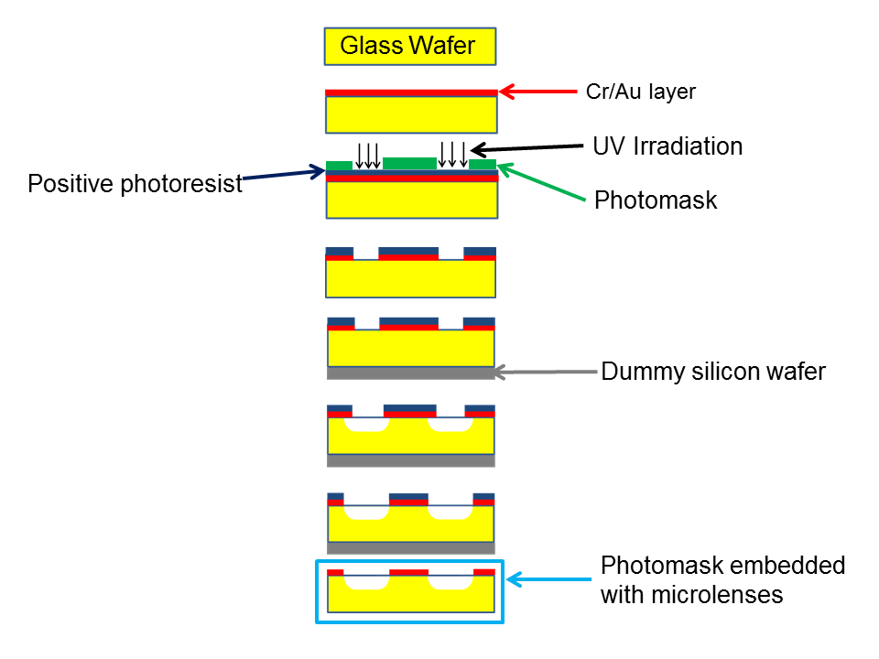
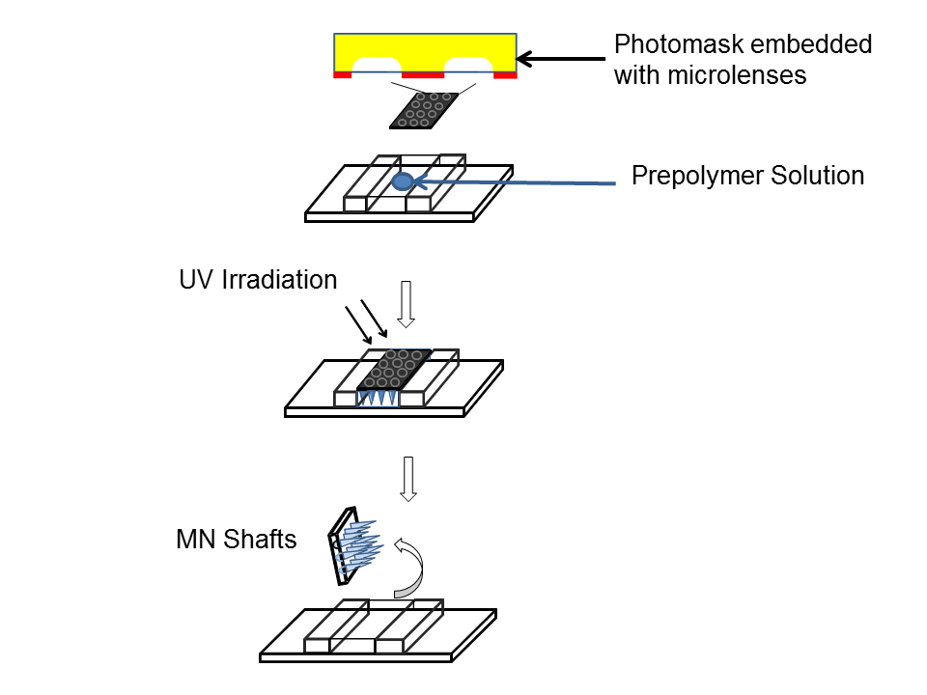
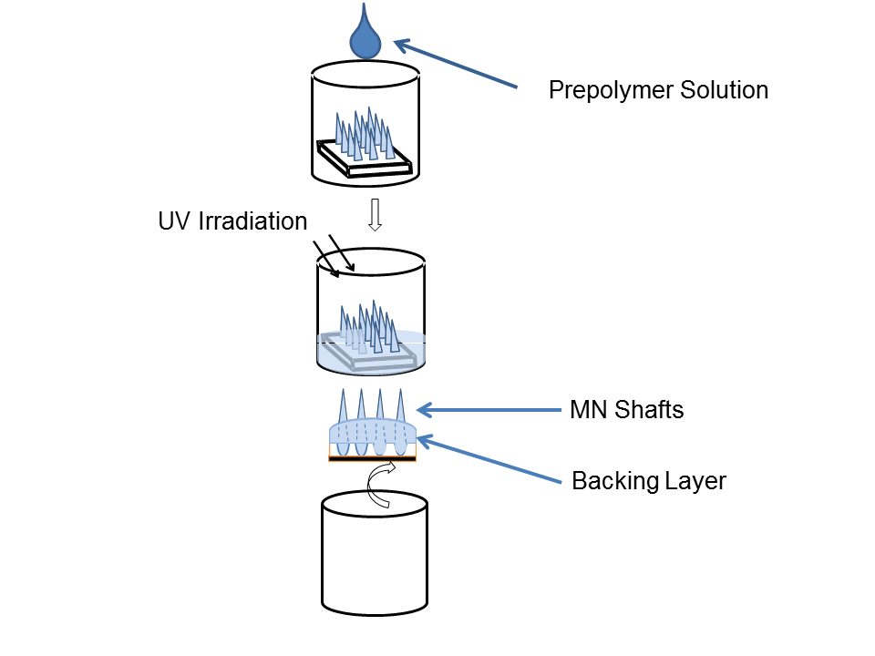
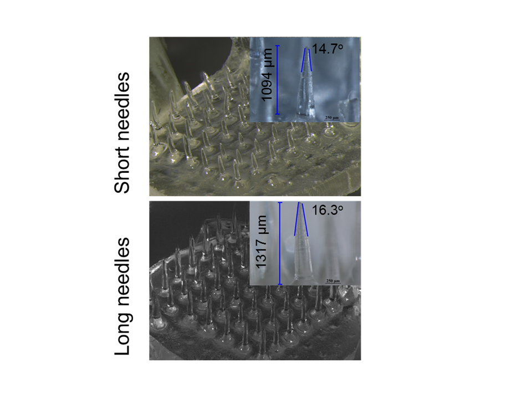
B. Interview: (Said by you on camera. Don’t forget to smile!)

  - Himanshu Kathuria: The main advantage of this technique over existing methods, like micro molding, is that it is mold-free process, it is faster, and does not require the use of high temperature.
  - Himanshu Kathuria: This method can help answer key questions in microfabrication, such as the microlenses to modify the path of UV light and the polymerization process.
  - Kang Lifeng: This technique can be used to fabricate polymeric microneedles which are used for transdermal drug delivery.
  - Kang Lifeng: Although we only demonstrate blank microneedle fabrication, this technique can also be applied to fabricate the drug loaded microneedle.

(CU - Close up; ECU - Extreme close up; MED - medium shot; SCOPE - microscopy footage; SCREEN - screen capture software).
Protocol (read by voice talent at JoVE):
- Photomask Fabrication
  - Begin cleaning a 4 inch glass wafer by immersing it into a quartz tank filled with piranha solution for 20 minutes at 120 °C. [2.1.1 - MED - TXT] Then, rinse the wafer in distilled water and dry it using compressed air. [2.1.2 - CU]
    - *Film as written (TEXT: Piranha Solution: 2:1 ratio of H₂SO₄ : H₂O₂)
    - *Film as written

2.2.1. Presenting the wafer through camera
  - Next, place the wafer into an e-beam evaporator [2.2.1 - MED] and pull a vacuum until the chamber reaches 5x 10⁻⁶ Torr. [2.2.2 - CU - TXT] Then, turn on the 10 kV power source and, with the shutter in the “off” position, pre-clean the chromium source for 30 seconds using the e-beam gun. [2.2.3 - CU]
    - *Film as written.
    - Talent turns on vacuum. (TEXT: 5 x 10⁻⁶ Torr)
    - *Film as written
  - Once clean, open the shutter using the monitor control panel and deposit a 30 nm layer of chromium onto the wafer. [2.3.1 - CU] Next, switch to the gold source, [2.3.2 - CU] pre-clean the gold source for 30 seconds, and then deposit a 1 micron layer of gold onto the wafer. [2.3.3 - CU]
    - *Film as written
    - Talent switches to the gold source
    - Talent pre-cleans (last few seconds), then switches to deposit the gold layer
  - When finished in the e-beam evaporator, place the wafer into a spin-coater setup and add 5 mL of a photoresist to the center of the wafer. [2.4.1 - CU] Spin the wafer at 3000 rpms for 30 seconds to produce a 2 µm thick photoresist layer. [2.4.2 - CU - TXT]
    - *Film as written
    - [combined with 2.4.1] *Film as written (TEXT: 3000 RPMs, 30 sec)
  - Next, prebake the photoresist on a hotplate at 100 °C for one and a half minutes [2.5.1 - MED] and then place the master photomask [2.5.2 - MED - LM] and wafer into the photomask aligner and expose the wafer.[2.5.3 - CU - TXT]
    - Talent places the wafer onto the preheated hotplate.
    - Talent places photomask into aligner. (Video Editor: Show Figure 2e (photomask) as an inlay and label it “Photomask”)
    - *Film as written (TEXT: Expose @ 11 mW/cm² for 12 sec)
  - Once exposed, hard bake the photoresist at 120 °C for 30 minutes on a hot plate. [2.6.1 - MED - TXT]
    - Talent places wafer onto a preheated hot plate. (TEXT: 120 °C for 30 min)
  - Then, etch the pattern into the glass wafer using a solution of chromium and gold etchants at room temperature for 1 hour.[2.7.1 - CU - TXT]
    - Talent places the wafer into the etchant. (TEXT: RT for 1 hr)
  - Place the etched glass wafer on a hot plate at 110 ºC and melt wax on the opposite side of the glass wafer so that the entire surface of the wafer is covered with wax. [2.8.1 - CU]
    - *Film as written
  - Temporarily bond the glass wafer to a dummy silicon wafer by placing a silicon wafer in contact with the glass wafer and pressing firmly to remove the excess wax. [2.9.1 - CU]
    - *Film as written
  - Next, prepare a 200 mL bath of 10 parts 49% hydrofluoric acid and 1 part 37% hydrochloric acid in a plastic container with a magnetic stirrer. [2.10.1 - MED - TXT] Add the sample and etch the micro-lenses at a rate of 7 μm/min for eight and a half minutes while stirring.[2.10.2 - CU]
    - *Film as written (TEXT: 10 parts 49% HFL : 1 part 37% HCL)
    - *Film as written
  - When finished, clean the wafer using deionized water and dry it at room temperature. [2.11.1 - CU]
    - Talent rinses the sample in DI Water and sets it aside to dry.
  - Once dry, place the wafer onto a hot plate preheated to 100 °C for 15 seconds. [2.12.1 - CU - TXT] Then, separate the glass wafer from the dummy silicon wafer. [2.12.2 - CU]
    - *Film as written (TEXT: 100 °C for 15 sec)
    - With the sample starting on the hot plate, remove the sample and separate the layers.
  - Place the glass wafer into an ultrasonic tank containing N-methyl-2-pyrrolidone at 80 °C and use ultra-sonication for 1 hour [2.13.1 - CU] to remove the remaining wax, the photoresist, and the overhanging chromium and gold layers at the edges of the lenses. [2.13.1 - CU]
    - Talent places the wafer into the tank and starts the ultra-sonication.
    - Talent removes cleaned wafer from the tank. (Video Editor: Do a time-wipe animation between the two clips in this step.)
  - Next, use standard techniques to create a PDMS mold replica of the microlenses that were fabricated on the photomasks. [2.14.1 - CU] Characterize the photomask dimensions using a scanning electron microscope [2.14.2 - MED] and the PDMS microlenses using a stereomicroscope. [2.14.3 - MED]
    - Talent performing one of the steps involved with creating the PDMS mold replica.
    - Talent places the sample into a SEM chamber. (Videographer: Skip if necessary and only shoot step 2.14.3)
    - Talent looks through stereoscope at the lenses
- Micro-needle Shaft Fabrication
  - Stack glass slides on either side of a rectangular shaped cavity to set the maximum height of the microneedles.[3.1.1 - CU - TXT]
    - Talent places pre-polymer and then glass slides onto the base. (TEXT: Cavity: 2.5 cm × 0.9 cm)
  - Secure each layer of the glass slide by applying a thin layer of pre-polymer solution onto the glass slides in between each layer. [3.2.1 - CU - TXT] When finished, irradiate the set up with a high intensity ultraviolet light for 2 seconds to fix the slides into place. [3.2.2 - CU]
    - Talent adds more pre-polymer solution and then a 2nd layer of glass slide onto each side. (TEXT: Pre-polymer Solution: Poly-(ethylene glycol) diacrylate, 0.5% 2-hydroxy-2-methyl-propiophenone)
    - *Film as written
  - Next, position the photomask so that the chromium-gold coated surface is facing the interior of the cavity. Ensure that the sides of the cavity walls are not obscuring the lenses embedded in the photomask. [3.3.1 - CU]
    - Talent sets the photomask down onto the cavity and adjusts it so the walls are not obscuring the lenses.
  - Fill the cavity with the prepolymer solution until the chromium-gold coated surface comes into contact with the solution without any visible bubbles. [3.4.1 - CU]
    - *Film as written
  - Then, place the setup into a UV curing station and place a radiometer next to the setup to measure the intensity of the UV light. [3.5.1 - CU] Irradiate the setup with high intensity UV light between 320 and 500 nm for 1 second at a distance of 3.5 cm from the UV source. [3.5.2 - CU - TXT]
    - Talent places the setup and radiometer under the UV light setup.
    - *Film as written (TEXT: *Vary UV intensity to adjust microneedle characteristics)
  - Following UV exposure, remove the photomask with the array of micro-needles [3.6.1 - MED] and pour the excess prepolymer solution back into its original container for reuse. [3.6.2 - CU]
    - *Film as written
    - *Film as written
  - Quantify the length and tip diameter of the micro-needles using a stereomicroscope using standard techniques. [3.7.1 - MED]
    - Talent looks through stereoscope at microneedles.
- Micro-needle Backing Layer Fabrication
  - With forceps, place the micro-needles attached to the photomask into a well of a 24-well plate, needle side up. [4.1.1 - CU]
    - *Film as written
  - Add 300 to 400 μL of the prepolymer solution into the well until the needles are submerged to the height of the desired backing layer. [4.2.1 - CU]
    - *Film as written
  - Next, irradiate the setup [4.3.1 - MED] with high intensity UV light measuring 15.1 W/cm² from 10.5 cm away for a duration of 1 second. [4.3.2 - CU -TXT]
    - Talent places sample under UV light.
    - Talent irradiates the sample. (TEXT: 15.1 W/cm², 10.5 cm, 1 sec)
  - Once the backing layer has polymerized, separate the backing layer on the micro-needle array from the photomask using a sharp blade. [4.4.1 - CU]
    - *Film as written
  - Then, quantify the length, tip diameter, and base diameter of the micro-needles with the backing layer using a stereomicroscope. [4.5.1 - MED]
    - Talent looks through stereoscope at the sample.
- Results: Properties of Mold-Free Microneedles
  - The effect of UV intensity on the micro-needle length and tip diameter was studied by varying intensity of the UV light from 3.14 to 15.1 W/cm² at a constant focal length and light source distance. It was found that the average micro-needle length and tip diameter increased with increasing intensity.[5.1.1 - LM]
    - Figure 3 (Video Editor: Show Figure 3a and 3b side by side. Highlight each as mentioned. Highlight the X-axis when the UV intensity is mentioned. With the last sentence add an arrow going up and to the right over each of the graphs.)
  - Shown here are the effects of 300 microliters vs 400 microliters of backing material on the overall length of the micro-needles as well as the fracture force of the needles. [5.2.1 - LM] As expected, with more backing material, the needles are shorter overall, but they also gain additional fracture force due to the extra support.[5.2.2 - LM]
    - Figure 4e-f (Video Editor: Highlight the respective columns when mentioned. Then, highlight Figure E with the words “overall length of the micro-needles” as well as Figure F with the words “fracture force of the needles”.
    - Figure 4e-f (Video Editor: Highlight the “400” columns with the last sentence.)

- Conclusion (said by authors on camera)
  - Kang Lifeng: After watching this video, I hope you have a good understanding of how to fabricate sharp polymeric microneedles using photolithography.
  - Himanshu Kathuria: Once mastered, this technique can be done in 5 to 10 minutes if the photomask is ready and the procedure is performed properly.
  - Kang Lifeng: Please remember that working with hazardous materials such as hydrofluoric acid, and UV rays is extremely hazardous. So, personal protective equipment should be worn at all times.

Provided Media

Authors, Please list all images, movie files, or 3-D rendered animations that can be included in the video per editor’s request. The step in the script/video where these images will be inserted should be specified. For example:

6.2 – 0123_PIname_Figure1.tif - dual color imaging of tumor angiogenesis at 40X
6.2 – 0123_PIname_Figure2.tif - dual color imaging of tumor angiogenesis at 100X

Formats: For static images we prefer .tiff, .eps, Illustrator, Powerpoint or Photoshop files at dimensions of at least 720X480 pixels and 300 dpi. The higher resolution, the better. Likewise any exported movie files should have at minimum these dimensions and be rendered to .mov, .mp4, or .avi files.

Insert your media filenames here.

General Preparation

It’s critical for a smooth and organized shoot that all reagents are accounted for, in advance.

Any overnight or long incubation steps should be recognized and specimens/samples be prepared in advance so that prior steps can be recorded and shooting can continue with pre-prepared specimens/samples.

All tubes/flasks should be pre-labeled neatly before we arrive.

Ex. Luciferase assay done in 96 well plates should be labeled with negative/positive control wells and experimental samples are labeled accordingly.

You will receive more detailed preparation instructions, as well as an introduction to your videographer, closer to your filming date.

