Submission ID #: 52913

Editor Name: Andy Fan

Videographer name: Brandon Hutchinson

Film Date: 3/26/15 (Thurs)

Authors and Affiliations: Yuhan Yao, He Liu, Wei Wu

Department of Electrical Engineering, University of Southern California, Los Angeles, CA

Title: Fabrication of High Contrast Gratings for the Spectrum Splitting Dispersive Element in a Concentrated Photovoltaic System

Corresponding Author:

Dr. Wei Wu

Department of Electrical Engineering

University of Southern California

Los Angeles, CA

Wu.w@usc.edu

Co-authors:
yuhanyao@usc.edu
heliu@usc.edu

Authors, please fill out the brief questionnaire below.

A. Will you require JoVE to record video microscopy, such as filming a complex dissection or microinjection technique? (NO)_________ (If you can record images/videos using your own camera/software, then mark No) If yes, please list make and model of your microscope: _____________________________________________
B. Does your protocol include detailed, step-by-step, descriptions of software usage? (No. ) If yes, we will need you to record using to QuickTime X capture the steps. If you use a Mac, QuickTime X also has the ability to record the steps.

C. Which steps of your protocol will viewers benefit most from having filmed? Please list 4-6 steps using the step numbers listed in this document. 1.2), 3, 4, 6, 7

D. What is the single most difficult aspect of this procedure and what do you do to ensure success? Please list the steps using the step numbers listed in this document._ All steps should be reliable

E. Will the filming need to take place in multiple locations? (Yes – inside and outside the cleanroom). If yes, how far apart are the locations? (Both lab spaces are within the same building)
______________________________________________
1. Introduction (Schematic Overview and Interview)

A. Schematic Overview (read by voice talent at JoVE):

Conceptual Narrative:

The overall goal of the following experiment is to demonstrate the fabrication of the high contrast, spectrum-splitting element in a concentrated photovoltaic system. (Intro)

This is achieved by performing PDMS (pronounced “P-D-M-S”) nano-imprint lithography over a titanium dioxide glass substrate covered with a layer of UV curable photoresist (pronounced “photo-resist”). (P1: When the words “PDMS nano-imprint” are spoken, animate the sequence of events in Panel 1a, 1b, and 1c, where the surface relief of the green PDMS mold is mechanically transferred onto the orange photoresist layer of the bottom substrate)

As a second step, the residual nanoimprint photoresist is etched away…and a patterned chromium hard mask is produced using lifted off techniques. (P2: When the words “is etched away” are spoken, make Panel 2a appear. Immediately afterwards, eliminate the orange recessed regions in Panel 2a such that two blue substrate regions are now “exposed” to air. Then, when the word “chromium” is spoken, make a layer of chromium metal “rain down” onto the previous structure. This will form the structure depicted in Panel 2b. Finally, when the words “lift-off” are spoken, delete any orange photoresist layers, along with any corresponding chromium over-layers, such that the structure in Panel 2c is formed. Keep this structure for the next set of animations.)

Next, reactive ion etch is used to form the titanium dioxide and glass grating array. (P3: When the words “reactive ion etch” are spoken, etch the “exposed” blue substrate regions. Immediately afterwards, make the remaining chromium metal layers disappear. The resulting structure will equate to Panel 3).

Based on measurement results from a spectrometer, the fabricated high contrast grating exhibits a broadband reflectance that can be used as dispersive elements in a concentrated photovoltaic system. (P4: When the words “Based on the measurements” are spoken, make Panel 4a appear, but only show the red “sphere” data trace in that plot. Then, when the words “can be used as dispersive elements” are spoken, keep Panel 4a and make Panel 4b appear. Then, shrink Panel 4a and, at the same time, translate the shrinking Panel 4a to the “Dispersive element” block in Panel 4b.)

P1b
P1c
P1a

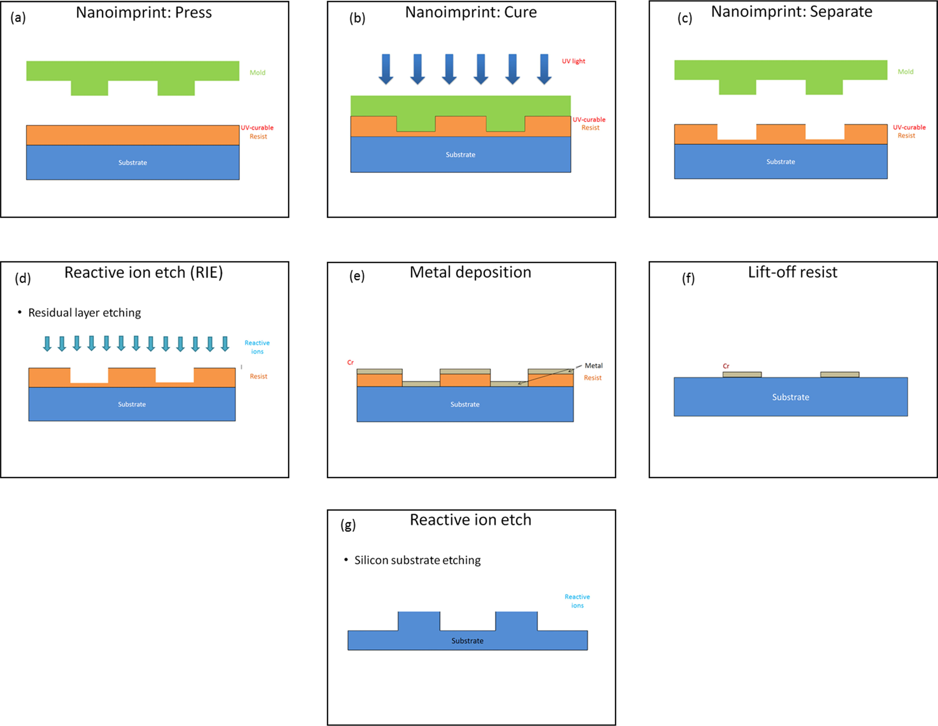
P3
P2c
P2b
P2a

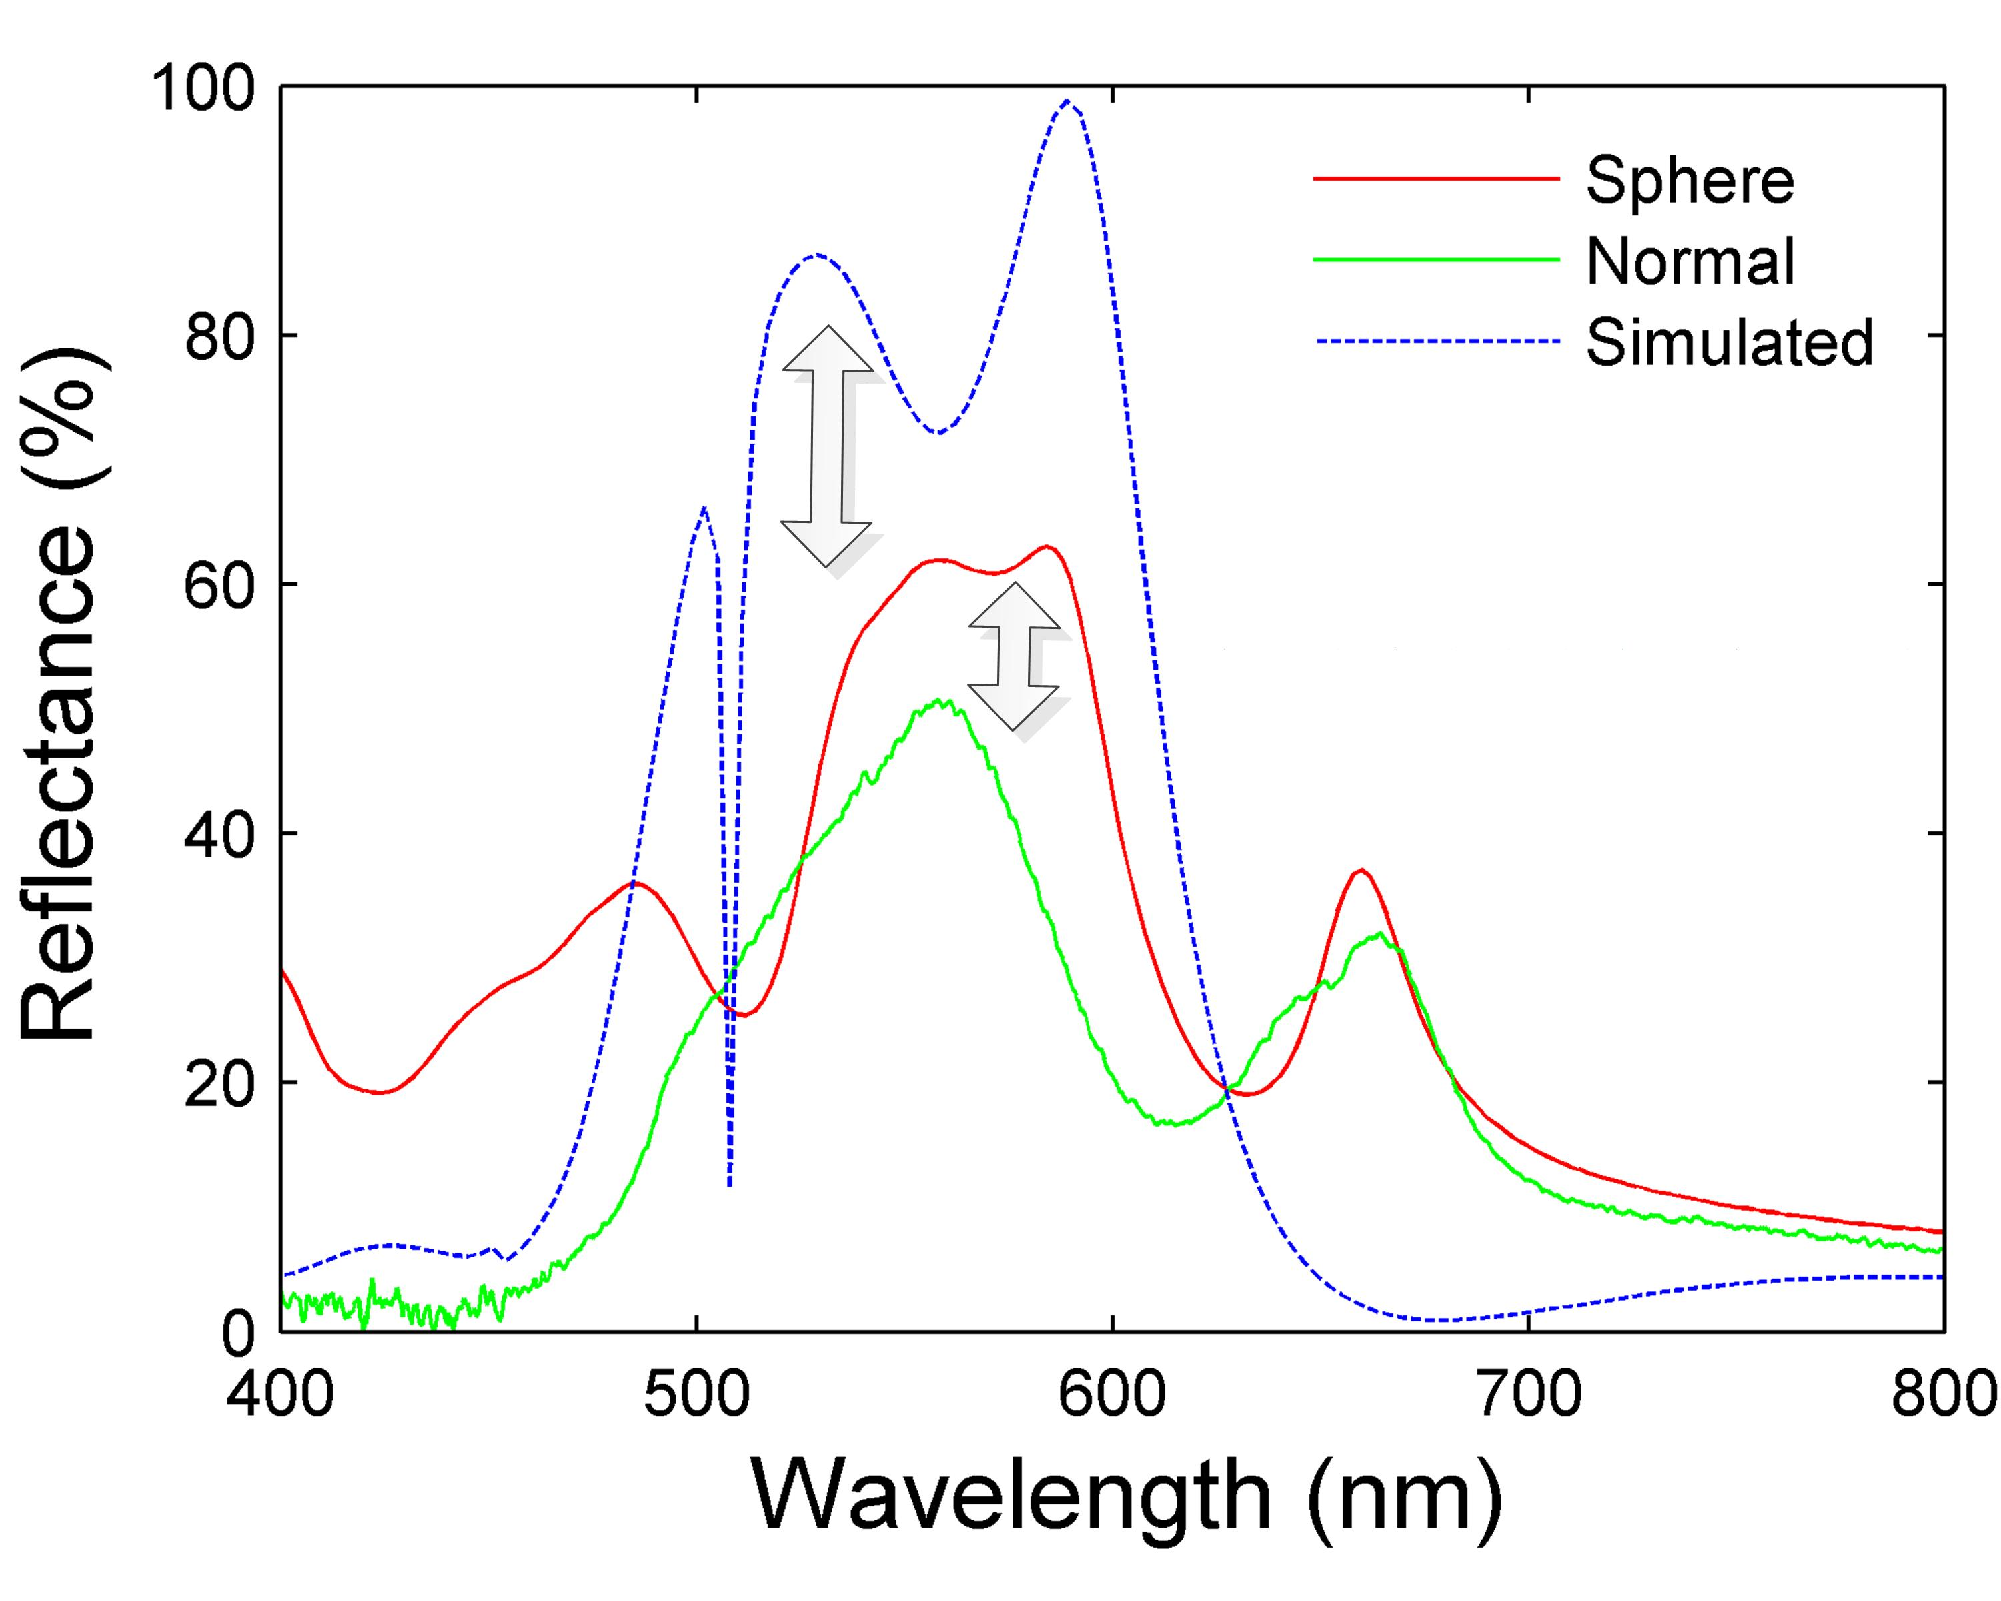
P4a

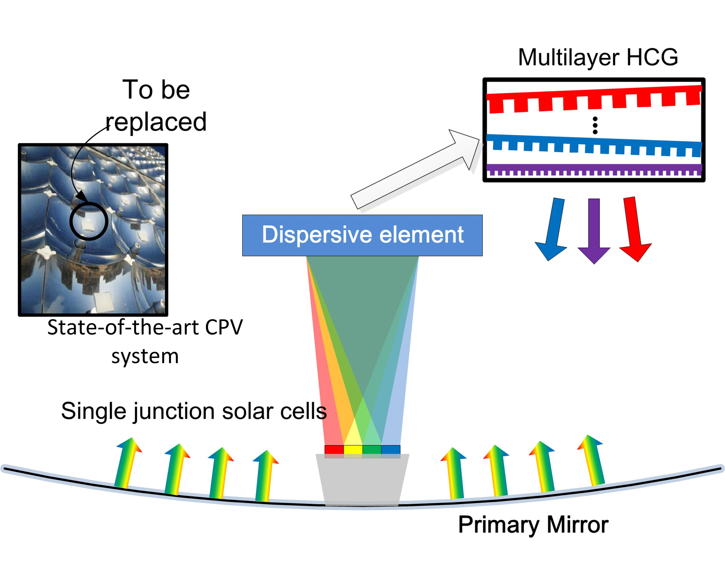
P4b

B. Interview: (Said by you on camera. Don’t forget to smile!)

Only one statement should be chosen and completed per author

1.1. Wei Wu: We first had the idea for this method when we discovered that, unlike traditional diffraction gratings, these titanium dioxide high contrast gratings exhibit an exotic broadband reflectance profile. Therefore, we can use it to build a spectrum-splitting, dispersive element that would enhance the energy absorption of single junction solar cells.

1.2. Yuhan Yao: The main advantage of this technique over existing methods, such as using expensive multi-junction solar cell technology to absorb broadband solar light, is that the gratings offer higher absorbance efficiencies at a lower fabrication cost.

1.3. He Liu: Nanoimprint lithography is a low-cost, high-yield fabrication technology that is suitable for fabricating large-area high contrast gratings

Protocol (read by voice talent at JoVE):

- Synthesis of the PDMS mold base
  - To begin the microfabrication process, place a clean silicon wafer into a glass vacuum desiccator… [2.1.1 – MED] and add 1 drop of liquid trichlorosilane (pronounced “tri-chloro-sigh-lane”) into a small beaker inside the desiccator [2.1.2 – MED-TXT].
    - Film as written
    - Film as written, (TEXT: 1 drop ~ 50 μL of liquid)
  - Close the desiccator lid…, and evacuate the chamber until the gauge dips below 1 atmosphere [2.2.1 – MED-TXT]. Then, shut off the source vacuum regulator, and allow the vaporized silane solution to coat the wafer surface for 5 hours under static vacuum [2.2.2 – MED]. After the treatment, release the vacuum and take the wafer out of the desiccator [2.2.3 – MED]
    - Film as written, (TEXT: Vacuum level ~ -762 torr, or approximately -15 psi).
    - After the vacuum regular is shut off, this should become a still shot for 1-2 seconds that signifies the subsequent, prolonged silane vaporization step under static conditions.
    - Film as written
  - Next, measure 10 g of PDMS and 1 g of PMDS curing agent in a medium-sized beaker [2.3.1 – MED]. Mix both parts evenly with a glass rod… [2.3.2 – MED], and place the dish inside a vacuum desiccator for 20 to 30 minutes to degas all bubbles from the mixture [2.3.3 – MED/CU]
    - Film as written
    - Film as written
    - This shot should be focused on the formation of bubbles on the surface of the PDMS during vacuum degassing
  - After degassing, place the wafer into a plastic petri dish… [2.4.1 – MED], and slowly pour the PMDS onto the silicon wafer [2.4.2 – MED-TXT]. Transfer the wafer into a vacuum oven… and cure the PDMS for 7 hours at 80ºC [2.4.3 – MED]. Finally, take the solidified PMDS out of the oven, and let the polymer film cool to room temperature [2.4.4 – MED].
    - Film as written
    - Film as written, (TEXT: Avoid bubble formation while pouring).
    - If visible, please include the temperature gauge of the vacuum oven (showing it’s at 80ºC) in this shot.
    - Film as written
- Constructing the PDMS Nano-imprinting mold
  - Starting with another piece of silicon wafer, place the substrate onto a spin coater chuck…, dispense 12 drops of UV-curable photoresist on the wafer…, and spin-coat the resist at 1500 rpm (pronounced “R-P-M”) for 30 seconds [3.1.1 – MED-TXT].
    - Please shoot the entire sequence (wafer placement, dispensing the photoresist, and then turning on the spin chuck) in one shot, (TEXT: 12 drops of resist ~ 600 μL)
  - While the photoresist is still wet, carefully remove a section of the cured PDMS from the previous wafer… [3.2.1 – MED], and gently press the PMDS onto the UV-curable resist. Allow the PDMS to remain in contact with the photoresist for 5 minutes [3.2.2 – CU], and carefully peel the PDMS from the photoresist substrate [3.2.3 – MED].
    - Film as written
    - The talent presses the PDMS onto the UV-curable resist and then leaves the PDMS-wafer combination on the lab bench. Stay with the still shot for 1-2 more seconds that suggest a “5 minute” incubation thereafter.
    - Film as written
  - To create an imprint of grating features onto the soft photoresist layer, gently press the PDMS film onto an existing silicon master mold containing the negative relief features of interest [3.3.1 – MED]. Place the PDMS-silicon master combination into a UV oven [3.3.2 – MED], and turn on the UV lamp to cure the soft, sandwiched photoresist layer for 5 minutes under a nitrogen atmosphere [3.3.3 – MED].
    - Film as written
    - Film as written
    - This should be a still shot of the PDMS-silicon master combo being irradiated inside an UV oven.
  - After curing, peel the PDMS mold from the silicon master wafer [3.4.1 – MED]. As a result, the PDMS surface should now contain a thin layer of cured photoresist with surface relief corresponding to the nano-grating features [3.4.2 – MED]
    - Film as written
    - If possible, please try to shoot at different angles and see if the cured layer of photoresist that’s covering the PDMS surface is visible.
  - Finally, treat the cured photoresist surface with a quick RF (pronounced “R-F”) oxygen plasma clean [3.5.1 – MED-TXT]. Then, place the PDMS mold in a vacuum desiccator… and incubate with 1 drop of trichlorosilane for 2 hours [3.5.2 – MED]. The features on the PMDS – photoresist nano-imprinting mold are now ready to be pattern-transferred onto any given substrate [3.5.3 – LM].
    - With the wafer already inside the plasma etcher, try to see if the white plasma glow can be filmed through the viewport of the etch chamber. (TEXT: RF Power: 30 W, Pressure = 260 mtorr, time = 1 min).
    - Film as written
    - Figure 6: Make only the green mold block in panel A of Figure 6 appear
- Nano-imprint pattern transfer onto TiO2 – glass substrates
  - To begin, place a fused silica device wafer, complete with a 340 nanometer layer of sputtered titanium dioxide on its surface, onto the spin coater chuck. Dispense 8 drops of PMMA (pronounced “P-M-M-A”) on the wafer…, and spin-coat the substrate at 3500 rpm for 50 second [4.1.1 – MED-TXT]. Transfer the wafer onto a pre-heated hot plate set at 120ºC, and hard-bake the PMMA for 5 minutes [4.1.2 – MED].
    - Please shoot the entire sequence (wafer placement, dispensing the PMMA, and then turning on the spin chuck) in one shot, (TEXT: Target PMMA thickness ~ 1 mm)
    - Film as written
  - After cooling the wafer to room temperature, place the device substrate back onto the spin chuck.., apply 8 drops of UV curable resist on the wafer surface…, and spin-coat the second layer of resist at 1500 rpm for 30 seconds [4.2.1 – MED]. The resulting device wafer is ready for the nano-imprinting transfer step [4.2.2 – LM].
    - Please shoot the entire sequence (wafer placement, dispensing the UV-curable photoresist and then turning on the spin chuck) in one shot.
    - Figure 6: Make Panel A of Figure 6 appear in its entirety (the green, orange, and the blue substrate)
  - While the UV resist is still wet, gently place the nano-imprinted PDMS mold, with the cured resist feature side facing down, into contact with the soft UV resist surface [4.3.1 – CU]. Place the entire sandwich into a UV oven [4.3.2 – MED], and cure the wet resist layer under UV illumination for 5 minutes under a nitrogen atmosphere [4.3.3 – MED]. Once the UV resist is cured, peel the PDMS mold off the device wafer [4.3.4 – MED].
    - Film as written
    - Film as written
    - Film as written
    - Film as written
  - To remove the remaining UV resist residing within the recessed regions of the grating features, transfer the wafer into an inductive-coupled plasma etcher [4.4.1 – WIDE]… and run the UV resist etch recipe with oxygen plasma for 2 minutes [4.4.2 – MED-TXT]. At the end of this step, the PMMA underlayer should now be exposed at the recessed regions of the nanostructure [4.4.3 – LM].
    - Film as written
    - With the wafer already inside the plasma etcher, try to see if the white plasma glow can be filmed through the viewport of the etch chamber. (TEXT: Etch recipe found in Table 1)
    - Figure 6: Make panel (d) appear
  - In order to remove the exposed PMMA layer and uncover the titanium dioxide film underneath, choose the PMMA etch program from the etcher console [4.5.1 – MED-TXT] and apply the oxygen plasma treatment for 2 minutes. At this moment, the device wafer is ready for metal deposition and patterning steps that would define the final features of the nano-grating. [4.5.2 – CU].
    - The talent changes the etch recipe from the computer console (TEXT: Etch recipe found in Table 1)
    - This should be a still shot of the device wafer itself under white light illumination. At this point, the wafer should exhibit a metallic cast that’s coming from the exposed titanium dioxide regions of the grating pattern.
- Metallization, liftoff, and final grating definition
  - To create the chromium etch mask on top of the titanium dioxide, first unload the wafer from the plasma etcher… [5.1.1 – MED] and transfer the substrate into an electron-beam metal evaporator containing a chromium source [5.1.2 – WIDE]. After chamber evacuation, melt the metal source and deposit 20 nanometers of chromium at a rate of 0.03 nanometers per second [5.1.3 – CU-TXT].
    - Film as written
    - The talent is in the process of loading the wafer onto an empty slot on the evaporator’s planetary wafer holder.
    - If possible, it would be great if the molten chromium metal can be filmed through the viewport of the evaporator. What one should see is an electron beam moving in a “figure 8” pattern inside the metal crucible containing the molten pool of chromium. (TEXT: Chamber pressure ~ 10⁻⁷ torr).
  - Unload the wafer from the e-beam (pronounced “E – beam”) evaporator and immerse the substrate in an acetone-filled glass container [5.2.1 – MED]. Then, place the container inside an ultrasonic tank [5.2.2 – MED].
    - Film as written
    - Film as written
  - Actuate the ultrasonic tank for 5 minutes at room temperature [5.3.1 – MED]. By applying ultrasonic agitation to the wafer, the solvent will quickly dissolve the underlying PMMA layer [5.3.2 – LM], thereby releasing any chromium that was not already in intimate contact with the titanium dioxide surface. As a result, the array of stable chromium patterns left on the wafer will define the final geometry of the grating [5.3.3 – CU].
    - For this shot, it would be great if the surface ripples at the liquid interface can be captured on film.
    - Figure 6: Make panel (e) appear. When the words “quickly dissolve” are spoken, make both the orange resist layers and the chromium layer that’s located on top of the orange resist layers disappear.
    - This shot should be focused on the device wafer itself, where bits and pieces of chromium are being shed from the wafer surface due to both the solvent attack and the ultrasonic agitation. extend lab media from 5.3.2
  - Using tweezers, take the device out of the acetone bath [5.4.1 – MED], and remove all traces of PMMA and loose metal filings with a rinse sequence of acetone… [5.4.2 – MED], methanol…, and isopropanol. Dry the wafer with a gentle stream of nitrogen or compressed air [5.4.3 – MED], and briefly check for any wafer defects under a microscope [5.4.4 – CU].
    - The talent takes the device wafer out of the acetone bath and places it into a clean glass container.
    - The talent takes a squirt bottle (usually a clear plastic bottle with red-lettering on it) and rinses the wafer with acetone. Then, the talent decants the supernatant into a solvent waste container.
    - Film as written
    - This should be a still shot of the device wafer in which all excess bits of chromium have been removed by the solvent washes. The wafer should exhibit an overall gray or white metallic luster due to both the chromium and the exposed titanium dioxide layers.
  - Then, load the wafer into the plasma etcher and commence the titanium dioxide etch recipe [5.5.1 – MED-TXT]. Unload the wafer after the etch, and verify the removal of the exposed titanium dioxide layer under the microscope [5.5.2 – CU]
    - With the wafer already inside the plasma etcher, try to see if the light purple-to-magenta plasma glow from the SF6 and C4F8 gasses can be filmed through the viewport of the etch chamber. (TEXT: Etch recipe found in Table 1)
    - This should be a still shot of the device wafer in which the titanium dioxide layer has been removed. Theoretically, the luster of the wafer should change from that of shot 5.4.6.
  - To define the glass sub-grating features underneath the titanium dioxide, reload the wafer into the plasma etcher and commence the silicon dioxide etch recipe [5.6.1 – MED-TXT], unload the substrate, and inspect the wafer for defects under the microscope [5.6.2 – CU].
    - With the wafer already inside the plasma etcher, try to see if the magenta or light pink plasma glow from the C4F8 gas can be filmed through the viewport of the etch chamber. (TEXT: Etch recipe found in Table 1) use one of the angles from 5.5.1
    - This should be a still shot of the device wafer in which part of the silicon dioxide layer has been removed. use one of the angles from 5.5.2
  - Finally, remove the chromium hard-mask with a quick acid etch [5.7.1 – MED-TXT]. The exposed titanium dioxide pattern and the glass recessed trenches both represent the final structure of the high contrast grating [5.7.2 – CU].
    - Film as written (TEXT: Cr-7 chrome etchant)
    - This should be a still shot of the device wafer in which the chromium over-layer has been removed.
- Grating reflectance measurements
  - To measure the broadband reflectance from the titanium oxide grating, begin by turning on the optical measurement system… [6.1.1 – MED] and placing a reference standard mirror on the sample holder [6.1.2 – MED].
    - Film as written
    - Film as written
  - Align the sample holder to the incident beam path [6.2.1 – MED], and calibrate the detector such that the total measured reflectance off of the standard mirror is at a theoretical 100% level [6.2.2 – MED].
    - Film as written
    - Film as written
  - Next, replace the standard mirror with the high-contrast titanium oxide grating [6.3.1 – MED], and commence the broadband reflectance measurement of the device [6.3.2 – MED]. Save the data from the measurement, and log out of the measurement system [6.3.3 – MED].
    - Film as written
    - Film as written
    - Film as written
- Results: Broadband reflectance characteristics of the high-contrast grating
  - While elevating the substrate temperature [7.1.1 – LM] during the metal sputtering process results in a larger titanium dioxide grain size [7.1.2 – LM] and a higher refractive index, its higher surface roughness [7.1.3 – LM] makes it an undesirable top grating material when compared to metal oxide films [7.1.4 – LM] deposited at lower temperatures.
    - Figure 5: Highlight the red 270ºC trace in Figure 5
    - Figure 4/5: Make Panel B of Figure 4 pop out of the 270ºC legend in Figure 5
    - Figure 4: Emphasize the rough metal oxide surface in the pop-up Figure 4b with an arrow
    - Figure 4/5: Highlight the green 27ºC trace in Figure 5, and right afterwards, make Panel A of Figure 4 pop out of the 27ºC legend in Figure 5.
  - When viewed under the electron microscope, the aspect ratio… [7.2.1 – LM], sidewall angle… [7.2.2 – LM], pitch… [7.2.3 – LM], and linewidth of the dual-layer grating structure can be readily seen.
    - Figure 9: Pick one of the pillars in Figure 9 and highlight its height and width using one vertical and one horizontal line, respectively
    - Figure 9: Keep the 2 previous lines and highlight the angle between them.
    - Figure 9: Highlight the horizontal distance from the left edge of one pillar to the left-edge of an adjacent pillar
    - Figure 9: Highlight the width of one of the pillars.
  - Compared with the reflectance data captured with a normal detector [7.3.1 – LM] of small angle of acceptance, a spherical detector [7.3.2 – LM] with a wider angle of acceptance can capture and characterize the grating reflectance and scattering from rougher metal oxide surfaces.
    - Figure 10: Highlight the green “normal” trace in Figure10
    - Figure 10: Highlight the “spherical” trace in Figure 10.
  - As the data suggests, a slight increase in the index of refraction [7.4.1 – LM] can induce a dramatic increase in the reflectance bandwidth. Moreover, as the sidewall angle deviates [7.4.2 – LM] from a perfect right angle, the reflectance bandwidth degrades dramatically.
    - Figure 11: Highlight the red 1”0% increase” trace in Panel A of Figure 11
    - Figure 11: Highlight all traces in Panel B of Figure 11 except for the blue one.

- Conclusion (said by authors on camera)

8.1. Wei Wu: Once mastered, this technique can be done in several hours if it is performed properly. It is important to remember to control the defects during the nanoimprint process.

8.2. Yuhan Yao: After watching this video, you should have a good understanding of how to fabricate large-area, high contrast gratings using nanoimprinting techniques and apply them to a photovoltaic system architecture.

Provided Media

Authors, Please list all images, movie files, or 3-D rendered animations that can be included in the video per editor’s request. The step in the script/video where these images will be inserted should be specified. For example:

6.2 – 0123_PIname_Figure1.tif - dual color imaging of tumor angiogenesis at 40X
6.2 – 0123_PIname_Figure2.tif - dual color imaging of tumor angiogenesis at 100X

Formats: For static images we prefer .tiff, .eps, Illustrator, Powerpoint or Photoshop files at dimensions of at least 720X480 pixels and 300 dpi. The higher resolution, the better. Likewise any exported movie files should have at minimum these dimensions and be rendered to .mov, .mp4, or .avi files.

Insert your media filenames here.
All the figures are the same as in the previous JOVE submission.

General Preparation

It’s critical for a smooth and organized shoot that all reagents are accounted for, in advance.

Any overnight or long incubation steps should be recognized and specimens/samples be prepared in advance so that prior steps can be recorded and shooting can continue with pre-prepared specimens/samples.

All tubes/flasks should be pre-labeled neatly before we arrive.

Ex. Luciferase assay done in 96 well plates should be labeled with negative/positive control wells and experimental samples are labeled accordingly.

You will receive more detailed preparation instructions, as well as an introduction to your videographer, closer to your filming date.

