Sandra Rieger, Ph.D.
Assistant Professor
MDI Biological Laboratory
P.O. Box 35 159 Old Bar Harbor Road
Salisbury Cove, ME 04672
Tel: 207-288-9880 EXT. 472
Fax: 207-288- 2130
URL: www.mdibl.org
E-mail: srieger@mdibl.org

December 9, 2014

Dear Dr. Nguyen,

Pleased find enclosed a revised version of the manuscript entitled “Capturing tissue repair in zebrafish larvae with time-lapse brightfield stereomicroscopy”.

Thank you for the rapid proceedings with our manuscript. We have made the requested changes and corrected some additional errors following the final proofreading. The changes are marked with the “track change” function. We have further updated the Equipment and Materials list. We hope that with this final version, the manuscript and video are acceptable for publication. We would like to submit the finalized JoVE video in a separate file, if possible, due to its large size (~1.2 Gb).
Sincerely,
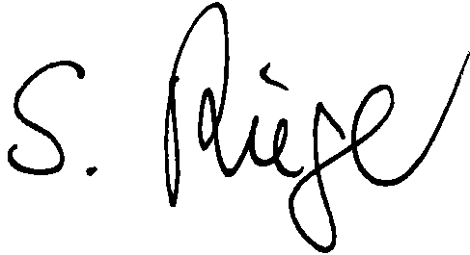

Sandra Rieger, Ph.D.
Assistant Professor

