Request for additional information to guide script writing for your JoVE submission

In order to facilitate the proper filming of your video, a script writer will prepare both a script and a story board from your protocol prior to filming. For many protocols, steps are straight forward and intuitive, describing actions like mixing solutions, turning on equipment, and so forth. In some instances, however, it is not immediately clear from the protocol itself exactly what the best way would be to represent the action / step in the video. This is especially true for steps describing less common equipment, theoretical processes, image processing or data analysis, and the use of computer programs or software.

When the script writer begins planning your video the protocol will act as a rough guide for the video voiceover. Please consider your protocol in this context and ensure that there are no long sections of text that would be awkward or not-feasible to be incorporated into a voiceover. Please note at this time, if you have not already done so, that text highlighting can be used to indicate to the JoVE staff what you would like to include in the video. Highlighting is used for longer protocols due to length constraints, but can also be useful for protocols of any length if there are sections of introductory or explanatory information that you would like to include in the written protocol but may not need to be included in the video (may be too bulky / time consuming). If you are using highlighting in this way, please use yellow text background and highlight a maximum of 2.75 pages total (including spaces between steps). Please contact your editor with any questions regarding protocol highlighting.
Generally, there are three types of visuals that can represent a protocol step in your video: (1) Videographer footage (for instance, a lab member performing the action, footage of a process occurring as recorded from videographer’s microscope attachments) ; (2) screen shots that display the action or the result of the action (for instance, if you describe setting parameters in software, screenshots can demonstrate the interface; if you describe utilizing a program to perform a step a screen shot of the code can accompany the step); (3) a schematic or figure can be displayed to represent the step.
As the goal of JoVE is to visualize methods that cannot be represented optimally in written protocols, we try to avoid having videos with too many screen shots or schematic representations of steps. It is best if actions are filmed live when possible. We understand that many aspects of your work may involve software / programing and the best way to present the protocol may be a combination of both live demonstration and static / animated images. Also please note that an action describing computer / software use should be demonstrated via screen shots, not via videographer footage of a lab member at a computer.
In most cases the determination of the shot list for your video happens later in the JoVE process. However, since there are some steps in your protocol that we are a bit unsure of, we ask that you provide some guidance for us at this time as described below. This way if any changes need to be made to the way the protocol is written or presented, to ensure the best version of your video is made, this can be done prior to peer review. We appreciate you taking the time to provide this information for us and please do not hesitate to contact your editor with any clarifications or questions.
Please note: this request only applies to certain steps in your protocol as listed in the editorial comments.
Please fill in the work sheet below, replacing the examples. For each of the steps requested, please designate which of the options would be the optimal representation for visualizing the step (videographer footage, screen shot or figure). If a single step requires two options (for instance part will be filmed in the lab, part will be shown via a screen shot) please separate the step accordingly in the table (not in the protocol). If a figure from the manuscript will be used please refer to it by number and panel letter. If a screen shot will be used, please add the screen shot after the table along with an identifying title. If the screen shot is not currently available a low resolution version or a brief description of it can be used instead. (Screen shots will not be sent to peer review.)
If edits are made to the protocol later in the review process this guide will not need to be updated unless major changes to the protocol are made. Edits to text segments in this guide will not be reflected in the manuscript.
* Please upload this completed work sheet under the file designation “Supplemental files (as requested by JoVE).*
Supplemental information for JoVE scriptwriter
Please note that the steps should correspond to the steps in the manuscript text.
Step # | Text | Visual representation
3.0 | AF ablation with the cryoballoon catheter | Still frame title introduction- Medtronic graphic will be supplied of equipment
3.3 | Introduce the cryoballoon catheter over the guidewire, through the steerable sheath, and into the LA chamber. | Videographer footage of lab member
3.5 | Obtain pulmonary vein-to-balloon occlusion by pushing the balloon towards the PV antrum while using fluoroscopy guidance. | Videographer footage of lab member
3.6 | Confirm PV-to-balloon occlusion by using radiopaque contrast agent and imaging with fluoroscopy. | Videographer footage of lab member
3.6.3 | Detect a non-occlusive balloon position by observing the presence of contrast agent leakage into the LA chamber. | Videographer footage of lab member
3.7 | Establish each subsequent PV-to-balloon occlusion at the antral surface of the LA using fluoroscopy. | Videographer footage of lab member
3.7.1 | When PV-to-balloon occlusion is established, freeze each PV for a minimum of two applications (freeze-thaw-freeze) with each lasting at least 180 seconds. | Videographer footage of lab member
3.7.2 | Ensure that cryoballoon nadir temperatures are no colder than -55ᵒ C, and immediately terminate freezes that are colder. | Videographer footage of lab member
3.7.3 | After each freeze, do not move the cryoballoon catheter until the catheter achieves a temperature reading of above 35ᵒ C. | Videographer footage of lab member
3.9 | Confirm PVI by testing electrical entrance and exit blockage at each PV while using two diagnostic cardiac catheters in a “pace-and-capture” protocol. | Videographer footage of lab member
3.9.1 | In the pace-and-capture protocol, place one circular conventional duo-decapolar diagnostic mapping catheter (variable loop diameter) within the PV and place the second linear decapolar diagnostic mapping catheter in the proximal coronary sinus. | Videographer footage of lab member
3.9.3-3.9.3.2 | Confirm both entrance and exit block at each PV using the pace-and-capture protocol. Pace (stimulate) from the circular mapping catheter inside the PV to confirm exit block and pace from the linear diagnostic catheter inside the CS to confirm entrance block. | Videographer footage of lab member
3.9.4 | Exchange electrical pacing by switching the pacing output to one catheter at a time through the pacing stimulator and capture between the two diagnostic catheters to confirm PV electrical isolation by the absence of electrical capture at each PV location. | Videographer footage of lab member
4.0 | AFL ablation with the cryofocal catheter | Still frame title introduction- Medtronic graphic will be supplied of equipment
4.1 | Introduce the 8 mm (9 Fr) cryofocal ablation catheter through the cryoballoon steerable sheath in the RA. | Videographer footage of lab member
4.3 | Place the duo-decapolar diagnostic catheter at the IVC-TV isthmus to access clockwise and counter-clockwise electrical activation around the TV annulus and CTI. | Videographer footage of lab member
4.4 | Deliver five to ten cryofocal lesions with the 8 mm ablation catheter with each ablation session lasting three minutes in duration with a target nadir temperature of about -80ᵒ C. | Videographer footage of lab member
4.5 | Use ICE imaging of the cryofocal catheter and the ICV-TV isthmus to space the ablation lesion sets at an equidistant location between focal lesion sets. | Videographer footage of lab member
4.5.1 | Place the ICE probe in a superior and lateral position near the ICV-TV isthmus. | Videographer footage of lab member
4.5.2 | Sweep the ICE probe across the intended ablation area to determine cryofocal catheter position and cardiac anatomy in the area of ablation. | Videographer footage of lab member
4.6 | Use the freeze time duration (of 180 seconds), to allow for the growth of the cryolesion by freeze temperature propagation, which will allow continuous lesions to be formed without the usage of an overlapping focal “point-to-point” method. | Videographer footage of lab member
4.7 | Employ the 3-dimensional electroanatomical mapping (3-D EAM) system to record previous cryofocal ablation locations, which will also facilitate placing ablation lesions at equidistant locations. | Videographer footage of lab member
4.7.1 | Construct a RA 3-D EAM using a conventional circular diagnostic catheter to map the area near the ICV-TV isthmus using approximately 30 points of anatomical reference. | Videographer footage of lab member
4.7.4 | Guide the cryofocal ablation catheter tip to the desired ablation location by visualizing the catheter tip on the 3-D EAM system. | Videographer footage of lab member
4.7.5 | Record the ablation position by saving the location on the 3-D EAM system, and continuously record all subsequent ablation positions. | Videographer footage of lab member
4.7.6 | Use the 3-D EAM system to guide the cryofocal ablation catheter to the next target location while measuring distances between ablations on the 3-D EAM system software. | Videographer footage of lab member
4.8 | When all freeze lesions are complete, assess the ablation procedure by activation mapping with the duo-decapolar diagnostic catheter to demonstrate a complete bi-directional electrical block. | Videographer footage of lab member
4.8.1 | Use electrical stimulation through the pacing stimulator and delivery pacing to the catheters on either side of the line of lesions to demonstrate block at the line from both directions. This is bi-directional block. | Videographer footage of lab member
4.8.2 | Conduct stimulation and activation mapping (at both the inferior septal and inferior lateral sites) to assess bi-directional block through the CTI, which is confirmed by an activation in the contralateral atrial wall at sites adjacent to the line of block during electrical pacing. | Videographer footage of lab member
4.9 | Remove all catheters and sheaths from the patient and use standard medical care to stop bleeding at the vascular entry points (groin), which can include manual pressure application at the site of vascular entry and intravenous protamine delivery after femoral sheath removal to reverse the biological effects of the heparin given during the LA ablation. | Videographer footage of lab member

Screen Shots: (Please copy and paste or insert the required screen shots here, in the order they are listed above.)
I can give you the high resolution version at time of filming.
Screen 1
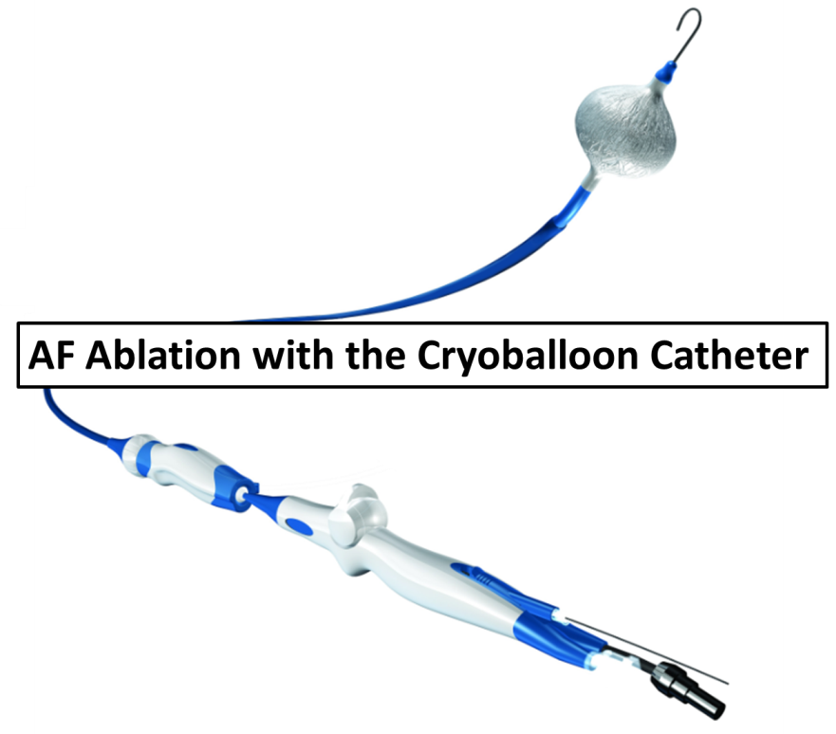

Screen 2
