Submission ID #: 52817

Editor Name: Melissa Ceo

Videographer name: Paul Donahue

Film Date: 2/26/2015

Authors and Affiliations:
Nicholas P. Stadie, Elsa Callini, Philippe Mauron, Andreas Borgschulte, Andreas Züttel

Hydrogen & Energy Laboratory
Empa, Swiss Federal Laboratories for Materials Science & Technology
Dübendorf, Switzerland

Title: Supercritical Nitrogen Processing for the Purification of Reactive Porous Materials

Corresponding Author:

Nicholas P. Stadie: nicholas.stadie@empa.ch

Co-authors:

Elsa Callini: elsa.callini@empa.ch

Philippe Mauron: philippe.mauron@empa.ch

Andreas Borgschulte: andreas.borgschulte@empa.ch

Andreas Züttel: andreas.zuettel@empa.ch

A. Will you require JoVE to record video microscopy, such as filming a complex dissection or microinjection technique? No.
B. Does your protocol include detailed, step-by-step, descriptions of software usage? No.
C. Which steps of your protocol will viewers benefit most from having filmed? Steps 3-5
D. What is the single most difficult aspect of this procedure and what do you do to ensure success? This whole procedure is very simple to complete. We iterate Steps 4 and Steps 5.1-5.3 in cases where we do not have the required results after one procedure. Filming the steps will not be an issue.
E. Will the filming need to take place in multiple locations? Yes. All filming will happen within one building, but in 3 different rooms. The main part of filming will happen in a single room. Just down the hall (4 doors or so), we have reserved the conference room/library for interviews. A third room contains the larger (much more professional looking) glovebox for materials handling. This could also be done in the first room if necessary, but we usually do it in the bigger glovebox. It is downstairs (ground floor) and 10-15 doors away (~2 min walk). There are elevators connecting the two floors. Map here: https://www.google.com/maps/d/edit?mid=zUf0ukPPAXAM.k7uBi6SMzQzg

1. Introduction (Schematic Overview and Interview)

A. Schematic Overview (read by voice talent at JoVE):

Conceptual Narrative: purple nitrogen, red magnesium borohydride
The overall goal of the following experiment is to purify magnesium borohydride, a porous complex hydride and high density hydrogen storage material, using supercritical nitrogen. (Intro)

This is achieved by first soaking a sample of magnesium borohydride in compressed liquid nitrogen in the near-critical region of the phase diagram at -163 degrees Celsius and 20 bar, where its high fluid density is indicative of a high solvent power toward target impurities such as diborane and n-butyl species. (P1, show PowerPoint slides 2-9)

As a second step, the liquid nitrogen is heated and compressed into the dense supercritical region of the phase diagram at -123 degrees Celsius and approximately 100 bar. (P2, show PowerPoint slides 10-22)

Next, the supercritical nitrogen and any dissolved species can be extracted from the sample by slowly reducing the pressure to vacuum at -123 degrees Celsius, thereby circumventing the liquid to gas phase transition where surface tension effects can lead to poor extraction of the target species. (P3, show PowerPoint slides 23-29)

The results show that after iterative supercritical nitrogen drying treatments, the gaseous decomposition products of magnesium borohydride only consist of hydrogen, based on temperature programmed decomposition coupled with infrared spectroscopy. (P4, show Figure 4)

Video Editor: Use NScD Animation.pptx in 2015.02.04.zip file. Additional notes from the authors are below.

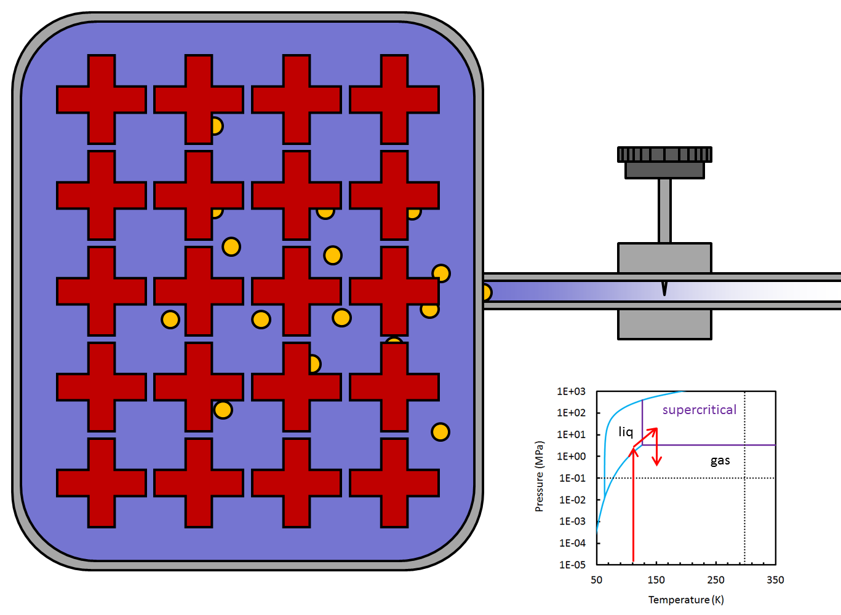

The above image is an example of a single frame from the NScD animation I uploaded to the JoVE website. There are a total of 6 files, each containing an animation of a different scenario. They are briefly described below:

NScD Animation.pptx – the is an animation describing the procedure we perform in this video. It is the best case example for the effective processing of a reactive and porous material (shown in red) using an inert, supercritical solvent (purple).

CScD Animation.pptx – this describes the same procedure as above except with a supercritical solvent that reacts with the treated material, such as CO₂.

Normal Fluid Animation.pptx – this describes a typical solvent assisted purification process where a liquid is introduced to the material and there is an attempt to extract all the impurities by removal of the liquid itself. This results in the formation of a shrinking liquid surface that serves to hold a substantial portion of the impurities within the narrow porous structure of the material, and is therefore not an ideal extraction methodology.

Heat Treatment Impure.pptx – this describes a simple heat treatment under vacuum, showing that an unstable material like γ-Mg(BH₄)₂ will decompose under heating to release hydrogen as well as impurities (if untreated). This is an example of the situation we would like to avoid.

Heat Treatment Pure.pptx – this describes the same scenario as above, except with a purified sample. This is not shown as an example of a purification process, but moreso shown to demonstrate the desirable pure hydrogen release that occurs under thermal decomposition.

Heat Treatment Carbon.pptx – this example shows how easy it often is to purify very thermally stable porous materials like activated carbon or silica. No solvent is required, just a suitably high temperature and a low vacuum pressure.

We do not have to include all the animations, of course. If we have time, it would be very informative but might take too much time.

I would like to work with the JoVE staff to make the animations more fluid and the motions smoother.

My latest thoughts on this are to only show slides from the file “NScD Animation.pptx” if we are short on time, which I suspect we will be. This animation is the most relevant to the experiment shown in the protocol. An open question is whether to include parts of this animation cut in with the footage filmed in our lab (e.g. showing the phase diagram in the lower right corner) or whether to show the whole animation before or after the protocol.

B. Interview:
  - Andreas Züttel: The focus of our research activities is the materials science connected to the storage of renewable energy. Since the beginning of our pioneering research on complex hydrides as hydrogen storage materials, the synthesis of borohydride compounds has been a challenge; pure compounds are difficult to produce but essential for scientific investigations.
  - Andreas Borgschulte: Purification methodologies can help answer key questions in the field of solid-state hydrogen storage, such as what role impurities play in the decomposition reactions of complex hydrides. The answer remains complicated, and a topic of dispute even today.
  - Nicholas P. Stadie: The idea to pursue this strategy was inspired by the work of Hupp and colleagues, who reported the effective use of supercritical carbon dioxide in the activation of metal-organic frameworks in 2009. Here we use nitrogen in a similar way for porous complex hydrides by exploiting the high density supercritical region of its phase diagram at much lower than ambient temperatures.
  - Elsa Callini: The main advantage of supercritical nitrogen processing over existing methods, like supercritical carbon dioxide drying, is that nitrogen is inert towards strongly reducing compounds such as alanates and borohydrides, while still exhibiting many advantages of an ideal supercritical solvent.
  - Philippe Mauron: Although this particular method has shown to be effective in treating porous magnesium borohydride, it can also be applied to other materials where the reactivity of carbon dioxide prohibits its use as a drying or extraction agent. The cold temperatures and modest pressures required make it almost universally applicable.

Protocol:
- Apparatus and Preparation

(Video Editor: The author wishes to include animation overlays or insets as indicated in red below. They will provide animated gauges for each step where indicated. If necessary for size, the box containing the number above the gauge can be removed, as long as the gauge itself remains.)
  - Use a basic supercritical drying apparatus comprised of a gas supply, dosing manifold, a vacuum system, temperature and pressure sensors, and the sample environment, all connected by high-pressure gas tubing [2.1.1-MED-TXT].
    - Show entire apparatus TEXT: See text protocol for details on apparatus and setup
      - Gas supply TEXT: See text protocol for details
      - Manifold TEXT: See text protocol for details – use take 2
      - Vacuum system TEXT: See text protocol for details
      - Temperature and pressure sensors TEXT: See text protocol for details
      - Sample environment TEXT: See text protocol for details
      - High pressure gas tubing TEXT: See text protocol for details
  - Load 0.1 to 0.5 grams of magnesium borohydride into the sample holder under an inert atmosphere such as an argon glovebox at ambient temperature [2.2.1-CU]. Close the sample holder with a filter gasket and then close the valve [2.2.2-MED-over the shoulder]. After removing the sample holder from the glovebox [2.2.3-MED], attach it to the apparatus [2.2.4-MED].
    - *Film as written
    - *Film as written
    - *Film as written – removing sample holder from glovebox
    - *Film as written – attaching sample holder to apparatus

Animation Overlay/Inset: Gauge is steady at 1 bar, TEXT: Sample Pressure (bar)
  - Following this, open the dosing manifold to vacuum via V2 and evacuate [2.3.1-MED-over the shoulder]. After opening V3 and evacuating, purge the apparatus with nitrogen via V1 and evacuate via V2 [2.3.2-MED]. Evacuate and purge a few times [2.3.3-CU]. Then, open V4 and evacuate the sample at room temperature for up to 24 hours, to reach the minimum pressure of the system [2.3.4-MED-over the shoulder].
    - *Film as written
    - *Film as written
    - *Film as written

Animation Overlay/Inset: Gauge decreases from 1 to 0 bar, TEXT: Sample Pressure (bar)
    - *Film as written **This was filmed twice: once with a thermometer, once without. The shot without is probably more simple and less confusing.

Animation Overlay/Inset: Gauge is steady at 0 bar, TEXT: Sample Pressure (bar)
  - Install the sample bath around the sample holder by raising the bath into position on a scissor lift [2.4.1-W] [2.4.2-MED].
    - *Film as written
    - *Film as written
  - Following this, set the heater to the desired future liquid temperature of -163 degrees Celsius [2.5.1-MED], and continue to evacuate the apparatus until the temperature equilibrates [2.5.2-CU].
    - *Film as written
    - *Film as written **Accidentally referred to as “2.4.2 take 3.” Please ignore that mislabel!

Animation Overlay/Inset: Gauge holds steady at 0 bar, TEXT: Sample Pressure (bar)
- Supercritical Nitrogen Exposure
  - For nitrogen supercritical drying processing of magnesium borohydride, select a liquid temperature of -163 Celsius corresponding to an intermediate density of 0.6 grams per milliliter [3.1.1-LM-TXT].
    - Fig 3 N2 Phase Diagram.tif, TEXT: Adjust T_{I} as necessary for other NScD treatment processes.
  - Next, close off the system to vacuum by closing V2 [3.2.1-MED]. Throttle open V1 slowly, allowing the pressure to increase into the liquid region of the phase diagram, above 20 bar [3.2.2-MED-over the shoulder].
    - *Film as written

Animation Overlay/Inset: Gauge holds steady at 0 bar, TEXT: Sample Pressure (bar)
    - *Film as written

Animation Overlay/Inset: Gauge increases from 0 to 20 bar, TEXT: Sample Pressure (bar)
  - After equilibrating the system at 20 bar and -163 degrees Celsius, allow the sample to soak in liquid nitrogen for 4 hours [3.3.1-CU].
    - *Film as written

Animation Overlay/Inset: Gauge holds steady at 20 bar, TEXT: Sample Pressure (bar)
  - Set the heater to -123 degrees Celsius with a ramp of less than or equal to 2 degrees per minute [3.4.1-MED]. Allow the pressure to increase no higher than the maximum rated pressure of the apparatus [3.4.2-CU]. If necessary… [3.4.3-MED-over-the-shoulder].
    - *Film as written
    - *Film as written

Animation Overlay/Inset: Gauge increases from 20 to 100 bar, TEXT: Sample Pressure (bar)
    - *Film as written
  - After equilibrating the system at the maximum rated pressure and -123 degrees Celsius, allow the sample to soak in supercritical nitrogen for 1 hour or more [3.6.1-CU].
    - *Film as written

Animation Overlay/Inset: Gauge holds steady at 100 bar, TEXT: Sample Pressure (bar)
- Supercritical Nitrogen Extraction and Post Treatment
  - At this point, close V1 and then carefully crack the system to vacuum by throttling V2 [4.1.1-MED], allowing the pressure to decrease as slowly as possible [4.1.2-CU-TXT].
    - This was accidentally referred to as “3.4.3” but is actually 4.1.1.
    - Two mock “time lapses” were shot by the videographer. They are just regular footage where we sped up the process. The second take should be used. It is ~40 seconds long, and should be sped up to meet the needs of the editor. It represents the total pressure drop that normally occurs over 12-24 hours. TEXT: Repeatedly crack the system to higher leak rates to achieve a gradual pressure decline to vacuum in 12-24 hours.

Depending on how the close-up turns out, we may not need an animation here. Otherwise:

Animation Overlay/Inset: Gauge decreases slowly from 100 to 0 bar, TEXT: Sample Pressure (bar)
  - Remove the sample bath [4.2.1-MED] [4.2.2-MED] and fully open V2 to completely evacuate the sample, equilibrating at room temperature and high vacuum [4.2.3-CU-TXT].
    - *Film as written
    - *Film as written
    - *Film as written, TEXT: Degas at RT and the highest possible vacuum for 1-24 hours

Animation Overlay/Inset: Gauge holds steady at 0 bar, TEXT: Sample Pressure (bar)
  - After treatment, close valves V3 and V4, and remove the sample holder from the apparatus [4.3.1-MED-over the shoulder].
    - *Film as written
  - Transfer the sample holder to an inert environment for handling, such as an argon-filled glovebox [4.4.1-MED]. Finally, remove the sample from the sample holder and store in a sealed container at ambient temperature [4.4.2-MED-over the shoulder].
    - *Film as written
    - *Film as written
- Results: Purification of Reactive Porous Materials by Supercritical Nitrogen Drying
  - The supercritical nitrogen drying methodology described herein was successful for the purification of porous magnesium borohydride [5.1.1-LM]. The target species of extraction were diborane and an unspecific n-butyl impurity, which were reduced to negligible quantities after iterated treatments with supercritical nitrogen drying, as shown by infrared spectroscopy of the gaseous species evolved during decomposition. After 3 treatments, no detected impurities remained [5.1.2-LM].
    - Fig 4.tif: Show top spectrum
    - Fig 4.tif: Show bottom two n-butyl and diborane spectra

- Conclusion (said by authors on camera)
  - Elsa Callini: Once a set of successful protocol conditions has been established for a particular application, this technique can be scaled up to purify large quantities of as-synthesized material. The main limitation is that the sample should have adequate thermal contact with the bath, and therefore an appropriately designed sample environment.
  - Philippe Mauron: When preparing an appropriate apparatus for this procedure, the most important consideration is the low temperature bath. Because this procedure does not demand exceptionally low temperatures, we opted for a simple design involving a typical benchtop heater immersed in liquid nitrogen as the coolant.
  - Andreas Borgschulte: Following this procedure, analytical methods like X-ray photoelectron spectroscopy, infrared spectroscopy, or Raman spectroscopy can be performed on the resulting sample without the unwanted influence of residual impurities. The sample can be processed immediately before characterization.
  - Nicholas P. Stadie: Supercritical extraction techniques are already used in a diverse variety of applications, from the decaffeination of coffee beans to advanced methods for catalyst deposition in porous supports. Using nitrogen as an extracting agent, we simply extend the applicability of these techniques to materials that are reactive toward other more common supercritical solvents.
  - Andreas Züttel: The development of new techniques allows scientists to answer questions relevant to emerging materials for hydrogen energy applications. Supercritical nitrogen processing may bring next-generation complex hydrides a step closer to serving as mobile hydrogen storage materials in the sustainable energy landscape of the future.

Provided Media

Authors, Please list all images, movie files, or 3-D rendered animations that can be included in the video per editor’s request. The step in the script/video where these images will be inserted should be specified. For example:

6.2 – 0123_PIname_Figure1.tif - dual color imaging of tumor angiogenesis at 40X
6.2 – 0123_PIname_Figure2.tif - dual color imaging of tumor angiogenesis at 100X

Formats: For static images we prefer .tiff, .eps, Illustrator, Powerpoint or Photoshop files at dimensions of at least 720X480 pixels and 300 dpi. The higher resolution, the better. Likewise any exported movie files should have at minimum these dimensions and be rendered to .mov, .mp4, or .avi files.

Insert your media filenames here.

See graphic overview above.

