Request for additional information to guide script writing for your JoVE submission

In order to facilitate the proper filming of your video, a script writer will prepare both a script and a story board from your protocol prior to filming. For many protocols, steps are straight forward and intuitive, describing actions like mixing solutions, turning on equipment, and so forth. In some instances, however, it is not immediately clear from the protocol itself exactly what the best way would be to represent the action / step in the video. This is especially true for steps describing less common equipment, theoretical processes, image processing or data analysis, and the use of computer programs or software.

When the script writer begins planning your video the protocol will act as a rough guide for the video voiceover. Please consider your protocol in this context and ensure that there are no long sections of text that would be awkward or not-feasible to be incorporated into a voiceover. Please note at this time, if you have not already done so, that text highlighting can be used to indicate to the JoVE staff what you would like to include in the video. Highlighting is used for longer protocols due to length constraints, but can also be useful for protocols of any length if there are sections of introductory or explanatory information that you would like to include in the written protocol but may not need to be included in the video (may be too bulky / time consuming). If you are using highlighting in this way, please use yellow text background and highlight a maximum of 2.75 pages total (including spaces between steps). Please contact your editor with any questions regarding protocol highlighting.
Generally, there are three types of visuals that can represent a protocol step in your video: (1) Videographer footage (for instance, a lab member performing the action, footage of a process occurring as recorded from videographer’s microscope attachments) ; (2) screen shots that display the action or the result of the action (for instance, if you describe setting parameters in software, screenshots can demonstrate the interface; if you describe utilizing a program to perform a step a screen shot of the code can accompany the step); (3) a schematic or figure can be displayed to represent the step.
As the goal of JoVE is to visualize methods that cannot be represented optimally in written protocols, we try to avoid having videos with too many screen shots or schematic representations of steps. It is best if actions are filmed live when possible. We understand that many aspects of your work may involve software / programing and the best way to present the protocol may be a combination of both live demonstration and static / animated images. Also please note that an action describing computer / software use should be demonstrated via screen shots, not via videographer footage of a lab member at a computer.
In most cases the determination of the shot list for your video happens later in the JoVE process. However, since there are some steps in your protocol that we are a bit unsure of, we ask that you provide some guidance for us at this time as described below. This way if any changes need to be made to the way the protocol is written or presented, to ensure the best version of your video is made, this can be done prior to peer review. We appreciate you taking the time to provide this information for us and please do not hesitate to contact your editor with any clarifications or questions.
Please note: this request only applies to certain steps in your protocol as listed in the editorial comments.
Please fill in the work sheet below, replacing the examples. For each of the steps requested, please designate which of the options would be the optimal representation for visualizing the step (videographer footage, screen shot or figure). If a single step requires two options (for instance part will be filmed in the lab, part will be shown via a screen shot) please separate the step accordingly in the table (not in the protocol). If a figure from the manuscript will be used please refer to it by number and panel letter. If a screen shot will be used, please add the screen shot after the table along with an identifying title. If the screen shot is not currently available a low resolution version or a brief description of it can be used instead. (Screen shots will not be sent to peer review.)
If edits are made to the protocol later in the review process this guide will not need to be updated unless major changes to the protocol are made. Edits to text segments in this guide will not be reflected in the manuscript.
* Please upload this completed work sheet under the file designation “Supplemental files (as requested by JoVE).*
Supplemental information for JoVE scriptwriter
Step # | Text | Visual representation
4.1. | Visually inspect the raw EEG data and reject segments with high-amplitude artifact. | Videographer footage of author
4.5. | Average the epochs for each individual and each condition and combine these averages according to group and condition for grand averages. | Screenshot of computer program titled, “Visual_1” (provided below)
5.1. | co-register each individual and grand average ERP file with either an age-appropriate MR template or an individual MR scan | Videographer footage of author
5.3. | Beginning with a grand average ERP, choose a time window of interest corresponding to a peak. Conservative parameters are typically +/- 20 ms around the peak of interest | Videographer footage of author
5.4. | Estimate the number and location of underlying sources to be fitted to the data. | Videographer footage of author
5.5 | Check the “goodness of fit” for the dipole solution using the software outputs of residual variance….Use a distributed source model (CLARA) to check your solution within the extended activity region. | Videographer footage of author
6.1 | Apply the dipole model solution to the raw, unfiltered, continuous EEG data. | Videographer footage of author
6.2. | Transform the time-domain single-trial source signal into the time-frequency-domain | Screenshot of computer program titled, “Visual_2” (provided below)
 | (to add more rows, place cursor in a cell, right click, select “insert” and select “insert row below”)

Screen Shots: (Please copy and paste or insert the required screen shots here, in the order they are listed above.)
Example Screen shot 1 – Average
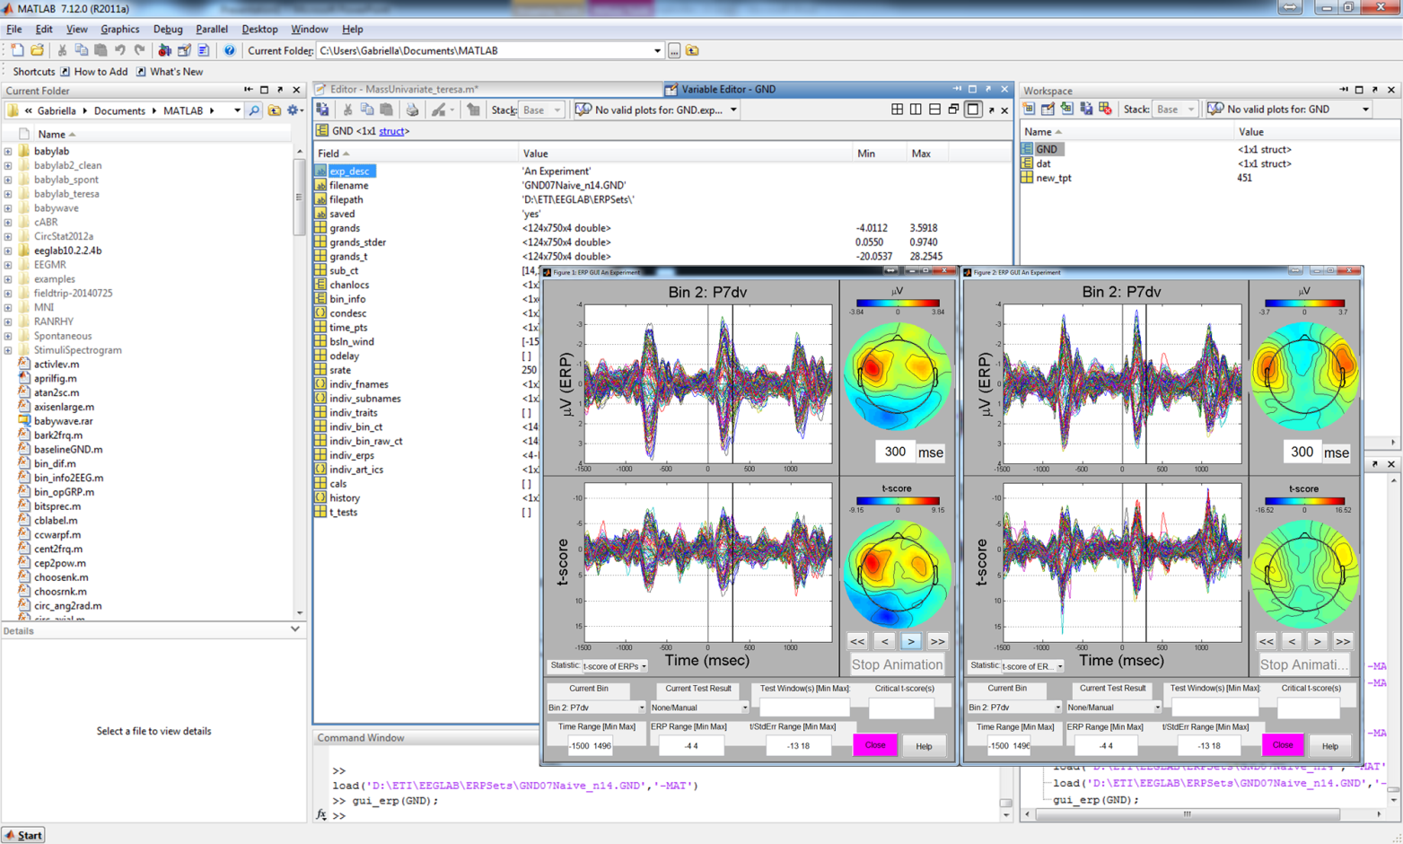
Example Screen shot 2 – Time Frequency Analysis

