Supplemental information for JoVE scriptwriter
Please note that the steps should correspond to the steps in the manuscript text.
Step # | Text | Visual representation
1 | Prepare larvae
1.1 | Rear larvae | Videographer footage of lab member
1.2 | Prepare mesh filter: mesh and funnel | Videographer footage of lab member
1.3 | Scoop food and larvae from culture vial | Videographer footage of lab member
 | Wash on mesh | Videographer footage of lab member
 | Select larvae for analysis | Videographer footage of lab member
2 | Prepare assay tubes
2.1 | Boil and pour gel | Videographer footage of lab member
2.2 | Inspect tubes | Videographer footage of lab member
2.3 | Moisturize tubes | Videographer footage of lab member
 | Observe moisture level in tube | Video recorded through microscope
2.4 | Insert larva | Videographer footage of lab member
2.5 | Seal tubes with agar plugs | Videographer footage of lab member
2.6 | Place tubes in monitor device | Videographer footage of lab member
2.7 | Secure tubes with putty | Videographer footage of lab member
3 | Measuring Locomotion
3.1 | set up monitor in incubator | Videographer footage of lab member
3.2 | Set up incubator and illumination | Videographer footage of lab member
3.3 | Allow acclimation | Videographer footage of lab member
3.4 | Connect monitor to computer | Videographer footage of lab member
3.5 | Set up software parameters - frequency | Screen shots with voice-over narration
3.6 | Set up recording parameters | Screen shots with voice-over narration
3.7 | Connect power to monitor | Videographer footage of lab member
3.8 | Connect monitor to computer | Videographer footage of lab member
3.9 | Start the recording | Screen shots with voice-over narration
3.10 | Stop the recording | Screen shots with voice-over narration
4 | Prepare data for processing
4.1 | Organize the data 1 | Screen shots with voice-over narration
4.2 | Organize the data 2 | Screen shots with voice-over narration
4.3 | Save the data | Screen shots with voice-over narration
5 | Accessing data for analysis
5.1 | Save to a table | Screen shots with voice-over narration
5.2 | How to read the table 1 | Screen shots with voice-over narration
5.3 | How to read the table 2 | Screen shots with voice-over narration
 | Representative Results – temperature effects | Still image of Figure 1
 | Representative Results – genetic effects | Still image of Figure 2

Representative Screen Shots:

Step 3.5
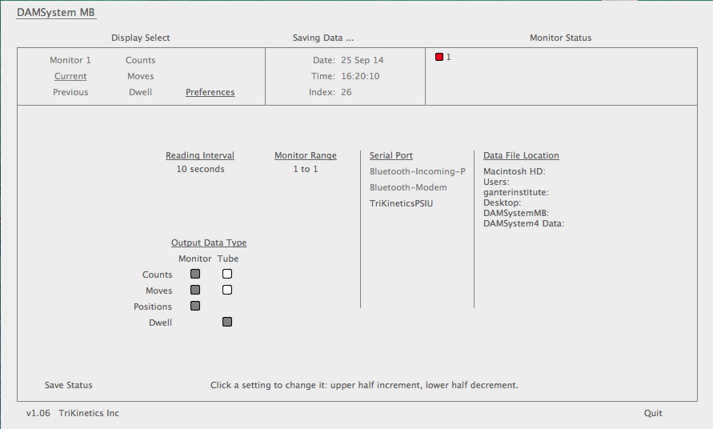

Step 4.1
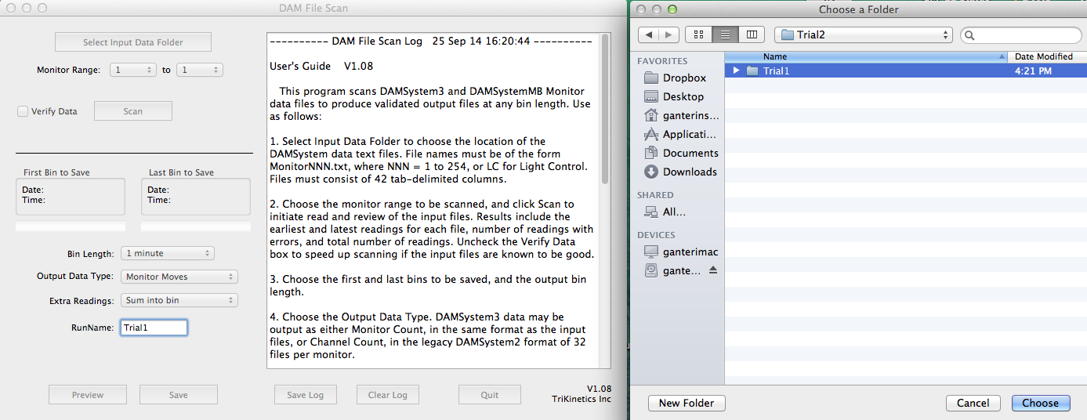

Step 5
