Submission ID #: 52707

Editor Name: Michael Linnes

Videographer name: Paul Donahue

Film Date: 4/30/15

Authors and Affiliations: Jordi Caballé-Serrano^{1,2,4}, Kosaku Sawada^{2,5}, Guenther Schuldt Filho^{1,2,6}, Dieter D. Bosshardt^{1,3}, Daniel Buser¹, and Reinhard Gruber^{1,2}
¹Department of Oral Surgery and Stomatology ²Laboratory of Oral Cell Biology, ³Robert K. Schenk Laboratory of Oral Histology, School of Dental Medicine, University of Bern, Bern, Switzerland ⁴Department of Oral and Maxillofacial Surgery, School of Dental Medicine, Universitat Internacional de Catalunya, Barcelona, Spain ⁵Department of Cranio Maxillofacial Surgery, Inselspital, University of Bern, Bern, Switzerland ⁶Department of Implant Dentistry, School of Dentistry, Universidade Federal de Santa Catarina, Florianopolis, Brazil

Title: Bone Conditioned Medium: Preparation and Bioassay.

Corresponding Author:
Reinhard Gruber
Department of Oral Surgery and Stomatology
School of Dental Medicine, University of Bern
Bern, Switzerland
reinhard.gruber@zmk.unibe.ch
&Laboratory of Oral Cell Biology
School of Dental Medicine, University of Bern
Bern, Switzerland

Co-authors:
jordi.caballe@zmk.unibe.ch
sawada@ngt.ndu.ac.jp
guenthersf83@hotmail.com
dieter.bosshardt@zmk.unibe.ch
daniel.buser@zmk.unibe.ch

A. Will you require JoVE to record video microscopy, such as filming a complex dissection or microinjection technique? (Y/N)____N_____
B. Does your protocol include detailed, step-by-step, descriptions of software usage? (Y/N)____N__
C. Which steps of your protocol will viewers benefit most from having filmed? Please list 4-6 steps using the step numbers listed in this document. _1.1 1.2 1.6 2.2
D. What is the single most difficult aspect of this procedure and what do you do to ensure success? Please list the steps using the step numbers listed in this document.___ 1.2 (bone scraping can be tricky, we will have prepared different pig mandibles)
E. Will the filming need to take place in multiple locations? (Y/N) ___N____

1. Introduction (Schematic Overview and Interview)

A. Schematic Overview (read by voice talent at JoVE):

Procedural Narrative:
The overall goal of this video is to describe how to prepare bone-conditioned medium and test its activity in vitro. (Intro)

This is accomplished by first harvesting bone chips from a pig mandible using a bone scraper. (P1: Use the jaw bone from DAM ID 3511 (bone only) and scrape the bone in the location shown in P1 with a tool looking similar to the one used in the P1 image (google bone scraper, similar looking tools = DAM ID 3690 (modify tip to be rounded). When scraping the bone, have little pieces (DAM ID 4145 or 4009) fall off into a petri dish (DAM ID 3767) with pink medium.) P1 refers to P1 in “Introduction_image.001.jpeg”

The second step is to heat treat, demineralize, or do nothing to the bone chips prior to incubating them in culture medium for 24 hours. (P2: Split the petri dish so that there are 3 replicates. Label the left dish “Denatured Bone Chips”, the middle dish “Demineralized Bone Chips”, and the 3rd dish as “Native Bone Chips” Simulate “heat” being added to the left one with the words “heat treat”, add a clear liquid to the 2nd one (demineralize) with the word “demineralize”, and do nothing to the 3rd one. Then, remove the “heat” and clear liquid and add pink liquid to all 3 dishes with the word incubating. The clear and pink liquids can be added via pipette such as (DAM ID 189). Add a clock and have it spin to simulate time.

Next, the bone conditioned medium is collected, containing all the factors released from the bone chips. (P3: Fade away 2 of the dishes at the start and draw up the pink liquid in the dish with the pipetteman from DAM ID 189.)

The final step is to stimulate cells with the bone conditioned medium or to pre-incubate a biomaterial with the bone conditioned medium and seed cells on it following the incubation period. (P4:Add the media in the pipette to cells plated in a dish such as DAM ID 4277 with the words “stimulate cells”, as well as to a material such as the grid shown in DAM ID 3675 that has been placed in the same petri dish (DAM ID 4277) with the word “biomaterial”, with the words “seed” add the cells from DAM ID 3675 to the scaffold that is In the pink medium.

Ultimately, quantitative real time PCR is used to show changes in gene expression of the cells following treatment. (P6: Show Real Time PCR graph from the right half of Figure 2 on the left and Figure 3b on the right half.)

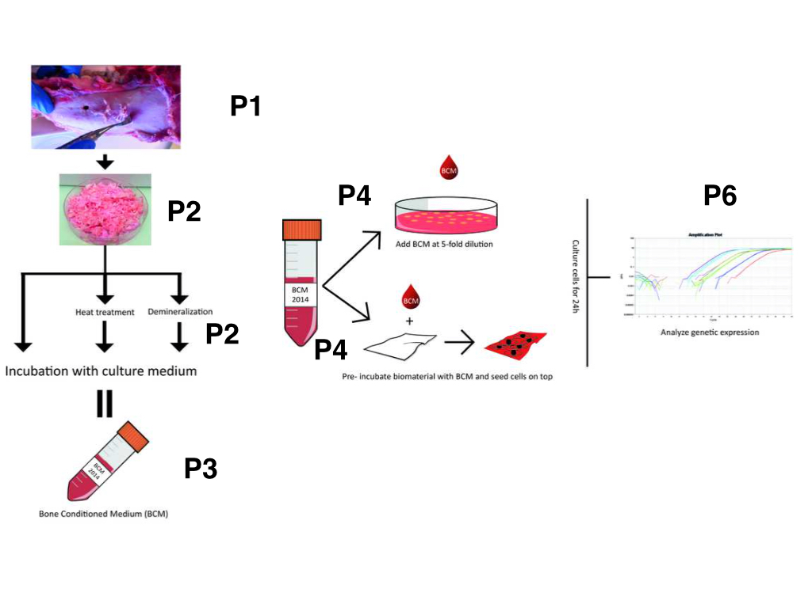
B. Interview: (Said by you on camera. Don’t forget to smile!)

Only one statement is allowed per author.
  - Daniel: changed Bone regeneration using autologous bone grafts alone or in combination with other biomaterials can help to bridge bone defects with good long term results.
  - Reinhard: This video presents an in vitro bioassay which is useful in determining the genetic response of mesenchymal cells to the large spectrum of biomolecules contained within bone conditioned medium.
  - Jordi: Bone conditioned medium can help answer key questions in the trauma, maxillofacial and dental field, such as why autologous bone is the gold standard graft in bone regeneration.
  - Kosaku: Preparing conditioned medium from processed bone like heat-treated bone autografts or demineralized bone matrix can be difficult to standardize, therefore it is important to be precise.

Protocol (read by voice talent at JoVE):
- Preparation of Bone Conditioned Medium
  - To begin, obtain fresh pig mandibles from a local butcher and place them onto a firm surface. [2.1.1 - MED] Next, use a periostotome to release a full thickness flap of periosteum while paying special attention not to leave any of the soft tissue attached to the bone. [2.1.2 - CU]
    - Talent places fresh mandible on the bench or in the hood.
    - *Film as written
  - Once the periosteum is removed, firmly grip the bone scraper and use long movements to harvest bone chips from the buccal side of the mandible. [2.2.2 - CU]
    - Added shot: MED: Both researchers scraping
    - *Film as written
  - Discard any of the bone chips that are smaller than 1 mm in length. [2.3.1 – CU MED]
    - Talent picks out small pieces and discards them discards small pieces and puts large pieces in the petri dish.
  - Prevent the bone chips from drying out by quickly covering them with culture medium in a 10 cm petri dish. [2.4.1 - CU - TXT]
    - Talent covers bone chips with medium. (TEXT: DMEM + 1% Antibiotic/Antimycotic)
  - After enough bone chips have been collected, prepare a thermal control batch by pasteurizing 5 grams of the bone chips. [2.5.1 - MED] Pasteurize the chips by heating them for 30 minutes at 80°C or autoclave them for 20 minutes at 121°C. [2.5.2 - MED]
    - Talent weighs out 5g of wet bone chips and places into a heat proof container.
    - Talent places sample of chips into an oven at 80C.
  - Next, prepare a demineralized control by adding 5 grams of bone chips into a 1 molar solution of hydrochloric acid [2.6.1 - MED] and placing them on a shaker for 4 to 6 hours at 4 °C. [2.6.2 - MED] Then, wash the bone chips repeatedly with culture medium until a neutral pH is reached. [2.6.3 - CU]
    - *Film as written
    - *Film as written
    - *Film as written
  - Place 5 grams of fresh bone chips and 5 grams of each of the control preparations into separate dishes and add 10 milliliters of fresh culture medium to each dish. [2.7.1 - MED]
    - Talent adds medium to each of the 3 dishes of bone chips.
  - Then, incubate the samples in a humidified atmosphere at 37°C for 24 hours in order to create the conditioned medium. [2.8.1 - MED]
    - Talent places the dishes into the incubator.
  - The next day, remove the media from each dish and place it in a 15 milliliter conical tube. [2.9.1 - CU] Centrifuge the bone conditioned media at 200 times gravity for 10 minutes [2.9.2 - MED] to remove any debris. [2.9.3 - ECU]
    - *Film as written
    - *Film as written
    - Talent holds up centrifuged tube of BCM to show debris pellet
  - Then, remove the supernatant [2.10.1 - CU] and pass it through a 0.2 micron sterile filter. [2.10.2 - CU] Store the aliquots frozen at -80 °C until they are needed. [2.10.3 - MED]
    - *Film as written
    - *Film as written
    - Talent places aliquots in the freezer.
- Mesenchymal Cell Based Bioassays
  - Start by seeding human mesenchymal cells such as bone cells or gingival and periodontal ligament fibroblasts into a 12-well plate at a concentration of 30,000 cells/cm². [3.1.1 - MED]
    - *Film as written
  - Cover the cells with growth medium [3.2.1 - CU - TXT] and let the cells attach to the plate overnight. [3.2.2 - MED]
    - *Film as written (TEXT: DMEM, 10% FCS, 1% Antibiotics/Antimycotics).
    - Talent puts plates in the incubator.
  - The next morning, discard the culture medium and wash the cells with pre-warmed PBS at 37 °C. [3.3.1 - CU] Then, stimulate the cells by adding pre-warmed serum-free culture medium with and without 20% bone conditioned medium. [3.3.2 - CU]
    - *Film as written
    - Talent adds medium with BCM to plate, then adds medium w/o BCM to other plate. *Ensure media bottles are clearly labeled so camera can capture the text.
  - If also testing the absorption ability of a biomaterial, add the bone conditioned medium including any controls to tubes containing the biomaterial of interest and incubate the tubes at 37 °C for 1 hour. [3.4.1 - CU]
    - *Film as written (add medium)
    - Added shot: MED: Put in incubator
  - Then, rinse the biomaterial vigorously with prewarmed PBS and seed human mesenchymal cells at a concentration of 30,000 cells/cm² onto the material. [3.5.1 - CU]
    - *Film as written (show rinsing the biomaterial in the tube)
    - Added shot: CU: Seed cells on the biomaterial
  - Incubate the cells alone, or those seeded on the biomaterials in a humidified atmosphere at 37°C for 24 hours. [3.6.1 - CU]
    - *Film as written
  - Then, discard the culture medium, rinse the cells with pre-warmed PBS, [3.7.1 - CU] and extract the cell’s RNA using a standard RNA isolation protocol. [3.7.2 - CU]
    - *Film as written
    - Talent adds lysis buffer to the plates (or other clear liquid).
  - Once the RNA has been isolated, prepare cDNA samples of each treatment group by starting with equal concentrations of the RNA extracted [3.8.1 - CU] and running a reverse transcriptase reaction on each sample. [3.8.2 - MED]
    - Talent prepares PCR plate.
    - Talent puts plate in PCR setup and runs RT cycle.
  - Then, perform quantitative real-time PCR on the samples [3.9.1 - CU] to look for levels of selected genes using the primers and conditions listed in the accompanying text protocol. [3.9.2 - MED]
    - Talent places film over wells of a plate.
    - Talent places plate in PCR machine, sets run parameters, and begins PCR.
  - Finally, calculate the quality of the bone conditioned medium based on the relative gene expression levels by normalizing to cycle threshold levels of the genes to the housekeeping gene GAPDH using the delta-delta-C-T method. [3.10.1 - MED Over the Shoulder]
    - Talent at computer looking at PCR curves and working in a spread sheet to calculate the expression levels. (Maybe creating a graph or something large and visible). *This type of shot was chosen over a screen capture because details aren’t critical since experiments vary and this is standard.
- Results: Bone Conditioned Medium Promotes Osteoinductive Gene Expression
  - Here are some typical results showing the changes in gene expression of oral fibroblasts exposed to bone conditioned medium for 24 hours. [4.1.1 - LM] Two genes, Adrenomedullin and pentraxin 3, were both significantly down-regulated to 40% of original levels, whereas interleukins 11 and 33, along with NADPH oxidase 4 and proteoglycan 4 were all up-regulated as much as 200 fold. [4.1.2 - LM]
    - Figure 3 (Video Editor: Start by showing both the A and B parts of Figure 3)
    - Figure 3 (Video Editor: Zoom in on part A until the word “whereas” then switch to part B.)
  - Interestingly, collagen barrier membranes, used to shield the bone chips from the surrounding soft tissue, [4.2.1 - LM] adsorb much of bone conditioned medium that is responsible for the changes in gene expression. [4.2.2 - LM] The collagen membranes, however, failed to absorb the factors that control Interleukin-33 expression, therefore interleukin-33 expression is not regulated in this setting. [4.2.3 - LM]
    - Membrane_1.tif
    - Figure 4 (Video Editor: Show all of Figure 4)
    - Figure 4 (Video Editor: Highlight the IL-33 column when it is talked about.)

- Conclusion (said by authors on camera)

  - Jordi: The protocol described here can be adapted to study the response of different types of cells involved in bone regeneration. Moreover, the protocol can be used to prepare conditioned medium from processed bone including other bone fillers.
  - Reinhard: The clinical relevance of this bioassay remains unclear. The cellular response to BCM in vivo is likely more complex and includes a large spectrum of genes and different target cells extending those presented here.
  - Reinhard: Nevertheless, our bioassay provides first insights into the presumably complex composition of bone-derived molecules and the in vitro cellular response.

Provided Media

Authors, Please list all images, movie files, or 3-D rendered animations that can be included in the video per editor’s request. The step in the script/video where these images will be inserted should be specified. For example:

6.2 – 0123_PIname_Figure1.tif - dual color imaging of tumor angiogenesis at 40X
6.2 – 0123_PIname_Figure2.tif - dual color imaging of tumor angiogenesis at 100X

Formats: For static images we prefer .tiff, .eps, Illustrator, Powerpoint or Photoshop files at dimensions of at least 720X480 pixels and 300 dpi. The higher resolution, the better. Likewise any exported movie files should have at minimum these dimensions and be rendered to .mov, .mp4, or .avi files.

P5: - BCM_phallo_jove.tif - it is a fluorescence image of the membranes with cells seeded on top. You can show it in the introduction part, after explaining that we seed cells on top of the membranes.

4.2: - Membrane_1.tif & Membrane_2_OK.JPG – As requested, we send you two images of the membranes. The first image is the membrane as the company supplies it. The second is already cut.

General Preparation

It’s critical for a smooth and organized shoot that all reagents are accounted for, in advance.

Any overnight or long incubation steps should be recognized and specimens/samples be prepared in advance so that prior steps can be recorded and shooting can continue with pre-prepared specimens/samples.

All tubes/flasks should be pre-labeled neatly before we arrive.

Ex. Luciferase assay done in 96 well plates should be labeled with negative/positive control wells and experimental samples are labeled accordingly.

You will receive more detailed preparation instructions, as well as an introduction to your videographer, closer to your filming date.

