Submission ID #: 52676

Editor Name: Renee Choi

Videographer Name: Kevin McRoberts

Film Date: 1/21/2015

Authors and Affiliations: Simran Sandhu; Arnavaz P. Kollah; Lara Lewellyn; Robin F. Chan; Mike Grotewiel

Department of Human and Molecular Genetics, Virginia Commonwealth University, Richmond, VA 23298

Title: An Inexpensive, Scalable Behavioral Assay for Measuring Ethanol Sedation Sensitivity and Rapid Tolerance in Drosophila

Corresponding Author:

Grotewiel, Mike

Department of Human and Molecular Genetics

VCU Alcohol Research Center

Virginia Commonwealth University

Richmond, VA 23298

msgrotewiel@vcu.edu

1+ 804-628-4086

Co-authors: Simran Sandhu: sandhusn@mymail.vcu.edu; Arnavaz P. Kollah: kollahap@mymail.vcu.edu; Lara Lewellyn: lclewellyn@vcu.edu; Robin Chan: chanr@vcu.edu

Authors, please fill out the brief questionnaire below.

A. Will you require JoVE to record video microscopy, such as filming a complex dissection or microinjection technique? (Y/N)___NO__ (If you can record images/videos using your own camera/software, then mark No) If yes, please list make and model of your microscope: ____________________

B. Does your protocol include detailed, step-by-step, descriptions of software usage?
(Y/N)__No__ If yes, we will need you to record using screen recording software to capture the steps. If you use a Mac, QuickTime X also has the ability to record the steps.

C. Which steps of your protocol will viewers benefit most from having filmed? Please list
4-6 steps by their protocol number. 2.1, 3.3, 3.4, 3.5, 3.6, 3.7, 3.8, 3.9

D. What is the single most difficult aspect of this procedure and what do you do to ensure success? Please list the step by its protocol number. 3.8. No individual step is very challenging, but 2.12 is arguably the most challenging.

E. Will the filming need to take place in multiple locations? (Y/N) _NO__ If yes, how far apart are the locations? ___________

1. Introduction (Schematic Overview and Interview)

A. Schematic Overview (read by voice talent at JoVE):

Conceptual Narrative:
The overall goal of the following experiment is to assess the sensitivity to ethanol sedation in fruit flies. (Intro)

This is achieved by placing flies in vials and exposing them to ethanol vapor. (P1: Show blue vial (blue cylinder) without the flies (black ovals). Add the flies so it appears they are being added from the top and move them into the cylinder, then add the top cylinder labeled “ethanol” so it caps the vial. Shot 2.1.1)

The second step is to determine the number of flies that are sedated in each vial at recurring time points until all of the flies are sedated. (P2: Leave the image from P1 on the screen, but rotate 5-7 flies (black ovals) 90 degrees so they are on their side and place them at the bottom of the vial. Zoom in on the bottom of the vial with the sedated flies (ovals on their sides). Shot 3.5.2)

Next, the time point is interpolated when 50 % of the flies are sedated for each vial. (P3: Show the clock running slowly as soon as the VO begins.)

The results show an index of the time required to sedate fruit flies with ethanol. (P4: Figure 1A & B)

Paste a copy of your graphic overview here. The original file should be Adobe Illustrator (preferred) or Powerpoint (see instructions) and should be uploaded through your online submission on the JoVE website. Please keep all layers in the file (i.e., do not flatten the file).

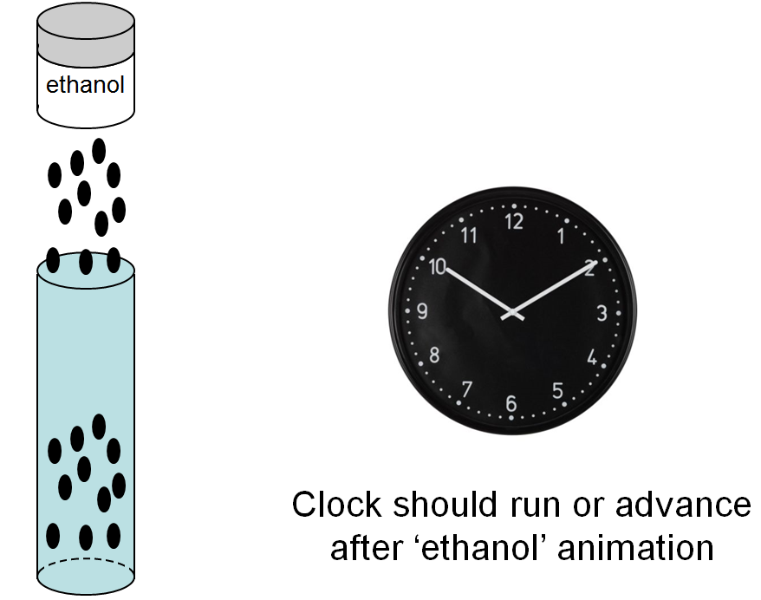

B. Interview: (Said by you on camera. Don’t forget to smile!)
  - **Mike Grotewiel: Demonstrating the procedure will be Simran Sandhu, a student from my laboratory.
    - Interview style: Author saying the above
    - The named technician, post doc, student looks up from workbench or desk or microscope and acknowledges the camera.

Protocol (read by voice talent at JoVE):
- Fly Collection and Ethanol Preparation
  - To begin the experiment, collect flies in fresh food vials in groups of 11 of a single sex for up to five minutes of CO₂ [2.1.1-MED].
    - *film as written
  - Allow the flies to recover overnight in food vials in an environmentally controlled space [2.2.1-MED-TEXT].
    - TEXT: 25°C, 60% relative humidity, 12-h light/dark cycle
  - Prepare ethanol solution by diluting pure, 100% ethanol in purified water to a final concentration of 85 % [2.3.1-MED Over the Shoulder]. Allow the solution to return to room temperature overnight [2.3.2-MED/WIDE].
    - If possible, capture the labels of the 100 % ethanol and the purified water, and the resulting 85 % ethanol in the shot
    - *film as written
- Ethanol Assay
  - Before the assay prepare a clean, empty food vial, which will serve as the testing vial, a new cellulose acetate plug, a silicone stopper, and 1 mL of ethanol solution for each vial of flies to be tested [3.1.1-MED].
    - Pan the ingredients in the order they are listed in the VO. LAB MEDIA: Table 3. Show this table in a split screen with the footage.
  - Adjust the room temperature to 20-25 °C and the relative humidity to 55-65 % [3.2.1-MED/CU]. Designate another worker to assign a unique code to each group of vials and record the code for later [3.2.2-MED]. Place coded vials with flies in the testing room to acclimate for a few minutes [3.2.3-MED/WIDE].
    - *film as written
    - Capture the talent communicating with colleague to assign code to vials
    - Talent places vials in testing room and closes the door
  - Next, label the empty testing vials to match the codes on the fly vials [3.3.1-CU]. Construct a hard copy testing log by entering the codes into columns with one column per vial in a spreadsheet [3.3.2-CU]. Using the testing log as a guide, arrange the coded food vials with flies and the empty testing vials into matching arrays in the testing room [3.3.3-MED Over the Shoulder].
    - Split screen. LAB MEDIA: Table 1. Show this in a split screen with the footage above.
    - *film as written
    - *film as written
  - Transfer the flies from the food vials into the matched and labeled testing vials one at a time, then immediately insert cellulose acetate plugs into the testing vials until the cellulose acetate plugs are 2 cm below the vial tops [3.4.1-CU].
    - Focus on the vial and plug in this shot as talent transfers flies into the vial and tops it with a cellulose acetate plug, then be sure to capture the placement of the plug in the vial and leave this shot on the screen for a beat.
    - Capture the pattern of the rows as the talent taggers them.
  - For the time 0 assessment, grasp each vial individually by the thumb and forefinger…tap gently on the table three times to knock the flies to the bottom of the vial, wait 30 seconds [3.5.1-CU], and count the number of flies that are immobile and or dead [3.5.2-CU]. Record the number of immobile-dead flies for each vial at time 0 min in the hardcopy testing log [3.5.3-MED Over the Shoulder].
    - *film as written
    - Capture the talent counting the number of flies
    - *film as written
  - Start the timer at time 0, and immediately add 1 mL of ethanol to the cellulose acetate plugs in a circular motion, at 5 second intervals for the first set of 4 vials in the order they will be tested [3.6.1-CU]. When the ethanol has been added to all 4 testing vials in the set, insert a silicone plug in each vial to seal it [3.6.2-CU].
    - *film as written
    - *film as written
  - At 1, 2, 3, 4, and 5 minutes, add 1 mL of ethanol to the second, third, fourth, fifth, and sixth sets of 4 vials, respectively [3.7.1-MED Over the Shoulder]. Continue inserting silicone stoppers after adding ethanol to each set of 4 vials [3.7.2-MED].
    - *film as written
    - *film as written
  - At 6 minutes, test the first set of 4 vials by grasping each vial with a thumb and a forefinger, and tapping gently on the table three times to knock flies to the bottom of the vial [3.8.1-CU]. Wait 30 seconds, then count and record the total number of flies that are sedated [3.8.2-MED]. Score flies as sedated if they, one, stand on the floor of the vial but do not walk or, two, lie on their backs with or without flapping their wings [3.8.3-CU/ECU].
    - *film as written
    - Capture the timer alarming at 30 seconds, then the talent documenting the number of flies sedated.
    - Show each of the conditions listed in the voice over, have talent point at flies with object if necessary to clearly indicate which fly is being discussed
  - Handle each vial within the set at 5 second intervals using this schedule [3.9.1-MED]. At times 7, 8, 9, 10, and 11 minutes, test the second, third, fourth, fifth, and sixth sets of vials, respectively, as done for the first set [3.9.2-MED Side View].
    - Split screen with LAB MEDIA: Table 2
    - *film as written
  - At 12 minutes, test the first set of 4 vials again and continue testing the second, third, fourth, fifth, and sixth sets of vials at 13, 14, 15, 16, and 17 minutes, respectively [3.10.1-MED]. Continue testing the flies until they are all sedated [3.10.2-MED].
    - Film as written
    - Film as written
  - Enter the total number of flies in each vial in the hard copy testing log [3.11.1-MED Over the Shoulder]. Censor immobile/dead flies at time 0 from the total number of flies [3.11.2-CU-TXT].
    - *film as written
    - TEXT: See accompanying text protocol for calculations
- Results: Effects of Different Factors on Ethanol Sensitivity
  - Raw data from the ethanol sedation assay were converted to the percent of active flies as a function of time [4.1.1-LM]. Sensitivity to ethanol sedation from the primary data was quantitated as Sedation Time 50, or ST50, the time required for 50 % of flies to become sedated [4.1.2-LM]. Ethanol volume impacted ethanol sensitivity [4.1.3-LM].
    - Figure 1A & 1B: Show the two images side by side and emphasize the text in the x-axis, “time,” in both graphs in yellow.
    - Figure 1C: Show image 1C and highlight the text on the graph, “ST50,” in yellow.
    - Figure 1C: Leave image 1C on the screen from the previous shot and box the legend at the top of the graph (0.33 ml, 0.66 ml, 1.0 ml).
  - The assay detects the effects of RNAi against Cnx14D in the nervous system, which blunted ethanol sensitivity relative to controls [4.2.1-LM]. Mutation of scb and aru enhanced ethanol sedation sensitivity and mutation of hppy blunted ethanol sedation sensitivity compared to controls [4.2.2-LM].
    - Figure 1D: Show image 1D and highlight the curve in blue for elav-Gal4/v5597 (filled black squares) when “Cnx14D RNAi” is said. Remove the highlight on elav-Gal4/v5597 when “relative to…” is said, highlight the curves and text for v5597/+ and elav-Gal4/+.
    - Figures 1E & F: Show images 1E and 1F side by side. Highlight the curves in orange for scb in 1E and aru in 1F when said, then remove the orange highlight and highlight the curve for hppy in light green when said.

- Conclusion (said by authors on camera)
  - Simran Sandhu: Once mastered, this technique can be done in one and a half hours, if it is performed properly.

Provided Media

Insert your media filenames here.

General Preparation

It’s critical for a smooth and organized shoot that all reagents are accounted for, in advance.

Any overnight or long incubation steps should be recognized and specimens/samples be prepared in advance so that prior steps can be recorded and shooting can continue with pre-prepared specimens/samples.

All tubes/flasks should be pre-labeled neatly before we arrive.

Ex. Luciferase assay done in 96 well plates should be labeled with negative/positive control wells and experimental samples are labeled accordingly.

You will receive more detailed preparation instructions, as well as an introduction to your videographer, closer to your filming date.

