Request for additional information to guide script writing for your JoVE submission

In order to facilitate the proper filming of your video, a script writer will prepare both a script and a story board from your protocol prior to filming. For many protocols, steps are straight forward and intuitive, describing actions like mixing solutions, turning on equipment, and so forth. In some instances, however, it is not immediately clear from the protocol itself exactly what the best way would be to represent the action / step in the video. This is especially true for steps describing less common equipment, theoretical processes, image processing or data analysis, and the use of computer programs or software.

When the script writer begins planning your video the protocol will act as a rough guide for the video voiceover. Please consider your protocol in this context and ensure that there are no long sections of text that would be awkward or not-feasible to be incorporated into a voiceover. Please note at this time, if you have not already done so, that text highlighting can be used to indicate to the JoVE staff what you would like to include in the video. Highlighting is used for longer protocols due to length constraints, but can also be useful for protocols of any length if there are sections of introductory or explanatory information that you would like to include in the written protocol but may not need to be included in the video (may be too bulky / time consuming). If you are using highlighting in this way, please use yellow text background and highlight a maximum of 2.75 pages total (including spaces between steps). Please contact your editor with any questions regarding protocol highlighting.
Generally, there are three types of visuals that can represent a protocol step in your video: (1) Videographer footage (for instance, a lab member performing the action, footage of a process occurring as recorded from videographer’s microscope attachments) ; (2) screen shots that display the action or the result of the action (for instance, if you describe setting parameters in software, screenshots can demonstrate the interface; if you describe utilizing a program to perform a step a screen shot of the code can accompany the step); (3) a schematic or figure can be displayed to represent the step.
As the goal of JoVE is to visualize methods that cannot be represented optimally in written protocols, we try to avoid having videos with too many screen shots or schematic representations of steps. It is best if actions are filmed live when possible. We understand that many aspects of your work may involve software / programing and the best way to present the protocol may be a combination of both live demonstration and static / animated images. Also please note that an action describing computer / software use should be demonstrated via screen shots, not via videographer footage of a lab member at a computer.
In most cases the determination of the shot list for your video happens later in the JoVE process. However, since there are some steps in your protocol that we are a bit unsure of, we ask that you provide some guidance for us at this time as described below. This way if any changes need to be made to the way the protocol is written or presented, to ensure the best version of your video is made, this can be done prior to peer review. We appreciate you taking the time to provide this information for us and please do not hesitate to contact your editor with any clarifications or questions.
Please note: this request only applies to certain steps in your protocol as listed in the editorial comments.
Please fill in the work sheet below, replacing the examples. For each of the steps requested, please designate which of the options would be the optimal representation for visualizing the step (videographer footage, screen shot or figure). If a single step requires two options (for instance part will be filmed in the lab, part will be shown via a screen shot) please separate the step accordingly in the table (not in the protocol). If a figure from the manuscript will be used please refer to it by number and panel letter. If a screen shot will be used, please add the screen shot after the table along with an identifying title. If the screen shot is not currently available a low resolution version or a brief description of it can be used instead. (Screen shots will not be sent to peer review.)
If edits are made to the protocol later in the review process this guide will not need to be updated unless major changes to the protocol are made. Edits to text segments in this guide will not be reflected in the manuscript.
* Please upload this completed work sheet under the file designation “Supplemental files (as requested by JoVE).*
Supplemental information for JoVE scriptwriter
Please note that the steps should correspond to the steps in the manuscript text.
Step # | Text | Visual representation
1.1.1 | Download the most recent stable version of the OLego source code or executable binaries from SourceForge. | Screenshot 1
 | Alternatively, use git to retrieve the most updated version of the source code from the repository: | Screenshot 2 &3
 | Browse into the “olego” folder by typing “cd olego” | Screenshot 4
1.1.3 | Compile the source code by typing “make”. | Screenshot 5 & 6
 | Two executable files (olego and olegoindex) will be created in the folder. | Screenshot 7
1.2 | Before running olego, a reference genome has to be indexed using “olegoindex” | Screenshot 8
1.2.1 | Download the FASTA genome sequence from the UCSC genome browser. Here the mouse genome is used as an example. | Screenshot 9 & 10
1.2.2 | Decompress the gz file | Screenshot 11 &12
 | Remove random chromosomes and haplotype sequences, | Screenshot 13
 | and concatenate the files into a single FASTA file | Screenshot 14
1.2.3 | Run olegoindex to build the index for the reference genome | Screenshot 15
 | This step will take a while, There will be eight files generated. | Screenshot 16 & 17
1.3.1 | It is strongly recommended that a database of annotated exon junctions should be provided to OLego. Download the pre-built exon junction database from the OLego website | Screenshot 18 &19
 | Decompress this file. | Screenshot 20
1.3.2 | Another required file is the regression model, you can find the logistic regression models for mouse and human exon junctions in the sub folder “models”. | Screenshot 21
1.3.2 | To generate configuration files for other species. Use the script included in the package to build models for other species. Type “perl regression_model_gen/OLego_regression.pl” in the olego folder to see the help message. | Screenshot 22
2.1 | With all these files ready, we can start to do a test mapping. We need to map the paired end reads separately. We start with the first mate, | Screenshot 23 & 24
 | Then the 2nd mate | Screenshot 25 & 26
2.1 | Use option “-t” to specify the number of CPU cores to be used in the alignment. Use “-M” to specify the maximum number of mismatches or indels allowed. Use “-w” to control the seed size.  For strand-specific RNA-Seq libraries, check option “–-strand-mode”. For other options, refer to the online documentation. | Screenshot 27
2.2 | Merge the mapping results from paired-end reads according to their distance and orientations to resolve ambiguities: | Screenshot 28 & 29
2.2.1 | Use “-d” to specify the maximum distance between the two ends on the reference. This script requires the two ends mapped to different strands by default, use “--ss” (requiring mapping to the same strand) or “--ns” (ignoring strand information) to change the behavior | Screenshot 30
2.3 | Optionally, to enhance the sensitivity, re-align reads with the exon junctions identified from the data. Some reads supporting novel exon junctions that are failed during the first-pass alignment can be recovered because of more extensive searches for reads mapped to known exon junctions.
2.3.1 | Convert the SAM alignment output file to BED format: | Screenshot 31
2.3.2 | Extract the exon junctions from the BED file | Screenshot 31
2.3.3 | Remap with this new exon junction annotation file, the process is almost identical to the previous run. Please refer to 2.2. | Screenshot 32
3.1 | For post-analysis, sort and convert the merge.sam into BAM format files. SAMtools¹¹ is required for this step: The bam files can be used in downstream analysis by other tools. | Screenshot 33 & 34

Screen Shots: (Please copy and paste or insert the required screen shots here, in the order they are listed above.)
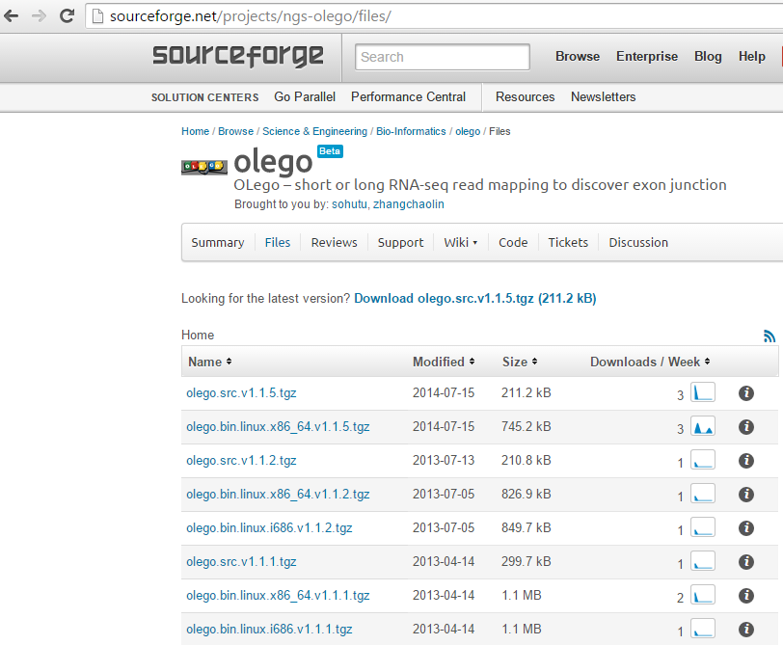
Screenshot 1

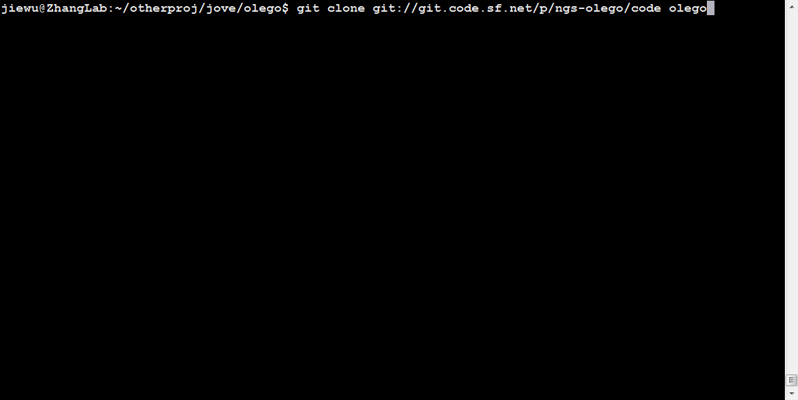
Screenshot 2
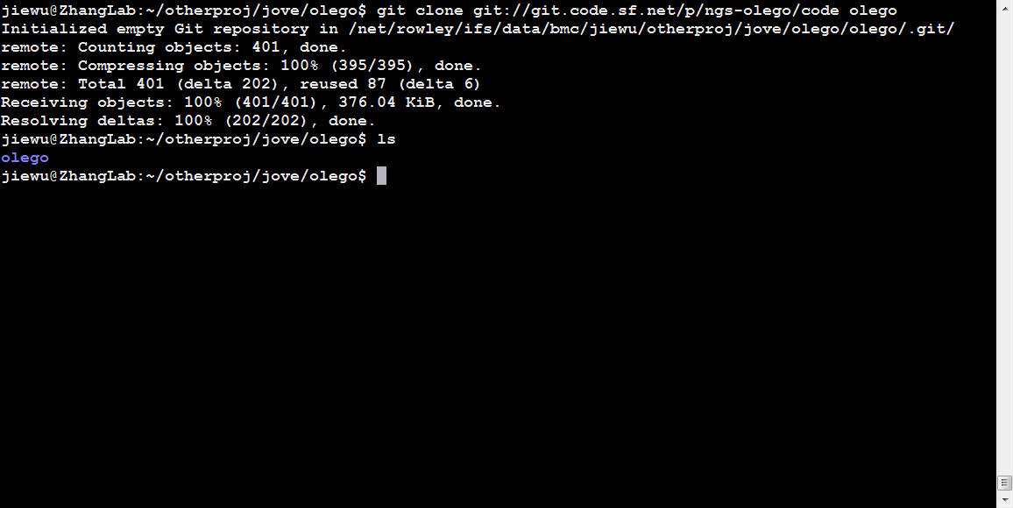
Screenshot 3

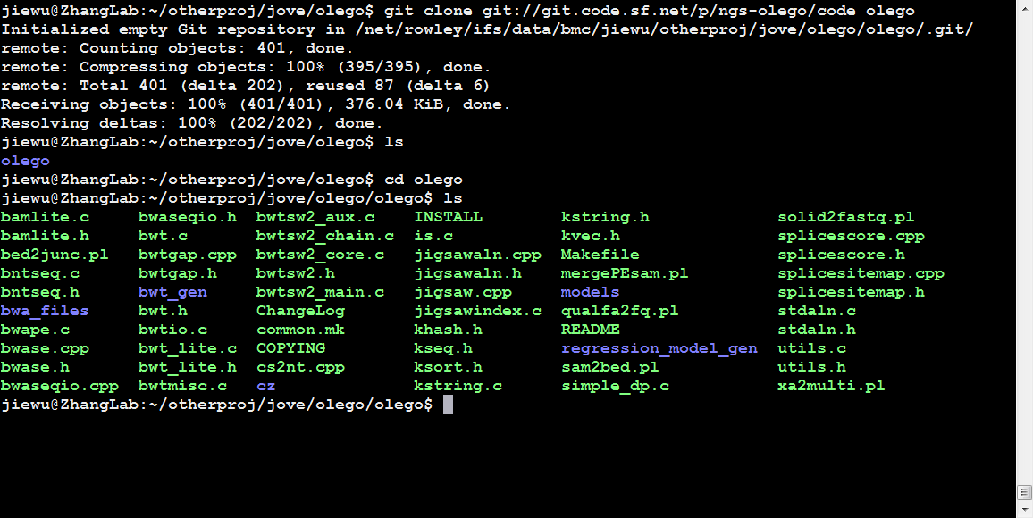
Screenshot 4
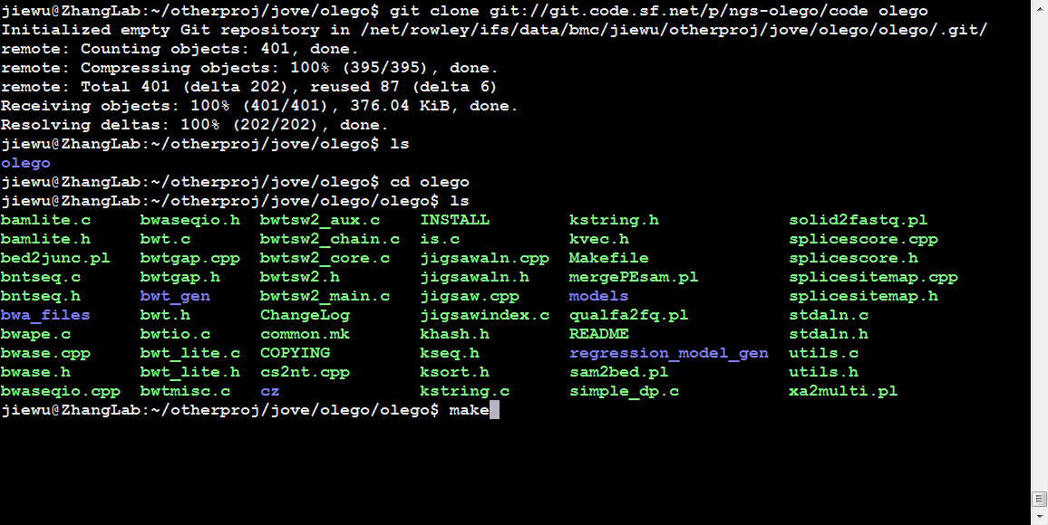
Screenshot 5
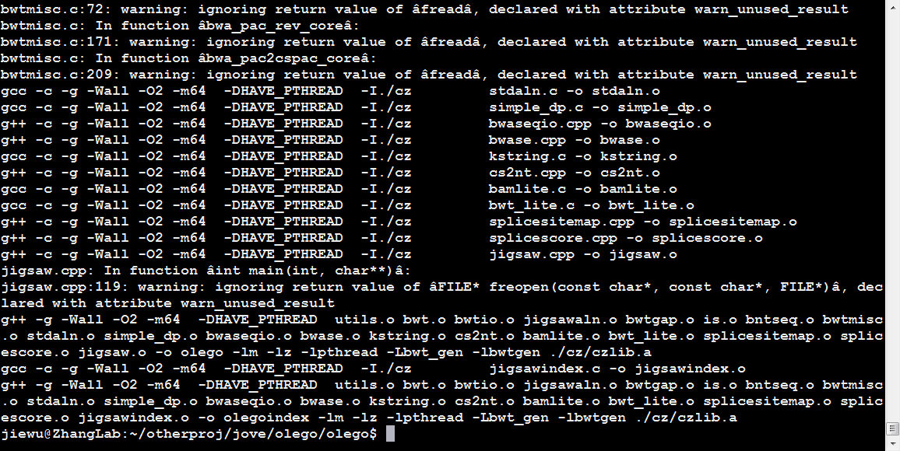
Screenshot 6
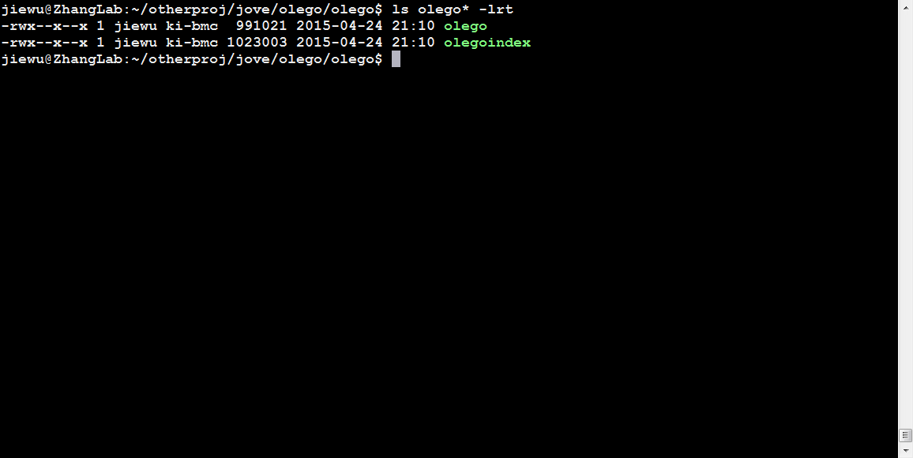
Screenshot 7
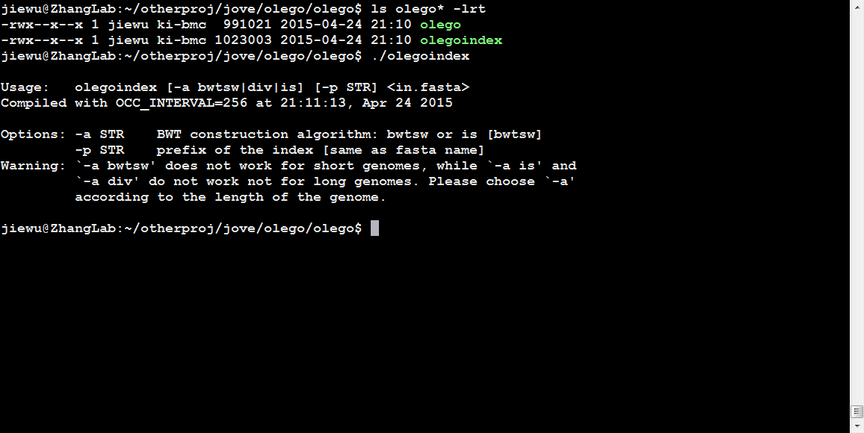
Screenshot 8
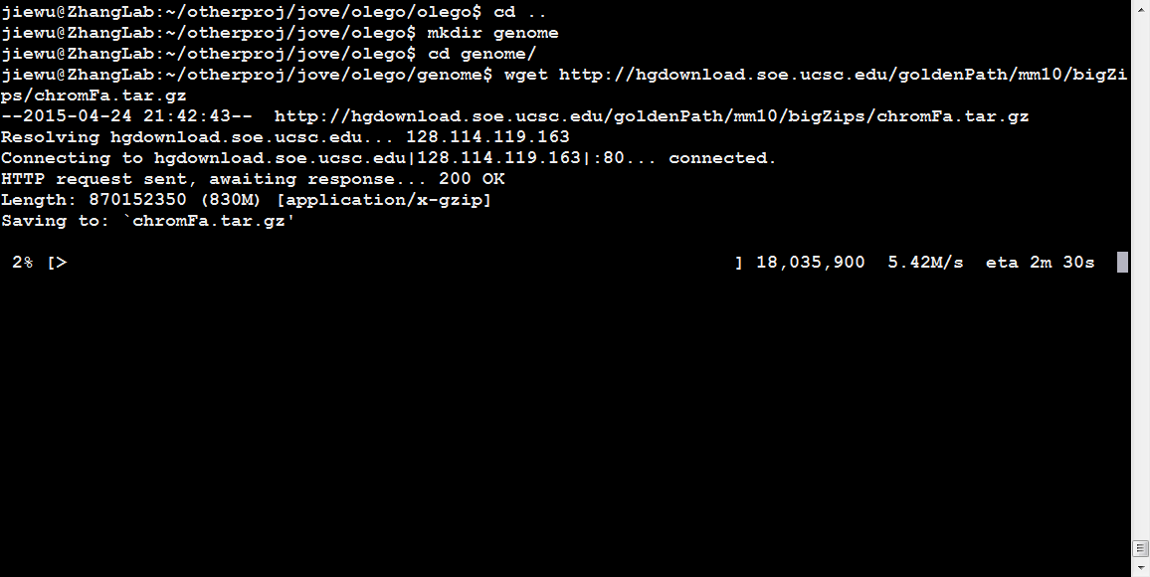
Screenshot 9
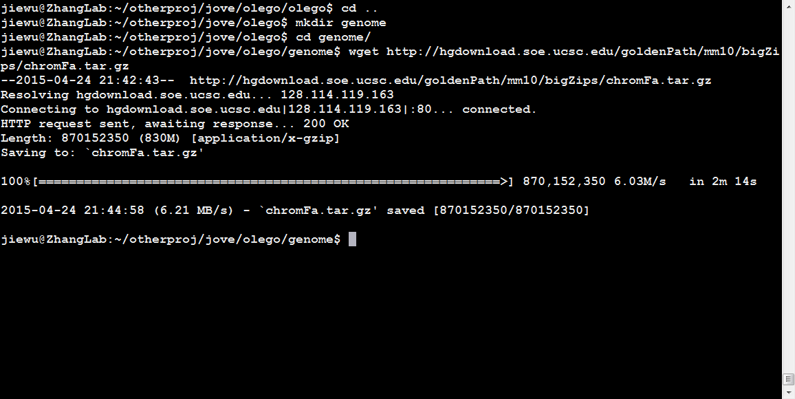
Screenshot 10
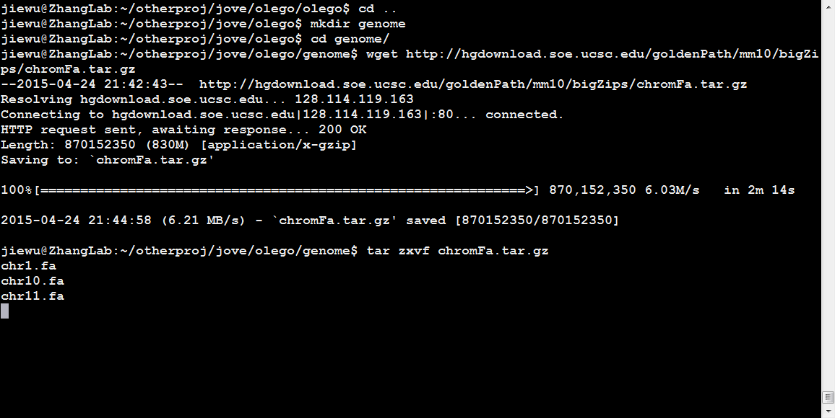
Screenshot 11
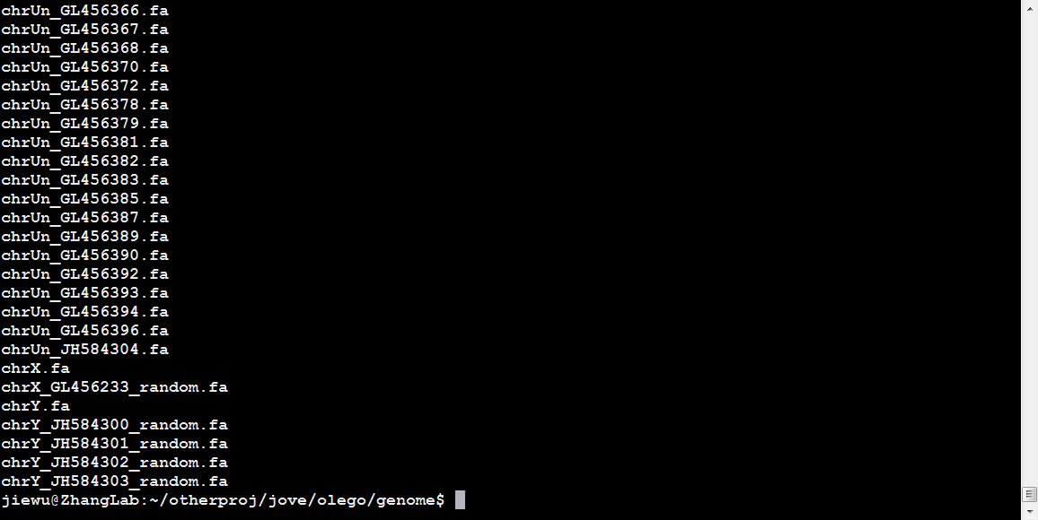
Screenshot 12
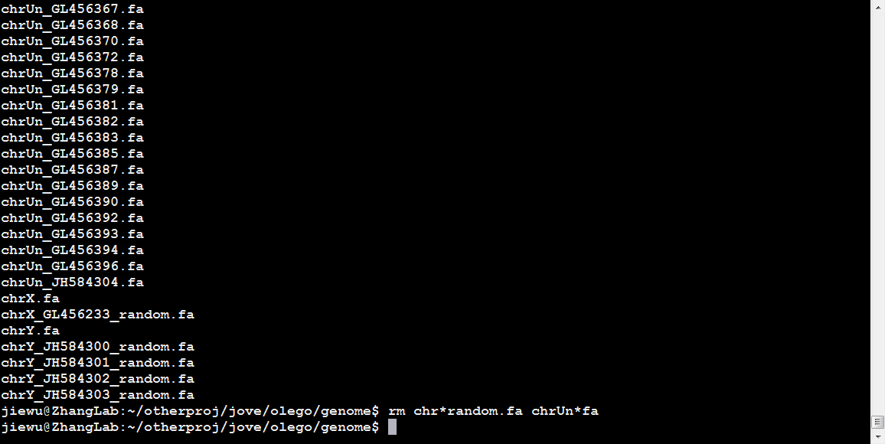
Screenshot 13
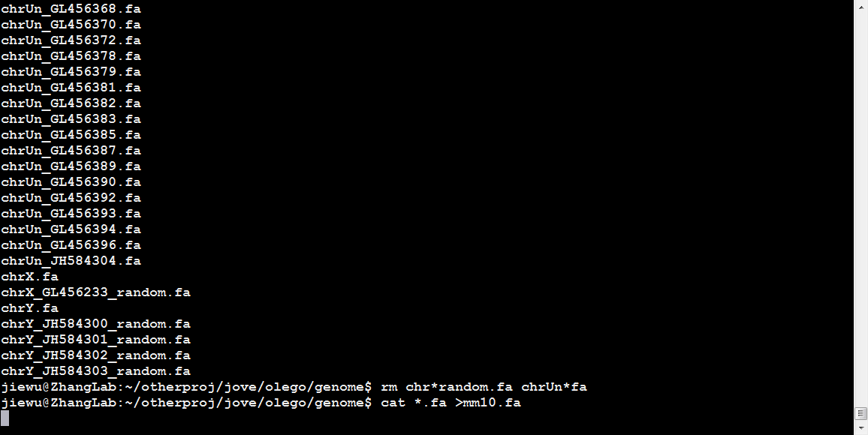
Screenshot 14
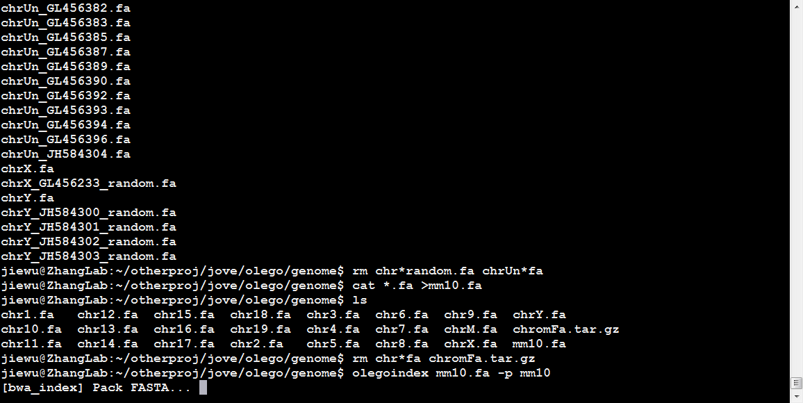
Screenshot 15
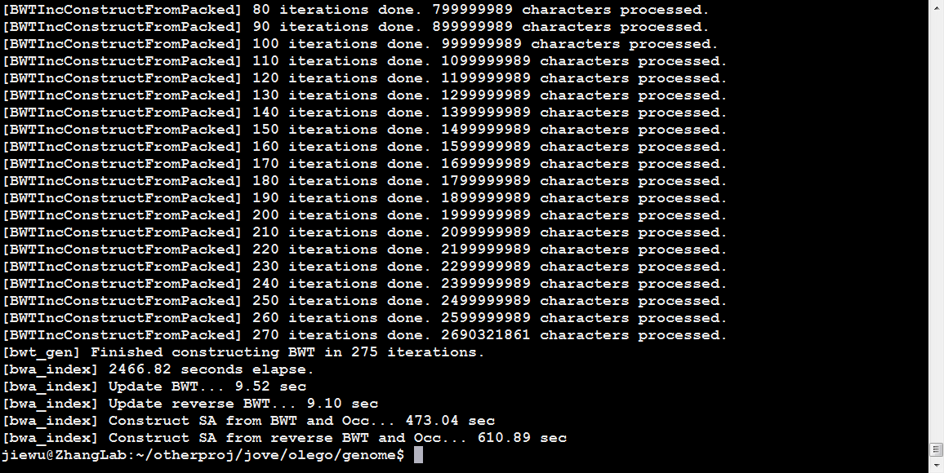
Screenshot 16
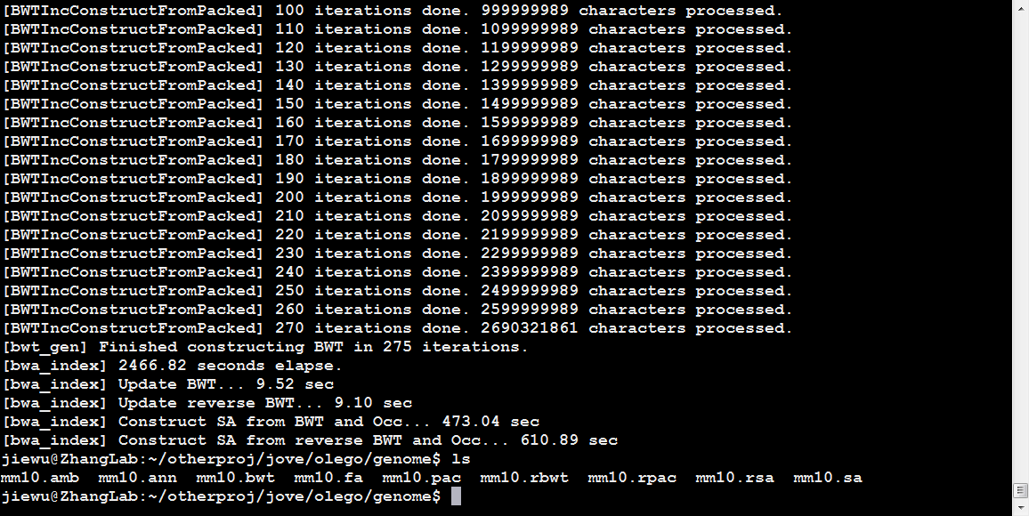
Screenshot 17
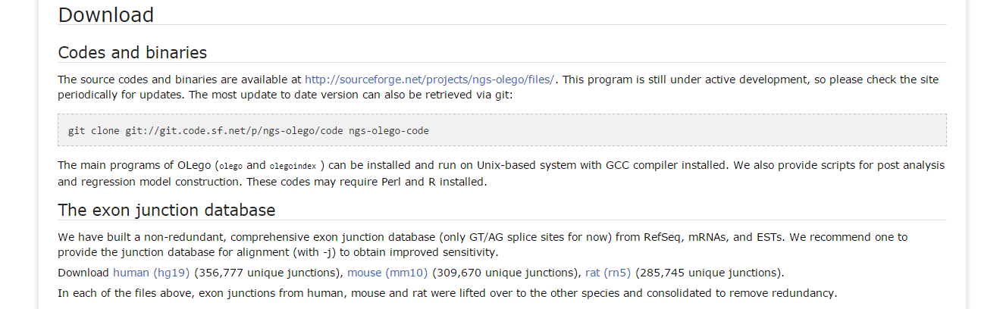
Screenshot 18
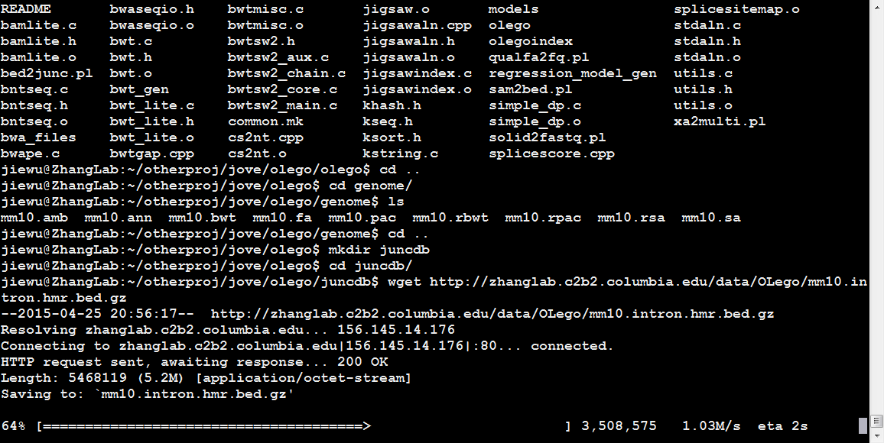
Screenshot 19
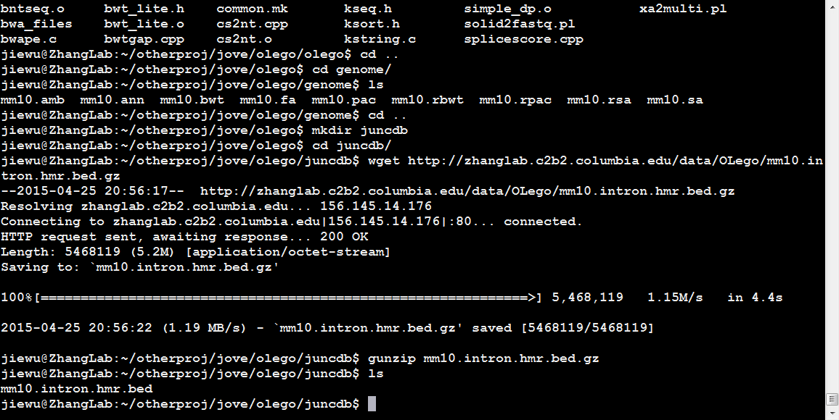
Screenshot 20

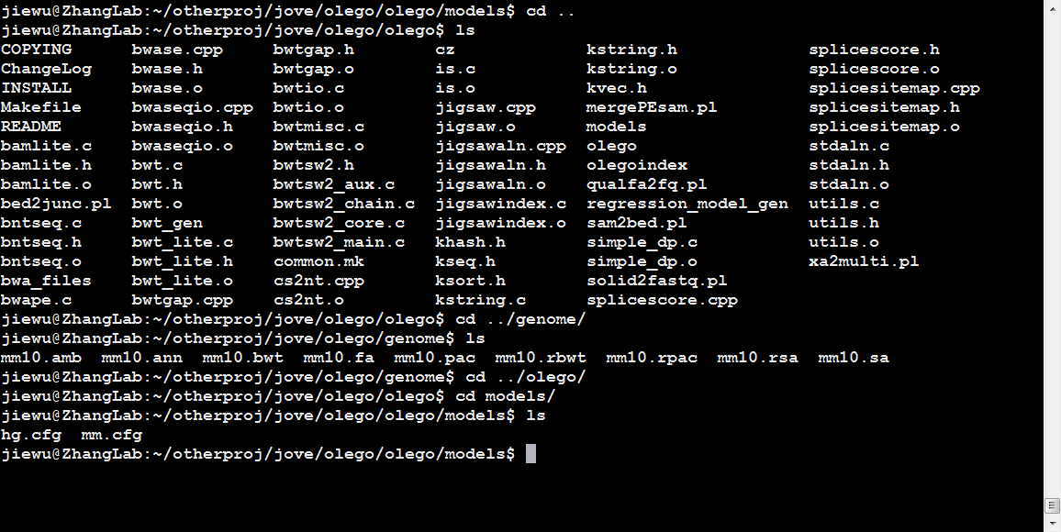
Screenshot 21
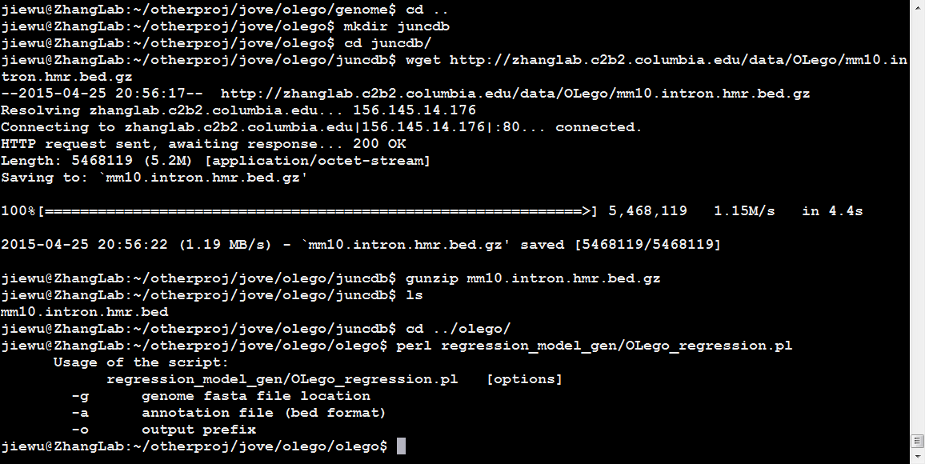
Screenshot 22
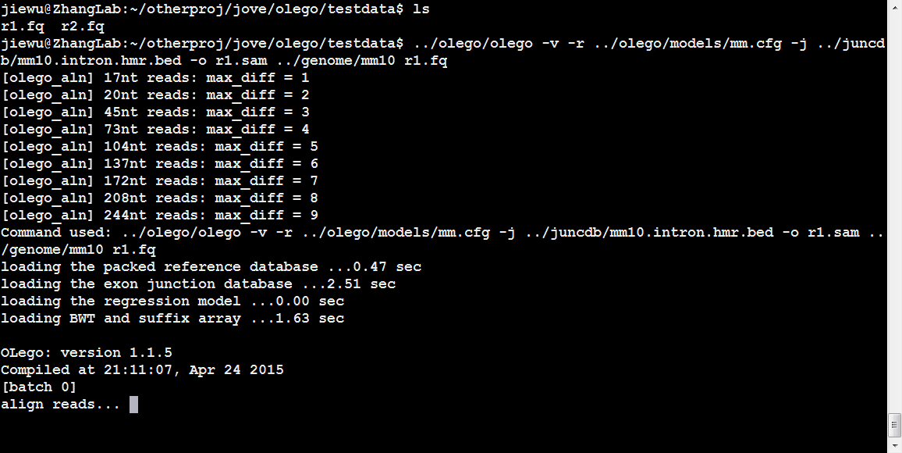
Screenshot 23
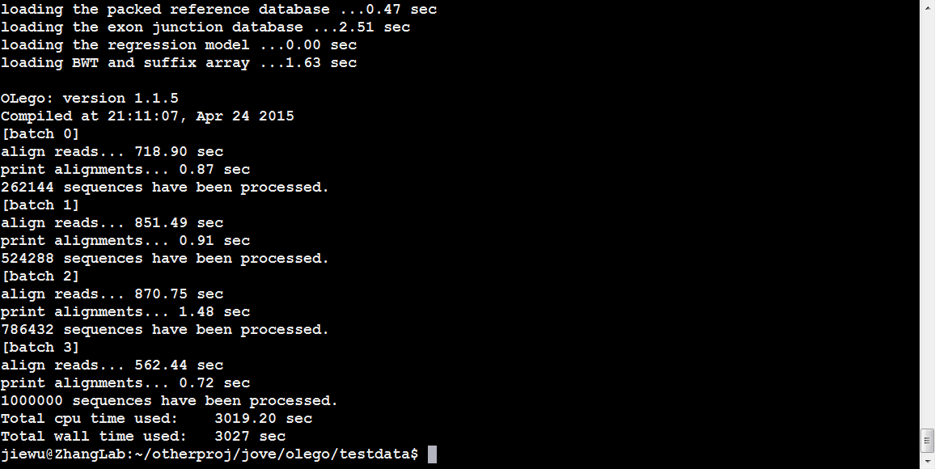
Screenshot 24
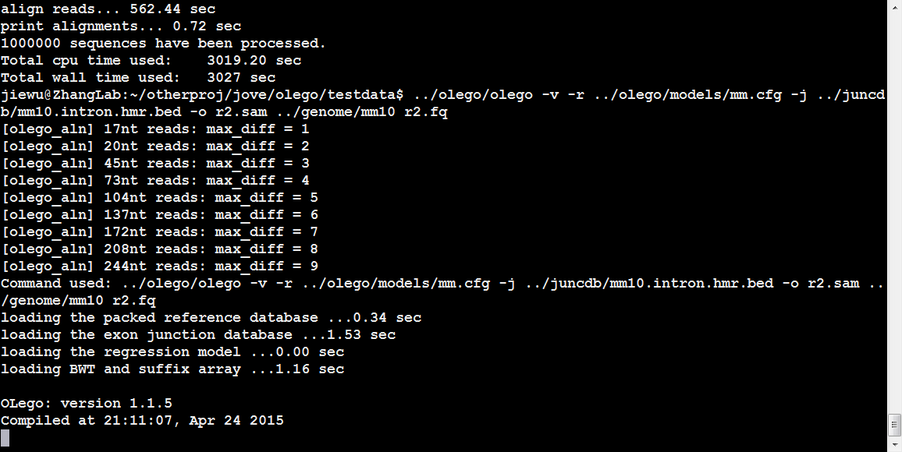
Screenshot 25
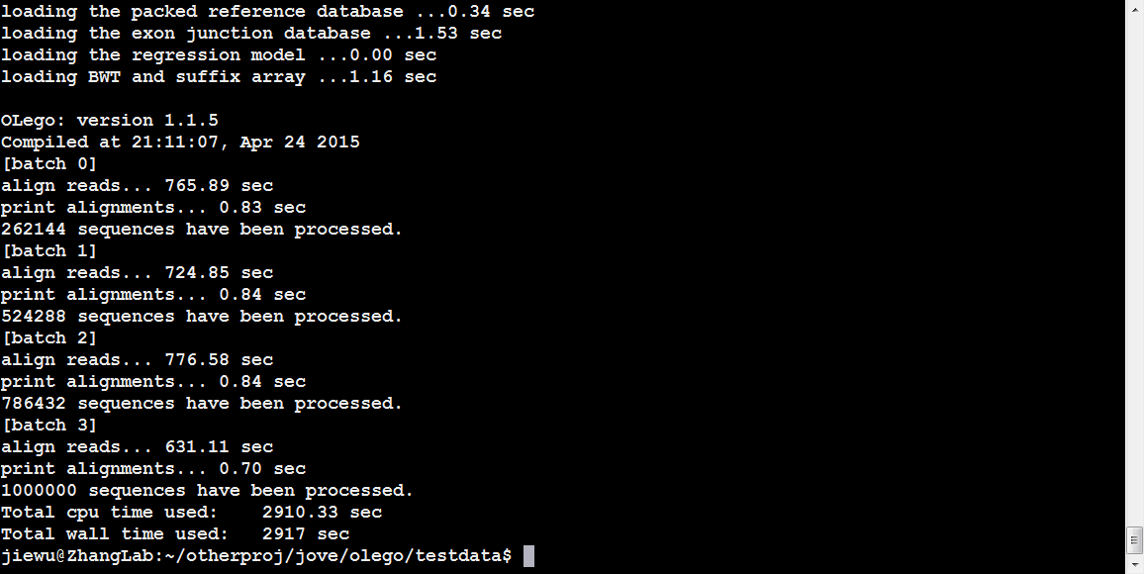
Screenshot 26

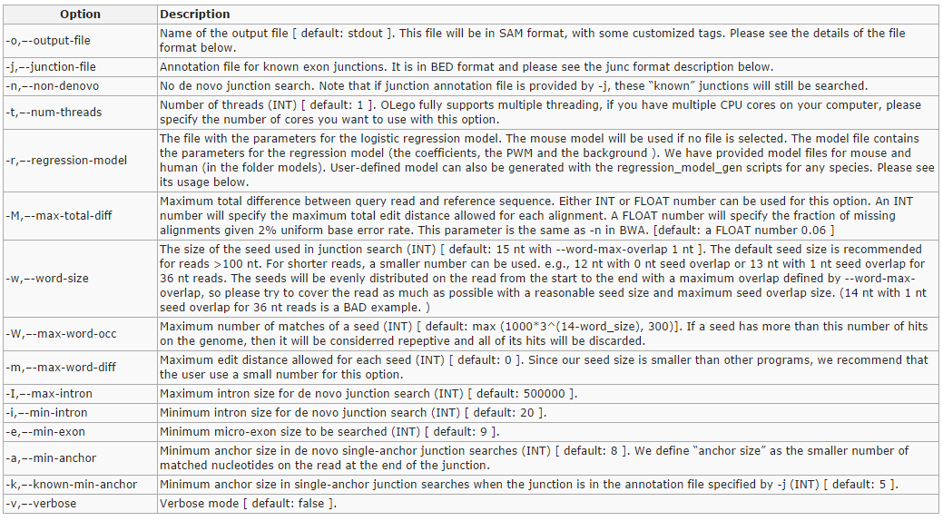
Screenshot 27
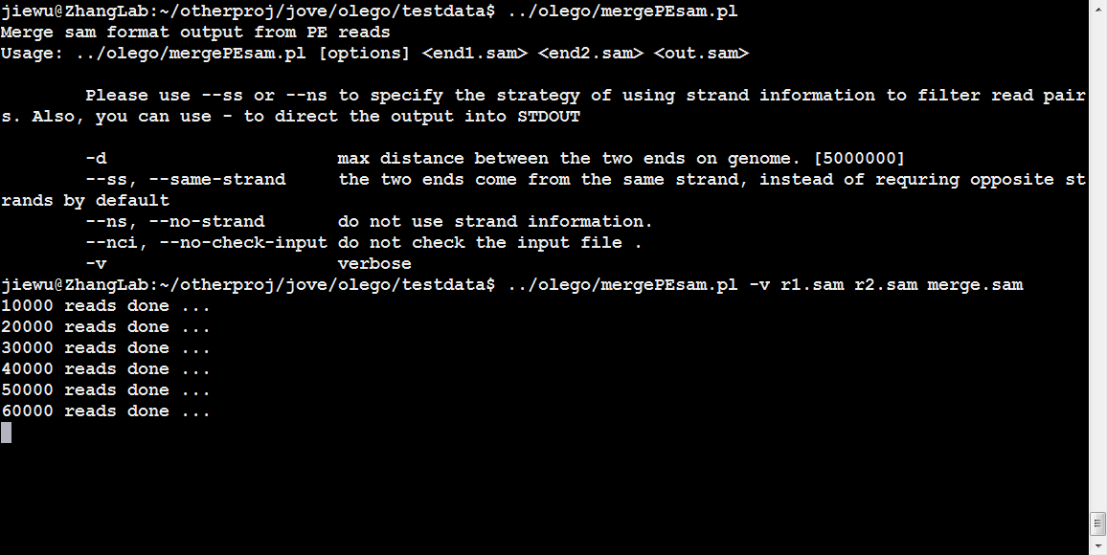
Screenshot 28
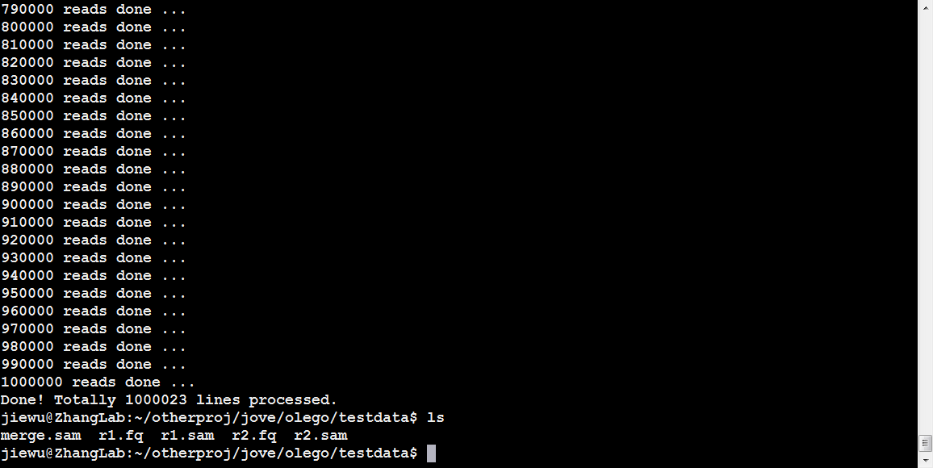
Screenshot 29
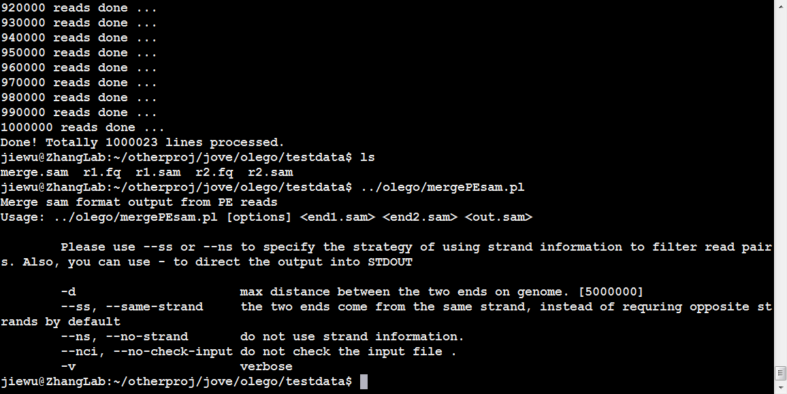
Screenshot 30
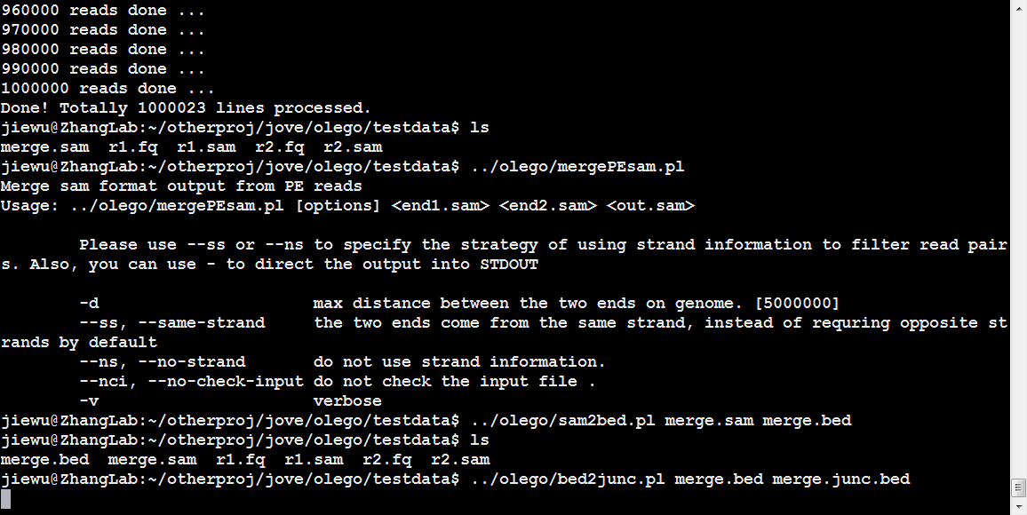
Screenshot 31
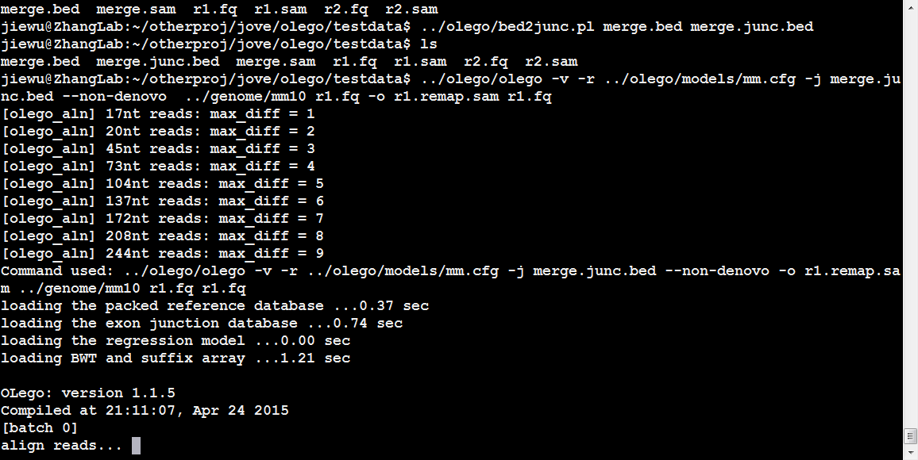
Screenshot 32
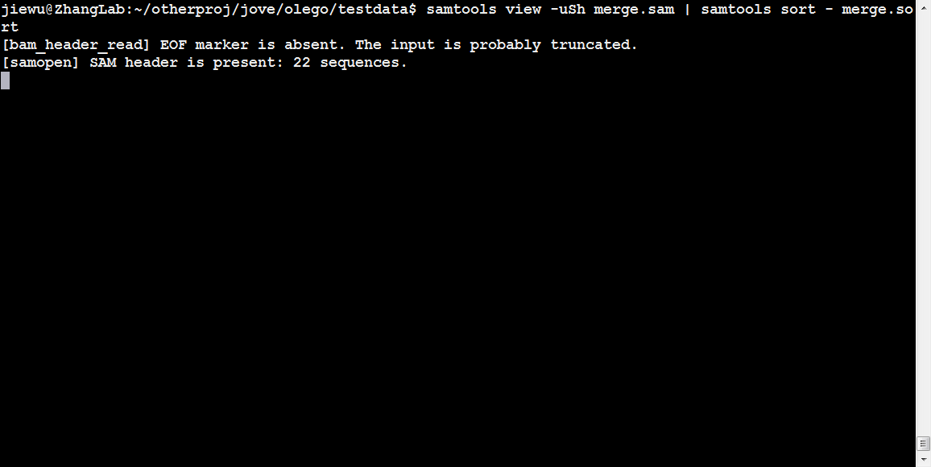
Screenshot 33
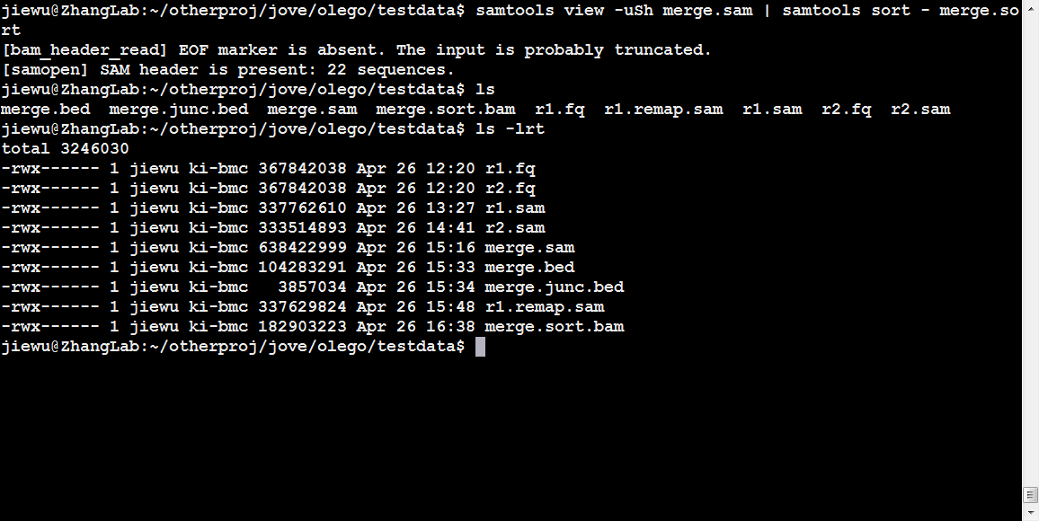
Screenshot 34

