Submission ID #: 52613

Editor Name: Renee Choi

Videographer Name: Nick Schweip

Film Date: 2/4/15

Authors and Affiliations: Sarah Khalil; Eliana Jacobson; Moria C. Chambers; Brian P. Lazzaro

Department of Entomology, Cornell University, Ithaca, NY

Title: Systemic Bacterial Infection and Immune Defense Phenotypes in Drosophila melanogaster

Corresponding Author:
Brian P. Lazzaro
Department of Entomology
Cornell University
Ithaca, NY
bplazzaro@cornell.edu

Co-authors: Sarah Khalil: sk2423@cornell.edu; Eliana Jacobson: ej89@cornell.edu; Moria C. Chambers: moria.chambers@cornell.edu

Authors, please fill out the brief questionnaire below.

A. Will you require JoVE to record video microscopy, such as filming a complex dissection or microinjection technique? (Y/N)__YES_______ (If you can record images/videos using your own camera/software, then mark No) If yes, please list make and model of your microscope: __Olympus SX 51 under white light___________________________________________
B. Does your protocol include detailed, step-by-step, descriptions of software usage? (Y/N)___NO___ If yes, we will need you to record using screen recording software to capture the steps. If you use a Mac, QuickTime X also has the ability to record the steps.
C. Which steps of your protocol will viewers benefit most from having filmed? Please list 4-6 steps using the step numbers listed in this document. __3.1, 3.2, 3.3/5.1, 4.1, especially emphasizing 3.1.3.3/3.1.4.1, 3.2.1, 3.2.2.2/3.2.3.2, 3.3.2 and 3.3.3___
D. What is the single most difficult aspect of this procedure and what do you do to ensure success.___3.1 and 3.2. require a steady hand, minimum of caffeine ______
E. Will the filming need to take place in multiple locations? (Y/N) __YES___ If yes, how far apart are the locations? _________ adjacent rooms on the same floor _______________

1. Introduction (Schematic Overview and Interview)

A. Schematic Overview (read by voice talent at JoVE):

Procedural Narrative:
The overall goal of this procedure is to deliver robust and repeatable bacterial infections to Drosophila melanogaster, then to subsequently measure infection severity and quantify the host immune response. (Intro)

This is accomplished by first delivering the bacterial infection into the flies using a nanoinjector. (P1: Display the fly on the left by itself, then bring in the nanoinjector (blue-green syringe and needle) and make it appear that the fly is injected by moving the plunger and liquid in the nanoinjector down to the tip of the needle and into the fly as seen in P2. Immediately display the fly with bacteria (green spotted fly on the right in P2).)

Host mortality can be tracked post-infection over time, and systemic bacterial load can be determined at any point by homogenizing infected flies, and measuring the number of bacteria present. (P2: Show the fly infected with bacteria (green spots), then move the fly into the vial for monitoring survival (as seen in P3). Next, take another fly and move it into the tube (w/ yellow liquid) and animate pestle being moved up and down to show the fly is being homogenized or crushed. Add the arrow to the right with the text “bacterial load” and show the image of the plate.)

The host immune defense can also be quantified by measuring the expression level of antibacterial peptide genes. (P3: Keep the image from the previous VO on the screen and add the image of the qRT-PCR output (mock graph labeled “immune induction”) at the end of the first arrow, and the text “your favorite assay” at the end of the second arrow).

Ultimately, quantification and characterization of bacterial infection in Drosophila melanogaster can be used to test how genetic and environmental factors alter immune competence of the fly. (P4: Figures 4A, 4B, 4C)

Paste a copy of your graphic overview here. The original file should be Adobe Illustrator (preferred) or Powerpoint (see instructions) and should be uploaded through your online submission on the JoVE website. Please keep all layers in the file (i.e., do not flatten the file).

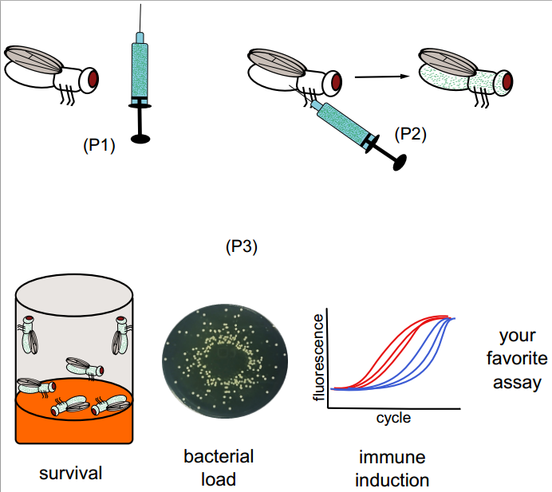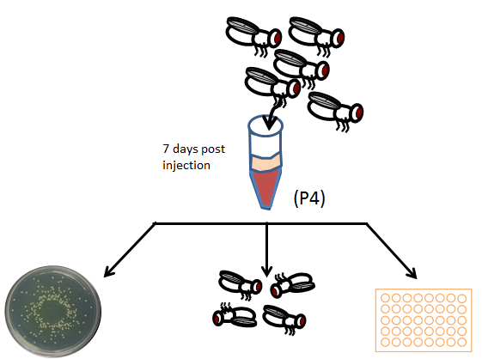

B. Interview: (Said by you on camera. Don’t forget to smile!)
  - Brian P. Lazzaro: This method can be used to address key questions in the field of insect immunity, such as how host genetic or environmental factors influence immune capability, or how distinct bacteria vary in their infection kinetics.
  - Moria C. Chambers: Although we are using this method to measure immune defense of Drosophila melanogaster against bacterial infection, it can also be applied to other other insects and can make use of other types of pathogens, like viruses or fungi.
  - Eliana Jacobson: A common problem people experience when they are first learning the method is that they may cause too much injury to the flies, which can result in excessively high mortality even in controls.
  - Sarah Khalil: Visual demonstration of this method is critical for learning how to do infection with minimum damage to the fly. Since our host species, Drosophila melanogaster, is so small, infection must be done under a microscope, which adds to the initial complexity of the technique. However, we believe that a small demonstration of the technique will render it accessible even to scientists who have only limited experience working with flies.

Protocol (read by voice talent at JoVE):
- Bacteria Preparation
  - To begin the experiment, select a single colony from a previously prepared master plate and inoculate a flask of sterile medium. Grow the bacteria overnight at 37 °C to stationary phase.
    - MED: Talent obtains plate and selects a single colony then inoculates a flask filled with sterile medium. (TEXT: See accompanying text protocol for fly collection & preparation and bacteria culture procedures)
    - MED/WIDE: Talent places flask in incubator for overnight storage and closes the door.
  - Once the culture has reached stationary phase, gently pellet the cells from 600 μL of the culture in a tabletop centrifuge for 3 minutes at 5000 x g…then discard the supernatant and resuspend the bacteria in 1000 μL of sterile phosphate buffered saline, or PBS.
    - MED – Over the Shoulder: Talent places flask in centrifuge, or transfers the culture to a secondary container and places the secondary container in a centrifuge. If possible, capture the settings the talent enters to run the centrifuge.
    - MED – Over the Shoulder: Talent discards the supernatant and adds 1000 uL of PBS and resuspends the pellet with a pipette. TEXT: PBS: 137 mM NaCl, 2.7 mM KCl, 10 mM Na₂PO₄, 1.8 mM KH₂PO₄, pH 7.4
  - Next, dilute the resuspended cells in sterile PBS to achieve the desired 600 nm absorbance, and use this suspension to infect the flies.
    - MED: Talent adds more PBS to the resuspended pellet then sets the culture aside.
- Fly Infection by Nanoinjector
  - Prepare a glass needle by pulling a borosilicate glass capillary and use forceps to break off the tip of the needle to create a 50 μm diameter opening.
    - CU: Talent holds up needle to camera so it is clearly in focus then holds up forceps to break off the tip of the needle.
  - Next, place the sealing O-ring and the white spacer, with the large dimple facing outward, onto the metal plunger of the injector. Fill the glass needle with mineral oil using a syringe with a 30-gauge needle. Then place the filled glass needle through the collet and place the larger O-ring around its base 1 mm from the blunt end of the needle.
    - CU/ECU: Talent sets O-ring and white spacer onto the metal plunger of the injector and demonstrates the orientation of the dimple onto the metal plunger.
    - CU: Talent fills glass needle with mineral oil.
    - CU: Talent carefully places the glass needle through the collet and places the larger O-ring around its base so it is 1 mm from the blunt end of the needle.
  - Slide the needle onto the metal plunger and gently screw on the collet until it is secure. Dispel the mineral oil from the injector, leaving a small volume of oil in the needle to act as a barrier between the injector and the bacterial suspension.
    - ECU/CU: Talent slides the needle onto the plunger and carefully screws on the collet.
    - ECU/CU: Talent dispels a small amount of mineral oil from the needle.
  - Make sure that there are no air bubbles within the mineral oil, bacterial suspension, or between the two liquids, then set the injector to the desired volume for injection.
    - CU: Talent points out that there are no air bubbles in the items listed in the VO, then sets the volume.
- Bacterial Pathogen Injection and Creating Wounding Controls
  - To generate wounding controls, inject anesthetized flies with sterile PBS in the anterior abdomen on the ventrolateral surface.
    - MED/CU: Capture the microscope in the background if possible, talent inserts the tip of the capillary needle into the PBS and presses the fill button.
    - SCOPE: Talent injects a fly in the abdomen.
    - [added] SCOPE: Shot of up close injection into the abdomen.
  - Place the injected flies into fresh vials with new media, and lay the vials on their side to prevent the flies from becoming stuck to the food before they recover from their anesthesia.
    - MED Side View: Talent brushes flies into new vial, then lays the vial on its side. Zoom in on the flies lying on the side of the vial, if possible.
  - Next, eject the remaining sterile media from the injector and refill the same needle with the bacterial suspension. Repeat the procedure and inject the flies with the bacterial suspension.
    - MED: Talent ejects the media then refills the needle.
    - MED: Talent works under the microscope to repeat the injection.
  - Alternatively, the infection can be delivered by a septic pinprick. To prepare the infecting pin, melt the end of a 200 μL micropipette tip and insert a 0.15 mm insect minutien pin into the molten plastic. Allow the plastic to solidify so that the pin is held in place with 0.5 cm of pin extending from the plastic.
    - MED/CU: Shot of septic pinprick mechanism.
    - CU/ECU: Talent melts the end of a micropipette tip, then inserts an inset minutien pin into the melted plastic.
    - CU/ECU: Talent leaves plastic to cool, show the 0.5 cm of pin extending from the plastic.
  - Anesthetize flies with CO₂ and prick the flies in the sternopleural plate of the thorax with the needle, avoiding the attachment sites of the wings and the legs. Remove the flies from the minutien pin using soft forceps. Make sure to dip the pin into the bacterial suspension between pricking each fly.
    - MED – Over the Shoulder: Talent anesthetizes flies and places them under the microscope.
    - SCOPE: Talent prick the fly with the needle as oriented in the VO.
    - SCOPE: Talent removes the fly from the pin with forceps.
    - [added] SCOPE: Shot of up close prick into the throrax.
  - Place the pricked flies into a fresh vial with new fly medium, laying the vial on its side until all of the flies have recovered from the anesthesia.
    - MED – Over the Shoulder: Talent places flies into fresh vial, closes the vial, and places it on its side.
- Infectious Dose Delivery Assessment
  - Place a subset of the infected flies into individual microcentrifuge tubes on ice. Add 250 µL of PBS to each tube and use a pestle to homogenize the flies.
    - MED: Talent brings fly vial to bucket.
    - MED/CU: Talent places anesthetized flies into microcentrifuge tubes on ice.
    - MED/CU: Talent adds PBS to each tube, then picks up one tube and homogenizes the flies with a pestle.
  - Next, plate the homogenate on an LB agar plate, using a spiral plater. To plate the homogenate by serial dilution, transfer each fly homogenate to the first row of a 96 well plate and fill each well of the remaining rows with 90 µL of PBS.
    - MED – Over the Shoulder: Talent pours the contents of the tube on the plate then spreads them. plates using the spiral plater.
    - MED – Over the Shoulder: Talent fills the first row on a 96-well plate with fly homogenate, then begins to fill the remaining rows with PBS. Capture the label of the PBS if possible.
  - Using a multichannel pipette, take 10 µL from the first row containing fly homogenate and dispense the homogenate into the second row. Pipette up and down at least 10 times to thoroughly mix the homogenate, then take 10 µL of the homogenate and transfer it to the next row. Repeat this procedure using the remaining rows.
    - MED – Over the Shoulder: Talent transfers 10 uL from the first row to the second row.
    - MED – Over the Shoulder: Talent pipettes up and down to mix the homogenate, then transfers 10 uL from the second row to the third row.
    - MED: Talent continues the process with the next row.
  - Starting from the bottom row, use the multichannel pipette to take 10 µL from each well and deposit it on an LB plate. Ensure that the samples are dispensed as discrete spots that do not touch each other. Repeat this step until all wells have been sampled from each row, dispensing them in descending order of dilution on the LB plate.
    - CU: Talent transfers 10 uL from bottom row to LB plate.
    - CU/ECU: Talent has filled up more of the plate, and continues to transfer 10 uL aliquots onto the plate.
    - MED – Over the Shoulder: Talent continues to aliquot the sample onto the plate.
  - Whichever plating method is used, take care not to overgrow the plates so colonies remain small and discrete.
    - MED: Talent sets plate aside to allow the spots to soak into the LB.
    - MED – Side View: Talent recovers plate and shows that the spots are no longer there to the camera, then places the plate in the incubator. Repeat shot with the spiral plated plate.
  - Remove the plate from the incubator once the experimental bacteria have grown visible colonies, but before colonies from the Drosophila gut microbiota become visible approximately 24 hours later. For spiral plates, count the colonies that grow using an automated colony counter that can estimate the bacterial load per mL of homogenate based on the number and position of the colonies on the plate.
    - MED: Talent removes the plate from the incubator and shows the plate to the camera to show the amount of growth needed. Repeat shot with the spiral plated plate. We would like both shots to be in the video. The plates look very different from each other and we want the audience to know how the plates should look after either type of plating.
    - MED – Over the Shoulder: Talent counts colonies with an automated counter.
  - For spot plates, manually count the colonies for each fly from whichever dilution contains 30-300 colonies and calculate the number of bacteria per mL of original homogenate.
    - MED: Talent pulls separate plate and manually counts colonies, then makes documentation to calculate number of bacteria (TEXT: See accompanying text protocol for characterization and analysis)
- Results: Bacterial Infection of Drosophila melanogaster
  - Flies were injected with 50 nL of bacterial suspensions covering a range of optical densities and immediately homogenized and plated. Infection dose varies with the optical density of the bacterial suspension used for injection. Initial bacterial load strongly correlates with initial OD injected.
    - LAB MEDIA: Figure 1 (Video Editor: Display the entire figure with all text. Add a trend line across all of the points on the graph when the second sentence begins. Remove the trend line, then when the third sentence begins add the text “r2 = 0.96”)
  - This protocol enables the observation of different types of infections. Flies were infected with Providencia rettgeri, which can cause a chronic, sub-lethal infection that persists for 20 days or longer. Flies infected with Escherichia coli will clear the infection within six hours post-infection. (Providencia is pronounced like Providence, Rhode Island, with an ‘ee-uh’ on the end, rettgeri is pronounced RETT-gehr-eye, Escherichia is pronounced “Esh-er-EE-she-uh”)
    - LAB MEDIA: Figures 3A & 3B (Video Editor: Show Figure 3A first when “20 days” is said, box the column above 20 on the x-axis. When the second sentence begins remove the box on Figure 3A, and display 3B to the right of Figure 3A. Box the column above 6 on the x-axis when “clear the infection…” is said.)
  - Induction of the immune system can be estimated through RNA isolation and subsequent qRT-PCR of antibacterial peptide transcript. Analogously but less quantitatively, flies expressing GFP under the control of antimicrobial peptide gene promoters can be used to visualize induction of the immune system
    - LAB MEDIA: Figures 4A-C (Video Editor: Display Figure 4A, then Figure 4B to the right after a beat with all text. When the second sentence begins remove Figures 4A and B and display Figure 4C with all text. After a beat display only the lower two images (bottom row).)

- Conclusion (said by authors on camera)
  - Moria C. Chambers: Once mastered, this technique can allow for the infection of hundreds of flies per hour.
  - Eliana Jacobson: Any number of phenotypes could conceivably be measured in the flies after they are infected, including fecundity, learning ability, metabolic status, or virtually any other trait that can be imagined.
  - Sarah Khalil: After watching this video, you should have a good understanding of how to deliver robust and repeatable bacterial infections to Drosophila melanogaster and how to subsequently measure infection severity and quantify the host immune response.
  - Brian P. Lazzaro: Don't forget that certain bacteria can pose human health risks. Make sure that proper biosafety procedures are followed and that adequate containment measures are in place to prevent infected flies from escaping.

Provided Media

Insert your media filenames here.

MockupGraphic_JoVE-Lazzaro.pptx

General Preparation

It’s critical for a smooth and organized shoot that all reagents are accounted for, in advance.

Any overnight or long incubation steps should be recognized and specimens/samples be prepared in advance so that prior steps can be recorded and shooting can continue with pre-prepared specimens/samples.

All tubes/flasks should be pre-labeled neatly before we arrive.

Ex. Luciferase assay done in 96 well plates should be labeled with negative/positive control wells and experimental samples are labeled accordingly.

You will receive more detailed preparation instructions, as well as an introduction to your videographer, closer to your filming date.

