United States Department of Agriculture

December 10, 20144

Michael Wisniewski
USDA-ARS
2217 Wiltshire Road
Kearneysville, WV 25430

Dear Dr. Prather,

I would like to take this opportunity to submit the second revision of our manuscript entitled, “The Use of High-Resolution Infrared Thermography (HRIT) for the Study of Ice Nucleation and Ice Propagation in Plants.” I have addressed all the comments and concerns indicated by the reviewers. The changes are visible in the revised document as all changes were made using “Track Changes.” I have also uploaded a response to each comment.
I trust that you will find everything in suitable order. Thank you for the invitation to publish this protocol.
Sincerely,

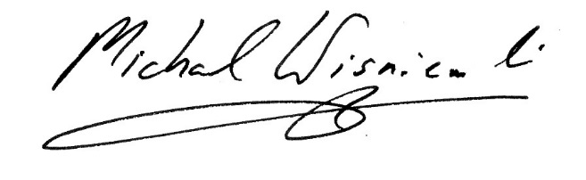
Michael Wisniewski

Research,
Education,
and Economics

Agricultural
Research
Service

Appalachian Fruit Research Station

2217 Wiltshire Road
Kearneysville, WV 25430
USDA is an equal opportunity provider and employer.

