Submission ID #: 52600
Editor: Steven Nilsen
Videographer: Chris Gegax
Film Date: April 23, 2015

Authors and Affiliations:
Tinen L. Iles¹, Brian Howard², Stephen Howard³, Stephen Quallich², Christopher Rolfes², Eric Richardson⁴, Hanna R. Iaizzo⁵ and Paul A. Iaizzo¹

1. Surgery, 2. Biomedical Engineering, University of Minnesota, Minneapolis, 3. Medtronic Inc., Minneapolis, 4. Bioengineering, Rice University, Houston, 5. University of Wisconsin, Madison, Wisconsin, United States.

Corresponding Author:
Tinen Iles
thealy@umn.edu

Other Author's Emails:
thealy@umn.edu
howa0236@umn.edu
stephen.howard@medtronic.com
qual0090@umn.edu
rolf0053@umn.edu
richardson@rice.edu
iaizz005@d.umn.edu
iaizz001@umn.edu

Title: Testing the Efficacy of Pharmacological Agents in a Pericardial Target Delivery Model in the Swine

A. Will you require JoVE to record video microscopy, such as filming a complex dissection or microinjection technique? (Y/N)__NO
B. Does your protocol include detailed, step-by-step, descriptions of software usage? (Y/N)___NO
Lab has a professional recording system and can render additional files from current proxy files.
C. From the steps you’ve indicated that you would like filmed, which steps of your protocol will viewers benefit most from having filmed?
Videographer: the most important steps are highlighted in yellow.
D. Will the filming need to take place in multiple locations? (Y/N) ___NO

1. Introduction (Schematic Overview and Interview)

A. The Schematic Overview (read by voice talent at JoVE):

The overall goal of the following experiment is to administer pharmacological agents into the pericardial space with minimal side effects. (Intro)
This requires a tightly monitored swine, which has sensors and pacing leads placed on its heart. (P1) The system determines the refractory period of the atria, atrioventricular node and the ventricles. (P2) Shocks are then delivered to the atrial appendage to induce atrial fibrillation. (P3)
Next, cardioplegia solution is applied and a sample from the coronary sinus is taken to identify glucose and lactate levels. (P4)
Thus, various pharmacological agents that may decrease the incidence of cardiac arrhythmias and/or ischemic damage can be assessed for their practicality during both cardiac surgery and transplantation. (P5)

Video editor: we are waiting for the graphics, I've made the following suggestions to the lab:
There are four AI image files for P1 to P4. For P5 there is a pptx file with two graphs.
P1 – The blue rectangle is a close-up of an exposed pig heart. For P1, P3 and P4, this heart graphic will remain central while various tools will be shown at the periphery. Show the two monitors to the side and animate some lines attaching the monitors to the heart.
P2 - zoom into the computer and show then, zoom into the screen, showing the chart with white, blue and green pulsing lines.
P3 – zoom back out to show the exposed heart again and animate the addition of the two black lines connecting the heart to the new device. The previous two monitors can be removed. Next, animate the green line graph moving across the monitor and the animate the pulse of the lightning bolt.
P4 – now remove the P3 device, leaving the heart and animate the addition of the bag and stand by running the line from the bag to the heart. Zoom into the heart and show the close-up which illustrates where the line attaches to the heart.
P5 – Show the two supplied charts, in Cartoons.pptx, each one at a time and without the text below.
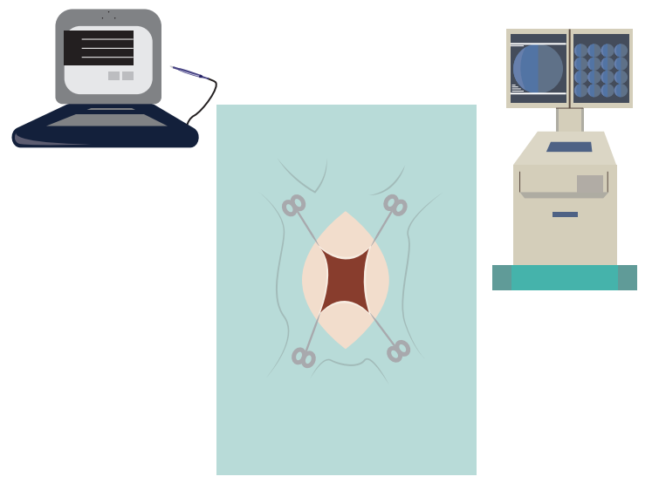
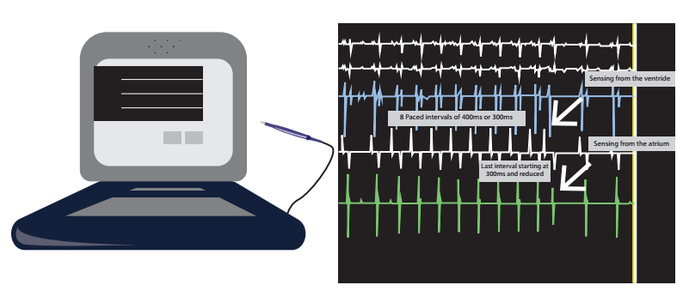

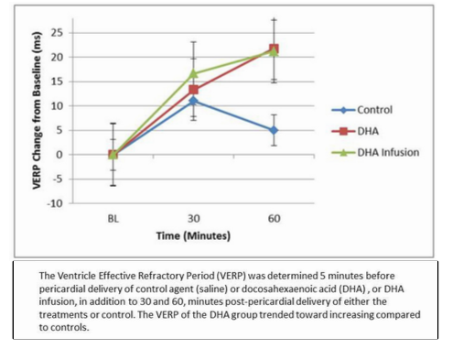
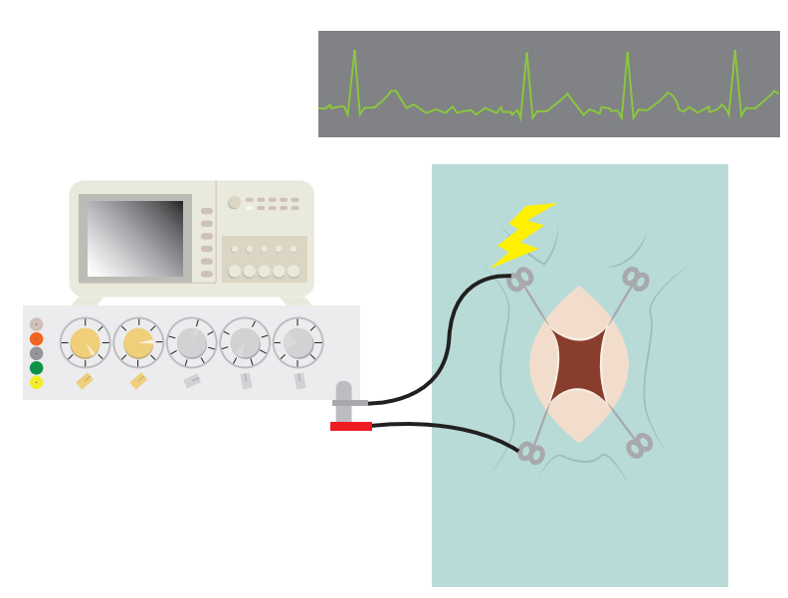
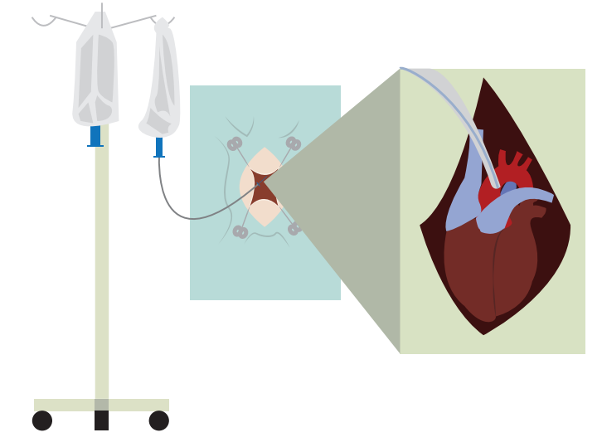
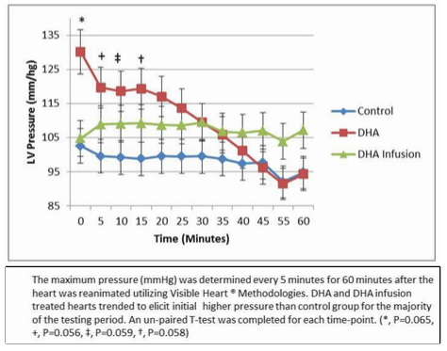

B. Introductory Interview (said by you on camera -- don’t forget to smile!)

  - Paul: Commonly, agents used to treat or prevent arrhythmias in open-heart cases are administered intravenously, which can result in undesired systemic effects. This target delivery approach onto the myocardium, minimizes these side-effects.
  - Tinen: The choice of swine has several advantages: it allows for placement of multiple sensing catheters and pacing leads; the swine’s cardiac anatomy mimics that of an adult humanl; a surgical pericardial cradle is easy to form in these animals; and their pericardial fluid volumes, hemodynamic behaviors, and electrophysiologic properties are similar to those of humans.
  - Steve Q: Various clinical procedures could benefit from the pericardial delivery of therapeutics, including: device delivery, cardiac surgical procedures and organ recovery for transplantation.
  - Brian: Tinen This method can also help answer important clinical questions relative to cardiac diagnoses and treatments, such as what agents are most efficacious for pericardial delivery in order to reduce AF burden and/or prevent associated arrhythmias with cardiac procedures.

C. The Protocol Section (read by voice talent at JoVE)

  - EXTRA TITLE CARD: This protocol was approved by the University of Minnesota Institutional Animal Care and Use Committee.
- Preparations of the Swine
  - To anesthetize a 70 to 80 kg swine, administer five to seven mg per kg of tiletamine with zilazipam via an intramuscular injection.
    - WID: establishing shot with swine, pre-anesthetized
    - MED: loading syringe with anesthetic
  - Through an ear vein catheter also administer methohexital. (TEXT: 5 - 7 mg / kg)
    - MED: anesthetized swine, catheter in ear, talent delivers methohexital
  - Then, intubate the animal with an endotracheal tube and begin ventilation.
    - MED: film as written
  - To maintain the anesthesia, provide at least 1.2 percent isoflurane in house air and oxygen.
    - MED: securing the gas mask to the swine
  - Before proceeding, ensure the swine is in a deep plane of anesthesia by checking for the absence of jaw tone.
    - MED: manipulating swine's jaw
    - CU: detail of relaxed jaw, talent showing how it moves easily
- Preparatory Surgery
  - Begin the surgery by carefully accessing the right external jugular and carotid artery with a cautery and blunt dissection.
    - WID: establishing the surgical team and swine, talents starting to dissection
    - CU/ECU: exposing the carotid (film as written) ; use best zoom to show all the necessary detail
    - ECU of exposing the carotid
  - Once exposed, put an 8.5F Swan-Ganz catheter into the external jugular and inflate the balloon to 1.5 cc.
    - [3.1.2 to 3.8.1 combined] MED: handling the catheter
    - ECU: placing the catheter
  - Then, traverse the catheter through the right atrium, into the ventricle, through the pulmonic valve and down the pulmonary artery until a wedge pressure is felt.
    - ECU: film as written
  - At this point, deflate the balloon and leave the catheter in this position.
    - CU: actions used to deflate balloon catheter
3.1.2b- record the right atrial pressure and pulmonary artery pressure.
  - Record the right atrial pressure and pulmonary artery pressure using the balloon.
    - MED: reading the instrument with right atrial pressure and taking notes
  - Then, record the wedge pressure -- the pressure in the lung.
    - CU: instrument showing lung pressure reading
  - If the lungs are considered normal, record the left atrial pressure.
    - CU: instrument reading left atrial pressure
  - Next, place a 5-F balloon pressure catheter in the external jugular and feed it into the right ventricle. Use this catheter to continuously record pressure.
    - ECU: film as written
- Just putting in the carotid
- Monitors with balloon up, watching the pressure in the left ventricle.
  - Place another 5-F balloon pressure catheter in the carotid artery. Prolapse it through the aortic valve and position it in the left ventricle.
    - ECU: film as written
  - Then, flush all the pressure catheters with 20 units per mL of heparinized saline …
    - CU: film as written (this is in 3.1.2 b)
  - ... and record all the pressure data from the left ventricle, right ventricle, pulmonary artery pressure and right atrial pressure.
    - MED: taking readings from the pressure meters, making notes a) preparing introducers and flushing b) placing in jugular
    - CU: a pressure reading, shot so it is clear which chamber of the heat it comes from
  - The next step is to carefully access the left external jugular with cautery and blunt dissection. Once accessed, place two 11-F hemostasis introducers in the jugular and secure them with suture. (TEXT: 0-size silk suture)
    - ECU: film as written
  - Then, position steerable catheters into the introducers.
    - ECU: film as written
  - Now, start using fluoroscopic guidance. Place active fixation leads in the right atrial appendage and the apex of the right ventricle.
    - MED: setting up fluoroscopic guidance tools
  - Connect the analyzer cables to the implanted leads …
    - ECU: making connection
b) showing capture during pacing w/ HR increase to 120 bpm
  - … and using programmable controls, test for capture. Set the parameters to 8V, 0.25 milliseconds, and set the pacing rate 10 bpm higher than the intrinsic rate at that time or even higher.
    - CU or SCREEN CAPTURE: screen showing selection of above parameters
Authors, for the above shot, if possible, create a movie using screen capture software of how the parameters are set. If not, we will take a shot of the screen
  - Then, record the relative impedance for each lead.
    - [combined with 3.16.1] MED: recording the values from the leads
  - Next, make a medial incision from the xiphoid process to near the insertion point of the sternocleidomastoid muscles.
    - ECU: film as written
  - Following the incision, use a sternal saw to remove the anterior protrusion from the sternum to enable a partial medial dissection of the sternum.
    - CU: film as written
  - Then, make a shear cut through the remaining portions of sternal bone structure, and to retract the sternum, dissect the sternal-pericardial ligament.
    - ECU: film as written
  - With the sternum retracted, make a blunt dissection to separate the pericardium from the pleural linings.
    - ECU: film as written
  - Next, make a three to five centimeter medial sagittal incision in the pericardium and create a pericardial cradle with four square knot sutures at each corner.
    - ECU: film as written
  - Finally, place a temporary bipolar lead in the apical region of the left ventricle and place a unipolar, plunge, temporary pacing lead into the left atrial appendage.
    - ECU: film as written
    - WID: re-establish surgical setting showing talents completing the preparatory surgery
- Measuring AF Burden
  - To begin, set the stimulus program. First program a burst induction of the PES study parameter to 8 paces at either 400 or 300 milliseconds. Next, program a minimum of 300 milliseconds pacing and reduce the pacing until the heart chambers fail to contract ...
a) ESI close-up b) stimulator close-up
    - Reuse 3.1.1
    - SCREEN CAPTURE: Authors, please provide a screen capture showing the above step. This is not a transient view of the screen.
  - … which is noted by the sensing of the pacing leads, and determines the relative refractory period.
    - CU: pacing lead sensor, dropping until heart cannot contract
  - Next, attach the Grass stimulator to the left arterial appendage via the plunge pacing lead.
    - ECU: film as written
  - Set it to deliver 2 second pulses at 4 hertz - check those settings with an oscilloscope.
    - CU: talent using oscilloscope to verify the stimulator settings
- Heart CU
- Oscilloscope CU
  - Now, deliver a single pulse to the left arterial appendage to induce atrial fibrillation, or AF.
    - CU: heart as first stimulation is provided
  - To determine the relative AF burden, use the Grass stimulator once per minute, up to ten times, until an AF is sustained for one minute. Then, allow the animal to remain in AF for up to ten minutes. This time length represents the AF burden.
    - MED: talent's taking notes and preparing for next stimulation
    - CU: timer reaching one minute
    - ECU: heart as second stimulation is give
  - If the heart hasn't stopped fibrillating after ten minutes, shock the atria with direct paddles at 5 joules to resynchronize the heart.
    - ECU: heart in AF, paddles applied, shocks delivered and heart resynchronizes
4.8- Pericardial delivery of agent
b)Tinen delivering
c) monitors
- Heart Explantation
  - To explant the heart, first, implant the aortic root cannula. Carefully dissect the pericardial tissue around the ascending aorta and remove the pericardium.
    - WID: establishing shot of surgical setting, preparing to implant cannula
    - ECU: implanting cannula and dissecting
  - Then, secure the cannula with 2.0 Ethibond sutures in the ascending aorta about 2 to 3 cm apart.
    - ECU: film as written
  - After attaching the sutures, administer 30,000 units of Heparin intravenously.
    - CU: film as written
  - Then, suture the aortic root cannula to the aorta.
    - ECU: film as written
  - With the delivery system pressurized, remove the stylet-bevel and place a clamp on the cannula to stop the flow.
    - CU: film as written
  - Next, prepare cold St. Thomas cardioplegia to deliver at 150 mm of Mercury.
    - [5.6.1 to 5.8.2 combined] MED: loading bag and raising to position for 150 mm Hg
  - Secure an irrigation catheter to the pressurized cardioplegia with a 3-way stop cock.
    - CU: attaching the catheter to the line from the bag after stop-cock
  - Then, secure the stop cock to the aortic root cannula and release a steady flush of cardioplegia through the catheter.
    - ECU: attaching catheter to aortic root cannula
    - CU: opening stop-cock, and closing
  - Now, perform a cross-clamp. Remove the clamp from the aortic root cannula and flush the heart with cardioplegia toward the aortic valve, thus closing the valve and perfusing the coronaries.
    - ECU: film as written
  - To stop the heart and prevent the heart from being over pressurized, clamp the superior vena cava and make an incision in the pulmonary artery.
    - ECU: film as written, show heart beat stop
  - Once the heart is stopped, excise it and transfer it into cold Krebs-Henseleit buffer. (TEXT: 3 - 8 °C)
    - MED: removing heart and placing in buffer
- Reanimation and In Vitro Study Paradigm
  - To reanimate the heart, cannulate the great vessels using Visible Heart methods.
    - MED: placing cannulas in heart
  - Once the perfused heart is within five degrees of 37 °C, restore a native sinus rhythm using 34 Joule shocks to the ventricles via epicardial patch electrodes.
    - WID: setting up shock pads
    - ECU: placing electrodes on heart and delivering shocks until heart beat returns a and b
    - Placing CS cannula
  - Monitor the cardiac function for an hour via a short-axis view.
    - CU: 2D view of heart, electrocardiography
  - Every five minutes, take a one cc sample from the coronary sinus.
    - CU: film as written a) sample from CS b) blood gas C) 1 more shot of apparatus.
  - Every ten minutes, calculate the ventricular wall thickness and ejection fractions. (TEXT: See the text protocol for details).
    - MED: representative actions of above step, talent's choice

- Pericardial Administration of Docosahexaenoic Acid
  - Using the described protocol, a notable increase in the ventricle effective refractory periods was seen following a DHA infusion in situ.
    - Figure 3
  - Measuring the maximum pressure after re-animation showed an increase in left ventricular pressure of DHA-treated hearts compared to controls. The left ventricular pressure in the treated hearts was significantly higher at several time-points.
    - Figure 4

- Conclusion
Author note: we forgot to shoot the conclusion. I do have professional recording equipment available to me in the lab, let me know if you would like me to record the two short conclusion pieces to send to you or how you would like to proceed.

  - Paul: This technique allows for the assessment of target delivered therapeutic agents that could be used translationally for patients undergoing cardiac procedures including surgery or for the recovery of hearts for transplantation.
  - Brian: Employing this experimental approach may pave the way for surgeons and researchers to explore novel agents and treatment strategies that mitigate atrial fibrillation, reduce myocardial damage and reduce associated reperfusion injury.

G. List of Provided Media (provided by you)

Make a listing of your media filenames here, so there is no confusion about which files the video editors should use.

Please list all images, movie files (including screen captures) and animations that you are providing to be included in this video. List the step in the script, the file name and a brief description. For example:

5.1 – 51234_Figure1_panelA.tif - dual color imaging of tumor angiogenesis at 40X
5.2 – 51234_Figure1_panelB.tif - dual color imaging of tumor angiogenesis at 100X

Formats: For static images we prefer .tiff, .eps, Illustrator, Powerpoint or Photoshop files at dimensions of at least 720X480 pixels and 300 dpi. The higher resolution, the better. Likewise any exported movie files should have at minimum these dimensions and be rendered to .mov, .mp4, or .avi files.

GENERAL PREPARATION NOTES

It’s critical for a smooth and organized shoot that all reagents are accounted for, in advance.

Any overnight or long incubation steps should be recognized and specimens/samples be prepared in advance so that prior steps can be recorded and shooting can continue with pre-prepared specimens/samples.

All tubes/flasks should be pre-labeled neatly before we arrive.

Ex. Luciferase assay done in 96 well plates should be labeled with negative/positive control wells and experimental samples are labeled accordingly.

You will receive more detailed preparation instructions, as well as an introduction to your videographer, closer to your filming date.

