Submission ID #: 52536

Editor Name: Linda DiBella

Videographer name:

Film Date:

Authors and Affiliations:

Dubory, Arnaud MD
(1): Laboratoire d’étude de la microcirculation,
Faculté de Médecine Paris Diderot Paris VII, U942,
Paris, France
(2): Department of orthopaedic surgery,
Bicetre Universitary Hospital,
Public Assistance of Paris Hospital,
Paris, France
arnauddubory@hotmail.fr

Laemmel, Elisabeth PhD
Laboratoire d’étude de la microcirculation,
Faculté de Médecine Paris Diderot Paris VII, U942,
Paris, France
elisabeth.laemmel@univ-paris-diderot.fr

Badner, Anna MSc
Institute of Medical Science,
Faculty of Medicine,
University of Toronto, Toronto,
Ontario, Canada
anna.badner@gmail.com

Duranteau, Jacques MD, PhD
(1): Laboratoire d’étude de la microcirculation,
Faculté de Médecine Paris Diderot Paris VII, U942,
Paris, France
(2): Department of Intensive care and Anesthesiology,
Bicetre Universitary Hospital,
Public Assistance of Paris Hospital,
Paris, France
jduranteau@me.com

Vicaut, Eric MD, PhD
Laboratoire d’étude de la microcirculation,
Faculté de Médecine Paris Diderot Paris VII, U942,
Paris, France
eric.vicaut@lrb.aphp.fr

Court, Charles, MD
Department of orthopaedic surgery,
Bicetre Universitary Hospital,
Public Assistance of Paris Hospital,
Paris, France

Soubeyrand, Marc MD, PhD
(1): Laboratoire d’étude de la microcirculation,
Faculté de Médecine Paris Diderot Paris VII, U942,
Paris, France
(2): Department of orthopaedic surgery,
Bicetre Universitary Hospital,
Public Assistance of Paris Hospital,
Paris, France
soubeyrand.marc@gmail.com

Title:

Contrast Enhanced Ultrasound Imaging for Assessment of Spinal Cord Blood Flow in Experimental Spinal Cord Injury

Corresponding Author:
CORRESPONDING AUTHOR:
Marc Soubeyrand
(1): Laboratoire d’étude de la microcirculation,
Faculté de Médecine Paris Diderot Paris VII, U942,
Paris, France
(2): Department of orthopaedic surgery,
Bicetre Universitary Hospital,
Public Assistance of Paris Hospital,
Paris, France
soubeyrand.marc@gmail.com
Tel: +33 6 76 14 63 97

A. Will you require JoVE to record video microscopy, such as filming a complex dissection or microinjection technique? (Y/N) _NO_ (If you can record images/videos using your own camera/software, then mark No) If yes, please list make and model of your microscope: _____________________________________________
B. Does your protocol include detailed, step-by-step, descriptions of software usage? (Y/N)_YES_ If yes, we will need you to record using screen recording software to capture the steps. If you use a Mac, QuickTime X also has the ability to record the steps.
C. Which steps of your protocol will viewers benefit most from having filmed? Please list 4-6 steps in this document. 2, 3, 5, and 6
D. What is the single most difficult aspect of this procedure and what do you do to ensure success? Please list the step in this document.___Step 3__
E. Will the filming need to take place in multiple locations? (Y/N) ___NO____ If yes, how far apart are the locations?

1. Introduction (Schematic Overview and Interview)

A. Schematic Overview (read by voice talent at JoVE):

Procedural Narrative:
The overall goal of this procedure is to assess spinal cord blood flow, or SCBF. (Intro)

This is accomplished by first inserting a catheter in the jugular vein of a rat (P1, Editor, begin with just the animal in STEP 1.psd, then add in the syringe as shown for inserting the catheter.)

Next, the animal is stabilized in an experimental frame, a laminectomy is performed and the ultrasound probe is positioned (P2, Editor, bring in the computer screen and the probe and place the probe on the animal’s back with the green underneath it as shown and transition from a blank screen to the screen in STEP 2.psd.)

A contrast agent is then prepared and blood flow is assessed on the intact spinal cord by injecting microbubbles. (P3, Editor, transition to the syringe that has blue in the entire tube and the mouse with the small blue dots in red structures.)

Then, an experimental spinal cord injury is performed followed by a second injection of microbubbles to assess blood flow in the injured spinal cord (P4, Editor, transition to STEP 4.psd where the animal has the gray bar on its back and tube is only half full of blue. Then transition to STEP 5.psd where the blue dots are injected into the heart again and the computer screen shows Ischemia.)

Ultimately, ultrasound is used to show changes in blood flow as a result of spinal cord injury (P6, Editor, use STEP 6.psd here).

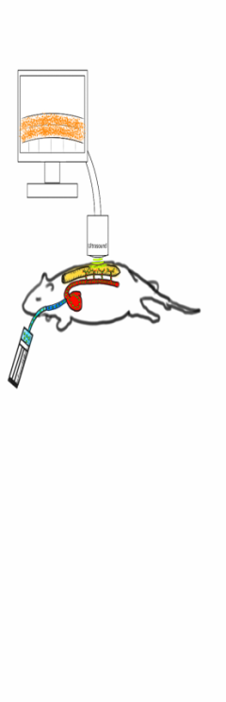
Illustrations of the steps : The first and the second step have been inverted. Could you please rearrange in the good order.
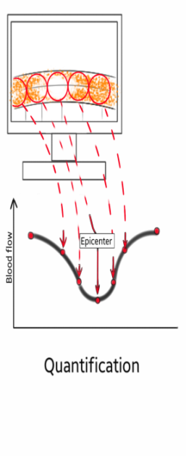
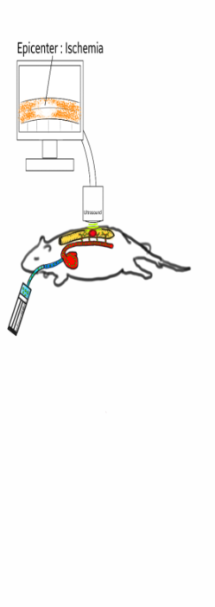

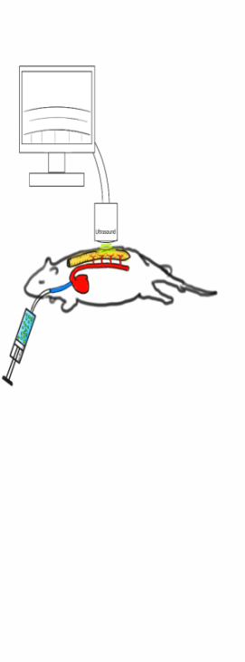
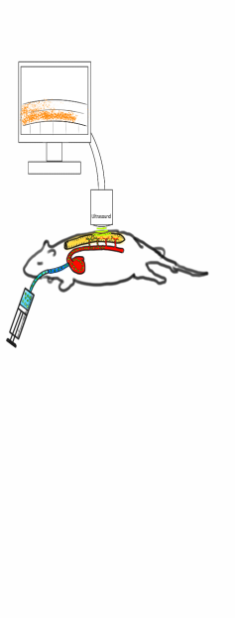

B. Interview: (Said by you on camera. Don’t forget to smile!)
  - Marc Soubeyrand : The main advantage of this technique over existing methods, like laser Doppler, is that it allows in-vivo temporo-spatial quantification of spinal cord blood flow while providing morphological assessment of the spinal cord parenchyma.

Protocol (read by voice talent at JoVE):

- Jugular Vein Catheterization
  - TEXT ON WHITE BACKGROUND: The methods described in this manuscript were approved by the bioethics committee of the Lariboisière School of Medicine, Paris, France (CEEALV/2011–08-01).
    - TEXT of the above statement
  - After preparing the instruments, reagents, 3D frame and weight drop device, and anesthetizing the animal according to the text protocol, confirm proper sedation by using forceps to pinch the paws. Apply vet ointment to the eyes to prevent dryness.
    - WIDE/MED of talent placing instruments down on bench
    - MED/CU Shot of 3D frame and weight drop device
    - MED/CU Talent places sedated animal on bench and performs paw pinch
    - CU Talent applies ointment to eyes (take 3)
  - Shave the neck and use a betadine solution and ethanol to clean the skin. Make a left sided incision on the neck. Then retract the soft tissues to find the jugular vein.
    - CU Talent uses betadine solution and then ethanol to clean skin (mixed solution)
    - CU Talent makes a left sided incision midline incision (with 2.3.1)
    - CU/ECU Talent retracts soft tissues sternocleidomastoidian muscle to find jugular vein; Videographer, have talent point out jugular vein; Editor, point out jugular vein
  - Next, insert a ligature at the rostral part of the vein and tighten it. Pass another thread around the vein just below the first ligature with the knot ready to be tightened.
    - CU/ECU Talent inserts ligature at rostral part of vein and tightens
    - CU Talent applies clamp (shot but not to use)
    - CU Talent passes another thread around vein with a knot ready to be tightened
  - Open the wall of the vein below the rostral ligature. Then introduce a 14g catheter into the lumen of the vein and push it towards the heart.
    - CU/ECU Talent opens wall of vein between clamp and below the rostral ligature
    - ECU Talent introduces catheter and pushes towards heart (with 2.5.1)
  - Push the catheter further. Secure the catheter in the vein by firmly tightening the knot on the vein with the catheter inside.
    - CU/ECU Catheter reaches clamp and talent releases clamp and pushes catheter further
    - CU/ECU Talent tightens knot (with 2.5.1)

2.6.2b EXTRA MED Talent finishing tighting knot
  - Now, assess the patency of the catheter by pressing the plunger rod to check there is no resistance, using heparinized saline to flush it. This prevents obstruction of the catheter from a potential blood clot.
    - CU/ECU Talent withdraws small amount of venuous blood in catheter MED Talent pushing the plunger rod
    - CU Talent flushes with heparinized saline to flush, Videographer, get enough footage for last sentence here too
    - EXTRA stiches set in place
  - Connect flexible tubing to the catheter for further injection of contrast agent. Keep it closed until ready for use.
    - CU Talent connects flexible tubing to catheter and shows that it is closed (end of take 3)
- Assessing the Spine, Laminectomy, and Rat and CEU Probe Positioning
  - To carry out a laminectomy, place the animal in a flat prone horizontal position. Shave and clean the thoracic region on the back of the animal.
    - CU Talent places animal in a flat prone horizontal position
    - CU Talent finishes cleaning the shaved region after drawing skin landmarks for incision
  - Palpate to identify the last rib to estimate the location of the XIIIth thoracic vertebra (TEXT: ThXIII).
    - CU/ECU Talent palpates to locate 13th thoracic vertebra
  - Make a 4 cm skin incision on the midline, centered on ThXIII, and open the skin and the underlying bursa. Carefully palpate the XIIIth ribs to localize the spine process of ThXIII.
    - CU Talent makes 4 cm incision on midline, centered on ThXIII and opens skin and underlying bursa
    - CU/ECU Talent palpates and locates the spine process of THXIII
  - Next, cut the muscular aponeurosis and detach the muscles on either side to expose the spinous processes, the laminas, and the facet joints from ThIX to L2. Expose the lateral aspects of L1 and L2 by detaching muscles from the transverse processes.
    - CU/ECU Talent cuts muscular aponeurosis and detaches muscles to expose spinous processes, laminas and facet joints; (3.4.2 tk 1) Videographer, have talent point out these structures. Editor, point out these structures.
    - CU/ECU Talent exposes lateral aspects of L1 and L2 by detaching muscles from transverse processes (take 2)
  - Then hook the animal’s incisor teeth on the 3D frame to secure the position. Use the modified forceps to clamp the L1 and L2 vertebrae and connect the forceps to the 3D frame in order to stabilize the animal.
    - CU Talent hooks animal’s incisor teeth on the 3D frame to secure position
    - CU/ECU Talent uses modified forceps to clamp the L1 and L2 vertebrae then connects forceps to 3D frame
  - While holding the lumbar spine, gently pull the forceps caudally in order to tighten the whole spine and to elevate the thorax from the bench.
    - CU Talent holds lumbar spine and gently pulls forceps to tighten spine and elevate thorax from bench
  - Now, (3.7.1B) remove the spinous processes from ThIX to ThXII and then gently insert the inferior blade of the bone cutter beneath the left lamina of ThXII. Then close the bone cutter in order to cut the lamina. (Figure 6)
    - CU/ECU Talent inserts inferior blade of bone cutter beneath left lamina of ThXII and closes bone cutter
  - Repeat the same maneuver for the right lamina and remove the posterior arch. Then repeat for the ThXI to ThIX vertebras to achieve a four-level laminectomy. Finally, remove both facet joints for each vertebra.
    - CU/ECU Talent uses bone cutter on right lamina and removes posterior arch (see 3.7.1)
    - CU/ECU Talent finishes cutting lamina for ThXI and ThIX (see 3.7.1)
    - CU/ECU Talent removes facet joints for each vertebra
  - To position the CEU probe, begin by using ultrasound gel to cover the dura mater. Connect a clamp to the 3D frame to stabilize the ultrasound probe, then manually position the probe. When the position is optimal, lock the jointed arm to stabilize it.
    - CU Talent covers dura mater with gel
    - MED/CU Talent connects clamp to 3D frame and positions probe
    - CU Talent locks arm (take 2 with the probe)
- Preparation of Contrast Agent - Microbubble Reconstitution
  - From the contents of a microbubble reconstitution kit, connect the plunger rod by fastening it tightly into the syringe. Open the transfer system blister and remove the syringe cap. Open the transfer system cap and connect the syringe to the transfer system (TEXT: fasten tightly).
    - MED/CU Talent picks up plunger rod and fastens tightly to syringe
    - CU Talent opens transfer system blister and removes syringe cap
    - CU Talent opens transfer system cap and connects the syringe to the transfer system
  - Remove the protective disk from the vial. Then slide the vial into the transparent sleeve of the transfer system and press firmly to lock the vial in place.
    - CU Talent removes protective disk from vial then slides vial into transparent sleeve and presses firmly to lock in place
  - Empty the contents of the syringe into the vial by pushing on the plunger rod. Shake vigorously for 20 seconds to mix all the contents in the vial to obtain a white, milky, homogeneous liquid.
    - CU Talent empties contents of syringe into vial by pushing on plunger rod
    - CU Talent shakes vigorously then stops and shows the contents of vial to camera (with 4.3.1, CU at the end)
  - Invert the system and carefully withdraw the contrast agent into the syringe. Then unscrew the syringe from the transfer system. After reconstituting the microbubbles as directed, draw the suspension of microbubbles into a 20 ml syringe.
    - CU Talent inverts system and withdraws contrast agent into syringe, then unscrews syringe from transfer system
    - CU/ECU Talent draws microbubbles into syringe
  - Insert the 20 ml syringe into the electric pump and close the lid.
    - MED/CU Talent inserts syringe into electric pump and closes lid
  - Next, start constant agitation of the reconstituted microbubbles by slowly rotating the syringe. Connect the pump to the jugular catheter through the flexible tubing. Set the ultrasound machine to “Harmonic Mode.”
    - CU Talent Pump slowly rotates syringe
    - CU Talent connects pump to jugular catheter through flexible tubing (see 2.8.1)
    - MED/CU Talent sets ultrasound machine to Harmonic mode
  - Purge the catheter by infusing a first dose of contrast agent. Check that the microbubbles appear on the ultrasound screen.
    - CU Talent infuses first dose of contrast agent
    - MED/CU Talent checks screen for microbubbles
  - Set the ultrasound machine to ‘B-mode’ to visualize the spinal cord parenchyma and the destruction of the few microbubbles remaining in the bloodstream. Let the animal lay still for approximately 30 minutes for stabilization of hemodynamic parameters.
    - MED/CU Talent sets ultrasound machine to B mode and spinal cord parenchyma and microbubbles show up on screen (one screen)
    - CU Animal lying still
- Assessment of Spinal Cord Blood Flow in the Intact Spinal Cord and Experimental Spinal Cord lnjury
  - Set the ultrasound machine to ‘Harmonic Mode.’ Simultaneously start infusion of the contrast agent and the chronometer.
    - MED/CU Talent sets ultrasound machine ‘Harmonic Mode’ (see 4.8.1 , split screen)
    - CU Talent starts infusion of contrast agent
    - CU Talent starts chronometer; Editor, place this next to 5.1.2 as a split screen; bring it in just after 5.1.2 (show VIDEO 1.m4v)
  - After 1 minute, press the ‘Clip Store’ button on the ultrasound machine. Then set the ultrasound machine to ‘B-mode.’ (The VIDEO 1.m4v should be associated to the step 5.1.3)
    - MED/CU Talent presses Clip Store button
    - MED/CU Talent sets ultrasound machine to ‘B-mode’ (see 4.8.1)
  - Using the micromanipulator connected to the 3D frame, position the weight-drop impaction device so that the tip of the impactor comes in contact with the dura mater at the junction between ThX and ThXI. (Figure 9)
    - CU Talent uses micromanipulator to position the weight-drop impaction device
    - CU/ECU Impactor comes in contact with the dura mater at junction between ThX and ThXI; Editor, place this as a split screen next to 5.3.1
  - Now, position the striker of the impaction device 10 cm high. Induce the experimental Spinal Cord Injury, or SCI, by releasing the striker of the impaction device, enabling the striker to fall and release the impactor, injuring the spinal cord.
    - CU Talent positions striker device 10 cm high
    - CU MED Talent releases striker and it falls and releases impactor
    - LAB MEDIA Video 2.mv4, Editor, show the movie next to 5.4.2. The striker falls and hits spinal cord ~13-14 seconds. Have the timing match with 5.4.2
  - Repeat the infusion of contrast agent as just demonstrated (TEXT: euthanize according to the text protocol). (Figure 10)
    - CU Talent begins infusion of contrast agent
    - LAB MEDIA VIDEO 3.mv4, Editor, place side-by-side with 5.5.1 and then when talent is done, zoom in on the video here to show the increase in signal in the left panel of the video
- Quantification of Spinal Cord Blood Flow by Offline Analysis
  - To quantify SCBF offline, start the Ultra-Extend software used for quantification on the ultrasound machine. Activate ‘quantification mode’ by pressing the ‘Chi Q’ button.
    - LAB MEDIA/SCREEN Talent starts Ultra-extend software
    - LAB MEDIA/SCREEN Talent presses Chi Q button
    - SCREEN Talent selects ‘Set ROI’ and chooses circular shape
  - Select ‘Draw ROI” and draw five adjacent circular regions of interest on the spinal cord. (Figure 11).
    - LAB MEDIA/SCREEN Talent selects ‘Draw ROI’ and draws five seven ROIs on spinal cord
    - LAB MEDIA/SCREEN Talent opens ‘Fitting’ and chooses the function ‘Curve value’
  - Choosing one of the curves that corresponds to changes in microbubble concentration, place the first vertical line at the beginning of the second phase of the curve and select ‘SET.’
    - LAB MEDIA/SCREEN Talent places the first vertical line at the beginning of the second phase of the chosen curve and selects SET
  - Look at the ‘CV’ menu and record the ‘AUC’ value, which corresponds to the ‘Area Under the Curve’ analyzed.
    - LAB MEDIA/SCREEN Talent places second vertical line at end of recording and selects SET
    - LAB MEDIA/SCREEN Talent checks CV menu and records the AUC value that corresponds to the Area under the Curve (see 6.2.2)
- Results: Assessment of Spinal Cord Blood Flow in Experimental Spinal Cord Injury
  - Using the protocol demonstrated in this video, it is possible to map the SCBF along a longitudinal spinal cord sagittal segment. As shown in this figure, in the intact spinal cord, there appears to be SCBF irregularities within the parenchyma due to the variable distribution of radiculo-medullary arteries from one animal to another that reach the anterior spinal artery and therefore provide a blood supply to the spinal cord parenchyma.
    - LAB MEDIA Figure 12, Editor, for ‘there appears to be irregularities within the parenchyma…’ point out the differences in the blue graphed lines above the panels of the images
  - After SCI, real-time CEU imaging shows a deficiency in circulation at the injury epicenter. The epicenter remains dark, as there is no active blood flow. Analysis of the blood flow using several ROIs shows three unique blood flow territories.
    - LAB MEDIA Figure 13, Editor, bring in the bottom black and white panel first without the red circles and ROIs. Then for the injury epicenter, add the red circle that correspond to ROI 1
  - At the level of the epicenter, the blood flow is the lowest with a mean decrease of about -90%. In the territories adjacent to the epicenter, corresponding to the ischemic penumbra zone, where neuroprotective therapies should be targeted, SCBF was also significantly decreased. In the most remote areas corresponding to intact tissue, SCBF is preserved.
    - LAB MEDIA Figure 13, Editor, for at the level of the epicenter, add in the graph and point out the dot on the graph that corresponds to ROI 1 – also add in the ROI 1 label. For the territories adjacent to the epicenter, add in the red circles that correspond to ROIs 3 and 4 and 5 and 6 and point out the areas on the graphs that correspond to these ROIs. For the most remote areas, add in the red circles for ROIs 2 and 3 and 6 and 7 and point out the areas on graph between these ROIs.

- Conclusion (said by authors on camera)
  - Marc Soubeyrand : After its development, this technique paved the way for researchers in the field of spinal cord injury to explore “secondary injury” and ischaemia in rats.

Provided Media

Authors, Please list all images, movie files, or 3-D rendered animations that can be included in the video per editor’s request. The step in the script/video where these images will be inserted should be specified. For example:

6.2 – 0123_PIname_Figure1.tif - dual color imaging of tumor angiogenesis at 40X
6.2 – 0123_PIname_Figure2.tif - dual color imaging of tumor angiogenesis at 100X

Formats: For static images we prefer .tiff, .eps, Illustrator, Powerpoint or Photoshop files at dimensions of at least 720X480 pixels and 300 dpi. The higher resolution, the better. Likewise any exported movie files should have at minimum these dimensions and be rendered to .mov, .mp4, or .avi files.

VIDEO 1.mp4
VIDEO 2.mp4
VIDEO 2.mp4

General Preparation

It’s critical for a smooth and organized shoot that all reagents are accounted for, in advance.

Any overnight or long incubation steps should be recognized and specimens/samples be prepared in advance so that prior steps can be recorded and shooting can continue with pre-prepared specimens/samples.

All tubes/flasks should be pre-labeled neatly before we arrive.

Ex. Luciferase assay done in 96 well plates should be labeled with negative/positive control wells and experimental samples are labeled accordingly.

You will receive more detailed preparation instructions, as well as an introduction to your videographer, closer to your filming date.

