Submission ID #: 52529

Editor Name: Jo Clark

Videographer name: Sean Glavey

Film Date: 12/3/14

Authors and Affiliations:

Labots, Maaike^{1,2}
¹Department of Animals in Science and Society
Utrecht University
Utrecht, The Netherlands
²Brain Center Rudolf Magnus
Utrecht, The Netherlands
m.labots@uu.nl

Van Lith, Hein A.^{1,2}
¹Department of Animals in Science and Society
Utrecht University
Utrecht, The Netherlands
²Brain Center Rudolf Magnus
Utrecht, The Netherlands
h.a.vanlith@uu.nl

Ohl, Frauke^{1,2}
¹Department of Animals in Science and Society
Utrecht University
Utrecht, The Netherlands
²Brain Center Rudolf Magnus
Utrecht, The Netherlands
f.ohl@uu.nl

Arndt, Saskia S.^{1,2}
¹Department of Animals in Science and Society
Utrecht University
Utrecht, The Netherlands
²Brain Center Rudolf Magnus
Utrecht, The Netherlands
s.s.arndt@uu.nl

Title: The modified hole board – measuring behavior, cognition and social interaction in mice and rats

Corresponding Author: Labots, Maaike

Co-authors:

A. Will you require JoVE to record video microscopy, such as filming a complex dissection or microinjection technique? (Y/N)__No_______ (If you can record images/videos using your own camera/software, then mark No) If yes, please list make and model of your microscope: _____________________________________________
B. Does your protocol include detailed, step-by-step, descriptions of software usage? (Y/N)__No______ If yes, we will need you to record using screen recording software to capture the steps. If you use a Mac, QuickTime X also has the ability to record the steps.
C. Which steps of your protocol will viewers benefit most from having filmed? Please list 4-6 steps using the step numbers listed in this document. _4.3, 4.4, 5.4, 5.5, 6.1, 6.2 (now 3.4, 3.5, 4.4, 4.5, 5.1, 5.2 – Jo).
D. What is the single most difficult aspect of this procedure and what do you do to ensure success? Please list the steps using the step numbers listed in this document The protocol should be executed under highly standardized conditions, but there is not one difficult/critical step._________________________
E. Will the filming need to take place in multiple locations? (Y/N) __No_____ If yes, how far apart are the locations? ___________________________________________________

1. Introduction (Schematic Overview and Interview)

A. Schematic Overview (read by voice talent at JoVE):

Conceptual Narrative:
The overall goal of the following experiments is to measure unconditioned behavior of small laboratory mammals and analyze their cognitive abilities. (Intro –Title card)

This is achieved by placing the animals in the modified hole board to observe and score their unconditioned behavior with or without the presence of their cage mates. (P1 Have the mouse appear in position)

Additionally, a novel and familiar object or food pellet can be placed in the apparatus before testing, which can be used to measure object recognition or food intake inhibition. (P2 Have the almond novel and familiar object appear)

A third application of this method is placing the animal in the cognitive version of the modified hole board, where the reward is cued with a contrasting colored identifier, in order to measure the cognitive abilities of the test subject. (P3 Have the mouse from P1 appear in the bottom right square)

The results show a spectrum of unconditioned behavior, since the method combines multiple behavioral dimensions in a single paradigm, which contains features from a traditional hole board and open field test. (P4 – Footage from 4.7.2. Animal showing unconditioned behavior)

*Note to video editor, the measurements can probably be removed from each image below as they are not relevant to the narrative.

P1
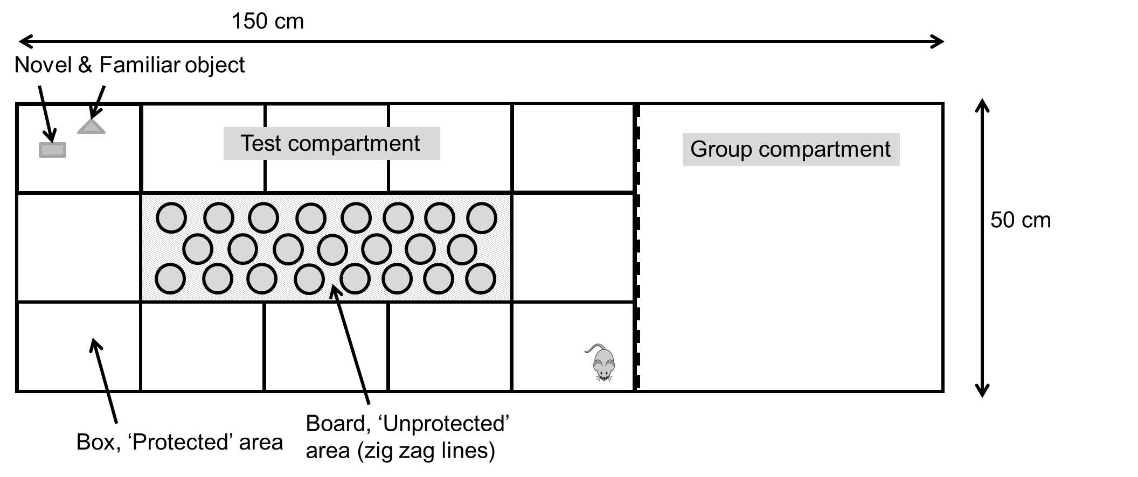
P2
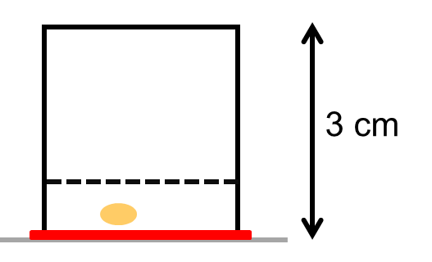

P3
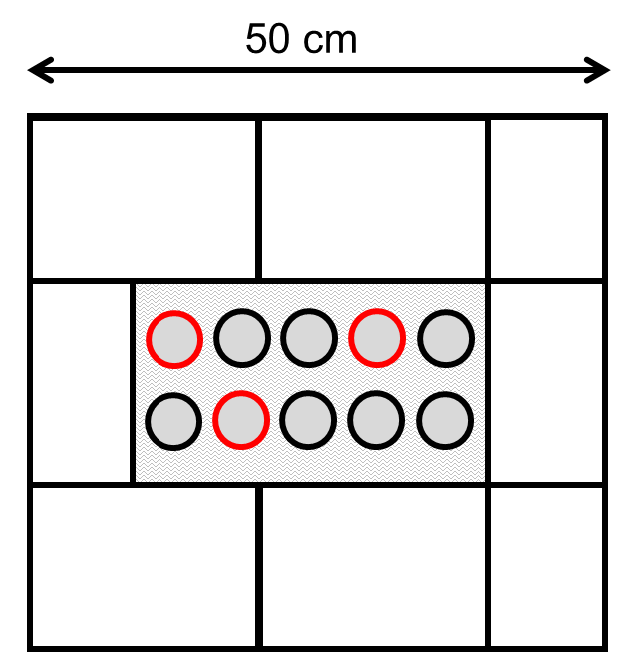

B. Interview: (Said by you on camera. Don’t forget to smile!)

  - Maaike Labots: The main advantage of this technique over existing methods, is that it overcomes the disadvantages of a test battery by reducing the number of animals used, circumventing the possible effects of test order and reducing time-effect and costs.

Protocol (read by voice talent at JoVE):
- Animal Statement
  - The experiments in this protocol were approved by the Animal Experiments Committee of the University Medical Center Utrecht (Pronounce: ‘You-trekt’ (example: https://www.youtube.com/watch?v=3nuRx4AcyJI) and Utrecht University, The Netherlands and followed the Dutch Code on Laboratory Animal Care and Welfare.
- Behavioral testing – without the presence of group mates (including Novel Object Recognition and Food Intake Inhibition)
  - Testing should be performed in the regular housing room during the dark phase, the animals’ most active phase. For the purposes of this video, testing is performed under bright light conditions [3.1.1-WIDE].
    - Talent enters the well-lit housing/testing room and goes over to the cage of animals to be used in the video.
  - Behavioral testing should be performed on animals that have been habituated to their environment and to handling by the experimenter. [3.2.1-WIDE-TXT]
    - Talent takes the cage from the rack to the testing area. TEXT: See the written portion of the protocol for details on habituation to each task.
  - Place the board containing the cylinders in the middle of the experimental box [3.3.1-MED]. Then, position a stage light above the board to create contrast in light intensity between the board and the box and increase the aversive character of the board [3.3.2-MED].
    - *no comment
    - *no comment.
  - To begin, place the familiar object in the apparatus 2 cm apart from a novel object in the corner across from the starting point [3.4.1.- MED-TXT].
    - TEXT: For food intake inhibition testing, use the familiar and a novel food item in the same way.
  - Then, remove the animal to be tested from the home cage [3.5.1-MED] and place it facing the wall in a specific corner of the apparatus [3.5.2.- CU-TXT]. Allow the animal to explore freely for approximately five minutes [3.5.3-MED-TEXT].
    - *no comment
    - TEXT: The same corner should be used throughout the experiment.
    - TEXT: Free exploration time may vary by protocol.
  - Have an experienced observer score the behavioral parameters using behavioral scoring software [3.6.1 – MED]. Use the parameters listed in this table [3.6.2-LM] and also measure the time the animal takes to approach the novel and familiar object or novel and familiar food item [3.6.3 – MED-TXT].
    - *no comment
    - JoVE_Labots_Table1(new). Show the whole table.
    - TEXT: Score zero if the animal does not approach the object or food within the 5 minute test period.
  - Clean the apparatus with tap water and a paper towel after every trial in order to avoid a bias based on olfactory cues [3.7.1 – MED].
    - *no comment.
- Cognitive Testing Using the Modified Hole Board

SEGMENT 5 SHOULD COME BEFORE SEGMENT 4
  - Before beginning this experiment, familiarize the animals with a highly palatable reward, here a piece of almond is used [4.1.1 – MED]. Offer the reward with tweezers in the home cage once a day for two consecutive days before the experiment [4.1.2 – CU].
    - Talent removes a piece of almond from a container.
    - *no comment.
  - Insert a partition to reduce the size of the box to 50 x 50 cm for testing mice and rats [4.2.1 – MED]. Place a smaller board in the middle of the box [4.2.2 – MED]. This diagram shows the set up of the modified hole-board [4.2.3 – LM].
    - *no comment
    - [combined with 4.2.2] *no comment
    - Figure1B(new). Use panel B without the inset showing the piece of almond under the cage floor.
  - Next, scent all ten cylinders with a flavor that the animals are attracted to, such as vanilla [4.3.1 – MED], and bait all cylinders with the reward placed beneath a grid so that it cannot be removed [4.3.2 – CU-TXT].
    - *no comment
    - TEXT: Or the number of cylinders specified by your own protocol.
  - Cue three cylinders (or the number of cylinders specified by your own protocol) with a colored ring that contrasts with the PVC [4.4.1 – MED] and bait those cylinders with a removable reward [4.4.2 –CU].
  - Again, place the animal in the same corner of the apparatus [4.5.1-MED] and have an experienced observer live score the behavioral parameters using behavioral scoring software [4.5.2 – MED]. Measure the parameters listed in table 2 in addition to those previously shown in table 1, with the exception of the parameters related to object recognition or food intake inhibition [4.5.3 – LM].
    - *no comment
    - *no comment
    - JoVE_Labots_Table2(new). Show whole table.
  - Perform four training trials daily with a constant inter-trial interval until a constant time for collection of all three almond pieces is established [4.6.1 – MED-TXT]. Clean the apparatus with tap water and a paper towel after every trial in order to avoid a bias based on olfactory cues [4.6.2. – MED].
    - Show mouse performing the task i.e. visiting the holes in the board and collecting an almond piece. TEXT: Or according to your own protocol.
    - *no comment.
  - To test reversal learning, once the animal is fully trained, cue and bait three different cylinders [4.7.1-MED], or as many different cylinders as required by your own protocol, and test the animal on the required number of trials [4.7.1 – MED].
    - *no comment
    - The animal performing the task i.e. going to one of the new baited cylinders OR going to one of the previously baited cylinder and coming up empty. Whichever is easier to record.
- Behavioral Testing in the Presence of Group Mates.
  - Place the group mates in the group compartment [5.1.1-MED-TXT] for 10 – 30 min before testing the experimental animal to allow for habituation [5.1.2. – MED].
    - TEXT: Place the dominant animal if testing social stress
    - Talent presses start on a countdown timer.
  - Then place the experimental animal in the test compartment [5.2.1 – MED] and allow it to freely explore the modified hole-board for 5 minutes or as long as required by your own protocol [5.2.2 – MED].
    - Animal placed in the same corner as before.
    - The animal explores the test compartment. Please get the group mates in the other compartment in shot.
  - Again, have an experienced observer live score the behavioral parameters using behavioral scoring software using the parameters listed in table 1 as before [5.3.1-MED].
    - Observer scoring the behavioral parameters.
- Results: Cognitive Testing Using the Modified Hole Board.
  - The first four images show results from the cognitive testing paradigm [6.1.1 –LM] that measure the cognitive functioning of C57BL/6J (Pronounce: ‘See-fifty-seven-black-six-Jay’) mice with mild cerebral hypoxia-ischemia, labeled HI-45 [6.1.2-LM]; severe hypoxia-ischemia, labeled HI-75 [6.1.3-LM]; and sham-control mice [6.1.4-LM]. This graph shows the number of hole visits until all food rewards are found, or until the scoring time has ended, on each trial day.
    - Figure3.pdf. Show the whole figure (all 4 panels).
    - Figure3.pdf. Use panel A. Highlight HI-45 in the figure legend and fade out HI-75 and sham lines on the graph.
    - Figure3.pdf. Use panel A. Highlight HI-75 in the figure legend and fade out HI-45 and sham lines on the graph.
    - Figure3.pdf. Use panel A. Highlight Sham in the figure legend and fade out HI-45 and HI-75 lines on the graph.
  - This graph shows the number of revisits to a baited hole on each testing day, a measure of short-term memory errors [6.2.1-LM].
    - Figure3.pdf. Show panel B.
  - Here revisits to baited holes are shown. This is a measure of long-term memory errors [6.3.1-LM].
    - Figure3.pdf. Show panel C.
  - Here the data for the number of omission errors are shown. An omission error is defined as the number of non-visited baited cylinders [6.4.1-LM].
    - Figure3.pdf. Show panel D.
  - To confirm that the HI-45 group had no cognitive impairment, this group was tested against the sham-controls in a reversal task. The three baited holes were appointed to three different cylinders and the animals were tested for 4 trials [6.5.1-LM]. The reversal effect [6.5.2-LM] becomes apparent when comparing the last trial of the first stage [6.5.3-LM] with the first trial of the reversal stage [6.5.4-LM]. This image shows the latency to complete the trial for both groups and a clear overall treatment effect is evident [6.5.5-LM]. This means that there is impaired cognitive flexibility in the HI-45 group that was detectable using the modified hole-board with the reversal task.
    - Figure4.pdf. Show whole graph.
    - Figure4.pdf. Show whole graph. Highlight ‘Reversal Effect ##’ and ‘Reversal’.
    - Figure4.pdf. Fade out all bars except those above ‘Previous trial’.
    - Figure4.pdf. Fade in the bars above ‘1’.
    - Figure4.pdf. Show whole graph. Highlight ‘Overall Treatment Effect**’.
    - Figure4.pdf. Show whole graph. Highlight all grey bars without fading out anything.

INSTRUCTIONS FOR AUTHORS:
Please ensure that the representative results narration is appropriate and correctly describes your images, movies, or figures. Our editors have ensured that the results are written in our format.

We consider this section a critical aspect of the video, because here is where you provide validation for your experiments. For example, if this is a cell culture preparation, this section is where the video will show your cells at various time points following culturing. If this is an imaging prep, then this part is where you will show examples of your imaging experiments.

Please limit the extent of narration to no more than 2-3 lines of text per image or movie file being described. Figures with multiple panels submitted with the original protocol should be broken up so that each panel is a separate image. Like the schematic, each image or movie file supplied in the results should be referenced by annotation in parenthesis, however for the results, the specific filename should be given in parenthesis.

Below is an example of results text:

EXAMPLE REPRESENTATIVE RESULTS

5. Evaluation of Morpholino Injection and Knockdown
5.1 Representative results of both morpholino injection and mRNA injection are shown here. The
uninjected control at 48 hours post fertilization looks normal, as expected
-LAB MEDIA: 0123_PIname_Figure1.tif (Replace 0123 with your jove video #)

5.2 However, embryos injected with the morpholino heg_e3i3_egfr1, which knocks down Heg isoforms
containing the first of two EGF-like repeats, exhibit brain edema.
-LAB MEDIA: 0123_PIname_Figure2.tif

5.3 Injection of heart of glass mRNA also produced an obvious phenotype. At 24 hours post fertilization,
the heads of the uninjected controls look normal
-LAB MEDIA: 0123_PIname_Figure3.tif

5.4 Conversely, some of the embryos injected with the mRNA exhibit cyclopia
-LAB MEDIA: 0123_PIname_Figure4.jpg

Please visit the following URL to see an example of how the results will look when complete:
http://www.jove.com/video/1597/results-example-mably?access=ksw0bprj

- Conclusion (said by authors on camera)
  - Maaike Labots: After watching this video, you should have a good understanding of how to use the modified hole board in both the general and the cognitive version.

Provided Media

Authors, Please list all images, movie files, or 3-D rendered animations that can be included in the video per editor’s request. The step in the script/video where these images will be inserted should be specified. For example:

6.2 – 0123_PIname_Figure1.tif - dual color imaging of tumor angiogenesis at 40X
6.2 – 0123_PIname_Figure2.tif - dual color imaging of tumor angiogenesis at 100X

Formats: For static images we prefer .tiff, .eps, Illustrator, Powerpoint or Photoshop files at dimensions of at least 720X480 pixels and 300 dpi. The higher resolution, the better. Likewise any exported movie files should have at minimum these dimensions and be rendered to .mov, .mp4, or .avi files.

Insert your media filenames here.

General Preparation

It’s critical for a smooth and organized shoot that all reagents are accounted for, in advance.

Any overnight or long incubation steps should be recognized and specimens/samples be prepared in advance so that prior steps can be recorded and shooting can continue with pre-prepared specimens/samples.

All tubes/flasks should be pre-labeled neatly before we arrive.

Ex. Luciferase assay done in 96 well plates should be labeled with negative/positive control wells and experimental samples are labeled accordingly.

You will receive more detailed preparation instructions, as well as an introduction to your videographer, closer to your filming date.

