



Research Center – Institut Curie
Physico-Chimie Curie
UMR 168 CNRS / Institut Curie/UPMC
26 rue d'Ulm
75248 Paris Cedex 05, FRANCE

Patricia Bassereau
Research Director CNRS
Tél. +33 (0)1 56 24 67 84 Paris, August 12th, 2014
Fax. +33 (0)1 40 51 06 36
patricia.bassereau@curie.fr

Dear Eric,

We are very grateful to the reviewers for studying our manuscript so carefully and providing such detailed comments and suggestions.

The only major concern was from reviewer #1, who noted that the channel conductance and inactivation in GUVs differs from studies of KvAP in Black Lipid Membranes (BLMs). However, as we explain in the response to reviewers, these differences in channel properties are entirely consistent with the different conditions in the BLM and GUV experiments, while the intrinsic characteristics of the channel (i.e. K-selectivity, voltage-dependent activation) remain unchanged (PLoS One 6, e25529). We have carefully revised the manuscript to discuss this issue more fully, and to incorporate the many suggestions from all three reviewers.

The reviewers’ input has greatly improved the paper, and we hope the paper and videos will help other scientists use GUVs with reconstituted proteins for many academic and technologic applications.

We are looking forward to hear from you,

Best regards,

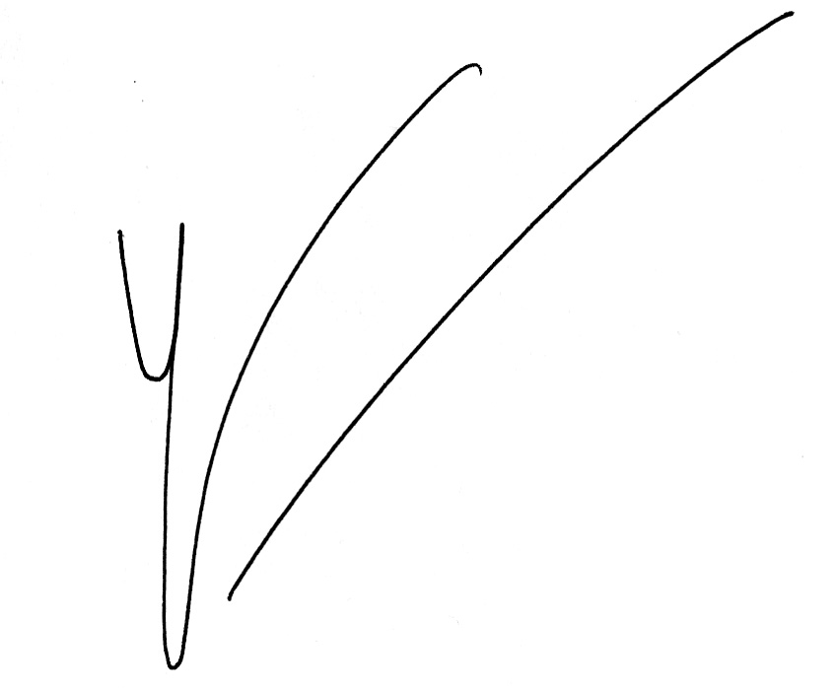Patricia Bassereau
Leader of the group « Membrane and Cell Functions»

