Dear Dr. Nguyen,
We appreciate your invitation to resubmit our manuscript JoVE52484R1 entitled, “Techniques for the Analysis of Extracellular Vesicles using Flow Cytometry”. We would like to thank you and the reviewers for your insightful feedback; the constructive criticisms we received were tremendously helpful and very much appreciated. Following your recommendations, we were able to make substantial improvements to the manuscript. In addition, we have provided a detailed, point-by-point response to each reviewer below. We believe these revisions have significantly enhanced the quality of our manuscript and hope you will reconsider this manuscript for publication in JoVE.

Reviewers' comments:
Editor’s Note: Please note that the reviewers raised some significant concerns regarding your method and your manuscript. Please thoroughly address each concern by revising the manuscript or addressing the comment in your rebuttal letter.
Reviewer #1:
Manuscript Summary:
comparison of protocols for microparticles analysis
Major Concerns:
1) The reading of the paper is difficult and not pleasant
We regret that the paper was difficult to follow (though Reviewer #2 found the protocol to be clear). We have incorporated the constructive criticisms of each of the reviewers and feel we have improved the flow of the manuscript.
2) The paragraph « processing of blood samples » is not sufficiently detailed (anticoagulant, volume of tube, temperature of centrifugation, control of platelet count in PPP,….) and should follow recommendations made by the 2 following papers (please add both references in the references section)
Pre-analytical issues in the measurement of circulating microparticles: current recommendations and pending questions. Mullier F, Bailly N, Chatelain C, Chatelain B, Dogné JM.J Thromb Haemost. 2013 Apr;11(4):693-6. doi: 10.1111/jth.12171. No abstract available.
Standardization of pre-analytical variables in plasma microparticle determination: results of the International Society on Thrombosis and Haemostasis SSC Collaborative workshop.
Lacroix R, Judicone C, Mooberry M, Boucekine M, Key NS, Dignat-George F; The ISTH SSC Workshop.J Thromb Haemost. 2013 Apr 2. doi: 10.1111/jth.12207. [Epub ahead of print]
We agree that the blood processing method should have been more detailed. We have added more specifics, including anticoagulant, volume of tube, and temperature of centrifugation to all applicable steps within the protocol. As our EV isolation protocol uses centrifugal forces that are somewhat on the higher end of what is necessary for platelet removal (and what the majority of researchers use for EV isolation), we can be certain that platelets have been effectively removed.
Per your suggestion, we have referenced the two papers above in our introduction. However, we decided against converting all of the blood processing techniques in our protocol to those recommended by the authors of the aforementioned papers. We have tested several anticoagulants and our internal research has shown ACD to be a good and reliable anticoagulant to use for EV studies. Of note, there is currently no consensus among EV researchers about which anticoagulant is best. For instance:
- Jayachandran et al. (reference below) concluded that protease inhibitor anticoagulants, like heparin, were the best anticoagulants to use because they preserve EV counts, whereas citrate and EDTA anticoagulants decrease or eliminate microvesicles from plasma by inducing adhesion of the microvesicles to platelets or other formed elements.
Methodology for isolation, identification and characterization of microvesicles in peripheral blood. Muthuvel Jayachandran, Virginia M. Miller, John A. Heit, Whyte G. Owen. Journal of Immunological Methods, Volume 375, Issues 1–2, 31 January 2012, Pages 207-214, http://dx.doi.org/10.1016/j.jim.2011.10.012.
- György et al. recommend the use of ACD, reporting that artificial, in vitro vesiculation was limited in ACD tubes compared to other tubes, because they had the lowest MP numbers and lowest standard deviation.
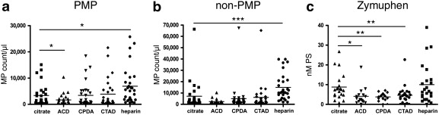
Improved circulating microparticle analysis in acid-citrate dextrose (ACD) anticoagulant tube. Bence György; Krisztina Pálóczi; Alexandra Kovács; Eszter Barabás; Gabriella Beko; Katalin Várnai; Éva Pállinger; Katalin Szabó-Taylor; Tamás G. Szabó; Attila A. Kiss; et al. Thrombosis Research. 2014;133(2):285-292.
- International Society on Thrombosis and Haemostasis (ISTH) recommends use of citrate for anticoagulant, seemingly solely for their pursuit of EV standardization (as opposed to research-proven evidence suggesting that ACD is somehow superior to all other anticoagulants).
Standardization of pre-analytical variables in plasma microparticle determination: results of the International Society on Thrombosis and Haemostasis SSC Collaborative workshop. Lacroix R, Judicone C, Mooberry M, Boucekine M, Key NS, Dignat-George F; The ISTH SSC Workshop.J Thromb Haemost. 2013 Apr 2.
3) The description of flow cytometry should follow recommendations performed by ISAC (international society for advancement in cytometry)
ISAC recommendations for minimum information about flow cytometry have been followed, however, the JoVE manuscript guidelines do not permit the use of commercial language within the article text, so all details specific to the flow cytometer, reagents used, etc., are listed in the Table of Specific Reagents/Materials.
Minor Concerns:
3) Thawing at room temperature is not recommended
In our hands, samples thawed at RT are comparable to samples thawed at 37°C. However, in order to be consistent with the current recommendations by ISAC, we have changed the thawing method in the manuscript to be performed 37°C.
4) L143 Is the cocktail antibody stable overtime ?
We have tested cocktails stored for up to several weeks and results have been consistent with freshly prepared cocktails.
5) L154 why was 4°C used instead of room temperature (standard protocol)
Incubation at 4°C is standard for cell surface staining. We have tested staining EVs at 4°C vs. RT and found no difference in outcome.
6) The authors should demonstrate that their washing protocol did not interfere with microparticles results
As this is a protocol and not a methods paper, the amount of extracurricular information presented must be limited to what is truly relevant to the protocol. Because a separate manuscript containing these results is currently being prepared for publication, and the current manuscript is meant to present a protocol and not de novo experimental data, we are unable to include these data in our discussion of the current protocol. We can assure you that all of the necessary optimization steps have been performed in the making of this protocol and articles using these protocols have been published in peer-reviewed journals. We have included additional examples of results using our washing technique below.

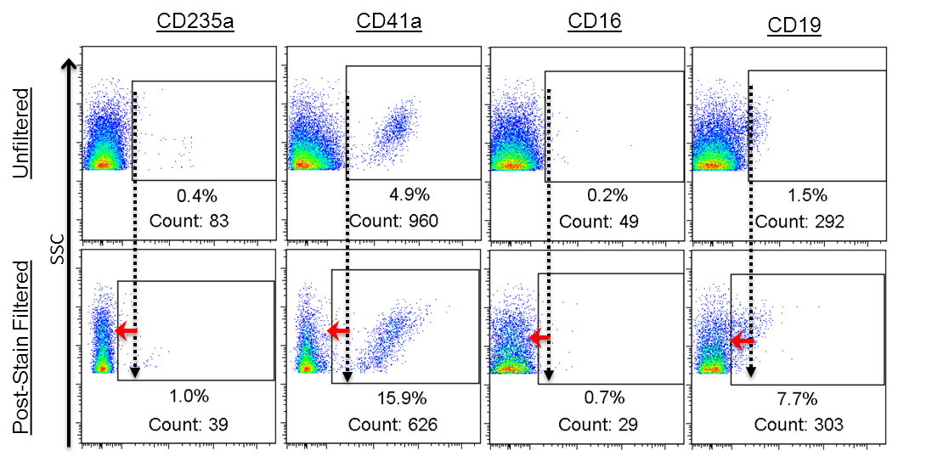

7) What is the flow cytometer used in this study ?
All experiments were analyzed using a BD LSRII flow cytometer. The JoVE manuscript guidelines do not permit the use of commercial language within the article text, so all reagents and instrument specifics (including flow cytometer make/model) are listed in the Table of Specific Reagents/Materials.

8)The method of threshold setting has an impact on microparticles results
We agree with this statement. We have developed this protocol with the purpose of being able to analyze subpopulations of EVs across the wide range of EV concentrations encountered in clinical PPP samples. The thresholds we use here were decided on after years of optimization studies. We found that the combination of both SSC and FSC thresholds provide the highest signal, lowest background and the highest reproducibility.
Reviewer #2:
Manuscript Summary:
This manuscript provides two clearly described flow cytometry methods for the identification of extracellular vesicles (EVs); individual detection of vesicles and a bead-based approach to detect smaller EVs. There is growing interest in the field of extracellular vesicles, yet the methodologies available has not been standardised. Therefore, publications aimed at improving the standardisation of such techniques and those providing detailed protocols are of great value.
Major Concerns:
Introduction:
1) The authors refer to the limitations of fluorescence minus one as a flow cytometry control for extracellular vesicles, but do not specify what these limitations are.
We have clarified this last paragraph. It now reads, “Common challenges among researchers include signals arising from immunoglobulin aggregates^{18,19} and self-aggregation of antibodies.²⁰ Furthermore, the long processing times and lengthy washing/isolation procedures used by many of the current protocols^{24,25} require multi-day time commitments to analyze a small number of samples, making them less than ideal for high throughput applications. Some researchers forgo a wash step altogether, rendering traditionally used FCM negative controls such as fluorescence minus one (FMO) and antibody isotypes useless in the accurate assessment of background fluorescence²¹.”
Methods:
1) Method A states that blood was drawn into citrate or other suitable anticoagulant tubes and Method B states that blood was drawn into acid citrate dextrose (ACD) or other suitable anticoagulant. The type of anticoagulant used can have large impacts on the levels of EVs detected, as acknowledged by the authors in the discussion. Was it the case that blood taken into different anticoagulants was used for different experiments? If so, this should be made clear in the methods and results sections.
Thank you for noticing this inconsistency. In both methods the same anticoagulant was used (ACD). We have fixed this discrepancy in the protocol so that the same anticoagulant is used in both methods.
2) The second centrifugation step of 13,000g for 10 min to remove platelets and large cell fragments, may also result in the loss of some large EVs. This should be mentioned in the limitations.
We agree that this should have been mentioned and have added the following comment to the discussion: “While there is no standardized method for the isolation of EVs, differential centrifugation is a widely used technique among EV researchers. The differential centrifugation method described here is based on common protocols for isolating PPP, which typically require an initial centrifugation between 1,200 - 1,500 x g for 10-20 minutes to remove cells, followed by a second centrifugation between 10,000 - 13,000 x g for 10-30 minutes to remove platelets 27. The protocol described herein uses a centrifugation at 1,500 x g for 10 minutes followed by a centrifugation at 13,000 x g for 10 minutes. While higher forces of 25,000 - 100,000 x g are typically required to pellet EVs, some of the larger EVs may be removed with this differential centrifugation protocol we have presented.”
3) It could be mentioned in the methods that the suggested antibodies can be substituted for other markers to adapt the protocol for individual users.
Your suggestion is much appreciated. It now reads, “Note: From this point on, the steps explain a high throughput protocol for analyzing 12 samples for 14 markers in 3 panels. However, other combinations of antibodies can be used here; the protocol can be adapted to study other EV populations by substituting the suggested markers for those of interest.”
4) Was the PBS used for washing and re-suspension of samples filtered prior to use, to reduce background noise on the flow cytometer? If so please specify the size of filter used.
Thank you for bringing this to our attention. We have included the filter pore size in the PBS definition. It now reads, “If purified EVs are needed for functional experiments, transfer 6 ml of the PPP to an ultracentrifuge tube and add 28 ml of 0.2µm-filtered phosphate buffered saline (PBS).”
Results:
1)The two gates defining positive events in Figure 6 are different in the unwashed and washed samples. Have these gates been set using lysed samples? If so, it would be useful to include the lysed sample plots to illustrate why these gates are different.
Thank you for your suggestion. We agree that clarification was needed to explain that the gates were based on each sample’s lysed counterpart and have added this remark to the figure legend. Because the gating technique using lysed vs. unlysed samples was demonstrated in the previous figure (Fig 5A), we have instructed the reader to this figure for gating examples. The figure legend now reads, “Effect of post-stain washing in individual detection. Values show percentages and numbers of positive events. Events shown are within the FSC/SSC EV gate. Gates for each sample were made using each sample’s lysed counterpart (not shown; refer to previous figure for gate-setting in unwashed vs washed samples). High background fluorescence makes distinguishing positive from negative events difficult (top plot). When washed, however, the positive population is revealed as unbound fluorescent antibodies are removed and background fluorescence is reduced (bottom plot).”

Discussion:
1) Authors state that there is no single best protocol and that a combination of methods provides more information. At this point in the discussion it would be useful to include a very brief summary on the other techniques available for detection of EVs with pros and cons.
Per your request, we have expanded this paragraph in the discussion to include other detection and isolation methods. It now reads, “Ideally, several different isolation and detection techniques should be evaluated first in order to develop a tailored protocol that takes into consideration individual cytometer performance with respect to the specific EV population being studied. Alternative isolation techniques include ultracentrifugation, sucrose density fractionation, immunomagnetic bead separation, chromatography, and affinity purification¹², while alternative detection methods include scanning electron microscopy, transmission electron microscopy, atomic force microscopy, dynamic light scattering, and western blotting⁸. By combining different techniques, the methods presented here can be adapted in order to create protocols best suited for studying various EV populations of interest.”
2) Lysed samples as negative controls provides a useful technique for controlling flow cytometry experiments and for identifying signals from non-specific aggregates in samples. However, this technique doubles the length of time required to acquire the data. Therefore, can this method be described as suitable for high-throughput of clinical samples?
Due to the nature of the clinical samples having vast differences in composition, any proper negative control would have to be run individually alongside each sample tested. The length of time required for the negative control would be the same if isotypes were used and much longer if FMOs were used (because each sample would need 15 FMO tubes (one for each color)). The “high-throughput” descriptor applies mostly to the use of filters rather than ultracentrifugation/sucrose gradient fractionation for post-stain washing and to the use of 96-well plates for the processing of multiple samples and multiple panels at once.
Minor Concerns:
1) Compensation beads described in the protocol are not listed in Materials Table
The JoVE manuscript guidelines do not permit the use of commercial language within the article text, so we were not allowed to refer to the compensation beads as “AbC” beads. The AbC beads are, however, listed in the Table of Specific Reagents/Materials, and the Comments/Description cell specifies that they are “used for compensation controls & negative AbC beads used for beads-based method.”
2) For Method A the manuscript states that 15 markers were used in 3 panels, however the Materials Table only lists 14 markers in the panels. Please clarify.
Thank you for spotting this discrepancy. We have changed the “15” to “14.”
3) For Method B, please state which antibodies are used to make up the antibody cocktail for staining of EV samples.
We agree that a better description is necessary here. It now reads, “2.3.1. Filter all antibodies. The same antibody panels used in Method A can be used, or if desired, a different combination of antibodies can be created as long as their fluorochromes are compatible with one another…”
4) In Figure 5B the marker being examined is CD14 and the fluorochrome on the axis is V450. The Materials Table states that CD14 is conjugated to APC-Cy7. Please clarify if a different antibody was used for this analysis and if so please add this to the Materials Table.
Again, thank you for spotting this discrepancy. We have updated the figure to include the correct fluorochrome (APC-Cy7) and have also added the isotype used in this figure to the Table of Specific Reagents/Materials.
Reviewer #3:
Manuscript Summary:
Two flow cytometry based methods for assessing the phenotype of extracellular vesicles are described. Human platelet poor plasma specimens are prepared by multi-step centrifugation to isolate extracellular vesicles. The first method, individual detection, employs direct antibody labeling of specific proteins on the EV. Centrifugal filters provide a means to prevent antibody aggregates, which can confound EV analysis due to their large size and misidentification as EV's rather than artifacts. Using detergent lysis, the authors present a method for correcting for false positive particle counts that are usually due to immune complexes or protein aggregates.
A bead-based detection method is also described for measuring multiple EVs and smaller EVs, such as exosomes. The bead based method requires an overnight incubation and multiple washing steps in contrast to the relatively short sample preparation times for individual detection. Appropriate flow cytometer control procedures are also included.
Major Concerns:
1. The most important addition that is needed in this manuscript is additional information for the specimen collection process/tube types. Lines 101-102 in section 1.1.1 state that blood should be drawn into "citrate or other suitable anticoagulant tubes" and in section 2.1.1 (lines 272-273) blood is collected in acid citrate dextrose (ACD). However, the blood collection tube is not listed in the table of materials. "Citrate" blood collection tubes are available in various formulations, such as 3.2% sodium citrate in 1.8mL, 2.7mL or 4.5mL draw volumes, or ACD-A or ACD-B tubes with an 8.5mL draw volume. The authors should state the preferred specimen collection tube for their method, how many tubes (plasma volume) is needed, and storage requirements (temperature and time). How long can the specimen be stored prior to centrifugation? At what temperature should it be stored? Does it need to reach room temperature prior to separation of the platelet poor plasma? Can either glass or plastic vacutainer tubes be used for blood collection? Controlling pre-analytical variables provides better reproducibility.
We agree that the blood processing method should have been more detailed. We have clarified the anticoagulant used, volume of anticoagulant used, volume and material of tube, max storage duration and centrifugation temperature to all applicable steps within the protocol. The blood collection tubes used have been added to the Materials table. Additionally, we have added the comment, “Note: for highest reproducibility, blood samples should be processed as consistently as possible from donor to donor. Any variation in EV isolation method could significantly impact the number and type of EVs detected” to the first protocol step.
2. Lines 116-117, section 1.1.5: For functional experiments, the authors use 6mL of PPP. How many tubes of blood do you collect to get 6mL of platelet poor plasma? Most patients have a hematocrit of 40-42%. This would require about 15mL of whole blood to yield 6mL of PPP, which would be about 6-7 tubes with a 1.8mL draw volume. Please state in the protocol how many tubes of whole blood you need for the various methods (individual detection, functional assays, bead-based detection).
Approximately 17 mL of blood was drawn into two 10 mL ACD tubes (each 10 mL tube contains 1.5 mL ACD) and around 5 mL plasma was harvested from each tube. We have added this in the protocol, which now reads, “1.1.1. Draw blood from donor/patient into two 10 mL glass tubes containing 1.5mL ACD-Solution A or other suitable anticoagulant and process immediately (within 30 minutes max) using the following 2-step differential centrifugation protocol. Note: this protocol will yield approximately 10 mL of platelet poor plasma (PPP) from the combined ~17 mL of blood drawn. If more or less PPP is needed, the number of tubes of blood collected may be adjusted accordingly.”
3. Lines 298-300, section 2.2.2: This section on washing the beads is unclear. Are the beads washed first or after they are combined with the sample prepared in step 2.2.1?
We have clarified this step to read, “Wash uncoated 6 µm polystyrene beads (e.g., negative AbC beads) 2x with media, and resuspend in 2 ml. Add 6000 beads to each FACS tube. To the negative control tube, add 400 μl media alone to the beads. To all other tubes, add 200 μl PPP or ultracentrifuged EVs (or their fractions) and 200 μl media.”
4. Lines 175-180, section 1.4.6: The note in line 175 states that "no liquid should remain on the filter top and longer centrifugation times may be needed." However this seems to contradict the statements in lines 179 in which the reader is instructed to "resuspend the material remaining on the tops of the filters…". Why is there fluid left on top of the filters after centrifugation? Should the filters be spun until no fluid remains on top?
When samples are post-stain filtered, the fluid containing unbound antibody and soluble protein flows through the filter, while EVs remain on top of the filter. After centrifugation, the top of the filter should appear to be “dry” with no visible fluid layer remaining. We have clarified this in the protocol by removing the words “material remaining on the” from the sentence in line 179. It now reads, “resuspend the tops of the filters in 300 µl PBS…” Also, we have added the sentence, “After centrifugation, the filter should appear to be “dry” with no visible fluid layer remaining on top” to line 175 in the protocol.
5. Discussion, lines 568-571: The statements regarding the impact of the anticoagulant should be explained in more detail. Provide examples of the effect on EVs in different anticoagulants and examples of when/how it may be advantageous to use an anticoagulant other than citrate as described in the protocol steps. Please justify the reason for using citrate and ACD in this protocol if different anticoagulants could be better depending on the application. What do you mean in this case by "application" - do you mean disease process, EV isolation method, EV staining method, or detection method?
We have tested several anticoagulants and ACD has proven to be a good and reliable anticoagulant for use in most EV studies. The plots below show examples of some of the differences we have observed with the use of several other anticoagulants. However, because a separate manuscript containing these results is currently being prepared for publication, and the current manuscript is meant to present a protocol and not de novo experimental data, we are unable to include these data in our discussion of the current protocol.
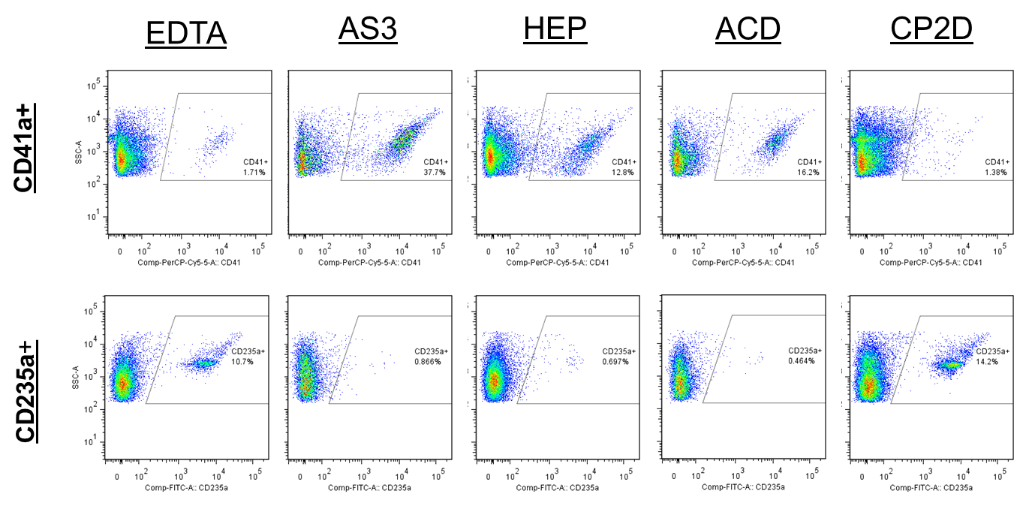
We have clarified our discussion of anticoagulants to include more specific examples. It now reads, “Finally, the anticoagulant used (e.g., heparin, ACD, ethylenediaminetetraacetic acid (EDTA), etc.) during blood collection may impact the quality and quantity of EV content. While ACD has proven to be a good and reliable anticoagulant for our studies, testing multiple solutions is recommended to ensure that the most suitable anticoagulant for the application is chosen. This is especially important when EVs will be used in downstream assays where the anticoagulant used can affect the outcome. Some anticoagulants (e.g., EDTA and heparin) are known to interfere with PCR reactions while others (e.g., theophylline, adenosine and dipyridamole) have been shown to inhibit EV release from platelets¹².
Minor Concerns:
Lines 146-154, section 1.3.2 and 1.3.3: Please consider adding a 96 well plate diagram with arrows showing which samples/antibodies are added to which rows. For example,
Row 1: samples
Row 2: antibody 1
Row 3: antibody 2
Row 4: antibody 3
Row 5: empty
Rows 6-8: PBS
Thank you for your suggestion. We have added this plate map to Figure 1. 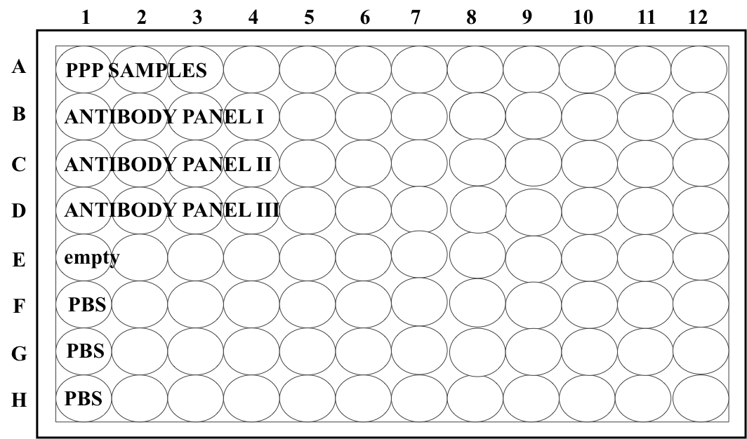
Line 158, section 1.4.1: Please state the type of "hood" - a chemical fume hood or a biological safety cabinet?
We have replaced “hood” with “biological safety cabinet” throughout the manuscript.
Line 162, section 1.4.2: Please list how many centrifugal filter tubes are needed. In the example protocol described for 12 samples, with 3 panels of antibodies, you would need 12x3=36 filter tubes.
That is correct. Per your suggestion, we have added this to the protocol step in the manuscript.
Line 322, section 2.3.3: How long can the samples sit prior to analysis? How long is the flow cytometer gating stable? Does this protocol require coordination between two people - one to prepare the samples while the other is calibrating the flow cytometer?
We have run samples up to several hours after staining without noticing an effect on sample quality. It is unlikely that the protocol would require coordination between two people, even if many samples were tested at once. We have clarified this in the protocol by adding “(or within the same day)” to line 322. It now reads, “Wash beads with 2 ml media, resuspend in 400 μl media and run immediately (or within the same day) on flow cytometer.”
Reviewer #4:
Major Concerns:
Introduction
The author should:
1. Explain, specifically, why other methods of EV analysis are not effective.
Our introduction does not state or imply that other methods of EV analysis are not effective. We believe other methods of EV analysis can be just as useful and have included specific examples in the discussion to expand on this.
2. Give a more detailed description of EV function, specific examples of biological processes they regulate, and outcomes resulting from that regulation.
We have enhanced our introduction to provide additional clinical examples. It now reads, “Through expression of various surface markers and/or direct transfer of biological material, EVs are able to alter the function of recipient cells to play either activating or suppressing roles in intercellular communication^{2–4}. Clinically, platelet-derived EVs are known to have strong anticoagulant activity⁵, while others have been shown to contribute to a wide range of conditions, from promoting tumor metastasis⁶ to protecting against disease⁷.”
Methods:
1.1.2: Centrifuging blood containing an anticoagulant results in three layers, not two. Also, it is incorrect to state that the first centrifugation will separate cells from plasma.
We have modified the wording of this sentence. It now reads, “1.1.2. Centrifuge the samples at 1500 x g for 10 min at room temperature (RT) to separate the plasma from the buffy coat and red cells. Transfer 1.2 ml aliquots of the plasma supernatant to 1.5 ml centrifuge tubes, being careful not to disturb the bottom layers containing the buffy coat and red cells.”
The materials list does not seem to include the media used for the EVs.
The media used is listed as “RPMI 1640 Media” in the materials table. To clarify this, we have added the note, “media used for bead-based detection method” to the comments/description column.
The author should expand on the note in lines 175 and 176.
We agree that this note needed some clarification. It now reads, Note: Ensure that no liquid remains on the filter tops. After centrifugation, the filter should appear to be “dry” with no visible fluid layer remaining on top. While unlikely, certain samples may require a slightly longer centrifugation time for the fluid to effectively move through the filter.”
Lines 182-183: What is the outcome if force and depression number is not consistent? How is force kept constant?
When force is not kept consistent from sample to sample, the number of EVs recovered from the filter tops will be different depending on the number of washes & force applied. More forceful pipetting may also cause damage to EVs. We have clarified this in the protocol. It now reads, “Note: It is very important to keep the force and number of pipette plunger depressions consistent among samples to avoid sample-to-sample variation. This should ideally be done using an electronic pipet that has been programmed to pipet up and down a specific volume (e.g., 280 µl) an exact number of times (e.g., 8 times) for each sample.”
Minor Concerns:
Method A:
The temperature should be included for all centrifugation steps.
We agree that the processing methods should have been more detailed. The centrifugation temperature has been added to all applicable steps within the protocol.
1.1.3: Does the author really mean "combine"? If so, what is being combined?
We can see how this sentence may have been confusing. The word “combine” was intended to refer to all PPP from a single donor (if, for example, multiple tubes were drawn). We have replaced the word “combine” with “add” for clarity.
1.3.1: Omit "To do this" and give the filtering steps an appropriate heading.
Per your request, we have omitted the words “To do this” and added a heading. It now looks like this:
1.3.1. Prior to staining, all antibodies (Abs) need to be filtered to remove aggregates, which can cause positive signals.
1.3.1.1. Combine antibodies to be used in each of the 3 panels into separate 0.22 µm centrifugal filter tubes and centrifuge using a fixed angle single speed centrifuge (~750 x g) at RT for 2 min, or until all of the Ab mixture has passed through the filter and no antibody liquid remains on the surface of the filter. Store Ab cocktails in the fridge for up to two weeks but re-filter each time before use.
The tables should be reformatted so that they are more easily viewed.
Thank you for your suggestion. We have changed the formatting of the text to “wrap” so that the entire contents within a cell are now visible.
1.5.2.3: What is the name of the software?
We used FACS Diva software, which was the software included with our cytometer. The JoVE manuscript guidelines do not permit the use of commercial language within the article text, so all reagents and instrument specifics (including flow cytometer software used) are listed in the Table of Specific Reagents/Materials. We have attempted to clarify this in the protocol by adding the text “Using the flow cytometer software included with your instrument, […]” to section 1.5.2.3.
Additional Comments to Authors:
The techniques for isolating EVs look the same in both methods.
Thank you for this observation. Since the isolation techniques are the same, we have removed the isolation method described in Protocol B and replaced it with instructions to the reader to refer to Protocol A’s isolation method in order to cut down on repetitive text.
The authors would benefit from reviewing and revising the manuscript more thoroughly.
We have made every effort to proofread the manuscript as thoroughly as possible and believe this revised draft to be a noticeable improvement.

