Submission ID #: 52420

Editor Name: Nadeeka Dias

Videographer name: Matt Lenz

Film Date: 4/17/2015

Authors and Affiliations: Gabriella Musacchia¹, Silvia Ortiz-Mantilla², Teresa Realpe-Bonilla², Cynthia P. Roesler², April A. Benasich²
¹Department of Otolaryngology - Head & Neck Surgery, Stanford University School of Medicine
Stanford, CA
²Center for Molecular & Behavioral Neuroscience, Rutgers University, Newark, NJ

Title: Infant auditory processing and event-related brain oscillations

Corresponding Author:
Gabriella Musacchia, Ph.D.
gmusacchia@ohns.stanford.edu

Co-authors:
Silvia Ortiz-Mantilla
sortizma@andromeda.rutgers.edu

Teresa Realpe-Bonilla
trealpe@andromeda.rutgers.edu

Cynthia P. Roesler
croesler@andromeda.rutgers.edu

April A. Benasich
benasich@andromeda.rutgers.edu

A. Will you require JoVE to record video microscopy, such as filming a complex dissection or microinjection technique? No
B. Does your protocol include detailed, step-by-step, descriptions of software usage? Yes.
If yes, we will need you to record using screen recording software to capture the steps. If you use a Mac, QuickTime X also has the ability to record the steps.
C. Which steps of your protocol will viewers benefit most from having filmed? Please list 4-6 steps using the step numbers listed in this document. 2.3, 2.4, 2.5, 2.7, 3.3, 3.7, 3.9
D. What is the single most difficult aspect of this procedure and what do you do to ensure success? Please list the steps using the step numbers listed in this document. Source localization; 3.6
E. Will the filming need to take place in multiple locations? Yes. If yes, how far apart are the locations? 20 ft

1. Introduction (Schematic Overview and Interview)

A. Schematic Overview (read by voice talent at JoVE):

Procedural Narrative:
The overall goal of this procedure is to estimate the dynamic, oscillatory communication in infant brain structures over a short time scale. (Intro)

This is accomplished by first applying a high-density sensor net to the infant’s head and recording brain waves during stimulus presentation. (P1: Schematic.pptx; Begin with the photo of the child with the EEG net. Then, show the EEG output image of brain waves.)

The second step is to preprocess the brain wave data to create event-related potentials. (P2: Schematic.pptx; Begin with a blank Amplitude/Time graph, and animate the wave being drawn, Add title “EEG waves”; Then, show the software interface image.)

Next, perform a discrete multiple source analysis projected onto an age-appropriate infant MRI scan. (P3: Schematic.pptx; Show the blue and red brain wave graph, Add title “Multi-source Analysis”; Then, show the graph of the raw EEG spectrum. Label the top blue wave “L Hemisphere”, and the bottom red wave “R Hemisphere”.

The final step is application of the source montage and decomposition of the signal into the time-frequency domain. (P4: Schematic.pptx; Show the frequency/time spectrum image. Highlight the x-axis “Time”, and the y-axis “Frequency”.)

Ultimately, analysis of infant brain oscillations is used to show changes in brain function in early development. (P5: Figure 4, i. ERP – Rapid Rate Condition; Label the graph of the left “Left Hemisphere”, and the graph on the right “Right Hemisphere”)

Paste a copy of your graphic overview here. The original file should be Adobe Illustrator (preferred) or Powerpoint (see instructions) and should be uploaded through your online submission on the JoVE website. Please keep all layers in the file (i.e., do not flatten the file).

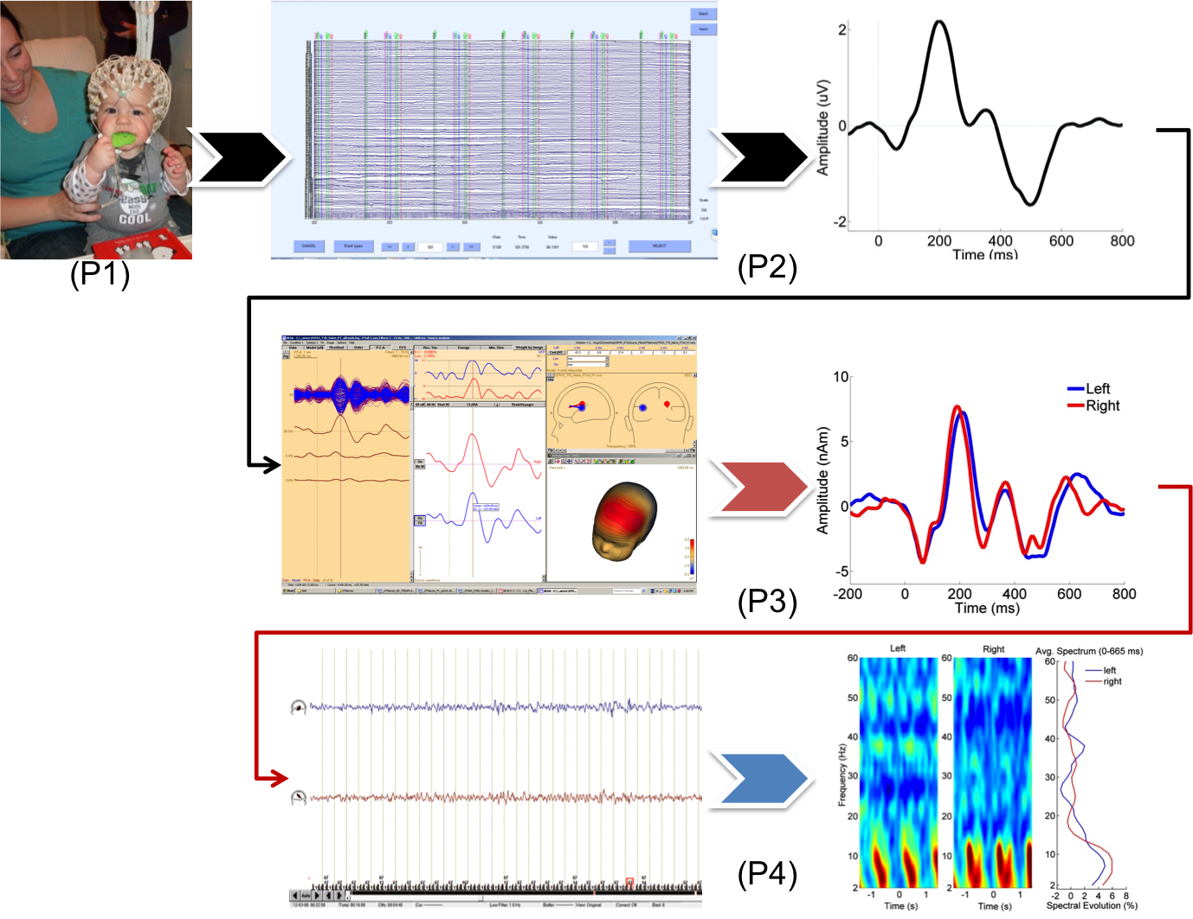
B. Interview: (Said by you on camera. Don’t forget to smile!)

  - Gabriella: The main advantage of this technique over existing methods, such as traditional high-density encephalogram or event-related potential analysis, is that it describes the brain response with distinct parameters of frequency, amplitude, time occurrence, and time span.
  - Teresa: Visual demonstration of this method is critical as the net application steps are difficult to learn because the actions of the hands, body, and arms in relation to the infant and caregiver are hard to describe in words.
  - April: Demonstrating this procedure will be Teresa, a technician from my laboratory, and Jess, another technician, who will be assisting her.
    - Interview style: Author saying the above
    - The named technician, post doc, student looks up from workbench or desk or microscope and acknowledges the camera.

Protocol (read by voice talent at JoVE):
- Infant Net Application and EEG Recording
  - To begin, escort the infant and caregiver into the testing chamber. Sit the infant on the caregivers’ lap, and have an assistant play with the infant while the net application procedure is explained.
    - WIDE: Talent brings infant and caregiver into testing chamber. Infant sits on caregivers’ lap.
    - WIDE: Entertainer enters room with toys to play with infant.
    - MED: Talent holds up EEG net and explains the procedure to the caregiver.
  - Measure the infants’ head circumference at the widest point of the head, and choose the appropriate net size based on this measurement.
    - MED: Talent uses tape measure to measure the infants’ head circumference.
  - Next, measure nasion-to-inion and mark the scalp at half of the total measurement. Then, do the same for the measurement from ear-to-ear. The final vertex between these two measurements is the Cz (pronounced C-z).
    - MED: Talent measures infants’ head from nasion to inion and marks the half-way point with a marker. Then, talent measures from ear to ear and marks that half-way point.
    - MED/CU: Shot of talent pointing to the vertex between the two points at the top of the head.
  - Place the net on the infants’ head as the assistant moves the chinstrap and colored front threads outside of the net.
    - MED: Talent places net on the infant’s head.
    - MED: Assistant moves the chinstrap and the colored front threads to the outside of the net
  - Adjust the net position by placing the Cz electrode at the vertex scalp mark. Position each electrode by moving from back to front to ensure there is a right angle between each electrode and the head surface.
    - CU: Talent adjusts the net on the infants’ scalp by moving the Cz electrode to the vertex scalp mark. Show electrode aligning with the mark.
    - MED: Talent positions each electrode, moving from the back of the head to the front.
  - Finally, plug in the net connector. Measure the electrode impedance with a threshold of less than 50 kiloOhms.
    - MED: Talent plugs in the net connector and checks impedance meter or NeuroAmp.
    - CU: Show impedance meter reading. It should be lower than 50 kOhms.
  - Prior to starting the recording, provide the caregiver with headphones to avoid any caregiver interference with the infant recording.
    - MED: Talent gives headphones to the caregiver.
    - MED: Caregiver puts on the headphones.
  - Now that the infant is prepped for the experiment, begin by presenting the auditory stimuli through speakers that are equidistant from the infants’ head. Then, start the EEG recording.
    - MED: Show the infant sitting on the caregivers’ lap. Then, show talent pointing to the location of the two speakers in relation to the infant. [Video editor: When speakers are shown on screen, insert the ‘Tone_2.8.wave’ audio file, overlaying the tone]

(AUTHORS: Please upload the tone file and label it “Tone_2.8.wave”)
    - MED (over the shoulder): Talent begins the EEG recording. Show a shot of the computer where talent clicks to begin the session.
  - Provide a calm quiet environment for the infant during the recording. Engage the infant using soft toys.
    - MED: Talent slightly dims the lights.
    - MED: Talent kneels in front of the infant, and shakes a soft toy in front of them.
  - After the experiment is completed, remove the net and dry the infants’ hair and head.
    - MED: Talent removes the net and dries the infants’ head with a towel.
- Data Processing
  - Begin processing the ERP (pronounced E-R-P) data by visually inspecting the raw output. Reject any segments with high-amplitude artifact.
    - MED (over shoulder): Talent sitting at computer looking through raw ERP data. (TEXT: ERP: Event Related Potential)
    - LAB MEDIA: highamplitude.jpeg

(AUTHORS: Please upload screenshot of ERP output that shows high-amplitude artifact, and title it ‘highamplitude.jpeg’. If possible, draw a box around a segment with the high-amplitude)
  - Take the average epochs for each individual and each condition. Combine these averages according to group and condition to make a grand average.
    - SCREEN: Talent averaging epochs for each individual and each condition, then combing the averages according to group.
    - LABMEDIA: Figure 1, step 1. [Video editor: Show when VO mentions ‘grand average’]
  - Next, co-register each individual and grand average ERP file with an age-appropriate magnetic resonance template.
    - MED (over shoulder): Talent sitting at the computer co-registers each ERP file
    - SCREEN: Show EEG image of electrode positions on head. Then, show the MR resonance template (TEXT: Magnetic Resonance Template)
  - To process the source localization data, begin by choosing a time window of interest within the grand average ERP file that corresponds to a peak.
    - MED (over shoulder): Talent sitting at the computer chooses a time window of interest within the ERP file that corresponds to a peak of interest.
    - SCREEN: Open the grand average ERP file. Choose a time window by putting a box around a peak (TEXT: Typically +/- 20 ms around peak)
  - Then, estimate the number and location of underlying sources to be fitted to the data. For this auditory paradigm, use a left and right dipole with free location and rotation.
    - MED (over shoulder): Talent sitting at the computer makes estimates for the number and location of sources to be fitted to the data.
    - SCREEN: Show estimations of the number and location of the sources to be fitted to the data.
    - LABMEDIA: Figure 1, step 2. [Video editor – label ‘L’ on the left side and ‘R’ on the right side]
  - Check the “goodness of fit” for the dipole model solution using the software output of residual variance. Adjust the time window to minimize the residual variance.
    - MED (over shoulder): Talent sitting at the computer uses the software output of residual variance to check the ‘goodness of fit’ to the dipole model solution.
    - SCREEN: Show output of residual variance. Talent adjusts the time window, which shows the residual variance decreasing.
  - Finally, to analyze the time-frequency data in source space, apply the dipole model solution to the raw, unfiltered, continuous EEG data.
    - MED (over shoulder): Talent sitting at the computer applies the dipole model solution to the raw unfiltered EEG data.
    - CU: Show the raw EEG data on the screen.
    - SCREEN: Apply the dipole model solution, and then show the raw, unfiltered EEG data.
  - Then, apply the dipole model solution to the raw EEG data file as a virtual electrode montage.
    - MED (over shoulder): Talent sitting at the computer applies the dipole model solution to the raw EEG data as a virtual electrode montage.
    - SCREEN: Apply the dipole model solution to the EEG data as a virtual electrode montage.
    - LABMEDIA: Figure 1, step 4.
  - Finish by transforming the time-domain single-trial source signal into the time-frequency-domain.
    - SCREEN: Show signal-trial data (TEXT: single-trail domain) first, then show data representing the time frequency domain (TEXT: time-frequency domain)
- Results: Event-related brain oscillations during infant auditory processing.
  - The results from this EEG study show a representative grand average ERP response from 23 4-month-old infants for a control and rapid rate condition. An oddball paradigm is used to determine if an infants’ brain can recognize the difference between two different tones.
    - LABMEDIA: Figure 2. [Video editors: Show only the Fz graph (top graph) and legend for each condition (control and rapid). (TEXT: DEV = 800-1200Hz variant tone pair) show text in red and highlight the red lines in the graphs when ‘results’ is mentioned in the VO; (TEXT2: STD = 800-800Hz invariant tone pair), show text in black, and highlight the black lines in the graph when ‘grand average’ is mentioned in the VO.) When ‘difference’ is mentioned in the VO, highlight the gray line in both graphs.]
  - Here, the results of the source-localized data are shown for the left and right dipole. During the rapid rate condition, a large peak at 400 ms is noticeable in the right hemisphere for the variant tone pair.
    - LABMEDIA: Figure 4ii, Source waveforms-rapid rate condition. (Video Editor: When 400 ms VO is mentioned, highlight the axis in yellow and make a horizontal dotted line across the graph at the 0 nAM. Then place a red arrow pointing to the lime green peak at 400 ms in the right hemisphere graph.)
  - In addition, these temporal spectral plots indicate that tones in the control condition with a 300 ms inter-stimulus-interval elicit event-related oscillations with power changes in the delta-theta range.
    - LABMEDIA: Figure 5i, control condition only. [Video editor: Make a bracket to the left of the colored spectrum graph between 2 and 14.4 and again to the right of the average spectrum graph in this same location. When the VO says ‘Delta-theta’, have 4 arrows each point to a dark red region in the spectrum.]

- Conclusion (said by authors on camera)
  - Teresa: Once mastered, this technique can be done in 10 minutes if it is performed properly.
  - April: Following this procedure, other methods like oscillatory coherence and coupling measurement can be performed in order to answer additional questions of brain function and development.
  - Gabriella: After watching this video, you should have a good understanding of how to record and analyze infant brain responses in both time and time-frequency domains.

Provided Media

Authors, Please list all images, movie files, or 3-D rendered animations that can be included in the video per editor’s request. The step in the script/video where these images will be inserted should be specified. For example:

6.2 – 0123_PIname_Figure1.tif - dual color imaging of tumor angiogenesis at 40X
6.2 – 0123_PIname_Figure2.tif - dual color imaging of tumor angiogenesis at 100X

Formats: For static images we prefer .tiff, .eps, Illustrator, Powerpoint or Photoshop files at dimensions of at least 720X480 pixels and 300 dpi. The higher resolution, the better. Likewise any exported movie files should have at minimum these dimensions and be rendered to .mov, .mp4, or .avi files.

Insert your media filenames here.

General Preparation

It’s critical for a smooth and organized shoot that all reagents are accounted for, in advance.

Any overnight or long incubation steps should be recognized and specimens/samples be prepared in advance so that prior steps can be recorded and shooting can continue with pre-prepared specimens/samples.

All tubes/flasks should be pre-labeled neatly before we arrive.

Ex. Luciferase assay done in 96 well plates should be labeled with negative/positive control wells and experimental samples are labeled accordingly.

You will receive more detailed preparation instructions, as well as an introduction to your videographer, closer to your filming date.

